SUBCOURSE EDITION
OD 1009 A

US ARMY ORDNANCE CENTER AND SCHOOL

MAINTENANCE PROCEDURES





MAINTENANCE PROCEDURES

SUBCOURSE OD1009
Edition A

10 Credit Hours

United States Army Combined Arms Support Command
Fort Lee, VA 23801-1809

GENERAL

The Maintenance Procedures subcourse part of the Light Wheeled Vehicle Mechanic MOS 638B Skill Level 3 course is designed to teach the knowledge necessary to perform tasks related to the operational procedures within the unit maintenance section. Information is provided in the types of services, forms and records, intermediate support responsibility, ground support equipment, and recovery. This subcourse is presented in five lessons which correspond to the following objectives.

Lesson 1: INTRODUCTION TO PREVENTIVE MAINTENANCE SERVICES

TASK: Describe the various types of PM services.

CONDITIONS: Given information and procedures on the various types of services to be performed.

STANDARDS: Answer 70 percent of the multiple-choice test items on the practice exercise correctly.

i

Lesson 2: PREPARATION OF UNIT LEVEL MAINTENANCE FORMS AND RECORDS

TASK: Identify and describe historical and operational records and forms that are maintained at the unit level.

CONDITIONS: Given information on the purpose and preparation of unit level maintenance forms.

STANDARDS: Answer 70 percent of the multiple-choice test items on the practice exercise correctly.

Lesson 3: INTERMEDIATE DIRECT SUPPORT MAINTENANCE PROCEDURES

TASK: Describe how an intermediate direct support (IDS) unit is organized. Explain the mission of an IDS unit. Describe the procedures for obtaining IDS assistance.

CONDITIONS: Given information on obtaining assistance from the IDS unit.

STANDARDS: Answer 70 percent of the multiple-choice test items on the practice exercise correctly.

Lesson 4: ORGANIZATIONAL MAINTENANCE OF AUXILIARY POWER GENERATORS

TASK: Describe the procedures for operation and unit maintenance on assigned power generators.

CONDITIONS: Given information on the procedures for operation and unit maintenance on power generators.

STANDARDS: Answer 70 percent of the multiple-choice test items on the practice exercise correctly.

Lesson 5: RECOVERY OPERATIONS

TASK: Describe the different procedures for the recovery of light wheeled vehicles.

CONDITIONS: Given information on the proper procedures for recovery operations of light wheeled vehicles.

STANDARDS: Answer 70 percent of the multiple-choice test items on the practice exercise correctly.

ii

TABLE OF CONTENTS

Section Page

TITLE PAGE i

TABLE OF CONTENTS iii

GRADING AND CERTIFICATION INSTRUCTIONS v

Lesson 1: INTRODUCTION TO PREVENTIVE MAINTENANCE SERVICES

Learning Event 1: Describe the Purpose and
Use of Preventive Maintenance Checks and Services (PMCS) 1

Learning Event 2: Define and Describe the
Use, Care, and Types of Tools and Test Equipment 6

Learning Event 3: Describe the Purpose of the Road Test 9

Learning Event 4: Describe Troubleshooting 10

Practice Exercise 11

Answers to Practice Exercise 12

Lesson 2: PREPARATION OF UNIT LEVEL MAINTENANCE
FORMS AND RECORDS

Learning Event 1: Define and Describe the
Purpose and Use of Historical Records 13

Learning Event 2: Define and Describe the
Purpose and Use of Maintenance and Operational
Forms and Records 17

Practice Exercise 27

Answers to Practice Exercise 28

iii

Section Page

Lesson 3: INTERMEDIATE DIRECT SUPPORT MAINTENANCE
PROCEDURES

Learning Event 1: Describe How an Intermediate
Direct Support Unit Is Organized 29

Learning Event 2: Describe the Organization
of an Intermediate Direct Support Unit
(Divisional and Nondivisional) 31

Practice Exercise 53

Answers to Practice Exercise 54

Lesson 4: ORGANIZATIONAL MAINTENANCE OF AUXILIARY
POWER GENERATORS

Learning Event 1: Describe the 3-KW Generator
Sets 55

Learning Event 2: Describe the 5-KW Generator
Sets 87

Practice Exercise 105

Answers to Practice Exercise 106

Lesson 5: RECOVERY OPERATIONS

Learning Event 1: Describe Recovery
Management 107

Learning Event 2: Describe Methods of
Recovery 124

Practice Exercise 145

Answers to Practice Exercise 146

iv

Ten credit hours will be awarded for successful completion of this subcourse.

If you are enrolled in the complete MOS 63B Skill Level 3 Light Wheeled Vehicle Mechanic Course, you must complete at least 60 credit hours each enrollment year, or the complete course, whichever is less.

v

IMPORTANT NOTICE

Do not accept assistance of any kind in completing the lesson exercises or the examination to this subcourse. Do not accept solutions or "copy" from other students, and do not let other students "copy" from you or see your solutions. If you violate these rules, you are subject to disciplinary action or discharge from the service under the provisions of AR 351-20, paragraph 13.

*** IMPORTANT NOTICE ***

THE PASSING SCORE FOR ALL ACCP MATERIAL IS NOW 70%.

PLEASE DISREGARD ALL REFERENCES TO THE 75% REQUIREMENT.

vi

Lesson l/Learning Event 1

LESSON 1
INTRODUCTION TO PREVENTIVE MAINTENANCE SERVICES

TASK

Describe the various types of preventive maintenance services.

CONDITIONS

Given information and procedures on the various types of services to be performed.

STANDARDS

Answer 70 percent of the multiple-choice test items on the practice exercise correctly.

REFERENCES

DA Pam 738-750
DA Pam 750-1
UMMS 84-1-2
Appropriate operator's manual
Appropriate maintenance technical manual

Learning Event 1:
DESCRIBE THE PURPOSE AND USE OF PREVENTIVE MAINTENANCE CHECKS AND SERVICES (PMCS)

What is preventive maintenance? Preventive maintenance (PM) is the care and servicing of equipment through the systematic inspection, detection, and correction of faults, either before they occur or before they develop into major defects.

One method of performing PM is to schedule the performance of certain checks and services at prescribed intervals and in conjunction with dispatching a vehicle.

Many of you have performed scheduled maintenance at one time or another or have had to dispatch a vehicle to help perform the unit's mission; however, you should understand the procedures involved in performing scheduled maintenance or inspections required before equipment can be dispatched.

1

Lesson 1/Learning Event 1

During this learning event, we will discuss and define PMCS and the different types of PMCS that are performed at the unit level.

PMCS, the care of equipment by the user, is the heart and soul of the entire maintenance system. A look at the vast complex that makes up the system might give a false impression that unit maintenance is unnecessary and that equipment can be driven until it fails and then unloaded on the broad shoulders of higher maintenance. This contradicts the fact that the entire system assumes the using unit will care for its equipment to avoid such failures. The system will bog down completely if the equipment is not properly operated, cleaned, lubricated, tightened, and adjusted on a systematic basis by the user. Even the minor repairs and parts replacements authorized within the scope of unit maintenance of equipment are preventive repairs, being designed to prevent or hinder the more complex and time-consuming repairs that would otherwise result.

The responsibility of PM is the job of every individual who is assigned to the unit. There are three types of PM used to keep vehicles operational that will be discussed in this learning event. These are operator/crew PMCS, unit scheduled PMCS, and unscheduled maintenance.

OPERATOR/CREW PMCS

Operator/crew PMCS is the first line of defense against deteriorating equipment. Operators can assist the maintenance program by detecting and reporting most equipment failures. They are in the best tactical position to do so. Since most Army equipment is built for durability in tactical operations, even those operators who avoid conscious abuse and observe published operating precautions help out in the maintenance effort. However, operators are required by the -10 operator's manual to perform specific checks. These checks are before-, during-, and after-operation checks and weekly and monthly checks.

2

Lesson 1/Learning Event 1

BEFORE-OPERATION CHECKS

Before-operation checks are required prior to operating the vehicle. At this time, the operator must have the -10 operator's manual and a DA Form 2404, Equipment Inspection and Maintenance Worksheet. The details for completion of this form can be found in DA Pam 738-750. If the operator finds an equipment problem that can be repaired without assistance, then an entry is not made on the DA Form 2404. Examples of this are low engine oil or low engine coolant. However, if the operator finds a problem that cannot be repaired, then the DA Form 2404 is completed in accordance with DA Par 738-750 and the local SOP and is submitted to the unit maintenance section. Examples are horn inoperative or gages do not work.

DURING-OPERATION CHECKS

During-operation checks are performed by the operator after the vehicle has been dispatched to the mission. This is when the operator must use the senses of sight, sell, and hearing to detect any problems that may arise after departing from the unit area. The operator must be constantly watching the gages, listening for unusual noises, or smelling for burning insulation or other items.

AFTER-OPERATION CHECKS

After-operation checks are required right after the operator has completed the daily use of the vehicle. At this time, the operator will check over the vehicle once again using the -10 manual and the DA Form 2404. During this check, the operator will be required to repair or report any problems that may have occurred during the operation.

WEEKLY AND MONTHLY CHECKS

Weekly and monthly checks will normally appear on the unit training schedule.

The before, during, after, weekly, and monthly checks are outlined on the PMCS table located in the appropriate -10 operator's manual.

3

Lesson l/Learning Event 1

SCHEDULED UNIT MAINTENANCE/SERVICES

Scheduled unit maintenance/services are required at prescribed intervals and scheduled on DD Form 314 (Preventive Maintenance Schedule and Record). This form is used to record maintenance and supply times, scheduled maintenance/services, and oil analysis samples. Other information may be entered on this form as directed by local policy or standing operating procedures (SOP). Complete instructions for this form can be found in DA Pam 738-750. Army doctrine requires that equipment be serviced periodically on the basis of days passed or hours/miles of operation. Some equipment is required to be serviced monthly, quarterly, semiannually, or annually. However, some vehicles may be required to receive all of these services with selected items to be checked at each interval. Exact intervals for scheduled services are in the technical manual or lubrication order for each type of equipment. This type of service will require unit level mechanics because it entails fairly complex maintenance tasks.

While performing services, mechanics often discover maintenance deficiencies and shortcomings that operators have missed. Scheduled services thus serve two purposes: PM and identification of unreported maintenance deficiencies and shortcomings.

While equipment is being serviced, all requires parts are requisitioned and any other deficiencies and shortcomings are corrected, if possible, within the scope of the maintenance allocation chart (MAC).

A complete PMCS table for the unit mechanic is located in the -20 maintenance manual. The mechanic must also use a DA Form 2404 to record the service and the results.

THE ARMY OIL ANALYSIS PROGRAM (AOAP)

The AOAP provides specific information on types and amounts of contaminants present in engine and automatic transmission oils. The list of equipment involved in the AOAP is always expanding as new equipment is entered into the Army inventory.

The contaminant profile is related to standards and deviation from these standards usually indicates existing or developing maintenance problems. The information provided to units is unique because it identifies the existence of a poor maintenance condition prior to a malfunction. The AOAP reports also provide a check on operator/crew maintenance.

4

Lesson 1/Learning Event 1

It is the responsibility of the unit maintenance section to ensure that all instructions received from the oil analysis laboratory are followed.

UNSCHEDULED SERVICES

Unscheduled services are those services and repairs that are required to be accomplished to correct a deficiency or short-coming that may occur between the times that a scheduled service is due.

Even though all the required services are performed correctly and on time, there will be malfunctions that occur between services that will have to be corrected. These items could be anything from a broken window to inoperative brake systems. If an operator finds a deficiency or shortcoming that cannot be repaired, then this becomes an unscheduled service for the unit maintenance section.

SUMMARY

During this learning event, we have discussed the different types of services that must be performed at the unit level. It is the maintenance supervisor's responsibility to ensure all required scheduled services are properly performed. However, the first-line supervisor must take the responsibility to ensure that the operators, under operational control, perform the required daily PMCS and report all deficiencies and shortcomings to the unit maintenance section.

5

Lesson 1/Learning Event 2

Learning Event 2:
DEFINE AND DESCRIBE THE USE, CARE, AND TYPES OF TOOLS AND TEST EQUIPMENT

TYPES OF TOOLS

Proper tools are a must when performing maintenance on equipment. Within the maintenance structure are many types of tools authorized by the tables of organization and equipment (TOE), tables of distribution and allowances (TDA), or the parts manual for the equipment. In the maintenance shop, there are three basic types of tools: common, special, and test, measurement, and diagnostic equipment (TMDE).

Common Tools

Used by the operator and mechanic to accomplish everyday maintenance tasks. Examples of these tools are wrenches, screwdrivers, and hammers that can be found on the vehicle, in the basic issue items (BII), and within the general mechanic's tool kit, as well as shop sets.

Special Tools

Certain vehicles require special tools peculiar to that specific type of vehicle to accomplish necessary maintenance functions. Tools of this type are specially designed for unit maintenance, repair, and general use on the particular items for which issued. The supervisor must ensure that proper use and care of tools is well understood.

TMDE

TMDE is part of the maintenance shop set. TMDE items consist of multimeters, simplified test equipment/internal combustion engine (STE/ICL), torque wrenches, and other items that are used to test and measure. Although much of this test equipment is sensitive, it should be kept available for use in the shop area under close supervision. Supervisors must ensure that personnel are adequately trained to operate test equipment. The appropriate technical manual should be consulted every time a test is conducted to ensure that the proper values are used and all necessary measurements are made.

6

Lesson 1/Learning Event 2

CARE AND USE

The proper use and care of all tools is very important for the mechanic and the operators to successfully accomplish proper maintenance. For example, you would not use a screwdriver in place of a chisel or a pair of pliers to remove or tighten a bolt and nut. Tools must also receive proper care. They should be clean and serviceable. Screwdrivers and chisels should be properly dressed on the tips. If all the tools are used for what they are designed for, they will serve you for a long time.

CALIBRATION

All units rely on TMDE to verify the serviceability of material. To rely on TMDE, the user must ensure that the equipment is operating properly, and its specific tolerances are verified. To ensure that the equipment is in good operating condition, a check is made against equipment of known accuracy. This process is known as calibration.

Unit maintenance personnel will determine what items of equipment require periodic calibration by reviewing TB 43-180. A review must be conducted each time a new TB 43-180 is received, a new change to the TB is received, or when a new item of equipment is received that requires calibration.

The Calibration Data Card (DA Form 2416) provides a means of identifying individual measurement standards and TMDE that require calibration. It provides the primary means of scheduling calibration services. It is the supervisor's responsibility to ensure all TMDE is calibrated.

CONTROL

Necessary tools and equipment must be on hand to perform unit maintenance properly. These items are controlled by the supervisor as well as the operator and mechanic.

AUTHORIZATION

The unit's TOE will list what the unit is authorized. The unit commander and the maintenance supervisor will ensure these authorizations are met.

7

Lesson 1/Learning Event 2

INVENTORY

The hand-receipt holder, along with the motor sergeant or maintenance supervisor, should conduct inventories to ensure all tools and equipment are accounted for. When the inventory is completed, the maintenance supervisor must ensure that all tools are signed for on hand receipts to the user. Special tool shadow boards are ideal for storage in locked toolrooms. The internal procedures of these inventories should be included in the unit maintenance SOP.

The hand receipt should be signed by the user. The mechanic is responsible for the tool kit. The toolroom custodian is responsible for the tools in the toolroom and should ensure that tools are signed for and returned. These tools would include common, special, and TMDE. The tool custodian should inspect each tool that is returned for cleanliness and serviceability. There should have been a locator card file established. If any tools are unserviceable, they should be turned in to the supply room immediately for replacement. The locator card shows the tool custodian the quantity on hand, quantity authorized location, applicable technical manual, and calibration if required.

It is the responsibility of the tool custodian through the unit commander to ensure that all tools are properly secured and accounted for.

SUMMARY

During this learning event, we have covered the types, use, and care of tools. We have also discussed the control and security of tools. This should give you some idea of how to maintain and control tools and TMDE.

8

Lesson 1/Learning Event 3

Learning Event 3:
DESCRIBE THE PURPOSE OF THE ROAD TEST

The road test is a very important part of any maintenance service. It is at this time that the mechanic checks any repairs that have been made. Furthermore, it may uncover another problem that my have been overlooked during the initial inspection of the vehicle.

The road test operation may also be used to verify any problems that the operator has reported on a daily PMCS.

There are some checks that should be made after a road test. A good example of this would be brakes that drag or do not apply evenly. A check of this would involve touching each brake drum to see if it is operating to hot or cold.

SUMMARY

In this learning event, we have discussed the purpose of the road test. Understanding this should place you in a better position to explain the importance of the road test to mechanics under your operational control.

9

Lesson l/Learning Event 4

Learning Event 4:
DESCRIBE TROUBLESHOOTING

When there is a malfunction in a vehicle system, the unit mechanic must be able to repair it as quickly and efficiently as possible. Just because the electrical charging system fails to function does not mean that the alternator is bad. It is the mechanic's responsibility to determine the problem and correct it without changing parts that may still be operational. This then is troubleshooting.

When troubleshooting, the mechanic must be able to use the five senses (sight, hearing, touch, smell, and taste). The mechanic must know how to properly use the TMDE that is-available. Using the TMDE will stop a lot of unnecessary parts changing. It will also reduce the cost of repair, resulting in a savings of many dollars to the US Army.

After taking your car to a garage for an electrical malfunction, how would you like to find that the mechanic had changed the alternator, drive belts, and other parts only to find that the whole problem was a broken wire? This is the kind of waste that could be eliminated by proper troubleshooting.

The first step on any problem is to isolate the system. Is it the charging system, starting system, or accessories? After this we must use the troubleshooting chart in the appropriate -20 maintenance manual. The troubleshooting chart is a systematic step-by-step series of tests using the GO or NO-GO chain. Using the troubleshooting chart will help lead you to the problem in the most efficient manner. Of course, to properly use the troubleshooting chart, you must be able to apply the TIDE to run
the test necessary.

In addition, the mechanic may have to use more than just one manual in troubleshooting. If, for instance, you start troubleshooting with .the STE/ICE manual, it may refer you to the basic -20 manual for a specific test.

SUMMARY

During this learning event, we have discussed the purpose and results of troubleshooting. After this learning event, you should be able to explain the importance of troubleshooting and use of TMDE.

10

Lesson 1

PRACTICE EXERCISE

1. What do the initials PMCS stand for?

a. Preventive Maintenance Checks and Services
b. Primary Mechanic Certification Standard
c. Pre-Mechanical Course System

2. How many types of PM are there?

a. One
b. Two
c. Three

3. A complete PMCS table for the unit mechanic is located

a. in the operator's manual.
b. in the maintenance manual.
c. in DA Pam 738-750 (Maintenance Management Update).

4. What are the three basic types of tools?

a. Hand, power, and pneumatic
b. TMDE, common, and special
c. Electric, air, and hydraulic

5. What type tool requires calibration?

a. Air impact wrench
b. Electric impact wrench
c. Torque wrench

11

Lesson 1

ANSWERS TO PRACTICE EXERCISE

1. a (page 1)

2. c (page 2)

3. b (page 4)

4. b (page 6)

5. c (page 7)

12

Lesson 2/Learning Event 1

LESSON 2
PREPARATION OF UNIT LEVEL MAINTENANCE FORMS AND RECORDS

TASK

Identify and describe historical and operational records and forms that are maintained at the unit level.

CONDITIONS

Given information on the purpose and preparation of unit level maintenance forms.

STANDARDS

Answer 70 percent of the multiple-choice test items on the practice exercise correctly.

REFERENCES

DA Pam 710-2-1
DA Pam 738-750
DA Pam 750-1
UMMS 84-1-2

Learning Event 1:
DEFINE AND DESCRIBE THE PURPOSE AND USE OF HISTORICAL RECORDS

HISTORICAL RECORDS

These records are maintained for a specific item of equipment. They are a control device for mandatory recording of events during the life cycle of equipment, including receipt, operation, condition, maintenance accomplished, modification, and transfer. The records are permanently identified with the applicable equipment by nomenclature and registration or serial number and must be safeguarded against loss or damage. The most important use of the records is to provide commanders with up-to-date information concerning the readiness of equipment, the condition of the equipment, and identification of equipment requiring the greatest maintenance effort.

During this lesson event, you will be familiarizes with, and given a brief introduction to, the use and purpose of historical records that are maintained at the unit level.

13

Lesson 2/Learning Event 1

DA FORM 2408-9 (EQUIPMENT CONTROL RECORD)

This form gives maintenance managers at all levels the means of getting initial basic equipment acceptances and identification information for selected items in the Army inventory. It also provides the means for updating information on ownership, location, usage, transfers, gains, losses, overhaul, rebuild, and disposition. This form also gives needed input data for management and control of the registration numbering of Army vehicles and material. AR 710-3 gives specific instructions on the use of this form for this purpose.

Acceptance and Registration

DA Form 2408-9 is prepared upon delivery and acceptance of a reportable item by the US Army. It will be used by the owner as the source document for data to complete all other TAMMS records.

If items of equipment are received without a complete DA Form 2408-9 acceptance, the organization which first determines that a need exists for this form will initiate and distribute the required copies.

Usage

DA Form 2408-9 provides the means for updating information on equipment ownership, location, and usage (miles and/00 hours). It is initiated by the unit maintenance section, usually the TAMMS clerk, and the type of equipment dictates when the form will be submitted. DA Pam 738-750 outlines when the report will be submitted depending on the classification of equipment.

Transfer

Each time that a reportable item is transferred to another property book after its initial acceptance into the Army inventory, a DA Form 2408-9 is required to be submitted. It is not required when the item is shipped or received on a loan basis. When the item is transferred, the form will be initiated by the unit that is shipping the item. When the unit receives the items, they also are required to initiate a transfer record.

Using this method, the Army is able to track the item from one unit to another.

14

Lesson 2/Learning Event 1

Loss

DA Form 2408-9 will be initiated by the losing unit anytime a reportable item is lost as a result of disassembly of a reportable integrated set or assembly, combat loss, turn-in to property disposal or salvage point, physical loss, or identification.

For this form, combat loss is defined as abandoned, captured, or destroyed in a combat zone. Physical loss will be reported due to pilferage or theft.

Gain

DA Form 2408-9 will be initiated by the gaining unit anytime a reportable item is gained as a result of combat gain, when items are reclaimed from property disposal or the cannibalization point, and for identification gains or inventory adjustment gains.

For the purpose of this form, combat gain is defined as a reportable item that has been recaptured or recovered.

As we have discussed, we can see that the uses of DA Form 2408-9 are numerous. For this reason, the information entered on this form must be accurate. Complete instruction on the use of the DA Form 2408-9 can be found in DA Pam 738-750.

DA Form 2408-9 is a multiple copy form and disposition should be made through higher headquarters to the destination indicated at the bottom of each copy in accordance with DA Pam 738-750.

DA FORM 2408-20 (OIL ANALYSIS LOG)

This form provides a record of oil samples taken and the results of laboratory analysis. DA Pam 738-750, Appendix E, and TB 43-0210 require that this form be maintained on appropriate equipment.

One form will be prepared for each component of an end item that requires oil sampling. It will be maintained in a consolidated logbook binder and must accompany equipment upon transfer. The form will accompany the equipment if a component identified for sampling is to be removed.

Disposition

When a DA Form 2408-20 is completely filled, it will be maintained for a period of six months after the last entry made in column 4. It will then be destroyed.

15

Lesson 2/Learning Event 1

SUMMARY

The records we have just discussed in this learning event are called historical records. They are a control device for mandatory recording of events during the life cycle of equipment, including receipt, operation, condition, maintenance accomplished, and transfer. The most important use of these records is to supply commanders with up-to-date information concerning the readiness of the item of equipment, the condition of the equipment, and identification of equipment requiring the greatest maintenance effort. The historical records must be safeguarded against loss or damage at all times. They are permanently identified by noun nomenclature, registration, or serial number. The records will be maintained in a central location in a logbook binder. Historical records will only be remade in the event of loss or damage to the extent that the information entered is illegible. When replacing a lost or mutilated form, refer to DA Pam 738-750.

16

Lesson 2/Learning Event 2

Learning Event 2:
DEFINE AND DESCRIBE THE PURPOSE AND USE OF MAINTENANCE AND
OPERATIONAL FORMS AND RECORDS

Maintenance forms and operational records are a part of a units function in recording important data concerning operation and maintenance. The objective is to record a minimum of data, yet record all that is required for the control, operation, and maintenance of equipment. It is your duty as a maintenance manager and supervisor to ensure that your personnel are using the correct forms and filling them out correctly. During this learning event, we will discuss maintenance forms and operational records for equipment assigned to a unit.

DA FORM 2404 (EQUIPMENT INSPECTION AND MAINTENANCE WORKSHEET)

This form is the one form from which all maintenance actions are initiated. It is used for recording faults during the operator's inspection, periodic PMCS, inspection of equipment by maintenance activities, diagnostic checkouts, and spot-check inspections of equipment.

Operator's Inspection

DA Form 2404 is used by the operator/crew to perform daily PMCS. If during the course of the inspection there are no faults or deficiencies found, the operator will date the DA Form 2404 in column "c" and initial column "e." If a shortcoming or deficiency is found that cannot be corrected, then the operator will enter the TM item number from the operator's PMCS table in column "a," the status symbol in column "b," and the shortcoming or deficiency in column "c." At this time, the operator will complete the heading and submit the DA Form 2404 to the maintenance section for verification.

Periodic Services

The unit mechanic is required to complete a DA Form 2404 when performing a scheduled maintenance service. During the initial inspection, using the PMCS table in the -20 maintenance manual, the mechanic will annotate the TM item number, status, short-coming or deficiency, and the corrective action. Once the fault has been corrected, the mechanic will initial column "e" of DA Form 2404.

NOTE: Requisitioning a part does not correct the fault.

17

Lesson 2/Learning Event 2

The DA Form 2404 is then submitted to the maintenance supervisor for a review and disposition in accordance with DA Pam 738-750 and the local SOP. The DA form must be reviewed by the supervisor to ensure it is completed and all required actions have been taken.

Intermediate Direct Support (IDS)

IDS uses DA Form 2404 when performing an inspection of equipment any time the using unit submits an item for repair. The support facility may accept or reject the equipment depending on the condition of equipment and local policy. In any case, a copy of their inspection will be furnished to the unit for corrective action. Inspection results may be an indication of the type of operator or unit maintenance that is performed in your facility.

The support facility also uses DA Form 2404 to perform estimated-cost-of-damage (ECOD) or actual-cost-of-damage (ACOD) inspections.

Diagnostic Checkouts

The unit mechanic will use the DA Form 2404 to record the results of all diagnostic checkouts. This could be a compression test or a complete checkout using the STE/ICE machine.

Spot-Check Inspections

The unit may be required to perform spot-check inspections on equipment that is to be, or has already been, dispatched. This is a good method for checking on the operator's maintenance. It is normally performed by a mechanic, but the maintenance supervisor or unit commander may want to conduct a spot-check inspection. Regardless of who conducts the inspection, the results must be recorded on a DA Form 2404. In this instance, the disposition of the form will be in accordance with the local SOP.

DA FORM 2408-14, UNCORRECTED FAULT RECORD

This form provides a means for recording uncorrected faults and deferred maintenance actions on equipment. It will be used for all equipment that has an open-deferred maintenance action. Status symbol X faults will not be entered on DA Form 2408-14.

18

Lesson 2/Learning Event 2

The commander or commander's designated representative will determine when a fault will be transcribed to DA Form 2408-14. Separate DA Forms 2408-14 are not required for items like rifles, protective masks, and M121 decons. A single form may be used to show deferred faults on such items as long as each fault entry is preceded in column "b" by the items administration or serial number.

When an item is identified as having a fault that can be deferred, the DA Form 2408-14 will be initiated in accordance with DA Pam 738-750. The end item nomenclature will be entered in block 1, the model in block 2, serial number in block 3, status symbol in block "a," fault in block "b" (administrative number or serial number will also appear in this block if the form is used for-more than one item), reason for delay in block "c," date from DA Form 2404 or 2408-13 in block "d," entry approved by signature in block "e," and date to DA Form 2408-3 or 2408-13 in block "f." Operators or crews will check the DA Form 2408-14 before each dispatch. They will look for faults that may affect the mission and faults that are overdue to be fixed. Should the operator or crew find any dates in column "c" that have already passed or actions that have already been taken, they will inform the maintenance supervisor.

Maintenance supervisors or leaders will review the form periodically (not less than every two weeks). They check status of parts on order, look for faults that have already been fixed but not closed out, or faults that are overdue to be fixed.

Disposition of the DA Form 2408-14 can be found in DA Pam 738-750.

DD FORM 314, PREVENTIVE MAINTENANCE SCHEDULE AND RECORD

This form provides a means for recording scheduled and performed unit maintenance services, lubrication services, oil sampling, and nonavailable equipment status. This form will be used for all equipment that the technical manual specifies for services performed by a mechanic or under the supervision of maintenance personnel. DD Form 314 is both an active and a planning form. As an active form, it is useful to the maintenance supervisor in daily or short-term planning. As a planning form, it is useful to the maintenance manager for long-term planning, maintenance analysis, and readiness reporting. To be useful in either case, the form must be accurately maintained.

19

Lesson 2/Learning Event 2

The form is used for scheduling required periodic services and oil sampling, providing a record of performed services, providing a record of nonavailability time and reason, and recording hourmeter and odometer changes.

One DD Form 314 may be initiated for each item of equipment; however, several like items may be scheduled on one DD Form 314 if they are scheduled for service on a common date. When several like items are scheduled on one DD Form 314, each item must be identified by serial number in the remarks section.

For reportable items, a DD Form 314 will be maintained on each subsystem. In addition, a DD Form 314 will be maintained on the overall system for the purpose of recording and computing nonmission capable maintenance (NMCM) or nonmission capable supply (NMCS) time on the system.

Before you can schedule maintenance or lubrication services, you must find out what services are required. For this information, refer to the appropriate technical manual or lubrication order for the equipment that you must schedule. After you determine what services are required, determine what symbol will be used.

NOTE: A complete list of authorized symbols can be found in DA Pam 738-750 and UMMS-84-1-2. After you have determined the type of service, you will then place the correct symbol on the correct day of the DD Form 314.

Service entries will be entered in pencil on the date that the service is due. This entry will be made using the appropriate symbol from the authorized list of symbols. Upon completion of a service, the pencil entry will then be changed to ink.

When a service is performed outside the authorized 10 percent variance, the service symbol and miles are recorded on the actual day the service is performed. The next service due is then scheduled from that date in accordance with DA Pam 738-750.

The visual signal system is used to indicate the date when a required service is scheduled. Once service is performed, the signal is removed. There are three colors of signals that are authorized for use.

- The green signal indicates that a lubrication service is due.

- A yellow signal indicates that a maintenance service of some type is due. The type of maintenance service will be indicated by the symbol placed in the square block.

20

Lesson 2/Learning Event 2

- The third color signal is red. This signal should be located on the right corner of the card and will be placed there anytime the equipment is in a nonmission capable (NMC) status.

If your TAMMS clerk is using the colored signals correctly, you should be able to look through the file and determine how many services are due during the current month and how many vehicles in you unit are NMC at anytime and compare this information with your DA Form 2406.

All nonavailability data will be recorded on the reverse side of the DD Form 314. NMC days are recorded for all reportable items and subsystems. Equipment may be NMC at the unit or IDS for either maintenance or supply reasons. The correct symbols to be used for this status can be found in DA Pam 738-750. Close coordination must be maintained between the maintenance supervisor and the support facility to obtain the current status of equipment each day.

Complete disposition instructions for the DD Form 314 can be found in DA Pam 738-750.

DA FORM 2407 (MAINTENANCE REQUEST)

This form provides maintenance information to all levels of maintenance management. It is used for requesting maintenance support modification work orders and warranty claims.

Maintenance Support

When an item of equipment has to be evacuated to the IDS facility for repairs that are beyond the capabilities of the unit, a DA Form 2407 will accompany it.

When the repairs are completed and the equipment is returned to the unit, a copy of the DA Form 2407 will be furnished to the using unit. This copy serves as a record of the repairs accomplished and is also a valuable document for readiness reporting.

If a team of support maintenance personnel is sent to your location for on-site repair of equipment, a DA Form 2407 must be completed.

21

Lesson 2/Learning Event 2

Modification Work Order (MWO)

When an HWO is published for an item of equipment, the using unit must request that the supporting unit apply the MWO. This request is submitted on a DA Form 2407.

When the support maintenance facility has completed applying the MWO, the equipment and part of the DA Form 2407 are returned to the unit. The copy of the DA Form 2407 will serve as a temporary record of the HWO application, as well as information for readiness reporting.

Warranty Claims

A DA Form 2407 must be submitted for warranty claims when components, parts, or assemblies are identified as being defective and are covered by the manufacturer's warranty and to obtain reimbursement for replacing the defective items.

It will be used to initiate claims actions at the unit, intermediate direct and general support, and depot level. The DA Form 2407 is also used to report settled and unsettled claims to the national level.

The DA Form 2407 is made up of five copies.

- The "receipt" copy is given to the owning unit at the time the equipment is accepted at the support unit. It will serve as a temporary hand receipt for accountability of the item until the item is returned to the unit.

- The "NMP" copy will be handled in accordance with DA Pam 738-750 or local policy.

- The "control" copy is handled as directed by the local command.

- The "organization" copy will be retained by the unit that initiated the request for a period of 90 days after the work is completed. (For MWOs and warranty claims, refer to DA Pam 738-750.)

For complete instruction for completing and disposition of DA Form 2407, refer to DA Pam 738-750 or to the front of the receipt copy.

22

Lesson 2/Learning Event 2

DA FORM 2765-1 (REPAIRABLE EXCHANGE)

This form is another maintenance record of interest to the maintenance supervisor, as it is used in the unit maintenance system. When it is used as a receipt for repairable exchange items not on hand at the support activity, it must be safeguarded. Many prescribed load list (PLL) clerks have misplaced or lost these receipts and have lost accountability for RX items.

DA Form 2765-1 consists of four copies. Copy 1 will remain with the using unit until such time that a serviceable replacement part can be obtained. Copy 2 will normally, but not in all cases, remain at the battalion level. Copy 3 will remain at the support level receiving the unserviceable part. Copy 4 will remain with the unserviceable item until it is repaired and used or disposed of by other authorized channels.

For complete instruction on the completion and disposition of DA Form 2765-1, refer to DA Pam 710-2-1.

DA FORM 2402 (EXCHANGE TAG)

This form is used as an identification tag to identify items held for warranty claims, items held as SF 368 exhibits, and other items as needed. Additionally, this form may be used as a receipt for TMDE needed calibration, unless a DA Form 2407 or DA Form 2416 is used.

DD FORM 1970 (MOTOR VEHICLE UTILIZATION RECORD)

This form will be used to control the use of special purpose, combat, tactical, and nontactical vehicles and equipment to include materials handling equipment (MHE).

The form will normally be initiated by the dispatcher when a completed operator's PMCS is presented. The unit dispatcher will have the responsibility to complete some of the information required. This is because some of the same information is required on the DA Form 2401 which is under the dispatcher's control and will be discussed later.

The information the dispatcher will complete includes the date, type, registration/serial number, administrative number, organization, first operator's name, time, miles, and hours out, report to, and the dispatcher's signature. The dispatcher must also ensure that the operator signs the DD Form 1970 prior to departure.

23

Lesson 2/Learning Event 2

The operator will complete the miles, hours, and time in and figure the totals. The operator is also responsible for recording the destination and stops of the equipment. The operator will record any fuel and oil that had to be added to the equipment.

Before returning the form to the dispatcher, the operator must obtain the signature of the official user after the final trip. This must be done to ensure that no unauthorized stops are made and that the user is actually finished with the equipment.

The maintenance supervisor should check the DD Form 1970 to ensure that it is properly completed. It will also serve as a source of information concerning mileage for the purpose of scheduling services.

When it becomes necessary to change operators, away from the control of the dispatcher, the equipment supervisor will close out the initial operator's entries and enter the second operator's name in the next operator's block. The supervisor will then sign in the dispatcher's column.

For complete instructions on the use of this form, refer to DA Pam 738-750.

DA FORM 2401 (ORGANIZATIONAL CONTROL RECORD FOR EQUIPMENT)

This form is the dispatch log maintained by the dispatcher and provides a ready identification of the operator and the location of equipment while it is on dispatch or in use.

This form may be used by maintenance supervisors to determine if equipment is being used properly where it is located, the expected time of return, if the vehicles are overused, and who is requesting various types of equipment.

The maintenance supervisor must inspect the DA Form 2401 to ensure that correct information is entered, that the form is properly closed out if the same form is used for more then one day, and that the time-in column is completed after each day of operation. Disposition instructions can be found in DA Pam 738-750.

24

Lesson 2/Learning Event 2

SUMMARY

During this lesson, we have discussed historical forms, maintenance forms, and operational records. With the information contained in this lesson and the references listed, you should be able to check and evaluate the forms and records of equipment assigned to your unit. An effective maintenance program depends upon you, the trainer, being able to detect and identify weaknesses in the units maintenance program. You must be able to perform systematic and effective inspections and correct the deviations from standards in equipment supporting maintenance and records.

25

Lesson 2/Learning Event 2

GO TO THE NEXT PAGE

26

Lesson 2

PRACTICE EXERCISE

1. The usage report is submitted on a

a. DA Form 1970.
b. DD Form 314.
c. DA Form 2408-9.

2. Historical records are maintained at

a. unit level.
b. battalion level.
c. support maintenance.

3. The equipment operator must initiate a new daily DA Form 2404

a. every day.
b. every week.
c. when a fault is discovered.

4. When a scheduled service is performed outside the 10 percent variance, the next service is scheduled from the actual

a. date the service was due.
b. date the service was performed.
c. due date plus 10 percent.

5. On the DD Form 314, the green-colored signal indicates a

a. service is due.
b. lubrication is due.
c. equipment is nonoperational.

27

Lesson 2

ANSWERS TO PRACTICE EXERCISE

1. c (page 15)

2. a (page 13)

3. c (page 17)

4. b (page 20)

5. b (page 20)

28

Lesson 3/Learning Event 1

LESSON 3
INTERMEDIATE DIRECT SUPPORT MAINTENANCE PROCEDURES

TASK

Describe how an intermediate direct support (IDS) unit is organized. Explain the mission of an IDS unit. Describe the procedures for obtaining IDS assistance.

CONDITIONS

Given information on obtaining assistance from an IDS unit.

STANDARDS

Answer 70 percent of the multiple-choice test items on the practice exercise correctly.

REFERENCES

DA Pam 738-750
DA Pam 750-1
FM 29-2

Learning Event 1:
DESCRIBE HOW AN INTERMEDIATE DIRECT SUPPORT UNIT IS ORGANIZED

A typical IDS company consists of five sections/platoons. The first is the company headquarters, which consists of the commander, first sergeant, administrative personnel, and unit maintenance mechanics (assigned to maintain organic equipment). The other four sections/platoons come under the company headquarters. They are the shop office, maintenance platoon, service and recovery section, and supply platoon. The maintenance platoon is usually divided into three sections: mechanical, armament, and electronic maintenance.

Support maintenance is an integral part of a unit's maintenance program. Unit leaders must know how the IDS unit can increase their equipment readiness and take full advantage of it.

29

Lesson 3/Learning Event 1

Your IDS activity is a significant link in the maintenance chain. Establishing a sound relationship will improve your maintenance program considerably.

The IDS units are organized in such a manner that the maintenance personnel are assigned to the section in which they have the most expertise.

30

Lesson 3/Learning Event 2

Learning Event 2:
DESCRIBE THE ORGANIZATION OF AN INTERMEDIATE DIRECT SUPPORT UNIT
(DIVISIONAL AND NONDIVISIONAL)

DIVISIONAL

The maintenance battalions of the infantry, mechanized, and armored divisions consist of the same basic structure, but vary in size according to the quantity of equipment supported. The armored division maintenance battalion is the largest, the infantry (mechanized) is the next largest, and the infantry division is the smallest. The characteristics of the battalion elements can be tailored to meet the requirements of the brigades; for example, mobile maintenance sections of the heavy maintenance company augment the forward support companies to increase their capabilities.

The battalions and their units have a flexible organization to permit employment of elements at multiple locations. They are organized and equipped to provide tailored support in accordance with requirements and to accomplish maximum repairs near the supported units or at the site of equipment failure.

ORGANIZATION OF DIRECT SUPPORT UNITS

INTRODUCTION

In previous lessons, we have discussed the various tasks that you, as a unit mechanic, will be required to do. You no doubt realized during these discussions that, while you will be required to do a lot of work on the vehicles, there are some things that you will not be able to do because it takes tools or parts you are not authorized at the unit maintenance level.

When there is work to be done on a vehicle that you cannot do, direct support (DS) maintenance units take over. A number of things must be considered before deciding which type DS unit will do the work. Probably the first thing is the type unit to which you are assigned. If you are assigned to a combat division, you will be supported by divisional DS units. If your unit is not part of a division, your maintenance support will most likely come from nondivisional DS units.

There are other types of support units, but in this lesson we will only discuss two, divisional and nondivisional DS units. As far as maintaining wheeled vehicles is concerned, the other DS units will not be too different.

31

Lesson 3/Learning Event 2

During this lesson, we will discuss the support you can receive from DS units and what you and your unit will be expected to do to get this support. When an automobile dealer in civilian life sells you a new car, you, as a customer, have a right to expect the dealer to help you keep the car in good condition. Normally, a dealer is equipped to perform most of the maintenance services and repairs the car is likely to need.

However, the dealer and the company that made the car also have a right to expect you, the user, to do your part to maintain the car in good condition. It is up to you to see that the car's oil is changed and that the batteries, brakes, and other items are checked and serviced.

If you and other car buyers fail to do your part in maintaining your cars, make jackrabbit starts, and make screeching turns, you will find yourselves doing a considerable amount of walking while your cars are being repaired at the dealer's shop.

You can well imagine what would happen if all civilian owners abused their cars or failed to do their part in keeping them in good condition. All of the garages would be swamped with more repair work than they could possibly handle. Our whole transportation system would break down.

In the Army, using units and DS maintenance units can be compared to car buyers and garages in civilian life--using units depend on their direct support unit (DSU) for their authorized repair parts, technical assistance, and for all major repairs to their equipment.

Like the civilian garage, DSUs treat all of their supported units as customers. If a using unit gets an unsatisfactory rating on an inspection, the DSU supporting that unit must share the blame. In other words, the main job of a DSU is to support or repair the user's equipment to the greatest possible extent. However, like a civilian garage, a DSU can be swamped with more work than it can handle if the supported units fail to perform unit maintenance on their equipment.

DIVISIONAL MAINTENANCE BATTALION

The first DSUs we will discuss will be the ones that are part of a combat division. In each US Army division, there is a support command that normally includes a support command headquarters, the division band, an administration company, a medical battalion, a supply and trains battalion, a quartermaster air equipment company, and a maintenance battalion.

32

Lesson 3/Learning Event 2

FIGURE 1. SUPPORT COMMAND MAKEUP.
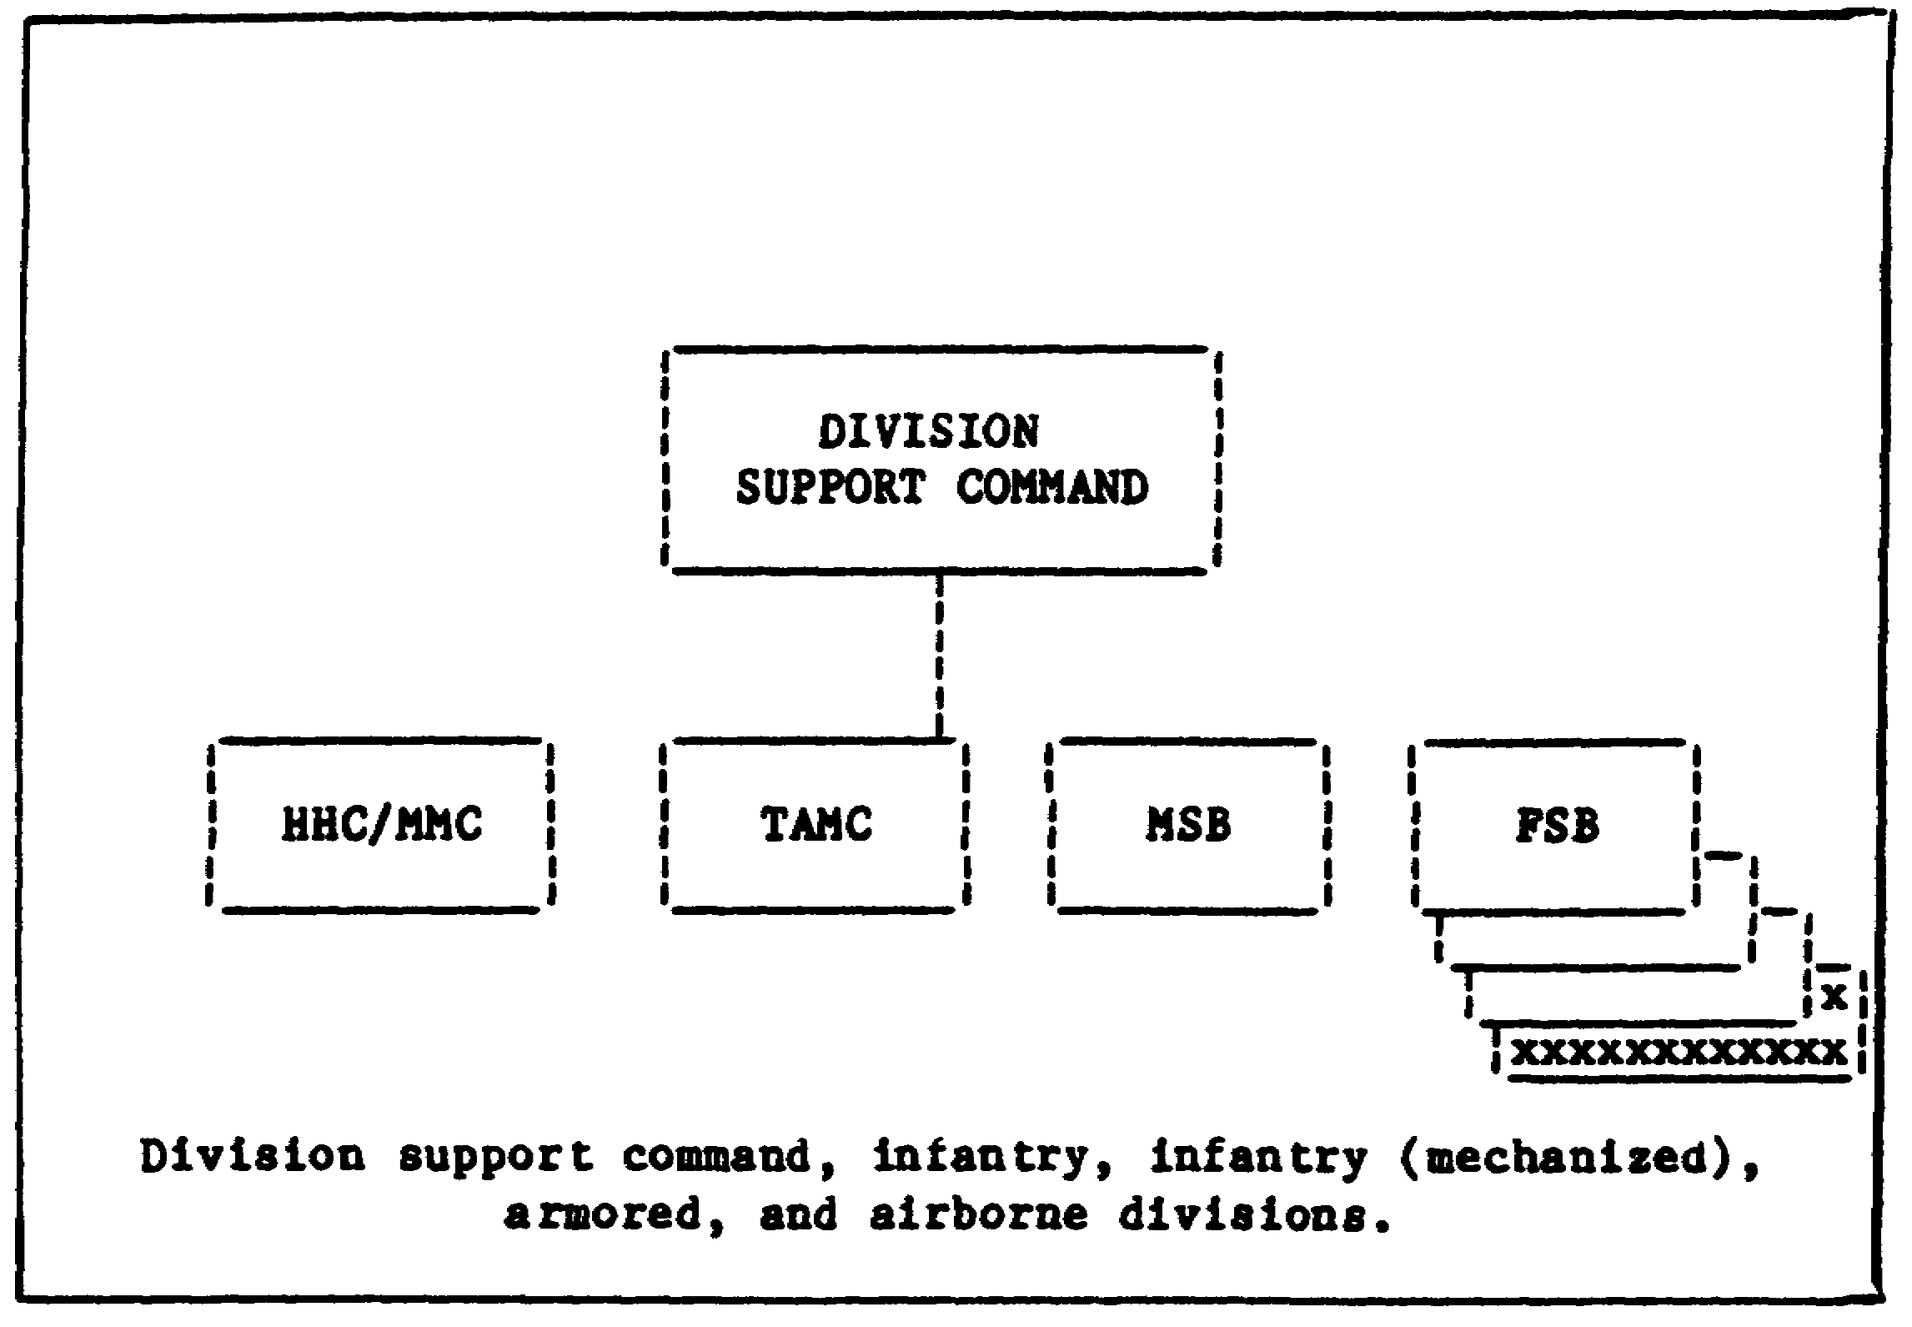

The exact makeup of a support command will vary, depending on the type of division it supports. The maintenance battalion will have three support platoons when assigned to an airborne division instead of three forward support companies. This is because the airborne division will have fewer vehicles, artillery pieces, and so forth, than an armored or infantry division. The companies in the maintenance battalion are designed or tailored to fit the needs of the using organizations they will support.

33

Lesson 3/Learning Event 2

FIGURE 2. MAINTENANCE SUPPORT BATTALION.
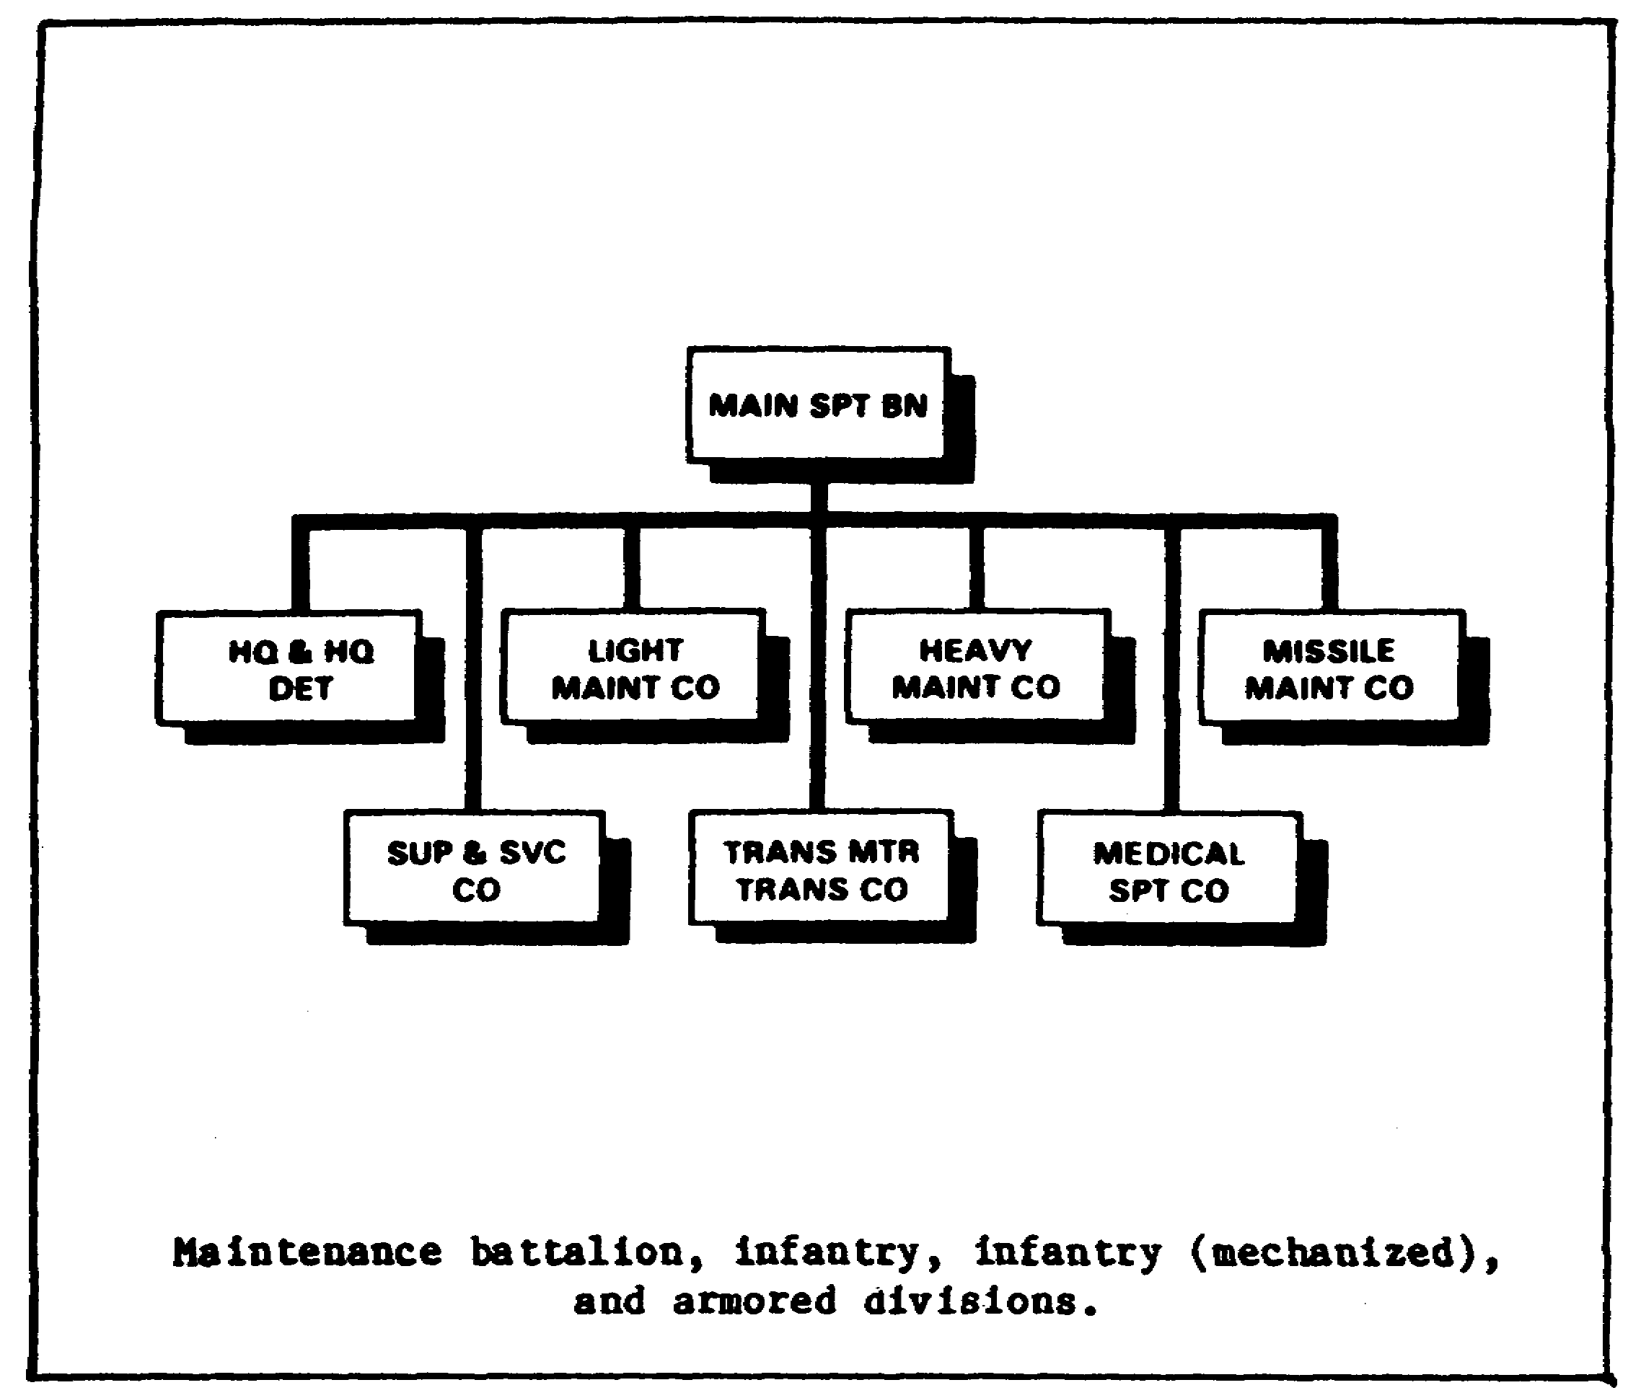

The headquarters and main support company is usually the largest company in the battalion. When the division is in the field, this company is normally located in the division rear area. It provides supplies and DS maintenance to all units that make up the division trains and the medical, chemical, signal, military police, engineer, and field artillery units assigned in the rear area.

The maintenance battalion headquarters detachment is usually located with the main support company. It directs and controls the activities of all of the companies in the battalion.

The combat elements of the division are organized into three brigades. A typical armored brigade may consist of four tank battalions, three mechanized infantry battalions, and supporting transportation, medical, artillery, chemical, and engineer units. One of the forward support companies of the maintenance battalion is assigned to provide maintenance support to each brigade.

34

Lesson 3/Learning Event 2

FORWARD SUPPORT COMPANY

If you are in a combat division, you will probably depend on a forward support company for most of your support in maintenance requirements. Let's see what one of these companies consists of and how it is organized.

FIGURE 3. FORWARD SUPPORT COMPANY.
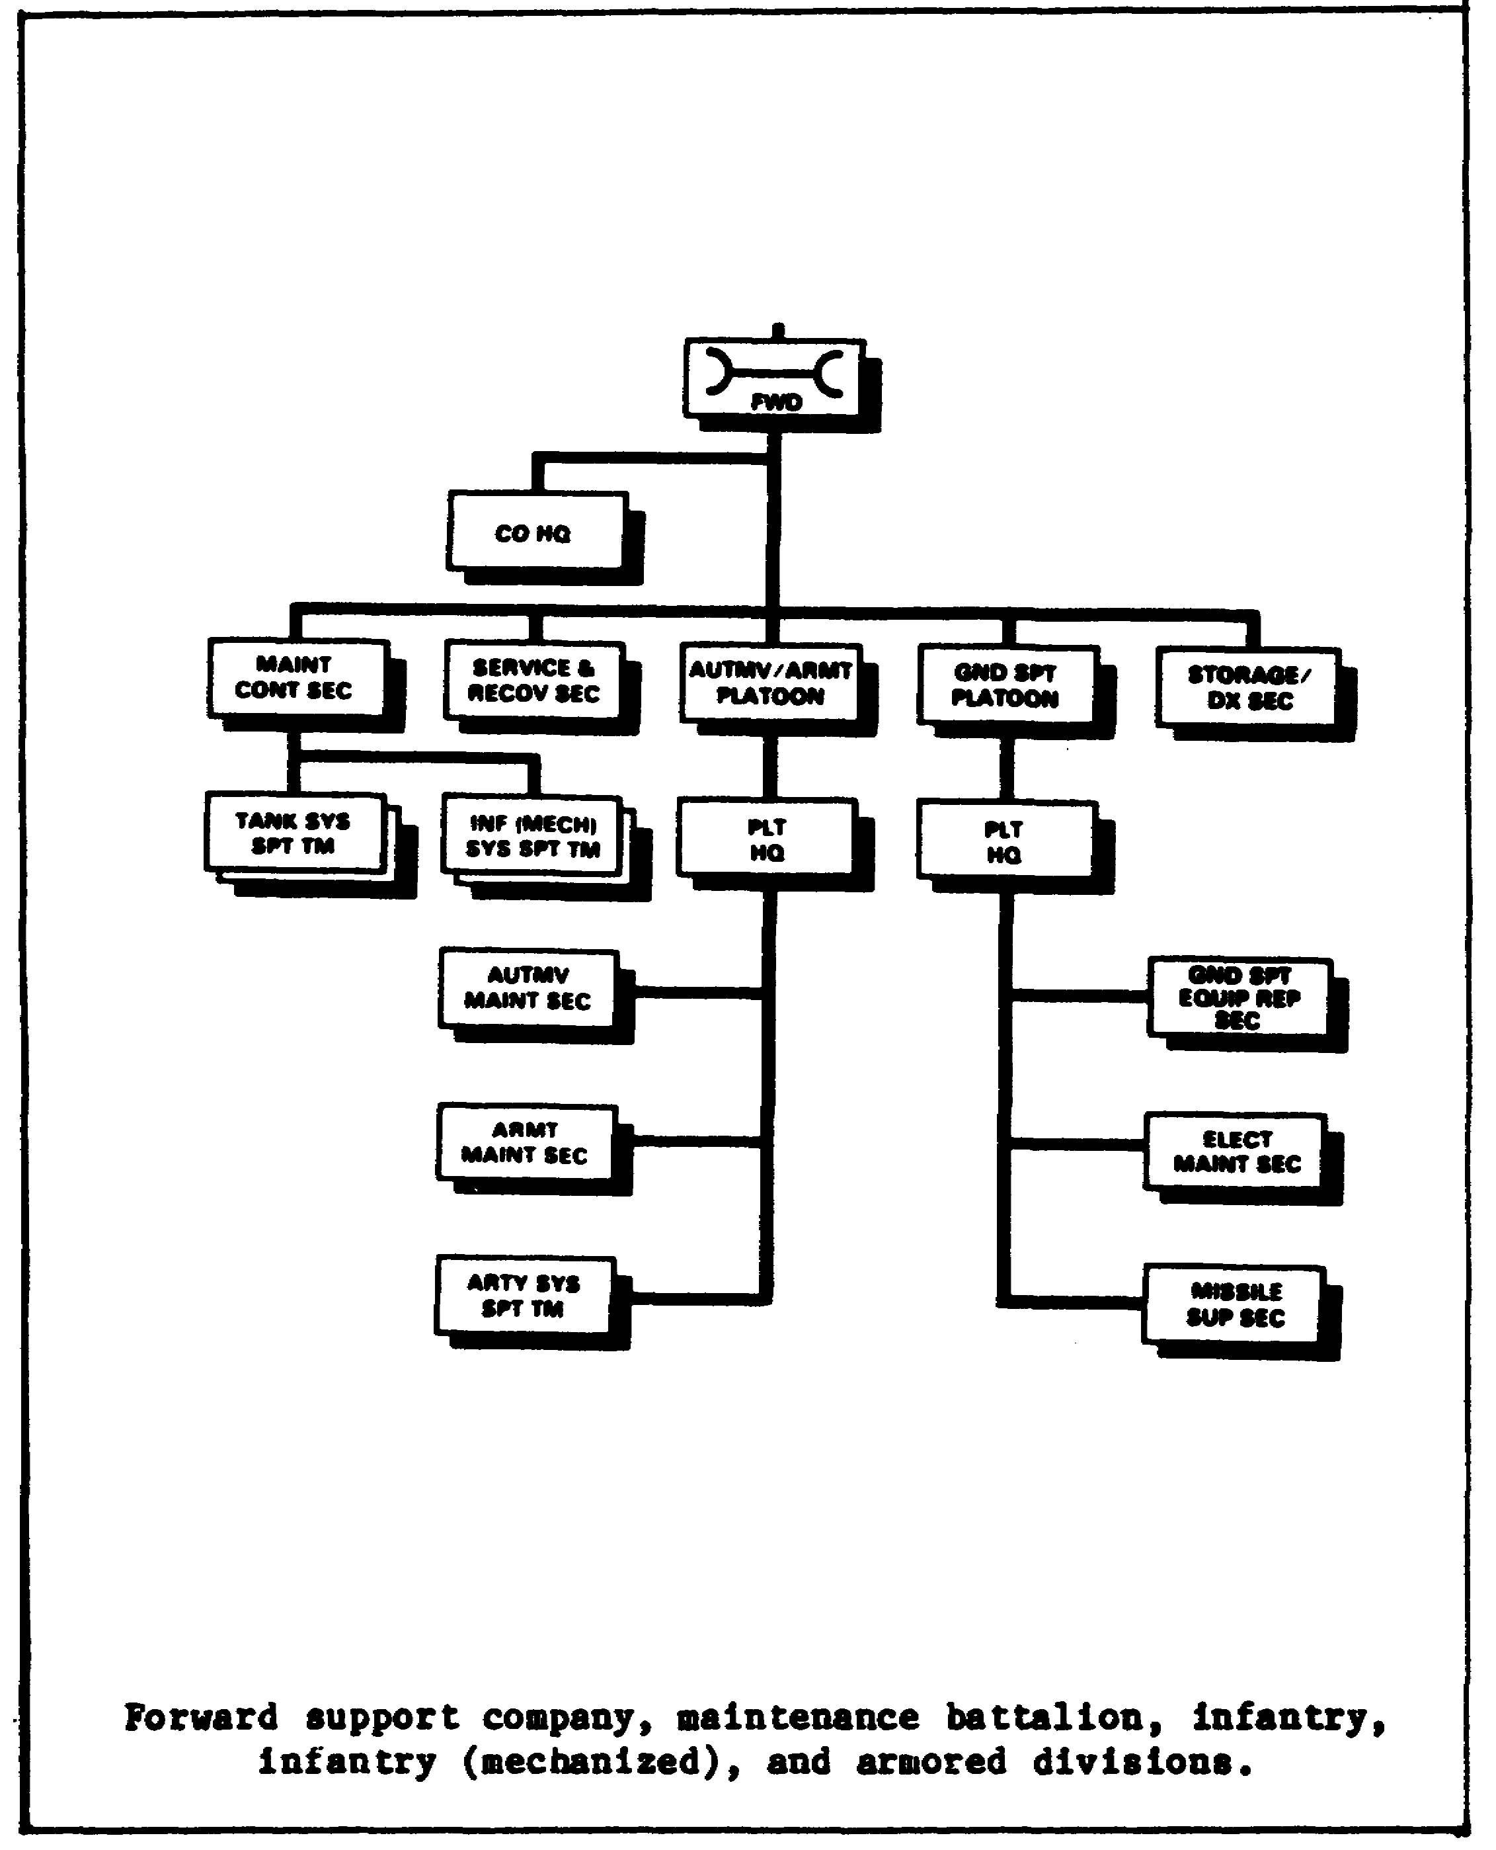

35

Lesson 3/Learning Event 2

The forward support company consists of a company headquarters; a shop office; a supply platoon which is further divided into a platoon headquarters, a stock control section, and a storage section; a service and evacuation section; and a maintenance platoon.

All of the forward support companies are made up of the same units, regardless of the type division they belong to. However, the number of people and the amount and type of equipment contained in the companies will depend upon the amount and type of equipment supported.

Forward support companies can be given additional personnel and equipment from the maintenance battalion whenever the supported brigade needs more maintenance support than normal. In other words, a forward support company can be tailored to fit the needs of a brigade regardless of its size or mission.

Forward support companies are always given enough vehicles so that they can be 100-percent mobile. If the brigade moves, the forward support company can move with it without having to shuttle equipment from the old shop area to the new one.

However, to stay 100-percent mobile, the forward support company cannot start repair work that will take too long to complete. If the company has a large number of using unit items torn down in the shop, 100-percent mobility is lost.

Host of the forward support company's repair work will be limited to the replacement of unserviceable assemblies. Under combat conditions, a forward support company would probably have the time to replace an engine in a truck, but it would not have the necessary time to make major repairs on an engine.

MAIN SUPPORT COMPANY

The organizational chart illustrates a headquarters and main support company. The unit mechanic will deal mostly with the main support company, and probably only some parts of it. These are the ones we will discuss in more detail later.

36

Lesson 3/Learning Event 2

FIGURE 4. HEADQUARTERS AND MAIN SUPPORT COMPANY.
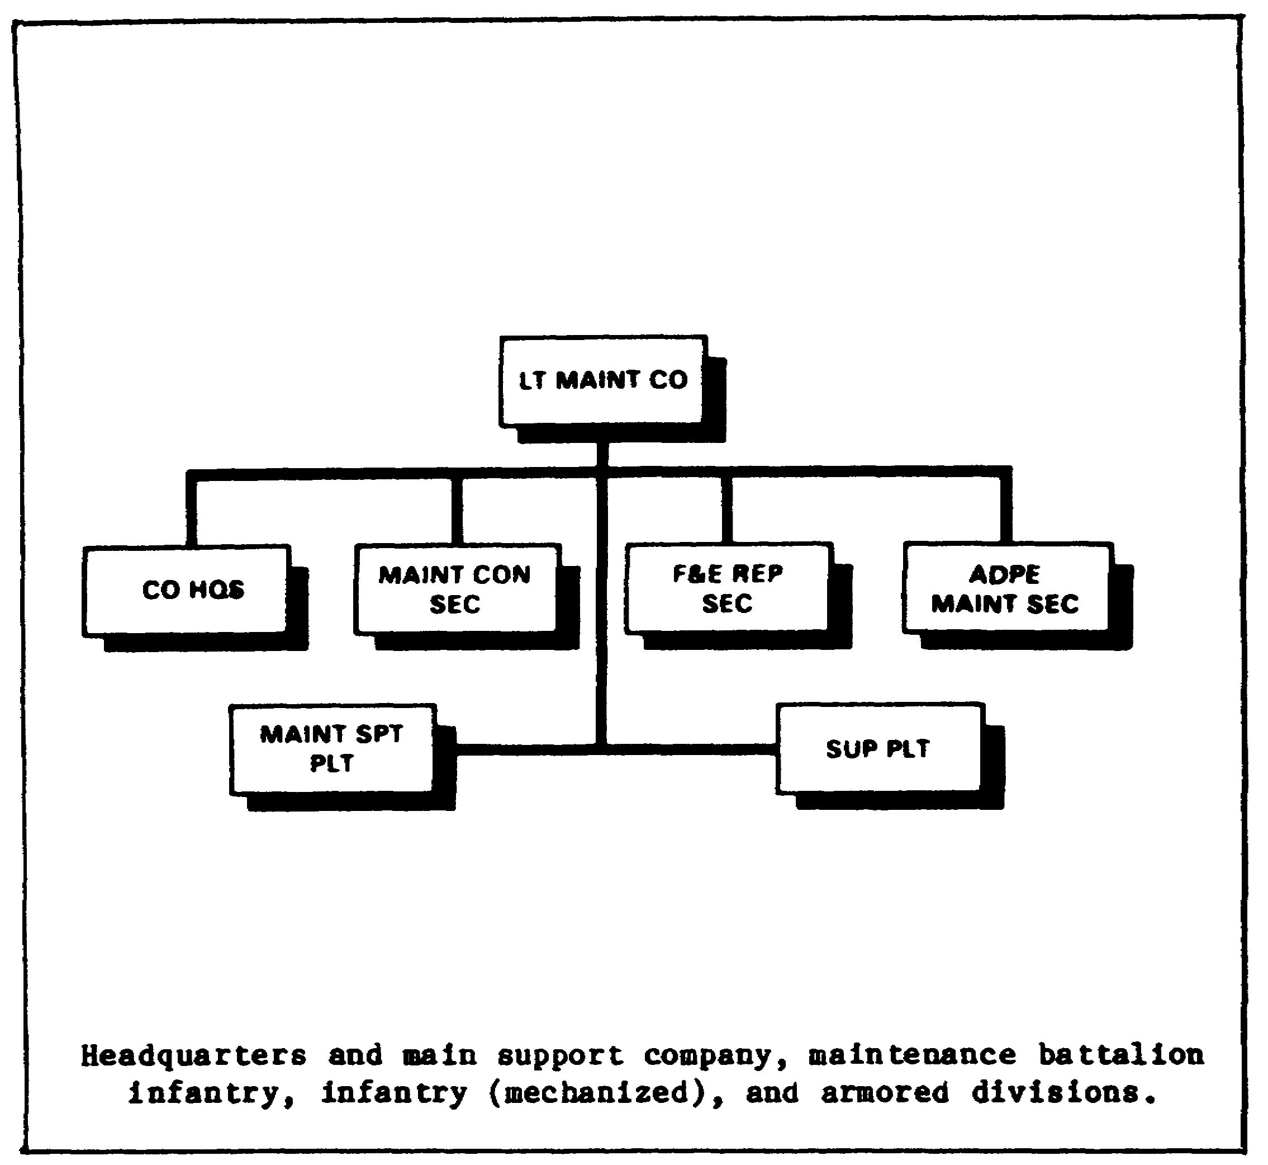

The main support company is divided into a company headquarters, shop office, service and evacuation platoon, supply platoon, mechanical maintenance sections, electrical maintenance platoon, mechanical maintenance platoon, and an armament maintenance platoon.

Main support companies are all set up about the same way in all types of divisions. However, there is a difference in the number of people and the amount and type of equipment they have. Here again, this depends on the type and mission of the supported units.

37

Lesson 3/Learning Event 2

NONDIVISIONAL MAINTENANCE BATTALION

Some units in a combat zone are not part of a division. In fact, there is often more nondivisional equipment in the area than divisional. There is also a lot of equipment around that will be different from any found in a division. For this reason, DS maintenance battalions are assigned to the field army support command (FASCOM) and then are attached to support groups or brigades where they are needed.

FIGURE 5. DIRECT SUPPORT MAINTENANCE BATTALION.
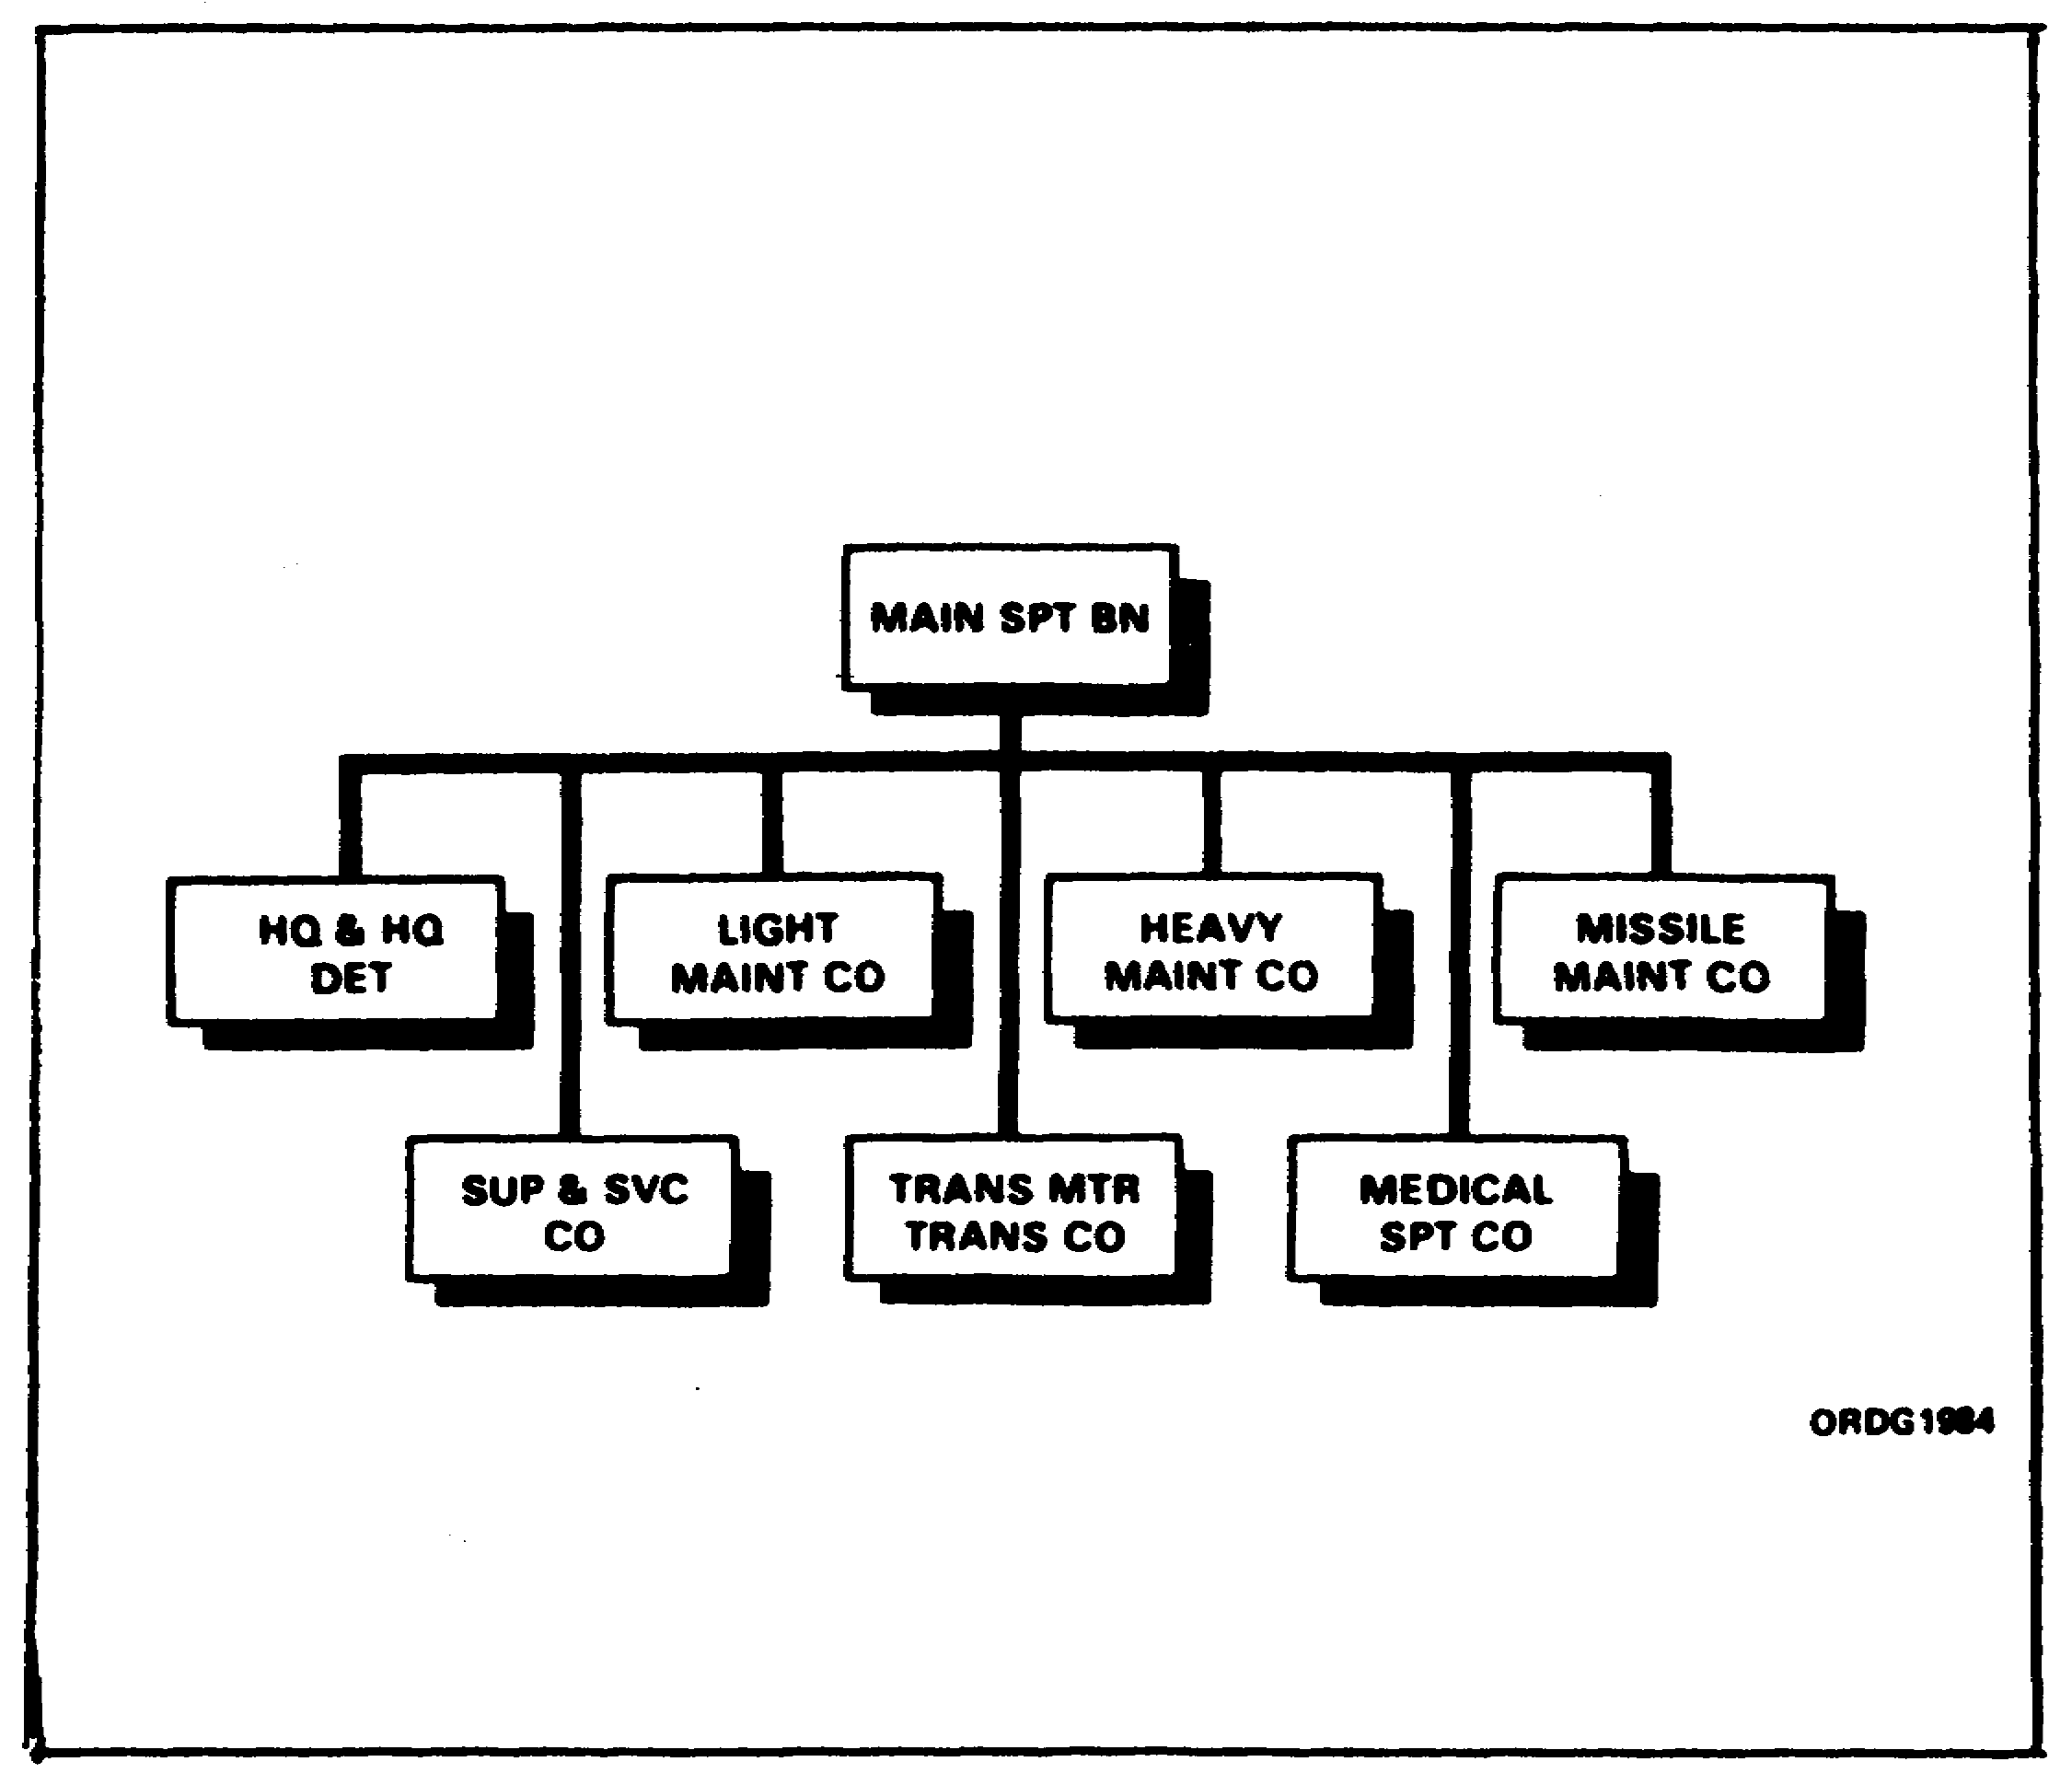

The DS maintenance battalion is made up of a headquarters and headquarters detachment, main support company DS, transportation aircraft maintenance DS company, light DS maintenance companies, and, if required, a rocket and missile support detachment. These units, too, can be tailored to fit what is needed in the area.

38

Lesson 3/Learning Event 2

While we usually think of a DS maintenance battalion as having the job of providing DS maintenance, repair parts supply, recovery and evacuation assistance, and technical assistance services to nondivisional units in the area, it will often do more. The DS maintenance battalion, or parts of it, may be used to replace or take over some of the work of a similar type unit in a divisional maintenance battalion.

You will often hear a DS maintenance battalion referred to as a composite, functional organization. This means that it provides maintenance and repair part support for a lot of different types of equipment. From this one unit, a using unit receives DS maintenance and repair parts for most of its equipment.

LIGHT DIRECT SUPPORT MAINTENANCE COMPANY

The company of a DS maintenance battalion that you, as a wheeled vehicle mechanic, will be most interested in is the light DS maintenance company. This company is made up of a company headquarters, shop office, supply platoon, service and evacuation section, and a maintenance platoon.

FIGURE 6. LIGHT DIRECT SUPPORT MAINTENANCE COMPANY.
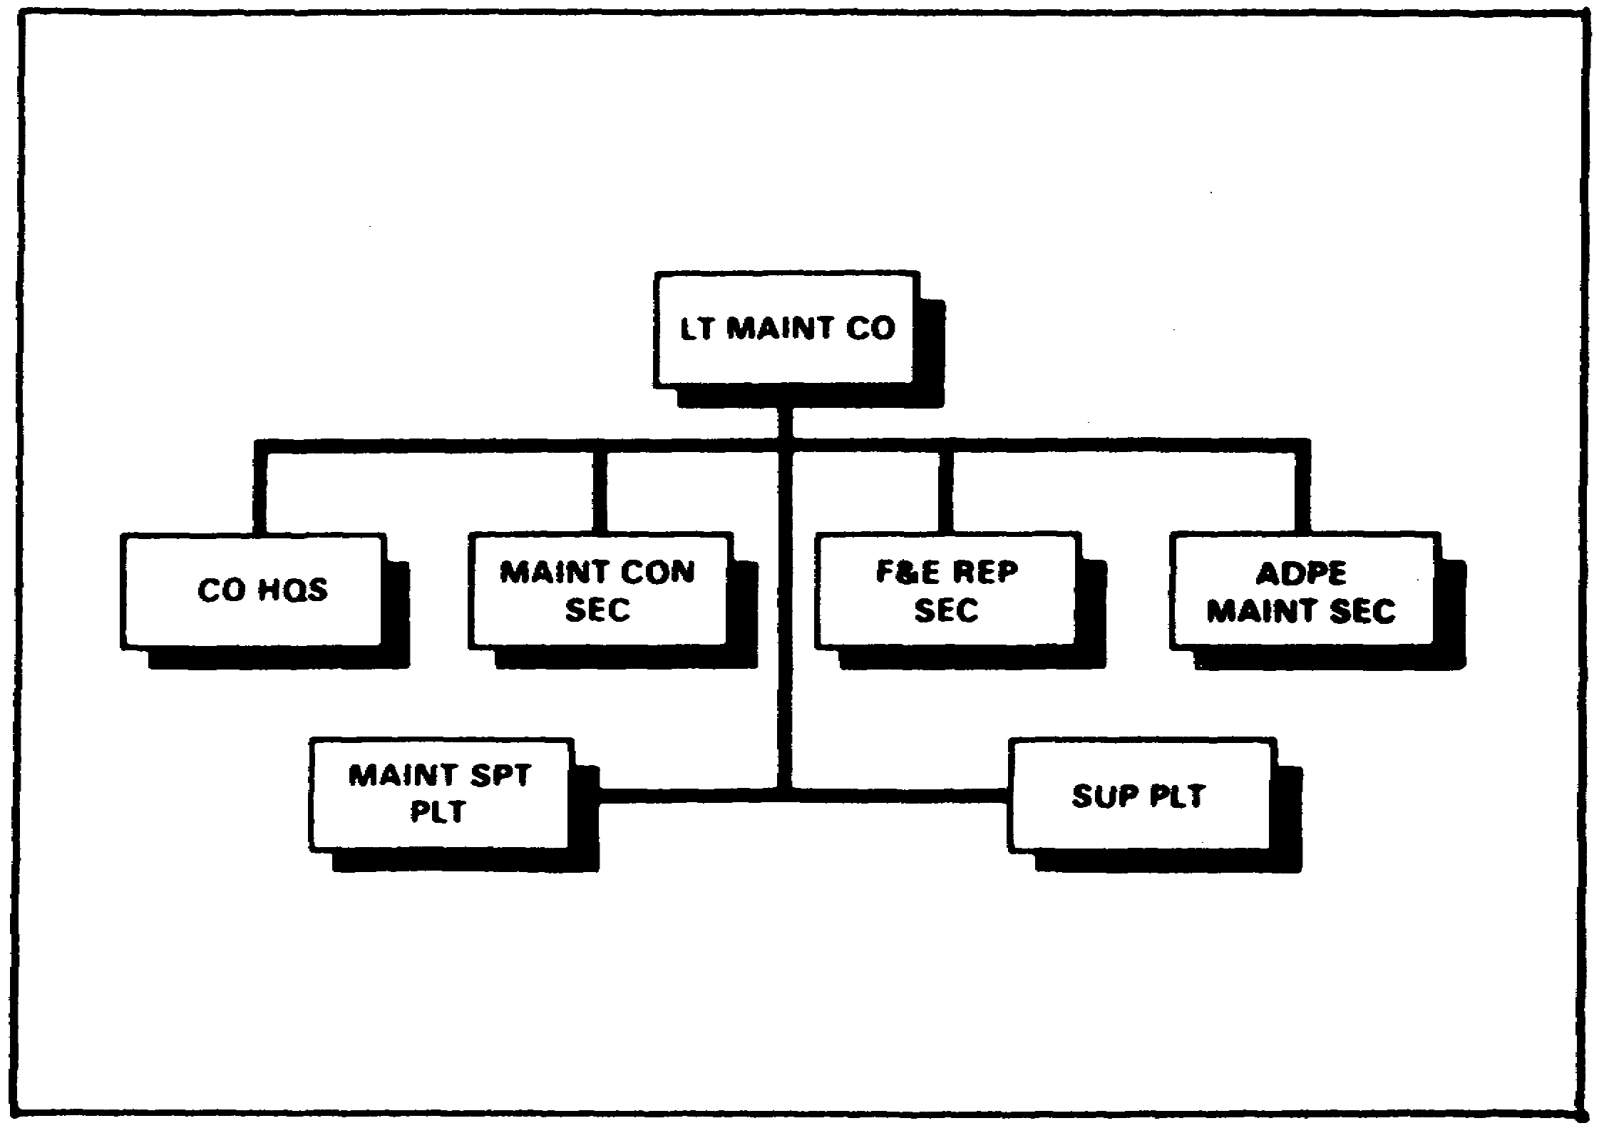

The supply platoon consists of a platoon headquarters, stock control section, and a storage section. The maintenance platoon is divided into a platoon headquarters, mechanical maintenance section, armament section, and an electronic maintenance section.

39

Lesson 3/Learning Event 2

The light DS maintenance company is, in many, ways, much like the forward support company of a divisional maintenance battalion. The biggest difference is that the light DS maintenance company maintains more different types of equipment and maybe does a little more work on them. It is limited, however, on how much it can do.

Some jobs may come into the light DS maintenance company that the unit cannot do, but the main support company DS can. When this happens, the equipment is sent to the main support company, or the main support company sends mechanics and equipment to do the job.

MAIN SUPPORT COMPANY DS

FIGURE 7. MAIN SUPPORT COMPANY DIRECT SUPPORT.
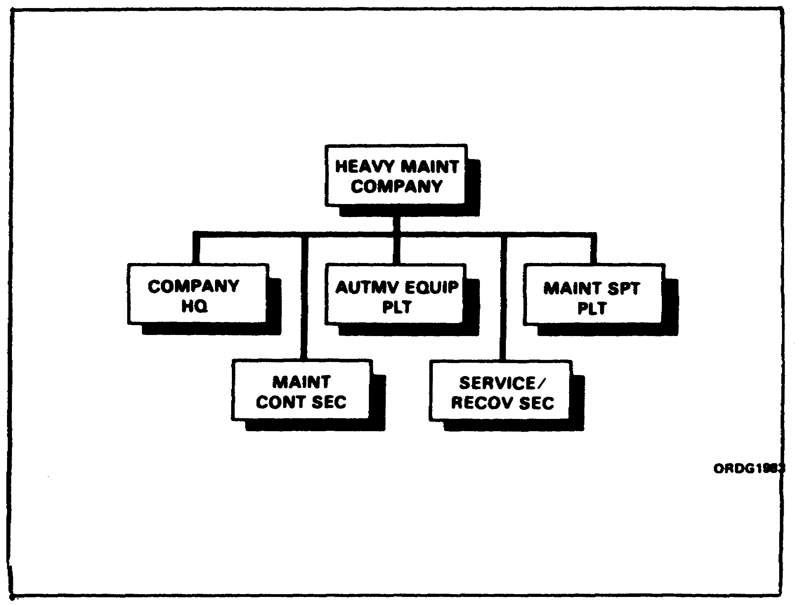

Using units do not often deal directly with the main support company DS. However, this type unit does play a big part in keeping your trucks running. The company has & lot of equipment and can give a lot of help to the light DS maintenance company and, through them, to you. This company Is made up of a company

40

Lesson 3/Learning Event 2

headquarters, equipment maintenance platoon, shop office, supply platoon, service and evacuation platoon, automotive maintenance platoon, electronic maintenance platoon, and an armament and instrument section.

The equipment maintenance platoon is made up of a platoon headquarters, mechanical repair section, generator repair section, and light equipment repair section. The supply platoon is made up of a platoon headquarters, stock control section, and a storage section. The service and evacuation platoon has a platoon headquarters, service section, and an evacuation section. The automotive maintenance platoon is divided into a platoon headquarters, fuel/electric section, and an automotive repair section. The electronics maintenance platoon is made up of a platoon headquarters, electronics repair section, and an electric components section.

From this you can see the main support company DS is a large, well-equipped company. If it cannot repair the equipment, the equipment will have to leave the DS category of maintenance and go to a general support (GS) unit.

MISSION OF DIVISIONAL DIRECT SUPPORT UNITS

So far, we have covered the DS units that will help you. In this part of the lesson, we will discuss just what help they can give you. Let's see what you can expect if you are in a combat division. Remember the two different units: the forward support company and the main support company.

FORWARD SUPPORT COMPANY

The company that usually knows your problems first is the forward support company. You depend on this company to make repairs you are not authorized to make, for the repair parts you need to make the repairs you are authorized to make, and to advise and instruct you on some of the repair procedures that may be new to you. You may also want help if there is more maintenance required than you can get done. Well, they will give you this support and often other services that you do not think too much about. Let's see just how they go about getting their job done.

MAINTENANCE SUPPORT

For some reason, we seem to think first of the maintenance the forward support company will do for us. This will be done by the maintenance platoon, normally in their shop area. It can also be done outside of their shops in your shop area. This is called on-site maintenance.

41

Lesson 3/Learning Event 2

On-site maintenance is being pushed more and more, especially on such things as tanks, heavy engineer equipment, artillery, and so on. however, it seems to be better to repair wheeled vehicles, most electronic equipment, and instruments in the shop.

When on-site maintenance is to be done, the shop office of the forward support company will send a contact team to do the work. A contact team is usually made up of a supervisor and the required number of repairers who have the needed skills. Sometimes a single repairer may be the contact team.

The contact team will try to take with them all of the repair parts and equipment they will need to do the job at your place. This means the using unit should give the forward support company all the information they can about the problem. If parts are needed that the contact team does not have, they will have to be obtained from either the forward support or the main support company. This will cause the job to take longer. The equipment operator or crew and the organizational mechanics must be available to help the contact team.

Work that cannot be done on site or that which is not desirable to do on site is sent to the maintenance shop. "Maintenance shop" and "shop' are terms used to describe all of the maintenance activities in the company area. More work can be done on a vehicle in the shop than on site. A job that is going to take too much time, however, will be sent to the main support company where there is more equipment and more time can be spent on the repairs.

Another service you expect and will receive is a supply of the repair parts you need in your work. The supply platoon of the forward support company carries up to a 15-day stock of fast-moving parts. Usually, these repair parts are issued to using units from a supply point. The repair parts may, however, be delivered by contact teams when they are doing on-site maintenance. In addition to supply of repair parts, the supply platoon provides a direct exchange service. Direct exchange is a way of giving quick service on repairable items of equipment such as generators and' carburetors. A direct exchange list will be given to your unit so that you will know what items will be available to you by this method. Direct exchange between you and your support unit will be done through the use of DA Form 2402, Exchange Tag.

42

Lesson 3/Learning Event 2

Another service available to you from your DS maintenance unit is a technical assistance team. This team is different from the contact team in that the contact team is a work party and will repair the equipment while the technical assistance team only gives advice or instruction. Technical assistance will be given on almost any problem the using unit may have. Some examples are:

- Advice and help on setting up PLLs; advice on preparing and maintaining repair parts records and in determining stock levels.

- The supported unit may ask for help when its personnel need more training or when it receives new equipment that they do not know how to maintain.

- Technical assistance is not limited to the help the supported unit requests. DS maintenance unit liaison parties normally make visits to the supported units at least once every 30 days. The liaison party should consist of at least an officer or NCO who knows maintenance procedures and requirements and a qualified supply specialist.

- In some cases, the liaison party will be able to give the supported unit the instruction and guidance necessary. However, there are times when this would require more time than the liaison party can spend. Also, more skills may be needed than are available in the party. In such cases, the liaison party will find out what is needed and a team will be sent by the supporting company to give this help. This lets the liaison party keep its schedule to visit other units.

The Jobs of the liaison party include, but are not limited to--

- Giving advice to the unit commander about the unit's organizational maintenance and repair parts problems.

- Advising the unit commander on the proper use of materiel.

- Checking on repair parts and supplies needed by the using unit to be sure they get the tools, repair parts, and cleaning and preserving materials needed to perform organizational maintenance.

- Determining what maintenance support is required so that a contact team can be sent to perform any required on-site maintenance.

43

Lesson 3/Learning Event 2

- Determining what technical instructions and training are needed by the unit.

- Giving the required instruction if time and personnel permit. If not, having a team sent from the support maintenance unit to give the required instruction.

The last section of a forward support company we will discuss is the service and evacuation platoon. The service this unit can give you consists of-

- The service section, which can do a limited amount of welding and body work and make a few parts that you may require. If any of these jobs are too big, they will be sent on to the service section of the main support company where more equipment is available.

- The evacuation section, which can provide you with a limited amount of help in the recovery and evacuation of your equipment. It will also give the required support to contact teams that may be repairing your vehicles.

MAIN SUPPORT COMPANY

We have seen that while a forward support company can do a lot of work, it will have to have some backup support. This is one of the jobs of the main support company. In many ways, the main support company is like the forward support company. Probably the biggest difference is the main support company has more personnel and equipment, so they are able to do more to the vehicle than the forward support company.

The main jobs of the main support company are to provide DS maintenance to units of the division who have no one else to support them, to send personnel and equipment to help the forward support companies when they are overloaded with work, and to take work the forward company cannot do or does not have time to do.

While most of the work of this company may be "in shop," it may do on-site maintenance if it is quicker and more practical than to bring the vehicle into the shop.

MAINTENANCE SUPPORT

If you are a unit mechanic in a unit being directly supported, the support you can expect from the main support company will be much the same as if you were supported by a forward support company.

44

Lesson 3/Learning Event 2

On-site maintenance will be provided when required. The way you go about getting this work done and the way it is done will be about the same as for the forward support company.

A contact team will be sent to do the job. Before they leave their work area, they should know as much as possible about the trouble and the parts they will need to do the job. It is up to you and your unit to give them this information.

Again, your unit will be expected to have the vehicle operator and its unit mechanics available to give the contact team any help they can.

While this unit may have more equipment than the contact team of a forward support company, there is still work that they cannot do too well on site. This work will be sent back to their shops. Here they can do quite a bit more than can be done in the forward support company, but there are still jobs that they cannot do. These will have to be sent to their support unit.

If your unit is being supported by the main support company, they will be responsible for furnishing the repair parts you need. This will be done in the same way the forward support company would get them to you. The main support company also furnishes parts required by the forward support company for their repair and supply missions, and they operate a direct exchange for the units they support and for the forward support companies.

The main support company will provide the same technical assistance to you as that provided by a forward support company. The main support company also provides technical assistance to the forward support companies to help with their problems and provides the required training for the personnel of these units.

The service and evacuation platoon of the main support company will provide the same services as provided by the forward support company. The only difference is that they can do more and they do repair such things as canvas and leather, which the forward support company does not. This means that if you are supported directly by the main support company, you could send the canvas covers or tops from your vehicles directly to them instead of having to send them through the forward support company. The evacuation section can help you and the forward support companies with recovery and evacuation problems by supplying personnel and equipment.

45

Lesson 3/Learning Event 2

MISSION OF NONDIVISIONAL DIRECT SUPPORT UNITS

As mentioned earlier in this lesson, there are probably more wheeled vehicles used by nondivisional units than by divisional units. These vehicles require the same maintenance regardless of what unit they belong to, except that some may be used more than others. For this reason, we have nondivisional maintenance battalions and companies. The two we will discuss are the light DS maintenance company and the main support company DS.

LIGHT DIRECT SUPPORT MAINTENANCE COMPANY

If you are assigned to a unit that receives its maintenance support from a light DS maintenance company, you will find the services they provide are very much like the ones discussed in the part of the lesson covering forward support companies. Probably the biggest difference is that the light DS maintenance company has a few more personnel and more equipment, so they can work on more types of equipment and do a little more work on them.

This company can perform on-site maintenance on your vehicles. The procedures for doing this are the same as when a contact team from the forward support unit is used.

The light DS maintenance company will provide you with the repair parts you require. They will provide direct exchange of such things as generators and carburetors. Again, a list of what is available will be furnished to you; however, this list may change from time to time.

The service section will provide welding and body and fender work and will be able to make some parts for you. While they may be able to do a little more than the same section of a forward support company, they are still limited in what they can do. They will have to send big jobs to their main support company DS. The evacuation section will provide the same support as the evacuation section of the forward support company.

The light DS maintenance company will furnish technical assistance and liaison teams to help your unit with any maintenance problems it may have. The team will do this by giving advice or instruction, as required, in the same way as the teams from a forward support company.

46

Lesson 3/Learning Event 2

MAIN SUPPORT COMPANY DIRECT SUPPORT

While the light DS maintenance company can do a lot of work on a lot of different equipment, it must also have support. This support will be provided by the main support company. This company is in some ways like the main support company discussed earlier in this lesson. However, it has more personnel and a lot more equipment and can do a lot of things that the main support company of a division cannot.

This company provides DS maintenance, limited evacuation, and maintenance supply support to nondivisional units who have no one else to depend on. It also provides backup support to the light DS maintenance companies of the battalion.

If your unit is being supported by a main support company DS, the service you get from them will be much like that from the main support company of a division. If you have a truck that needs DS maintenance, a contact team from the automotive maintenance platoon may be sent to do on-site maintenance. The automotive maintenance platoon is well suited for this operation as it contains two sections that are just alike. One of these sections will usually stay in the company's shop area. The other may be used to perform on-site maintenance in your unit, or it can be set up to operate in some distant area for a long period of time; for example, to perform maintenance at refueling points along the road. Again, this unit should know as much as possible about what will have to be done to the vehicle and what parts they are going to need. It is up to your unit to give them this information. Your unit will also be expected to have the vehicle operator and the unit mechanics available to help as much as possible.

While this automotive repair section is well equipped, there are jobs it cannot do too well on site. When they get this type of job, it is evacuation to their maintenance shop. Here is where the difference between a divisional main support company and a main support company DS can be seen. The main support company DS has a lot more equipment and can do a lot more work on the vehicle. In addition to repairing vehicles from your unit, they will also be getting them from the light support companies and probably some from the divisional maintenance units in the area.

The main support company will also have technical assistance and liaison teams to work with you. They will operate in the same way as the teams discussed previously. These teams will also give assistance to the other maintenance companies we discussed.

47

Lesson 3/Learning Event 2

This means that if a unit supported by a forward support company has a problem which the forward support company cannot take care of, the problem can be passed on up the line to the main support company DS. If it should happen that they cannot solve the problem, they, in turn, can pass it on to the GS level of maintenance, and so on up the line until someone somewhere comes up with an answer. Most of your maintenance problems can be solved before they get to the main support company DS, and not too many have to be turned over to GS maintenance.

The supply platoon of the main support company DS will furnish you the repair parts you need the same as the supply sections discussed earlier. A direct exchange section will also be available to you. The maintenance companies supported by the main support company DS may depend upon this platoon for at least part of their supplies and most of the direct exchange items.

The service section provides allied trades support to the supported units, including the maintenance companies. This service includes welding, painting, metalbody repair, making parts and tools that are not otherwise available, and the repair of canvas and leather items such as holsters, binocular cases, and vehicle canvas and upholstery. The evacuation section helps the other maintenance companies and supported units with their recovery and evacuation problems as required.

EMERGENCY SERVICE

In addition to providing DS to units in their area, each DS maintenance unit provides emergency maintenance support for the types of equipment it supports to all vehicles passing through the area and to units temporarily bivouacked in the area. This emergency service may be done at the roadside, in the DS shop, or on site. Usually, it is performed as on-site maintenance by contact teams. Emergency roadside service may consist of recovery and evacuation of wrecked vehicles or it may be simple repair jobs. The normal roadside repair does not require too many parts or tools and does not require too much time. Fuel system failures, overheated engines, and electrical failures are the usual troubles. Emergency roadside service may be provided by road patrols, wrecker service, or by means of "service stations."

Road patrols consist of two or more automotive repairers in a light vehicle. They carry with them a small stock of repair parts, repair kits, and tools. These patrols usually travel in such a way that they will pass any given point on a main supply route at least once every two hours.

48

Lesson 3/Learning Event 2

Emergency service is given on the spot to any disabled vehicle found along the route. When necessary, a wrecker crew is called by the patrol to haul disabled vehicles to the DS maintenance shop.

A wrecker crew may be stationed at an intersection along the route or it may be on call in the DS maintenance unit. The wrecker should not go with the patrol unless it is known that it will be needed.

A good way to provide maintenance service is to set up service stations along heavily traveled routes. Mobile filling stations and DS maintenance units may be combined to make up this service station. Petroleum platoons provide mobile filling stations along roads to refuel convoys. This service can also be used to provide fuel to all vehicles using the route. A small maintenance team may be located at the same place. This unit will usually consist of four to six automotive repairers equipped with a 3/4-ton truck and cargo trailer carrying small, easily replaceable repair parts and direct exchange items, such as ignition points, spark plugs, fan belts, batteries, and fuel pumps.

While the vehicles are being refueled, the maintenance unit can make a spot check of the vehicle. Minor troubles can be taken care of on the spot. Other faults which do not keep the vehicle from running but should be corrected should be listed on the inspection sheet. This form should then be given to the driver so that the trouble can be taken care of as soon as the vehicle is returned to the unit. If the vehicle is unsafe to operate and cannot be easily repaired on the spot, it will be evacuated to the nearest DS maintenance unit. Wrecker service, if required by the service station, can be provided by the nearest DS maintenance unit.

Of all the maintenance companies we have discussed, the main support DS has the most personnel and equipment. While they can do a lot of work, there is a limit to what they are able to do. They, too, need backup support. This support is a GS unit, which is the next level of maintenance after DS. After that, there is depot maintenance. As this lesson is on DS maintenance, we will only mention that the other two exist, as the unit mechanic will have very little, if any, contact with them.

PROCEDURES FOR OBTAINING DIRECT SUPPORT ASSISTANCE

So far in this lesson, we have discussed what DS maintenance units can and will do for you. Now, let's see what you can and should do for them, and also what you must do to obtain the services the maintenance units have available to you.

49

Lesson 3/Learning Event 2

REPAIRABLE EXCHANGE

First, let's discuss unit maintenance. This is your job, and a very important one. In fact, if you do this and do it right, there will not be too much DS maintenance required. Your support unit will supply you with the repair parts you need to maintain the vehicles. To make it quick and easy for you to get some of these parts, they have a repairable exchange system. All you have to do to get the part is take off the old one and fill out DA Form 2765-1. The repairable exchange section will then trade you a serviceable part for the old one. Procedures for filling out the DA Form 2765-1 are found in DA Pam 710-2-1 and DA Pam 710-2-2.

DIRECT SUPPORT MAINTENANCE

When a vehicle requires DS maintenance, there are a few things you and your unit must do.

Let's suppose you have an engine that is not running too well. After making the required checks, you find the valves are burned. A check of the maintenance allocation chart (MAC) in the vehicle's technical manual shows that the repairs must be done by DS. Your job will now be to get the vehicle ready so DS can take over.

Your next step will be to make a thorough inspection of the vehicle. Use a DA Form 2404, Equipment Inspection and Maintenance Worksheet, to record what you find at fault. Correct all the faults you find that are supposed to be corrected by the using unit.

In this case, if the engine is a valve-in-head type, a contact team may come and replace the head. In any case, the motor sergeant or motor officer will have to prepare a DA Form 2407, Work Request. If the vehicle has to be repaired in the support unit's shop, the unserviceable vehicle, together with its equipment and logbook, will have to be evacuated to the DSU.

Once the vehicle is in the DSU shop, it will be repaired and returned to you as soon as possible. However, there are times that, for a number of reasons, the vehicle will have to go to the main support company for repair. Most DSUs have, or have available to them, a maintenance float. This is a group of vehicles that are ready to be issued to their supported units when, for some reason, the vehicle sent to them for repair cannot be completed for some time. If the vehicle cannot be repaired in a reasonable length of time, the support unit will often issue a replacement vehicle to the using unit. When the vehicle in the shop is completed, it is then returned to the maintenance float.

50

Lesson 3/Learning Event 2

This is a little like a direct exchange for vehicles. The difference being, the using unit does not request the exchange; the support unit makes the exchange if they feel it is going to take too long to repair the vehicle.

SUMMARY'

In this lesson, we have discussed the four types of DS maintenance units you have available to help you with your maintenance problems. We also discussed the support the DSUs will give you, to include such things as doing work you cannot do, supplying you with repair parts, and providing direct exchange of parts, technical assistance teams, liaison teams, allied trades support, and some help with recovery and evacuation.

From the information in this lesson, you might think that with all of these maintenance support units backing you up, you could keep rolling no matter what. This is not quite true. Army equipment can be kept in a combat-ready condition only if everyone whose job is maintenance does the job well. This is especially true at the unit maintenance level.

If every using unit should let their unit maintenance become lax, the maintenance support units would have a lot more work than they could do. The equipment users and the unit maintenance personnel must perform all of the maintenance services that are required at the user level or be prepared to do a lot of walking.

51

Lesson 3/Learning Event 2

GO TO THE NEXT PAGE

52

Lesson 3

PRACTICE EXERCISE

1. If you are assigned to a unit that is part of a combat division, you will normally be supported by which type unit?

a. Forward support company
b. Light DS maintenance company
c. Main support company DS

2. If a forward support company needs more repairers and equipment because of a heavy work load, they should first expect help from which type unit?

a. Supported companies
b. Light DS maintenance company
c. Divisional maintenance battalion

3. What unit, because of the many types of equipment it maintains, is often referred to as a composite, functional organization?

a. Main support company
b. Divisional maintenance battalion
c. DS maintenance battalion

4. What unit is organized to provide DS maintenance to a nondivisional unit?

a. Forward support company
b. Light DS maintenance company
c. Main support company

5. What platoon of a main support company DS repairs wheeled vehicle generators?

a. Equipment maintenance
b. Automotive maintenance
c. Electronic maintenance

53

Lesson 3

ANSWERS TO PRACTICE EXERCISE

1. a (page 35)

2. c (page 36)

3. c (page 39)

4. b (page 40)

5. a (page 41)

54

Lesson 4/Learning Event 1

LESSON 4
ORGANIZATIONAL MAINTENANCE OF
AUXILIARY POWER GENERATORS

TASK

Describe the procedures for operation and unit maintenance on assigned power generators.

CONDITIONS

Given information on the procedures for operation and unit maintenance on power generators.

STANDARDS

Answer 70 percent of the multiple-choice test items on the practice exercise correctly.

REFERENCES

DA Pam 738-750
TM 9-8000
Appropriate operator's manual
Appropriate technical manual

Learning Event 1:
DESCRIBE THE 3-KW GENERATOR SETS

INTRODUCTION

Most Army units have one or more generator sets to produce electrical power for special purposes and for the field. Much of the knowledge required in maintaining vehicles can be applied to generator sets. Nevertheless, the wheeled vehicle mechanic must have some special training before attempting to set up, operate, and maintain generator sets. Most generators produce enough electricity to electrocute a person, which can very easily happen if the set is improperly set up and operated.

55

Lesson 4/Learning Event 1

Each generator set consists of an air-cooled, gasoline engine coupled to a generator and the necessary controls and instruments mounted in a frame. Their size is rated by the maximum power in watts that they can produce without damaging themselves. The power output is spoken of in kilowatts (kw). One kilowatt is 1,000 watts of electrical power; this is equal to the power used in lighting ten 100-watt bulbs.

There are so many makes, models, and sizes of generator sets that it would not be practical to cover all of them in one book. In this lesson, we will cover two sizes of generator sets: the 3 kw (3,000 watts) and the 5 kw (5,000 watts). Common models are covered in each size to give you a good general knowledge of generator sets. We will discuss the 3-kw generator first. Almost all models of theses sets are powered by a four-cylinder military standard engine.

MODEL MEP-021A

Generators are self-contained, frame-mounted, portable units. They are powered by four-cylinder military standard engines (models 4A032-1 and 4A032-11) which are directly coupled to the generator.

56

Lesson 4/Learning Event 1

FIGURE 8. MEP-021A GENERATOR SET.
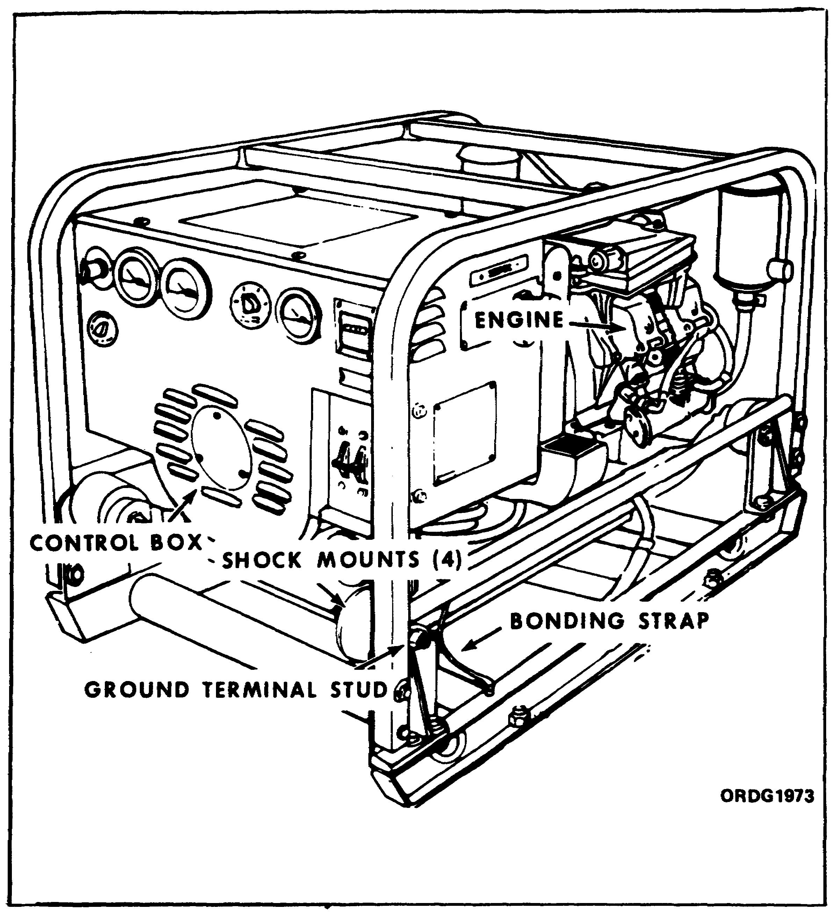

The military DOD model MEP-021A generator set is a self-excited, 400 hertz (cycle; also Hz), alternating current (AC) generator. The generator outputs are 120/240 volts, single-phase; 120 volts, three-phase; and 120/208 volts, three-phase (four-wire).

This generator set, as well as all of the other 3-kw generators we will discuss, is rated at 3 kw at 8,000 feet altitude. The engine used in these generators, like all gasoline engines, becomes less efficient as altitude increases.

57

Lesson 4/Learning Event 1

MODEL MEP-016A

FIGURE 9. MEP-016A GENERATOR SET.
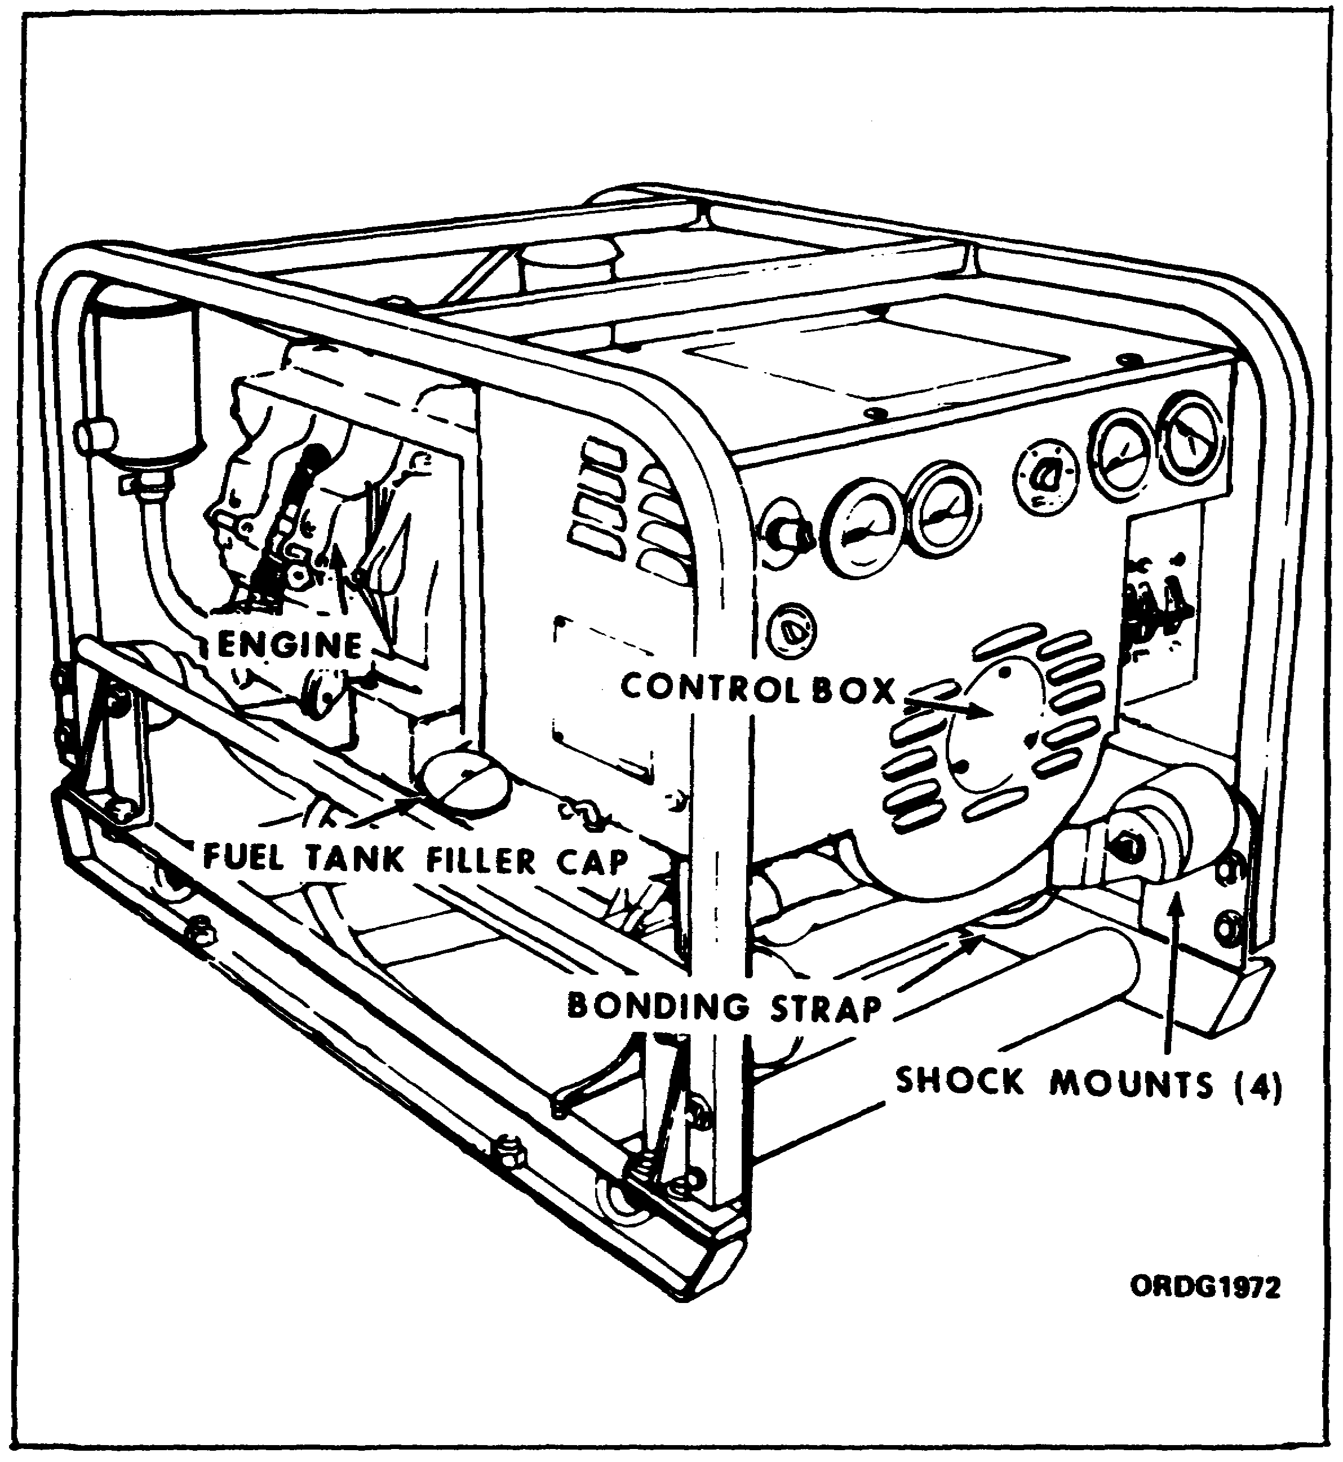

This set has a self-excited, 60 Hz (cycle), AC generator. The generator outputs are 120/240 volts, single-phase; 120 volts, three-phase; and 120/208 volts, three-phase (four-wire). The operator selects the desired voltage.

58

Lesson 4/Learning Event 1

MODEL MEP-026A

FIGURE 10. MEP-026A GENERATOR SET.
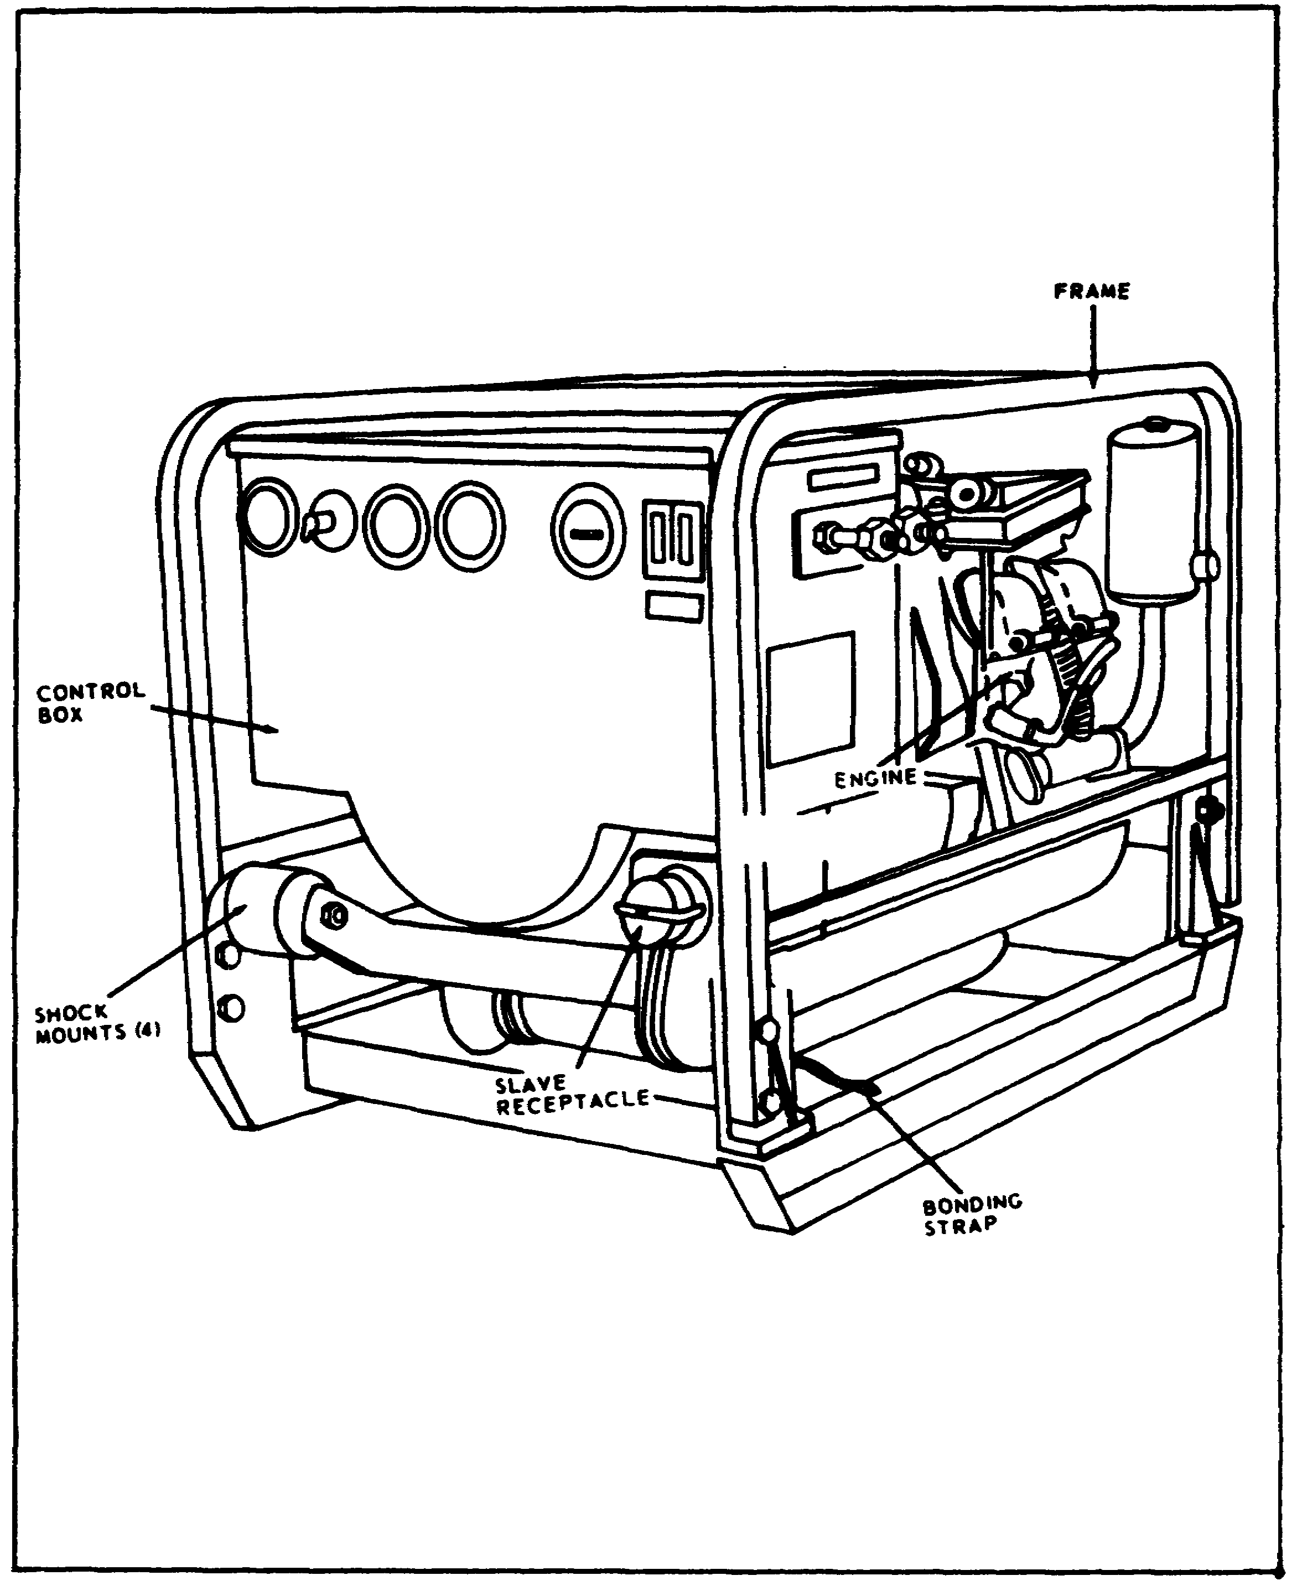

The last 3-kw generator set we will discuss is the military DOD model MEP-026A generator set. This set has a 28-volt, self-excited, direct current (DC) generator. It, too, is rated at 3 kw at 8,000 feet altitude.

59

Lesson 4/Learning Event 1

DATA AND INSTRUCTION PLATES

The control boxes for the above generator sets contain all of the instruments, electrical components, and electrical controls necessary for the operation of the generators. Like most pieces of military equipment, generator sets have identification and instruction plates mounted on them.

First, the Corps of Engineers plate or US Army plate. This plate is located on the right side of the control box. It lists the manufacturer, manual number, stock number, model number, serial number, contract number, date of manufacture, engine make, and registration number.

The generator nameplate is located on top of the generator housing and lists the model number and serial number.

An operating instruction plate is located on top of the control box cover. It lists the steps required to operate the generator set.

The wiring diagram nameplate is located on the underside of the control box cover and shows the wiring diagram of the generator set.

60

Lesson 4/Learning Event 1

GENERATOR INSTALLATION

Since you may be required to install, operate, and maintain generators, let's see how you should go about these tasks.

FIGURE 11.
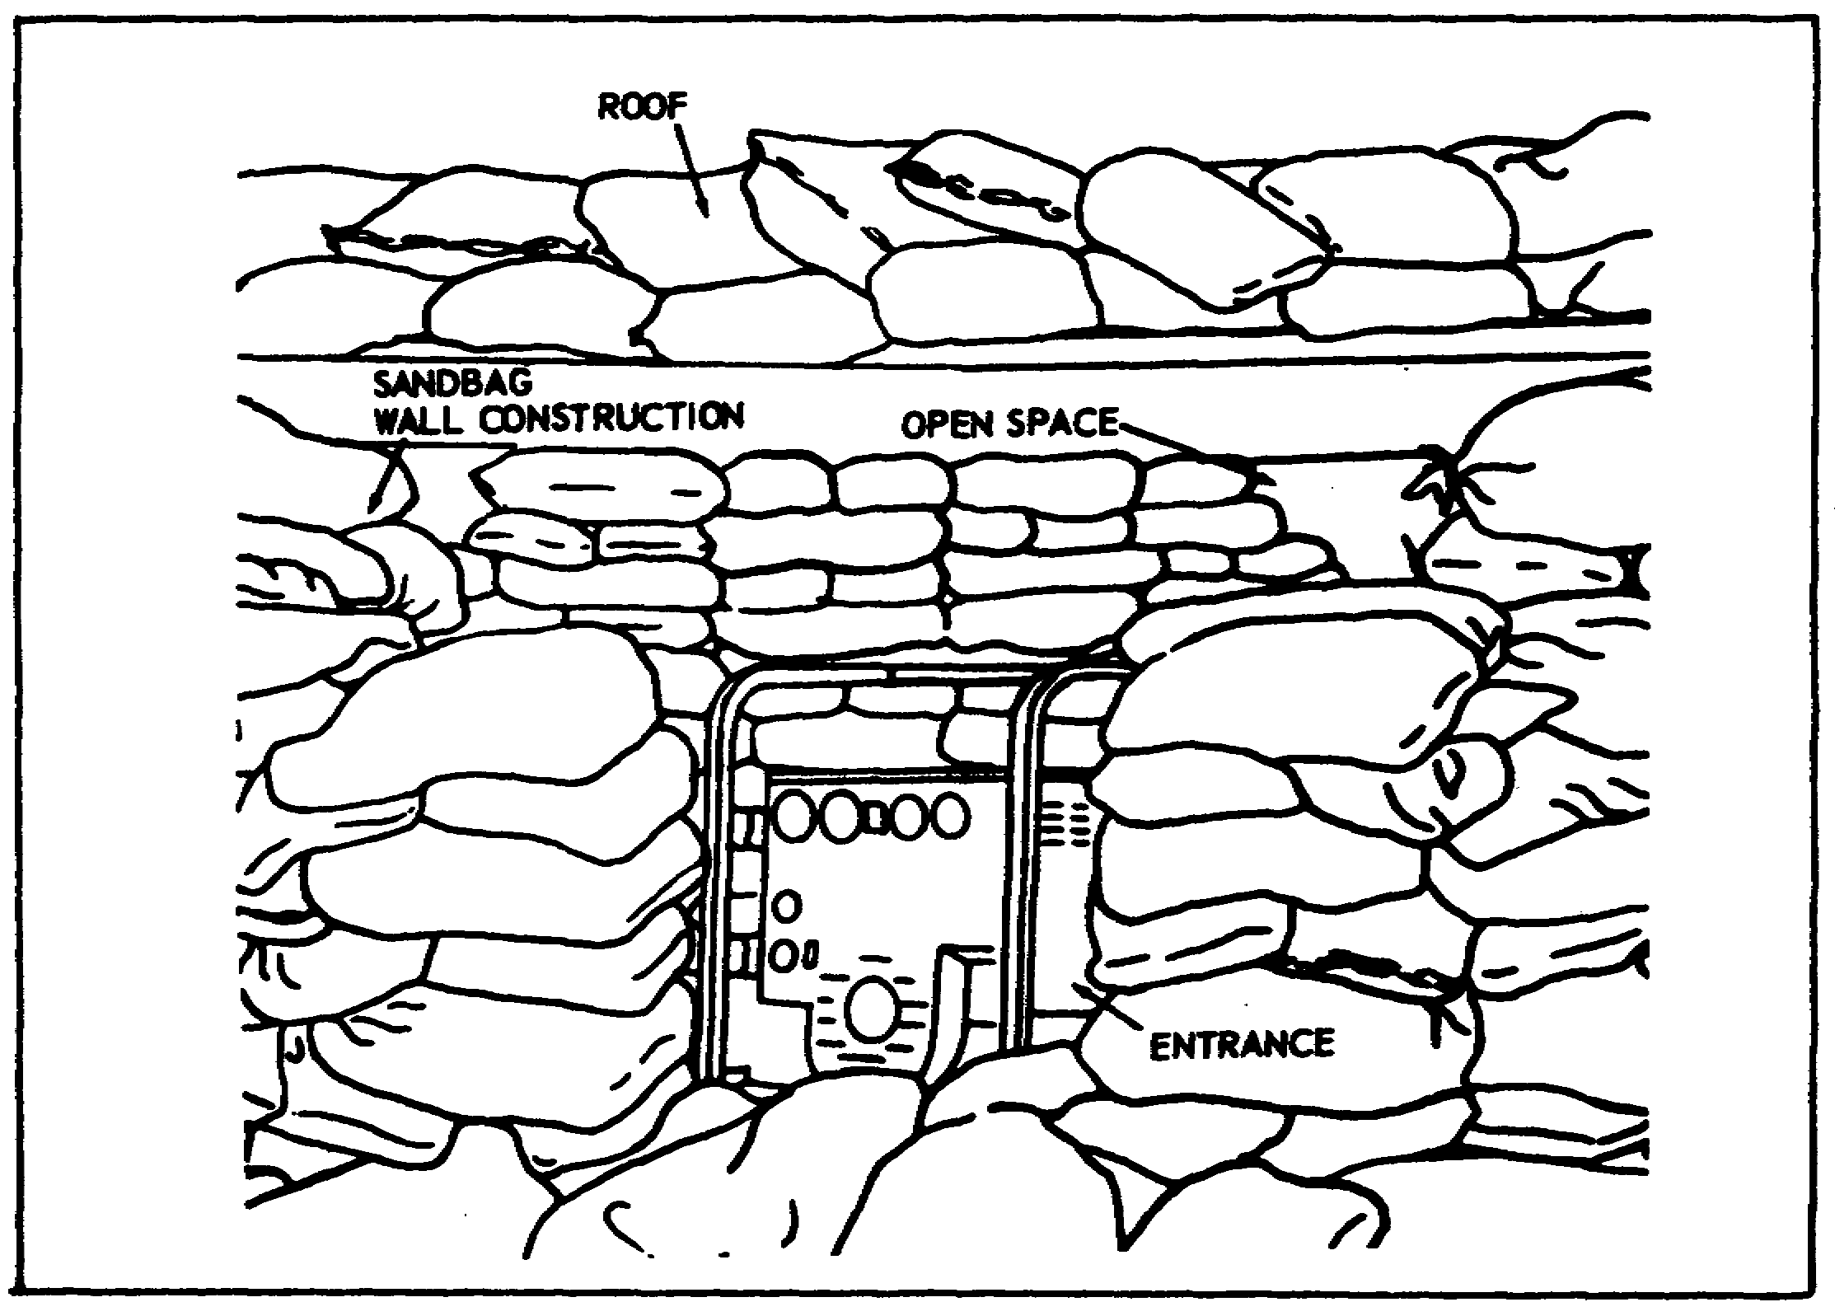

All of the generators should be installed on a level site, be clear of obstacles, and have plenty of ventilation. In combat areas, there has been some trouble with generators because they were installed in pits or surrounded by sandbags. The result is not enough air, so they overheat and are soon unserviceable. Be sure the generator is set up so it will get enough air for proper cooling. In addition, be sure the site selected is as close to the work as possible to reduce voltage losses and other problems caused by long transmission lines.

61

Lesson 4/Learning Event 1

FIGURE 12. GROUND ROD.
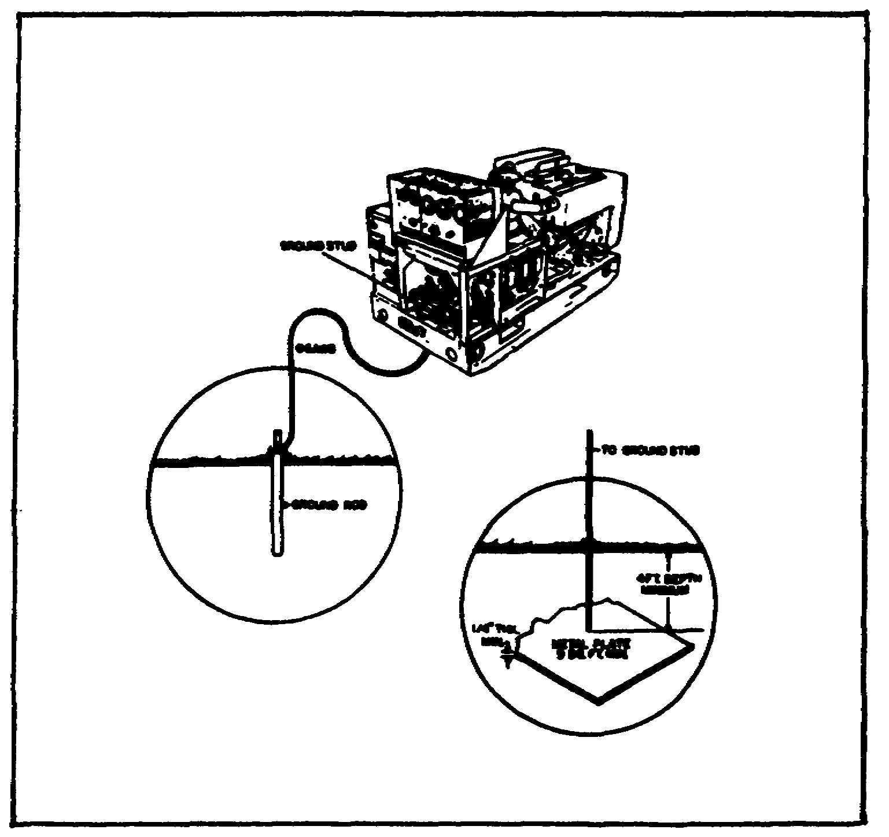

Once you have prepared a place for the generator to sit, the generator must be grounded before it is put into operation. If not, there is a chance you or someone else may be electrocuted. The generator set can be grounded by means of an underground metallic water piping system, a metal rod driven into the ground, or a buried metal plate. If a ground rod is used, it must have a minimum diameter of 5/8 inch if a solid rod is used or 3/4 inch if a pipe is used. The rod must be driven to a minimum depth of 8 feet. If a ground plate is used, it must have a minimum area of 9 square feet and be buried at least 4 feet deep. The ground lead must be a No 6 AWG (American Wire Gage) copper wire and be bolted or clamped to the rod, plate, or piping system. Connect the other end of the ground cable to the ground terminal on the generator set.

If the generator is to be installed inside a building, be sure to keep the room well ventilated so that the generator will get enough cooling air. Also install a gastight exhaust line, as large as the exhaust outlet, to pipe the exhaust gases outdoors. Place metal shields around the exhaust line if it passes through flammable walls. Do not operate the generator set in an enclosed area unless the exhaust gases are piped to the outside. Breathing the exhaust fumes can result in serious illness or death.

62

Lesson 4/Learning Event 1

FIGURE 13.
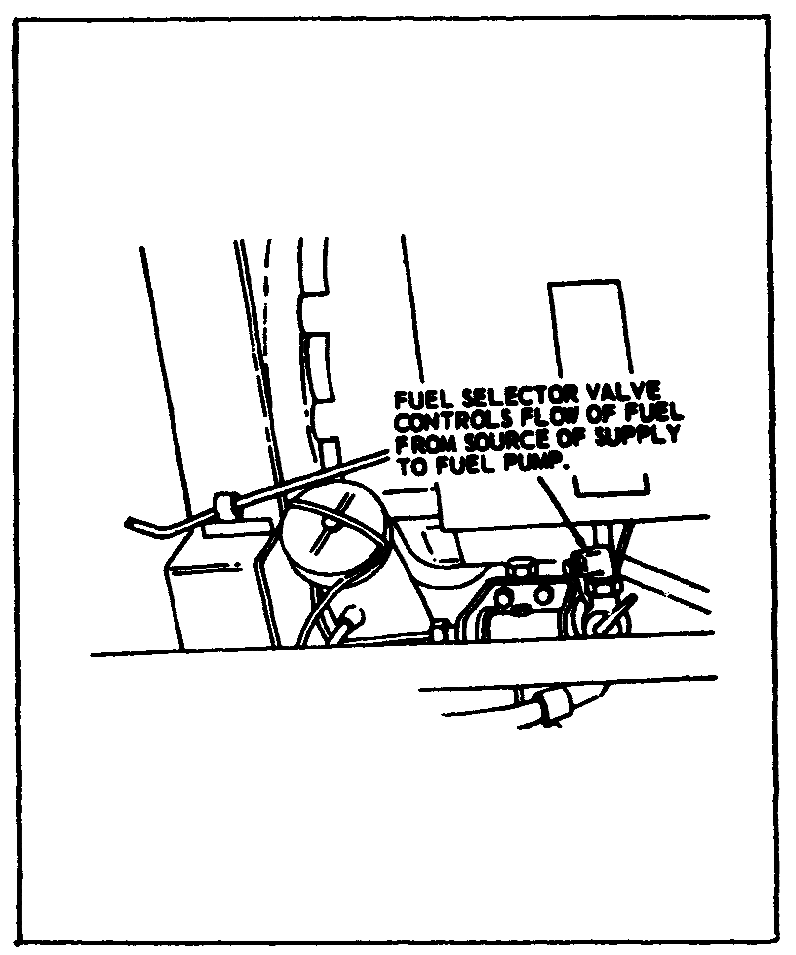

If you are going to use an extra fuel tank in addition to the one mounted on the generator set, connect the fuel hose from the extra tank to the fuel selector valve. A special adapter may be required for some models.

63

Lesson 4/Learning Event 1

FIGURE 14.
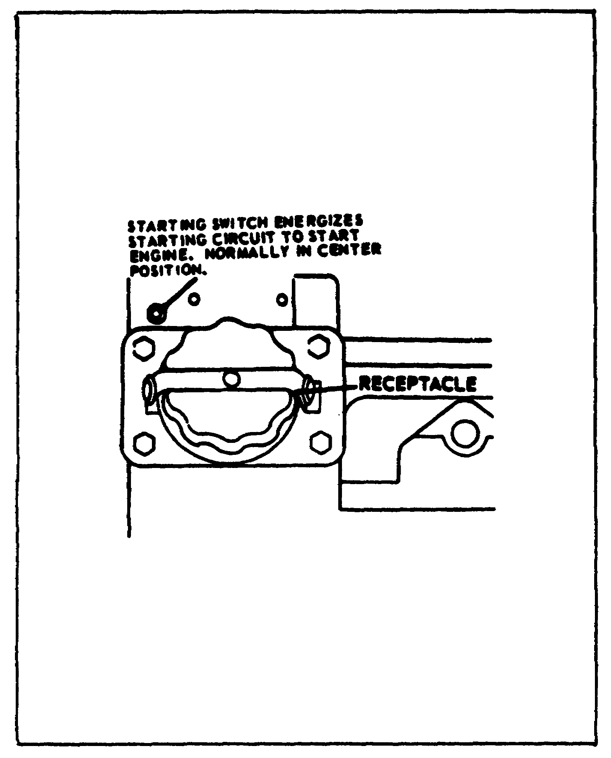

If you are going to use an external power source for starting the engine, connect the external power line to the external power source receptacle on the generator set. The external power source must be 24/28 volts DC.

After the above steps are completed, you are ready to set the generator for the output voltage and phase you need. There are two ways of doing this on AC generators, depending on what model generator you have. If the generator you are working with has a changeover plug and a changeover board, all you have to do is pull the changeover plug out and then insert it back into the changeover board in the desired position.

64

Lesson 4/Learning Event 1

FIGURE 15. AC GENERATOR SET LOAD TERMINALS.
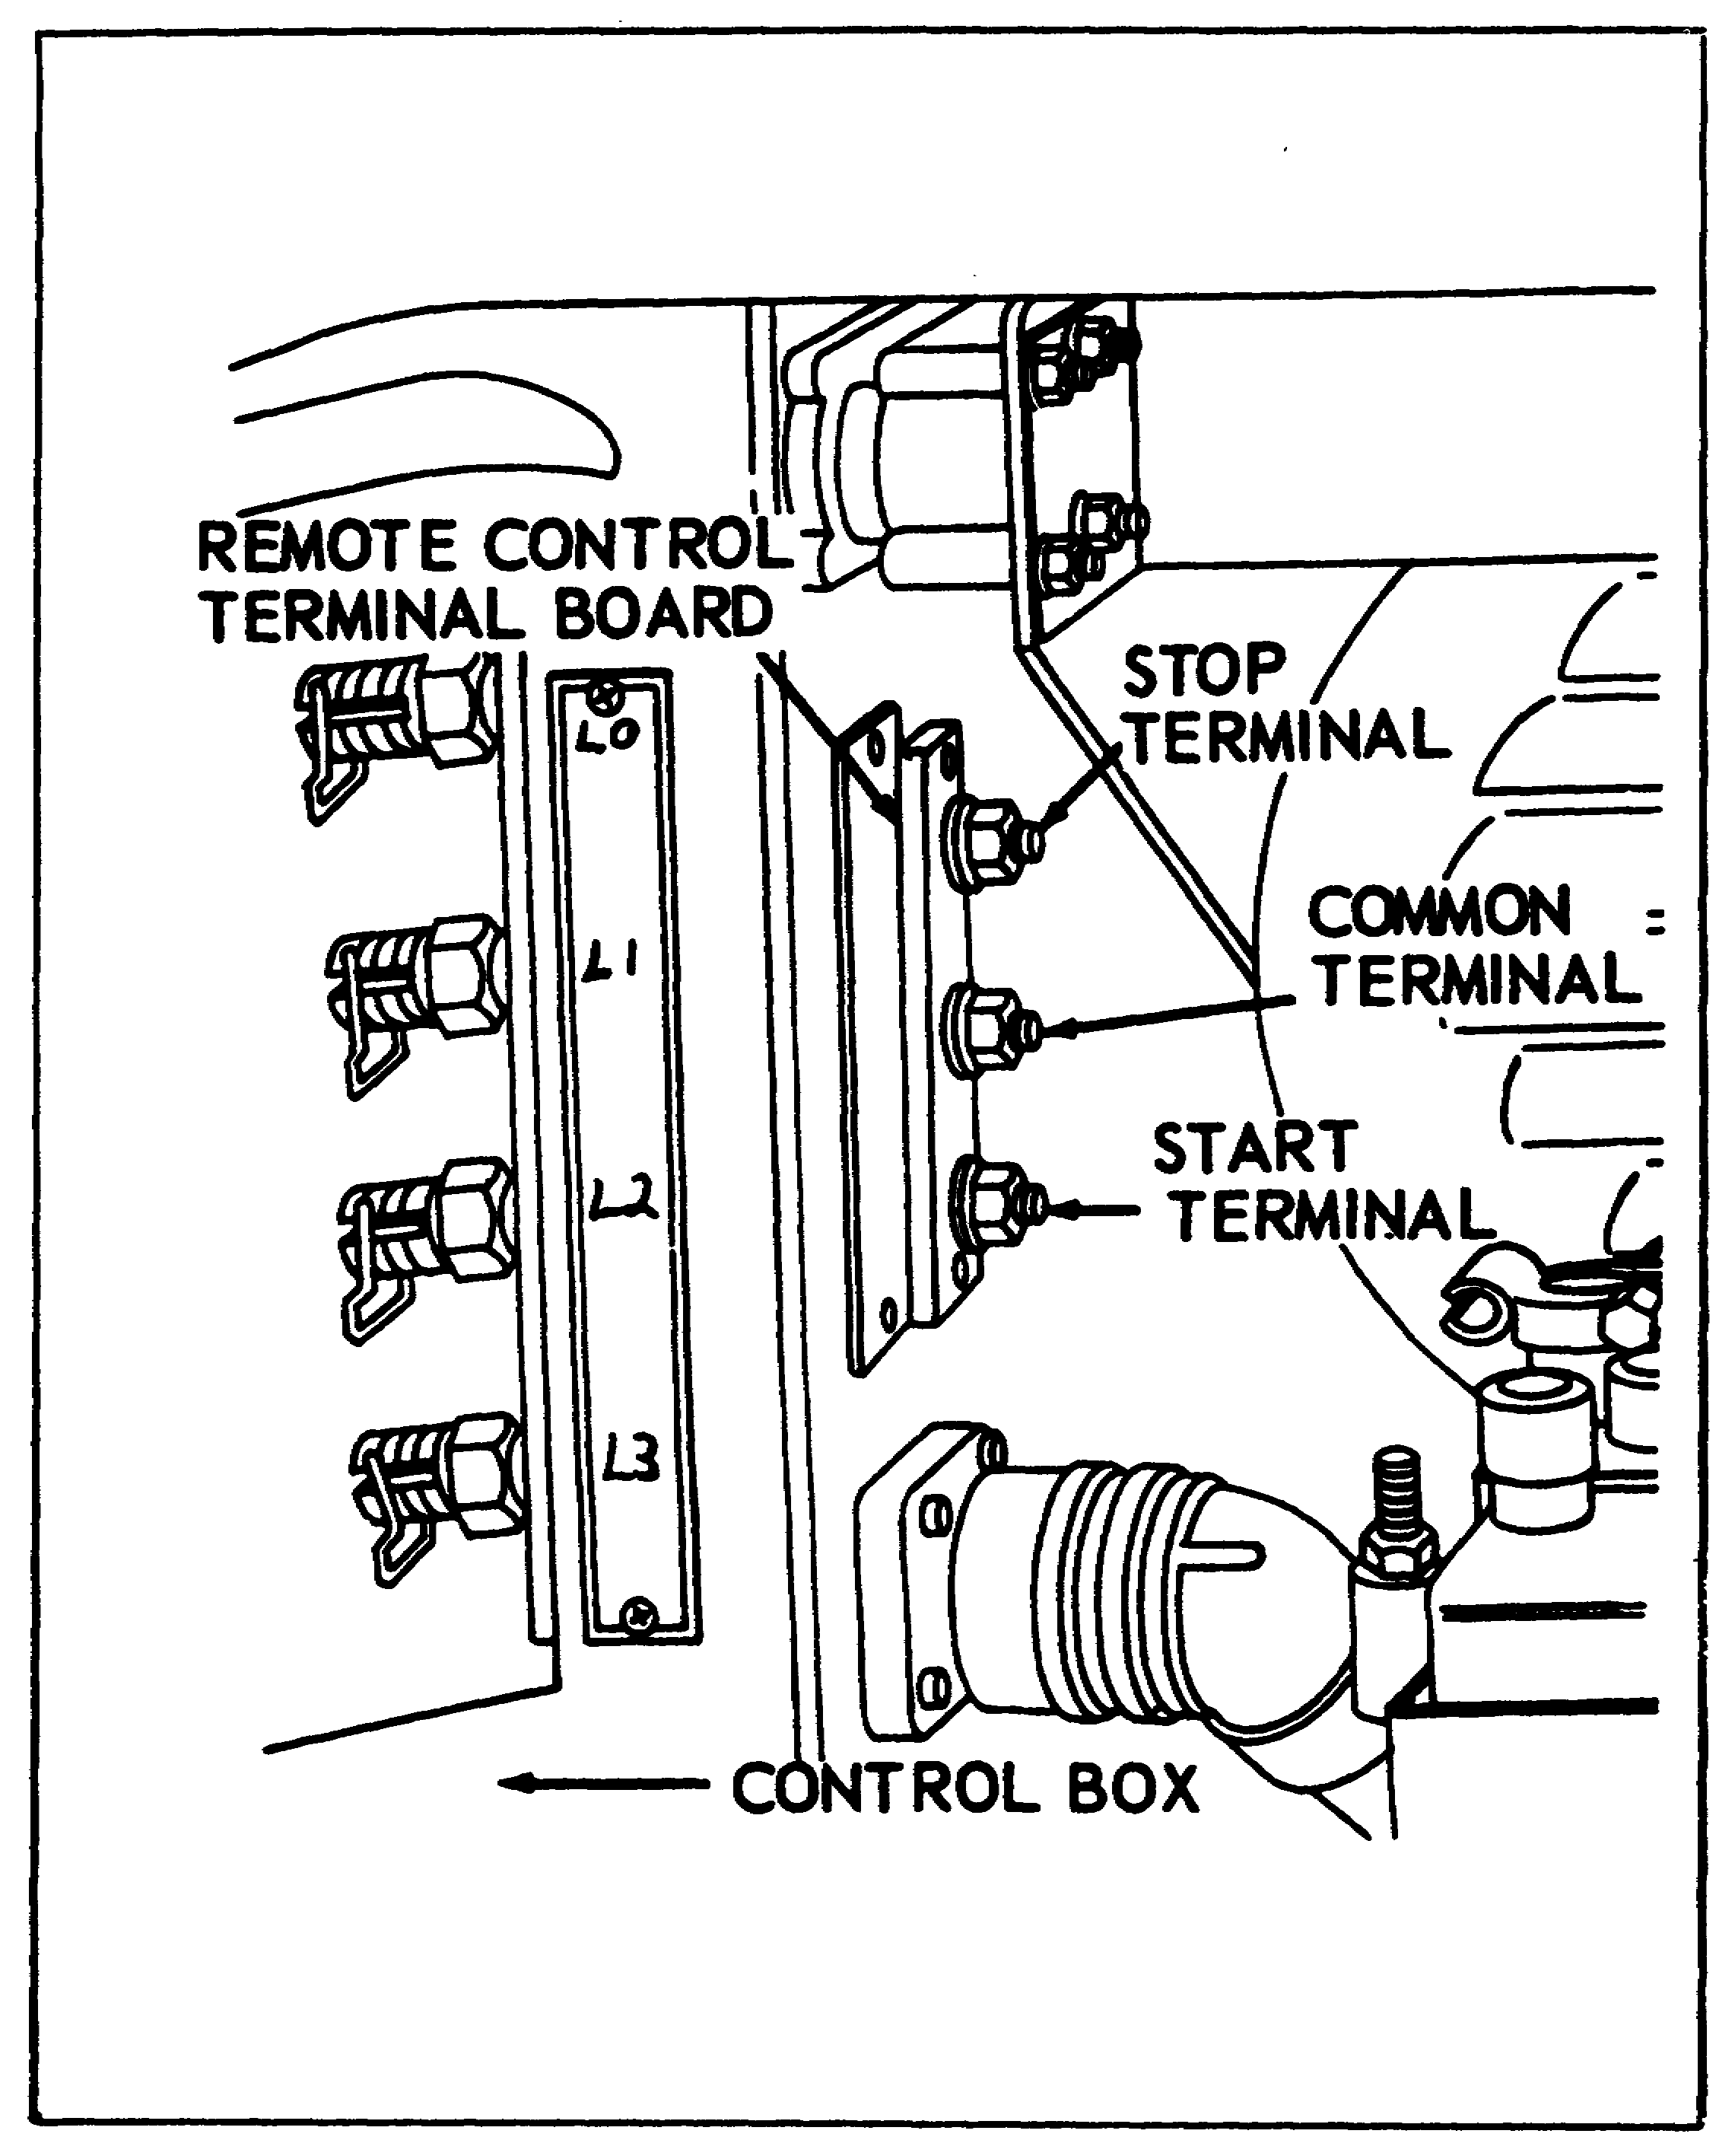

65

Lesson 4/Learning Event 1

FIGURE 16. OUTPUT SELECTOR SWITCH.
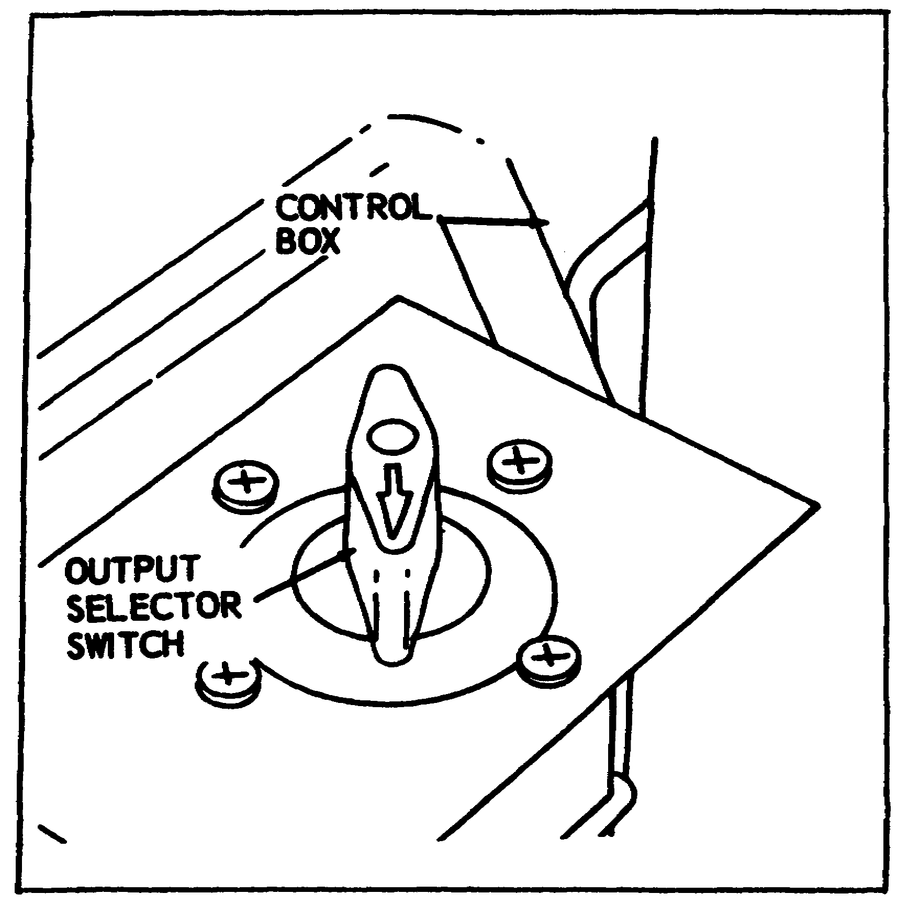

Other AC generator sets have an output selector switch instead of the changeover board. To connect the output of this type generator set, all you have to do is turn the output selector switch to the position that matches the desired output.

When installing DC generators, you do not have to worry about setting the proper output; DC generators have only one output of 28 volts DC.

66

Lesson 4/Learninag Event 1

FIGURE 17.
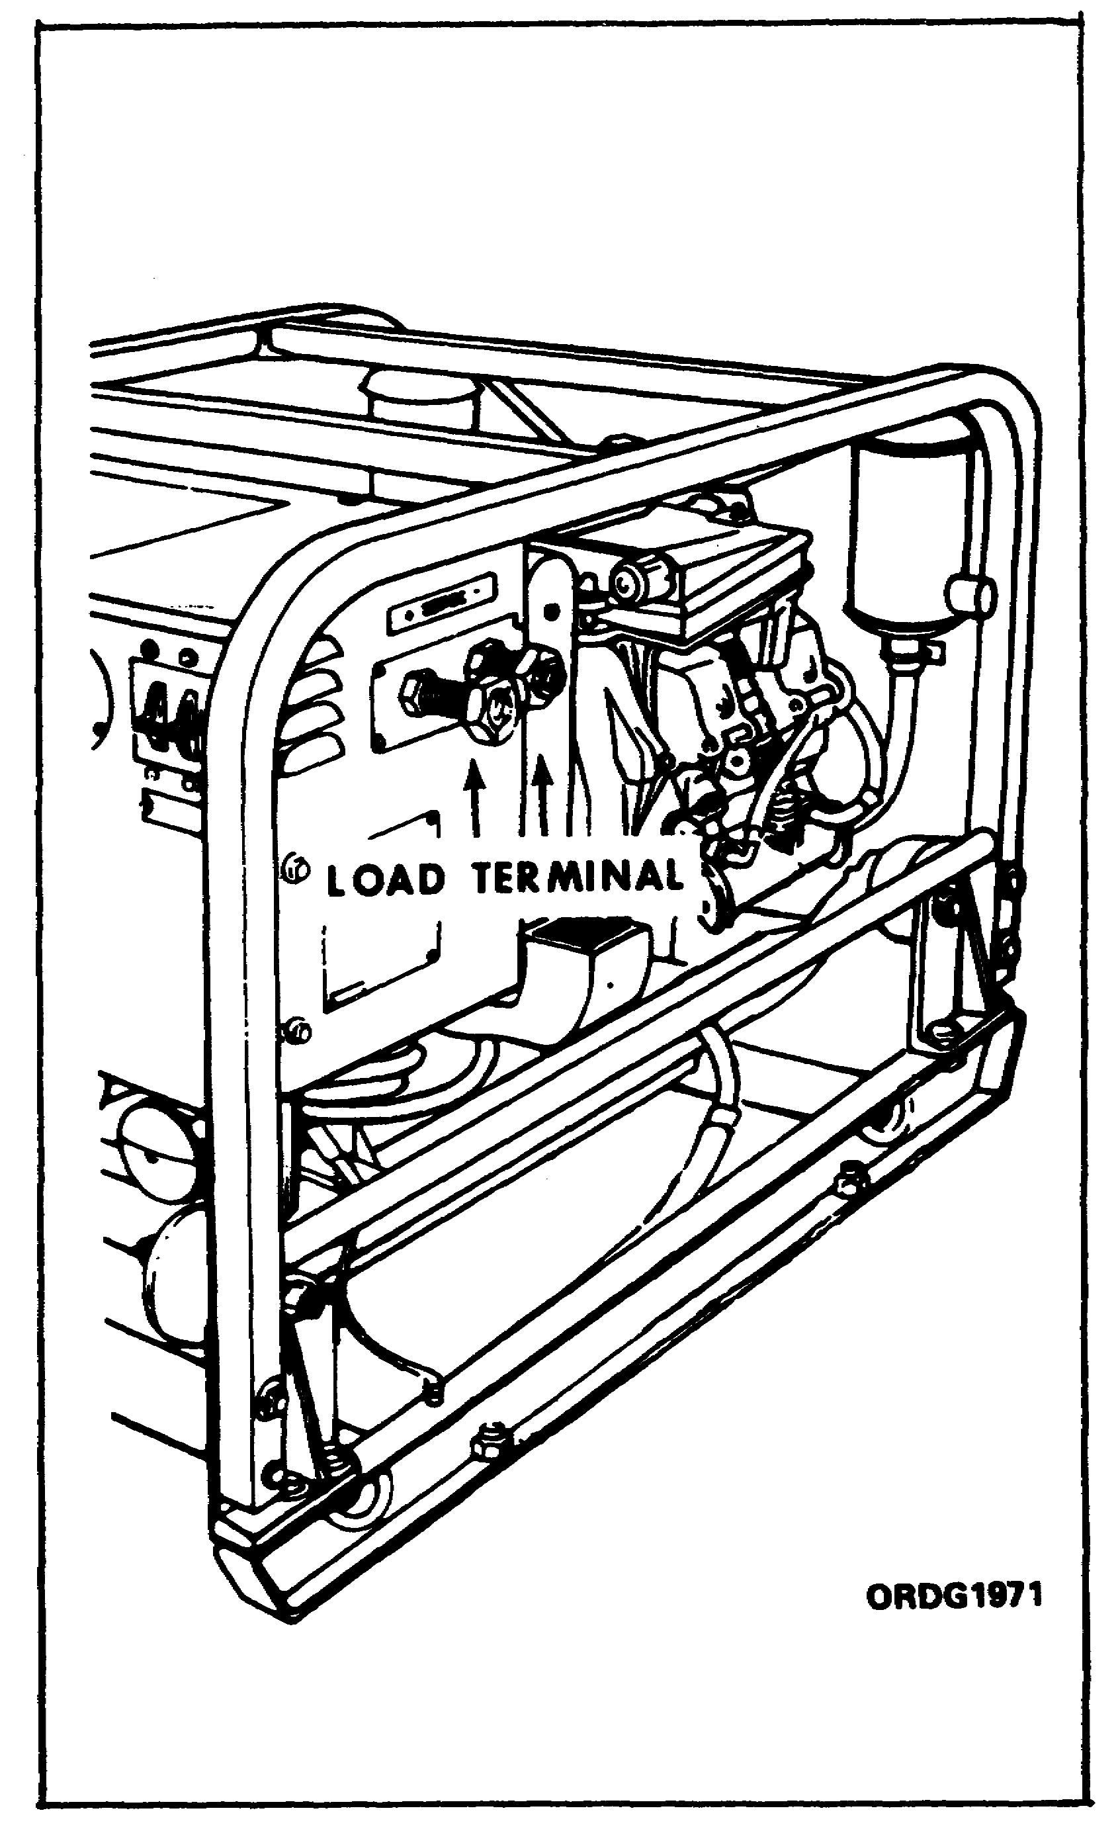

The DC generator sets have two load terminals. One is marked “+” (positive); the other "-" (negative). When connecting the load cable to the generator set, ensure that the positive wire is connected to the load terminal marked "+" and the negative wire is connected to the terminal marked "-."

67

Lesson 4/Learning Event 1

PREOPERATIONAL CHECKS

Before starting any engine, you should perform a before-operation inspection. The inspection of engines in generator sets is much like that performed on engines in wheeled vehicles. Check the engine oil level, check the fuel level, look for fuel and oil leaks, check for loose or missing bolts and nuts, and look for loose electrical connections. Since the engines in 3- and 5-kw generator sets are air cooled, you will not have to look for water leaks, but you must be sure that the engine can get all the air it needs for cooling.

CONTROLS AND INSTRUMENTS

You must know what controls and instruments are used, where they are located, and what they are used for before you will be able to properly operate generator sets.

68

Lesson 4/Learning Event 1

FIGURE 18.
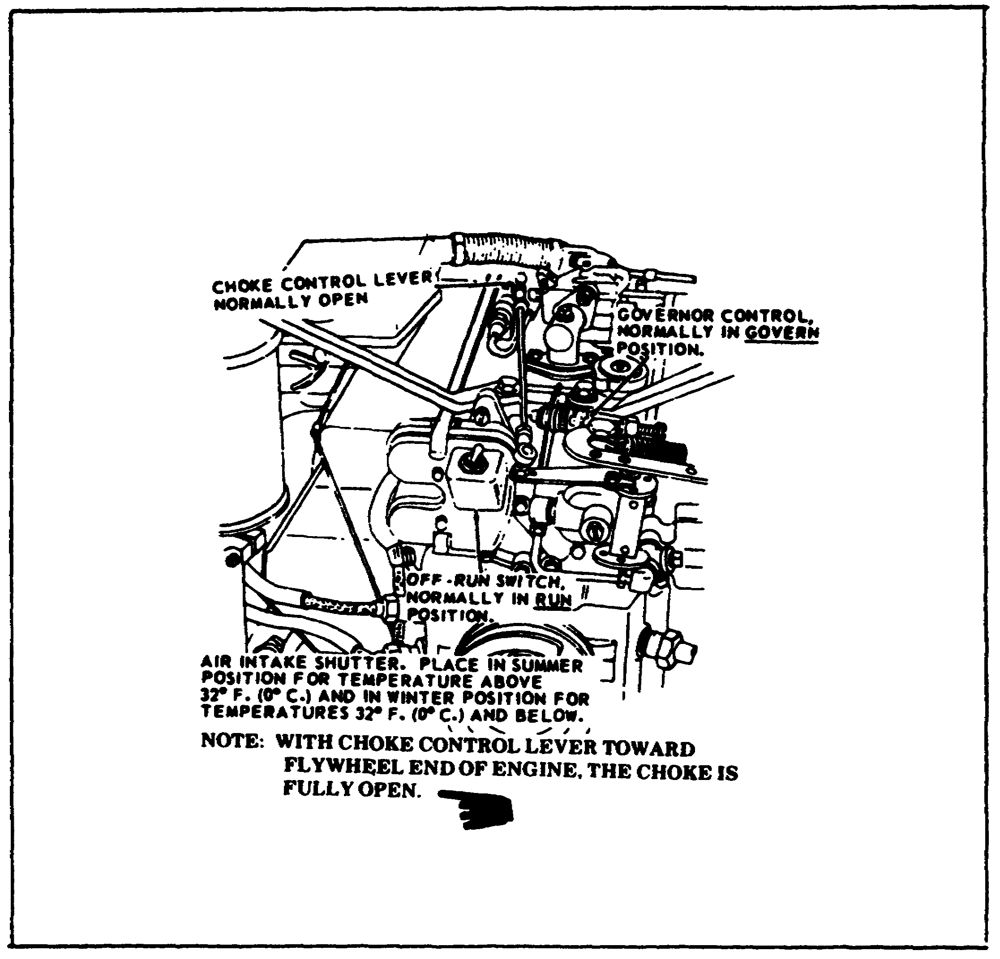

Engine controls are about the same on all generator sets. They have a choke which is usually controlled by a lever at the carburetor. An off-run switch, located on the engine magneto, is used to turn the ignition on or off. A governor control, located on a bracket near the governor, is used to lock out the governor control when starting and warming the engine. Normally, the governor control is set in the GOVERN position so that the governor will automatically control engine speed. An air intake

69

Lesson 4/Learning Event 1

shutter in the cooling system air intake can be positioned to partially block cooling airflow by placing it in the WINTER position. The shutter permits free flow of air in the SUMMER position.

FIGURE 19.
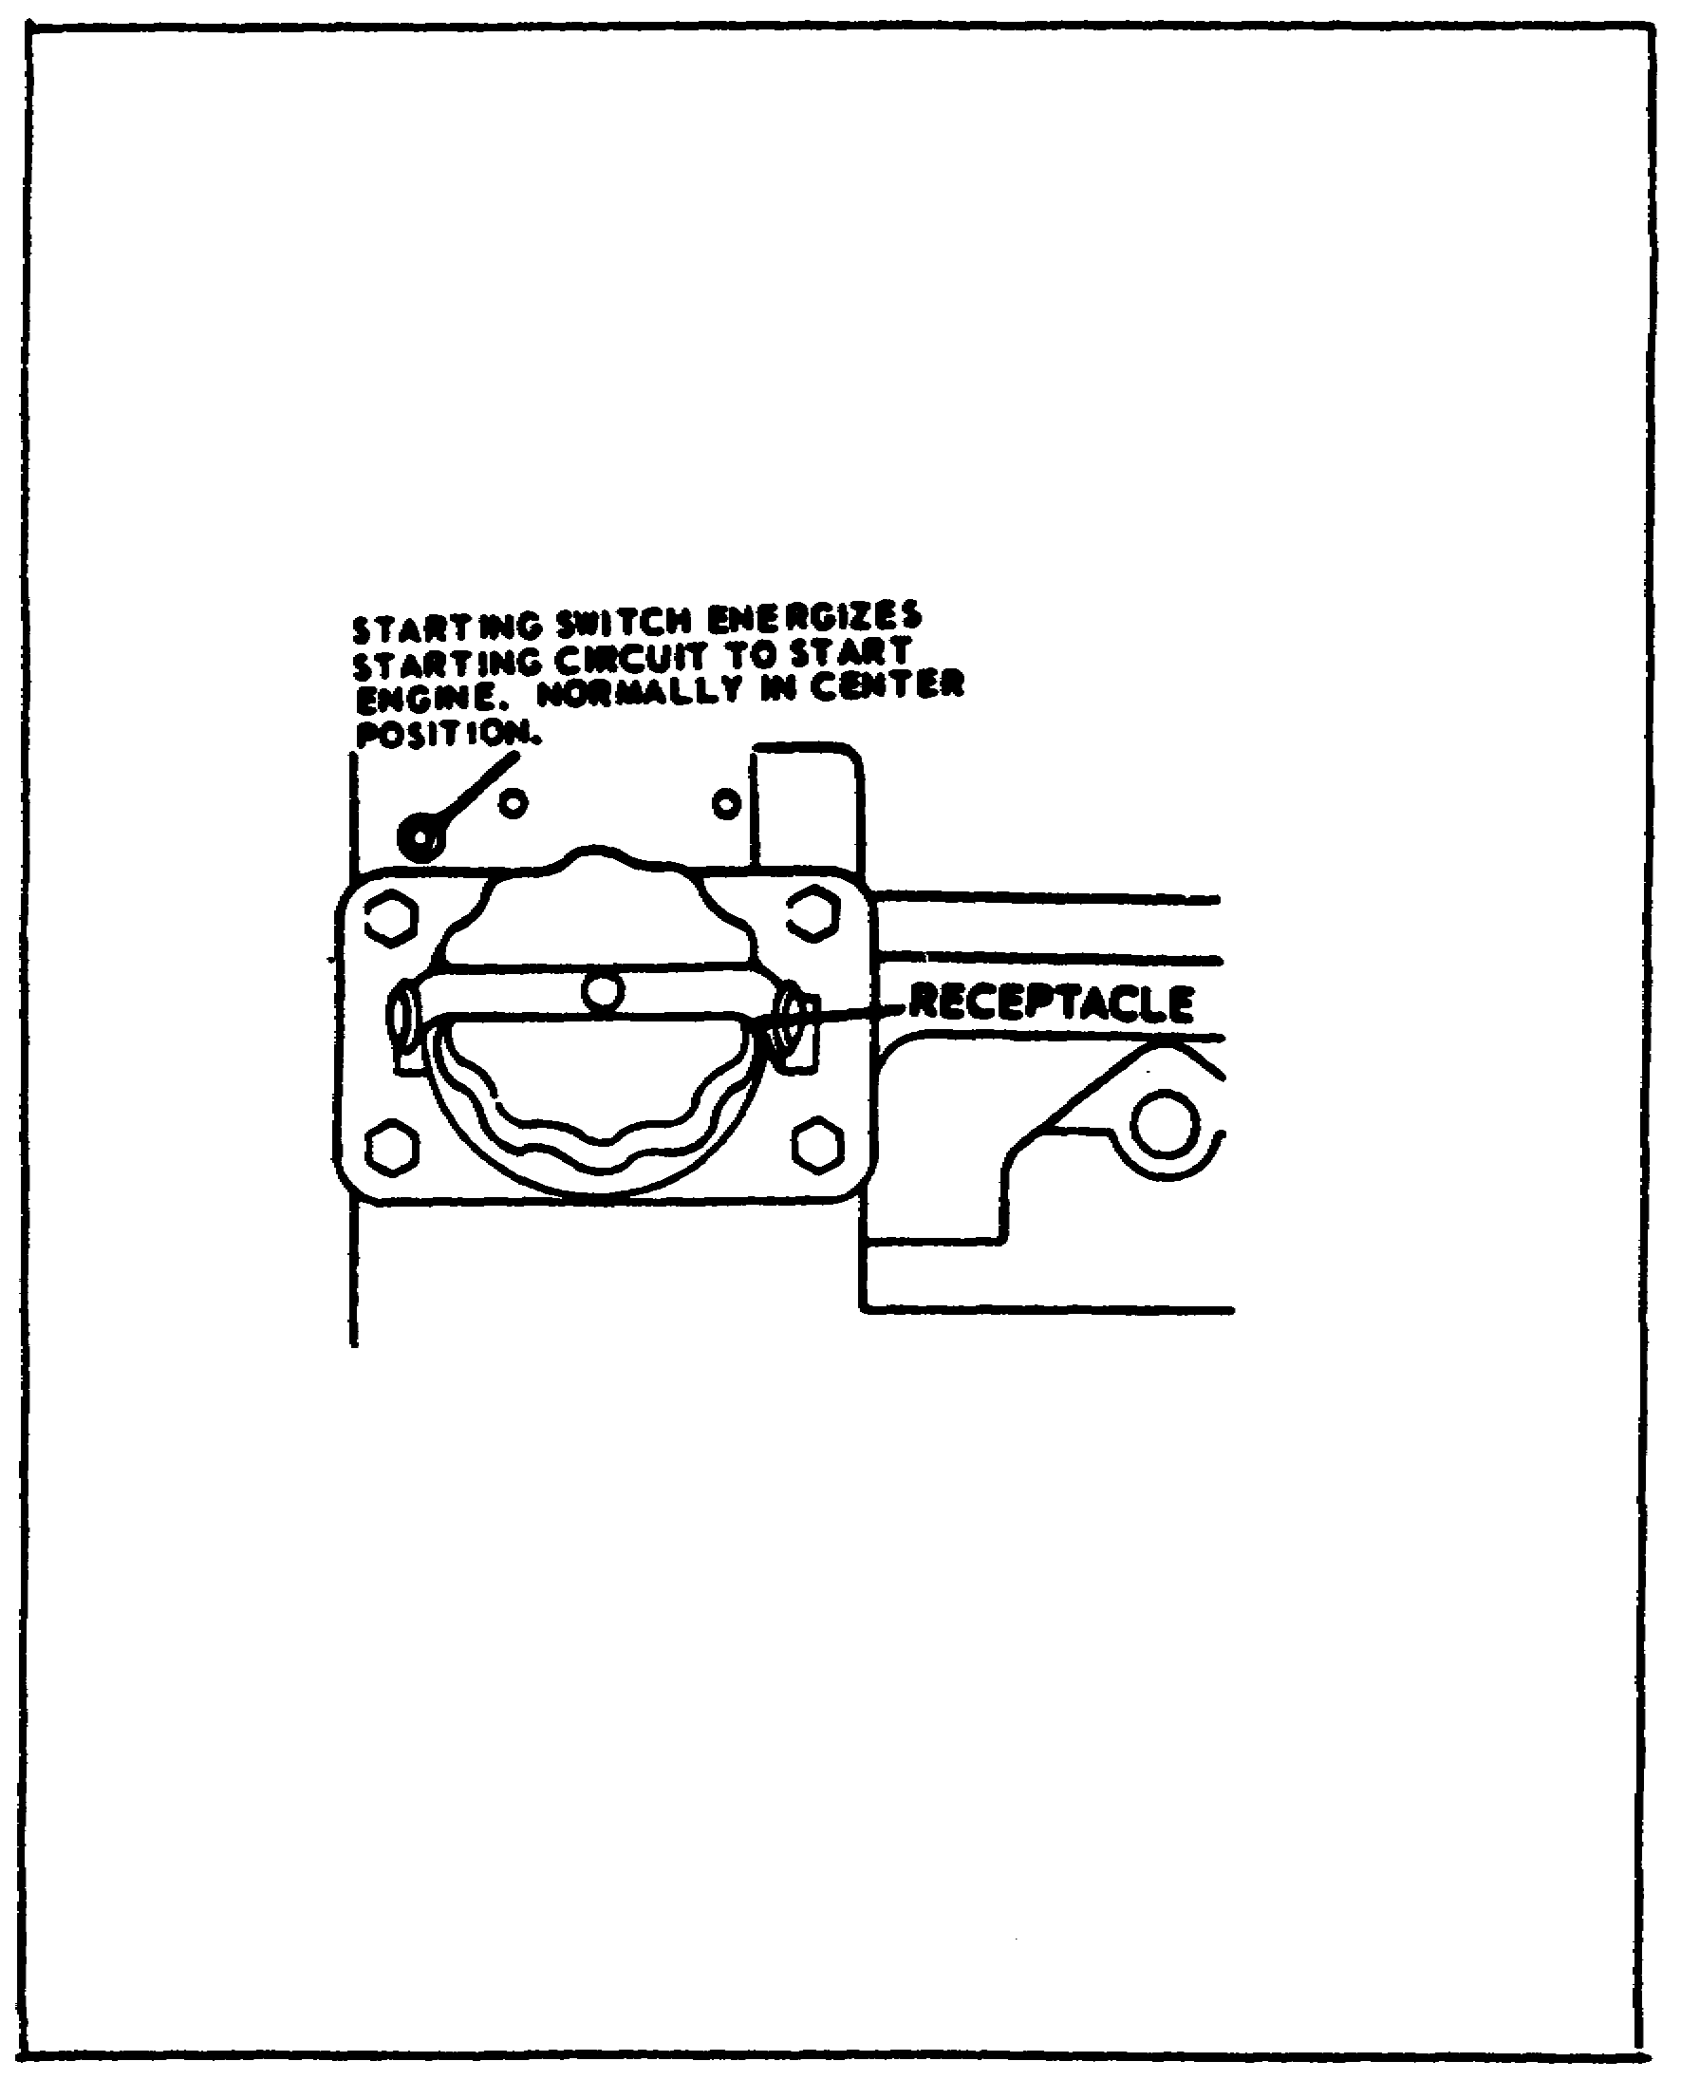

If the generator set is made so the engine can be electrically cranked from an external power source, there is a starting switch located near the external power source receptacle.

70

Lesson 4/Learning Event 1

FIGURE 20.
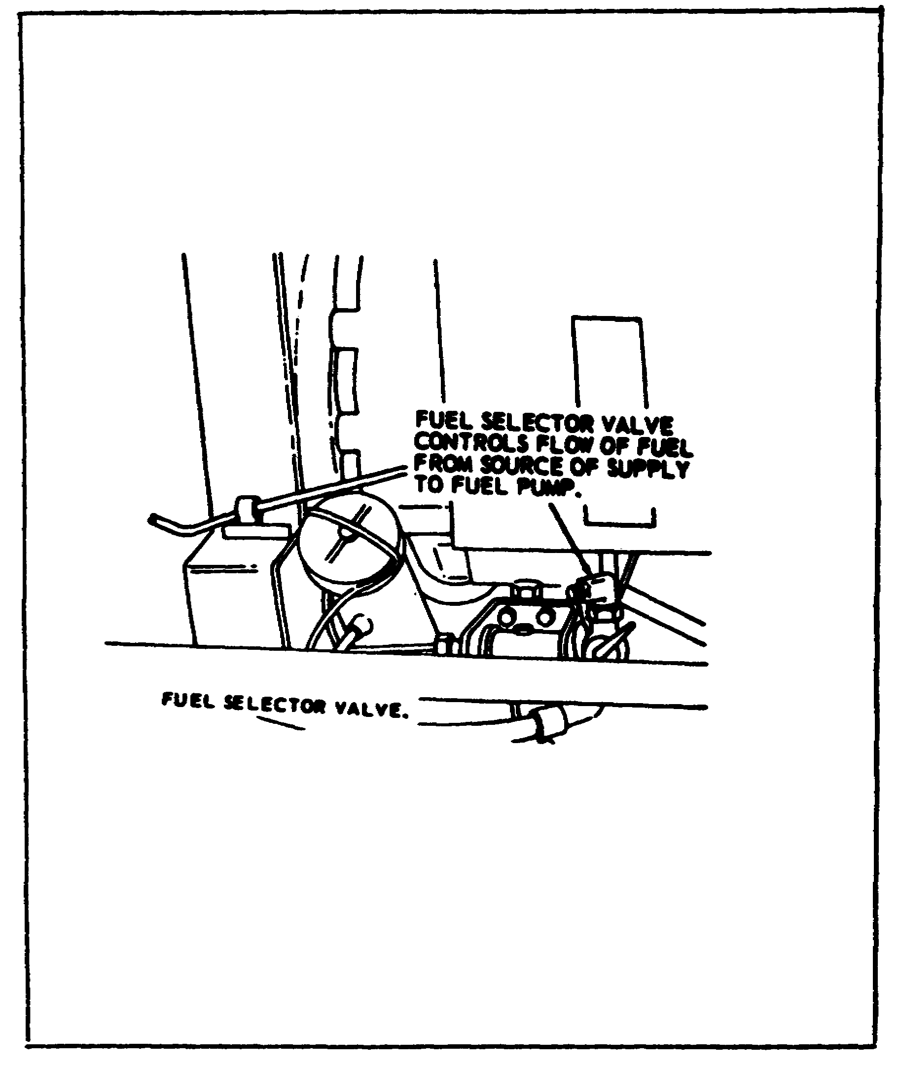

On generator sets designed to use an external fuel supply, a fuel selector valve is located in the fuel inlet line to the engine fuel pump. The valve is positioned to select whether the fuel is drawn from an external supply or from the fuel tank located on the generator set.

The AC generator sets have instruments that show the output of the generator in hertz (cycles), voltage, and percentage of load current being used. Controls are provided for making adjustments in generator output and for energizing the generator fields to start the output. The following figures show the location and purpose of the controls and instruments on the various 3-kw generator sets. Note that DC generator sets do not have a frequency meter.

71

Lesson 4/Learning Event 1

FLASHING THE GENERATOR FIELDS

FIGURE 21.
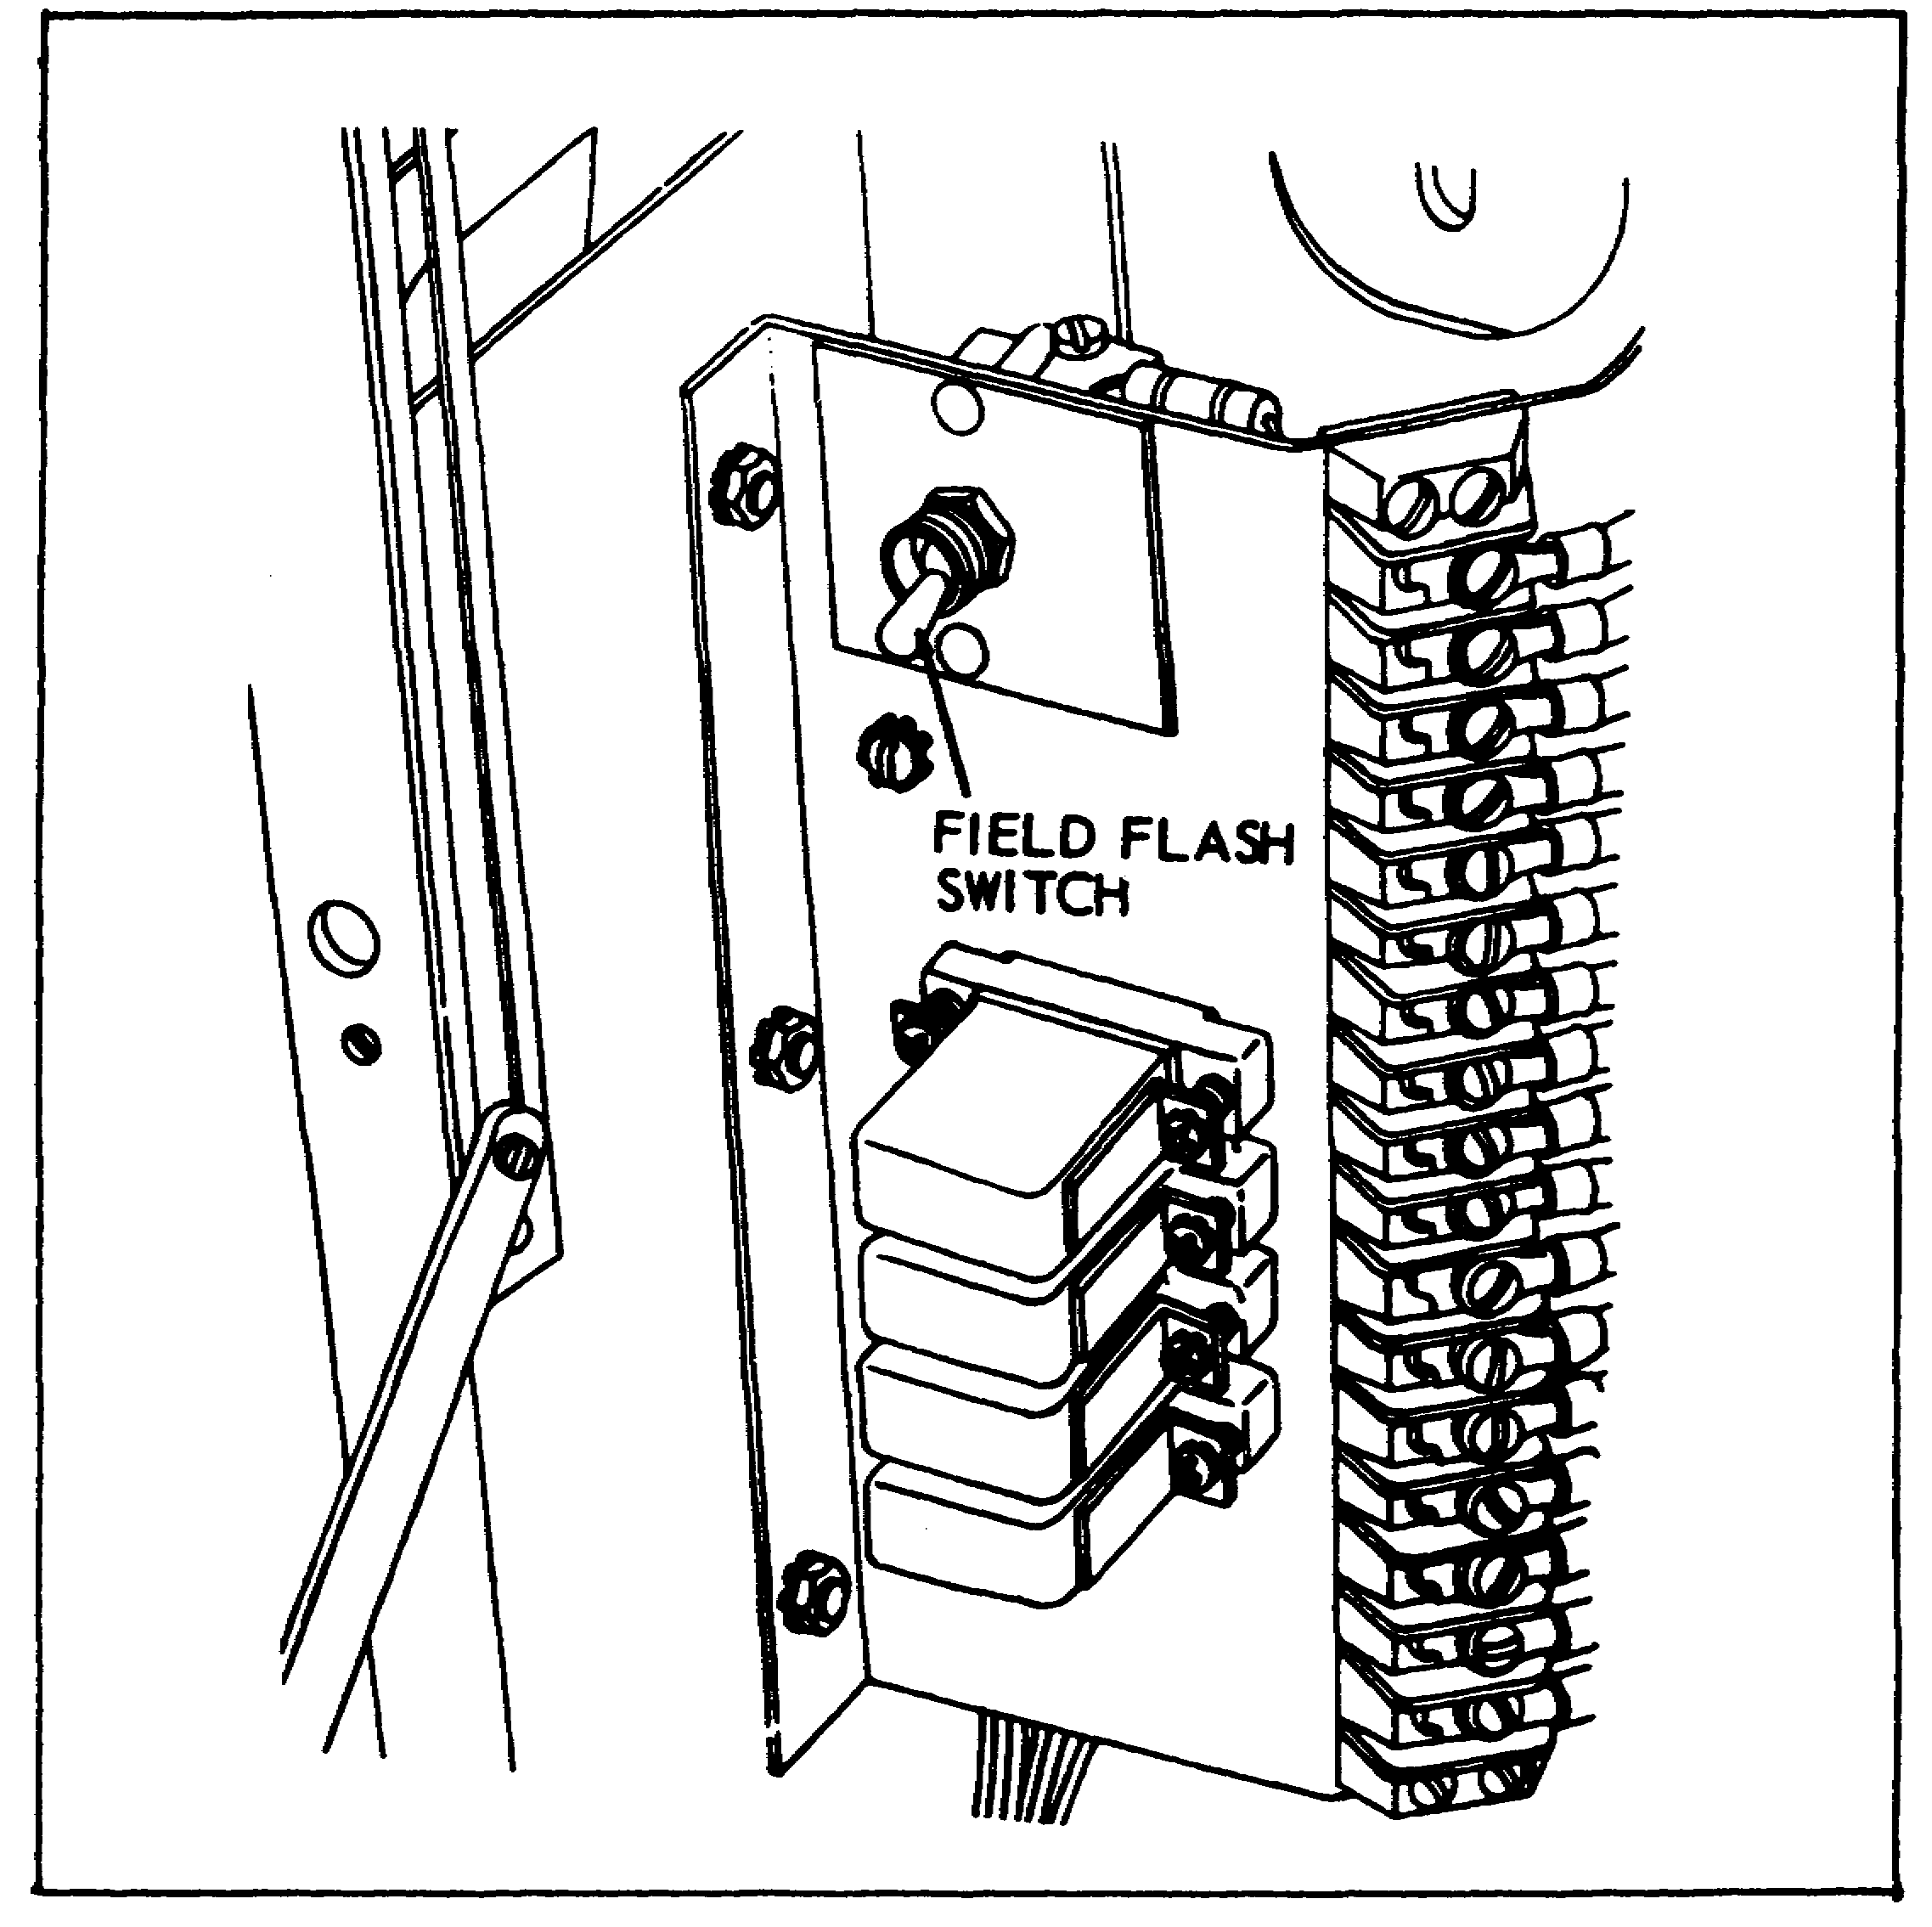

72

Lesson 4/Learning Event 1

FIGURE 22.
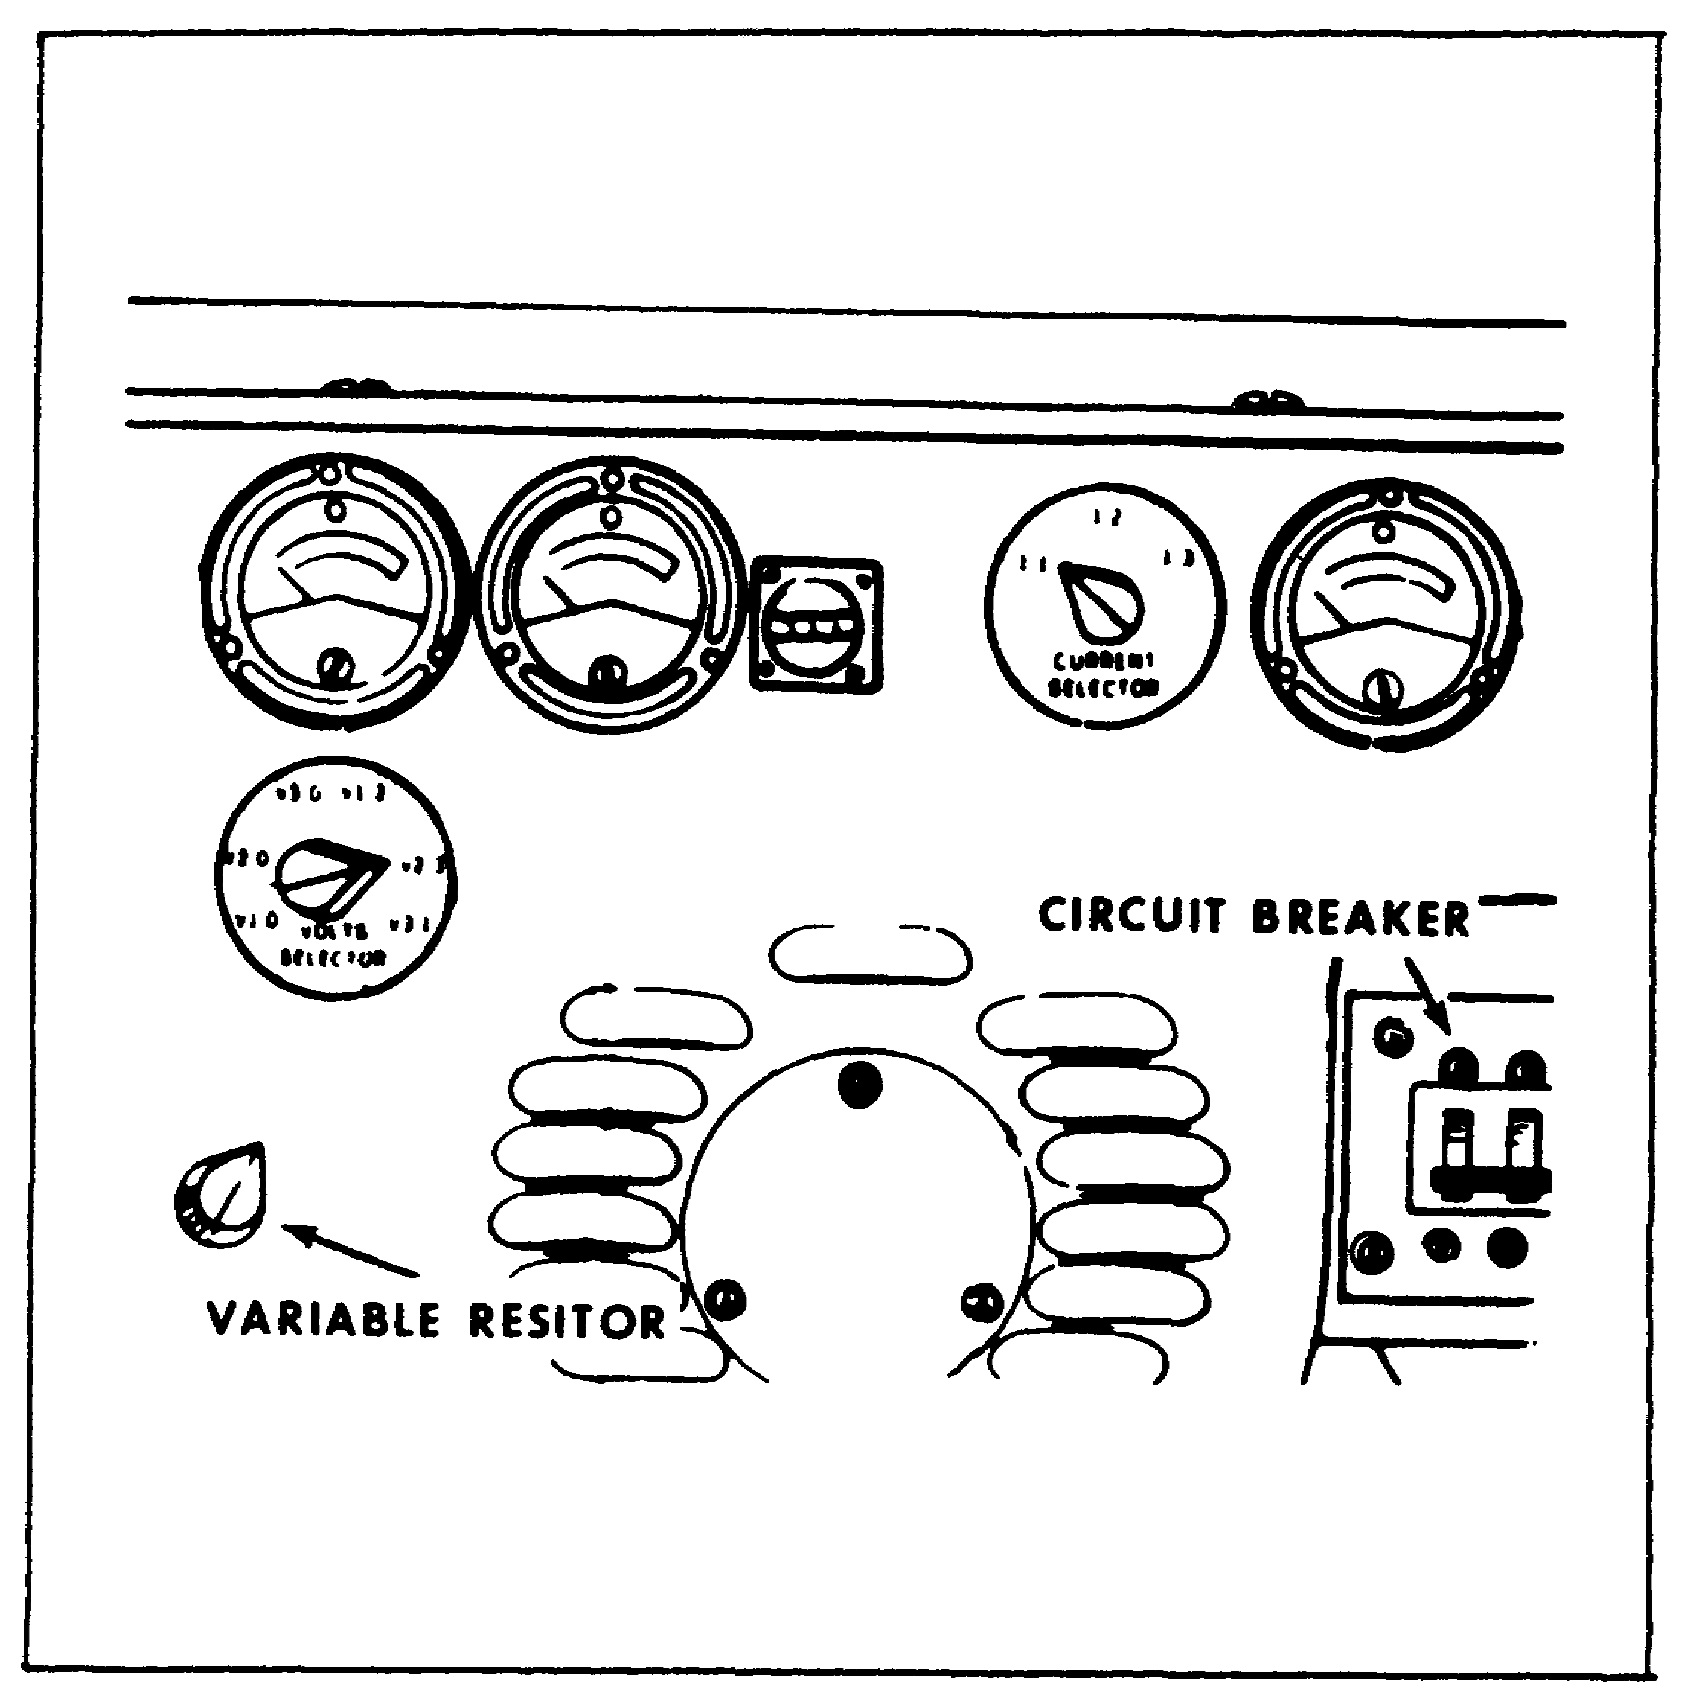

73

Lesson 4/Learning Event 1

FIGURE 23.
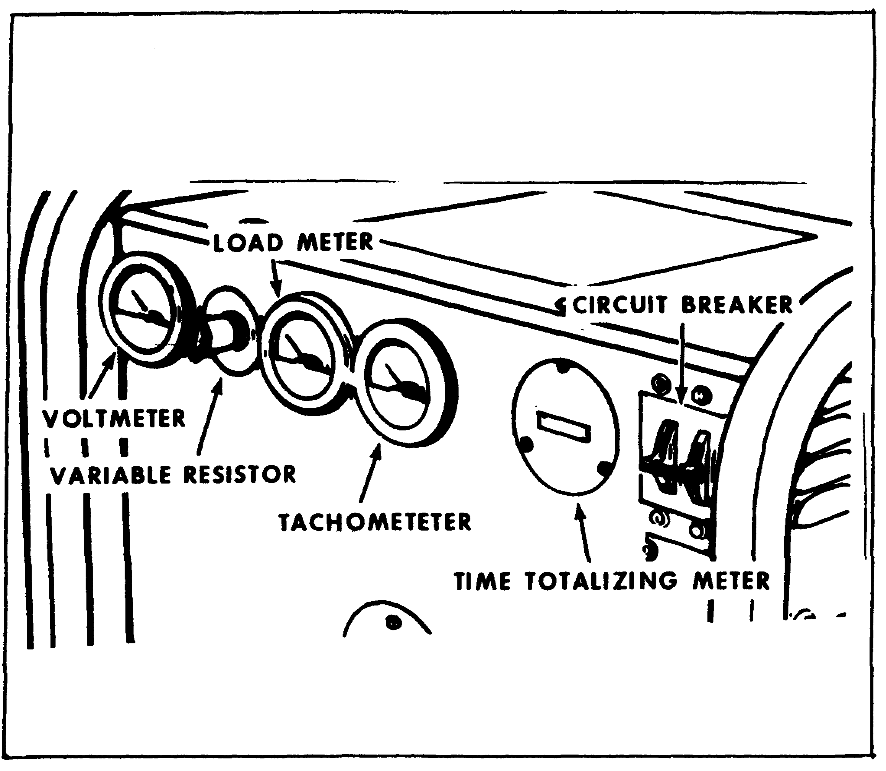

Most of the above figures of generator controls and instruments show a field flash switch and also a note stating that later models of generator sets may not be equipped with a field flash switch. We also want to point out that some older generator sets have been modified and do not have the switch.

The purpose of the switch is to send direct current through the field from the external power source until the generator builds up enough current to take over. It is no longer considered necessary for the generator to be equipped with a field flash switch, for most of the time the generator will start producing current without it because of residual magnetism in the generator.

74

Lesson 4/Learning Event 1

However, if you should find a generator that has lost its residual magnetism, here is a way you can flash the fields when the set has no field flash switch. First, remove the control box cover. Then hold two flashlight batteries together (the way they are normally positioned in a flashlight) and connect a wire to each end. Connect the positive wire from the batteries (this will be attached to the center terminal on the battery) to terminal 20 on the voltage regulator. Start the generator set. (Starting will be covered later in this lesson.) Then, momentarily touch the flashlight battery negative wire to terminal 21 on the voltage regulator. This applies 3 volts across the terminals to energize the generator fields. An automotive battery can be used instead of flashlight batteries if extra precaution is taken when touching the negative wire to terminal 21. The wire must not touch the terminal for more than a fraction of a second as the automotive battery supplies more than 3 volts and could damage the field windings.

STARTING THE ENGINE

There are two ways to start the engine: electrical or manual starting. Let's go through the electrical starting first.

FIGURE 24.
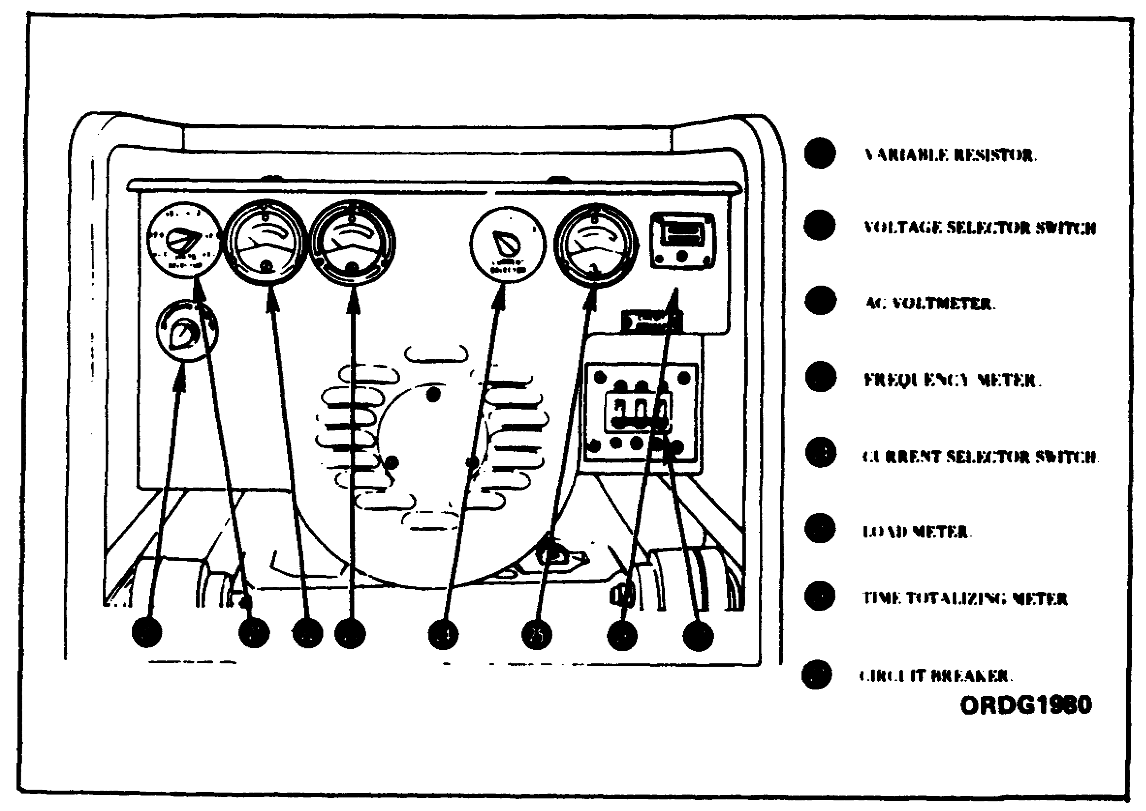

75

Lesson 4/Learning Event 1

Before attempting to start the engine, turn the variable resistor knob that controls generator output voltage (labeled “adjust volts” or “increase volts”) fully counterclockwise. Be sure the load circuit breaker is in the OFF position to disconnect the load from the generator.

FIGURE 25.
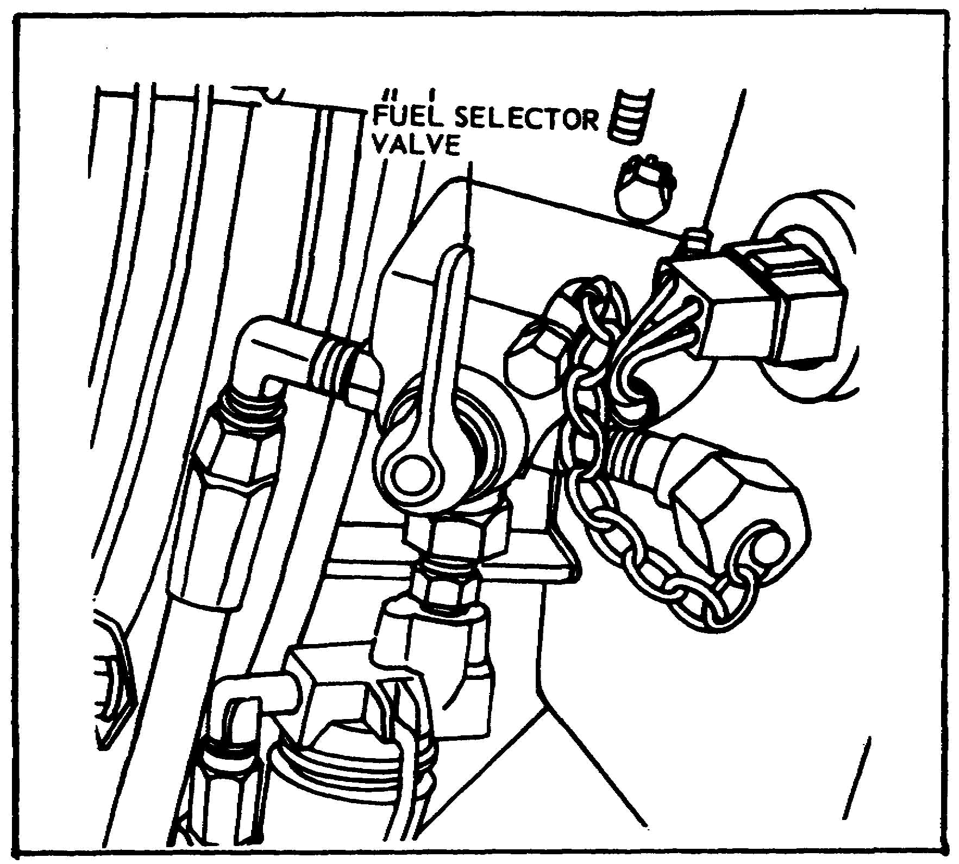

Place the fuel selector valve in the SET TANK or AUX TANK position, depending on whether you want to use fuel from the generator set tank or the auxiliary tank.

76

Lesson 4/Learning Event 1

FIGURE 26.
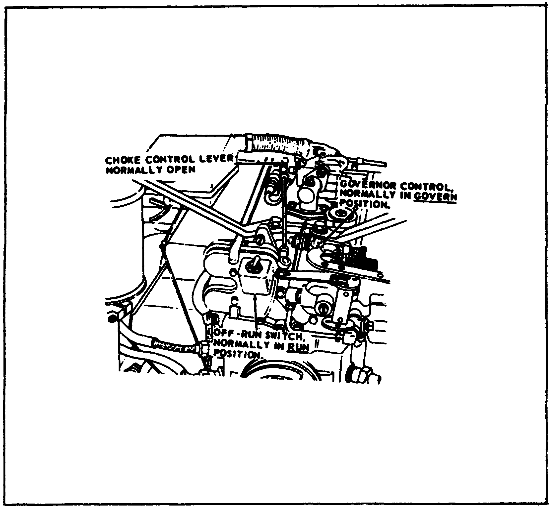

Next, place the air intake shutter in the proper position. This will depend on the temperature - SUMMER position for temperatures above 32°F, and in the WINTER position for temperatures 32°F and below. The governor control should not be placed in the START AND IDLE position, the choke control lever closed, and the OFF-RUN switch in the RUN position.

77

Lesson 4/Learning Event 1

FIGURE 27.
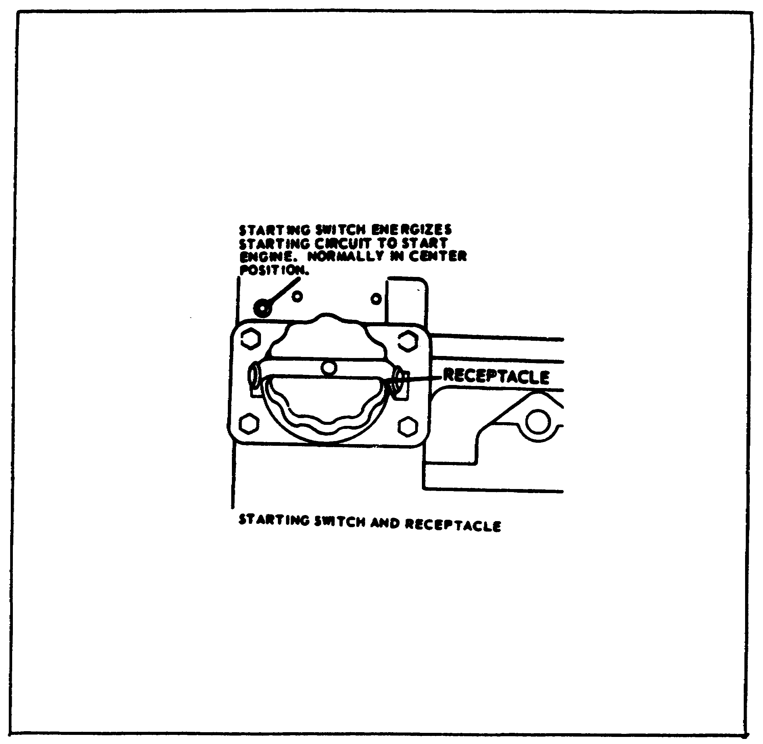

Now to start the engine. Connect a 24-volt DC power source to the external power source receptacle, and hold the starting switch in the START position to crank the engine for not more than 15 seconds. If the engine does not start, allow a cooling off period of one minute before again attempting to start the engine. Place the governor control in the GOVERN position.

78

Lesson 4/Learning Event 1

FIGURE 28.
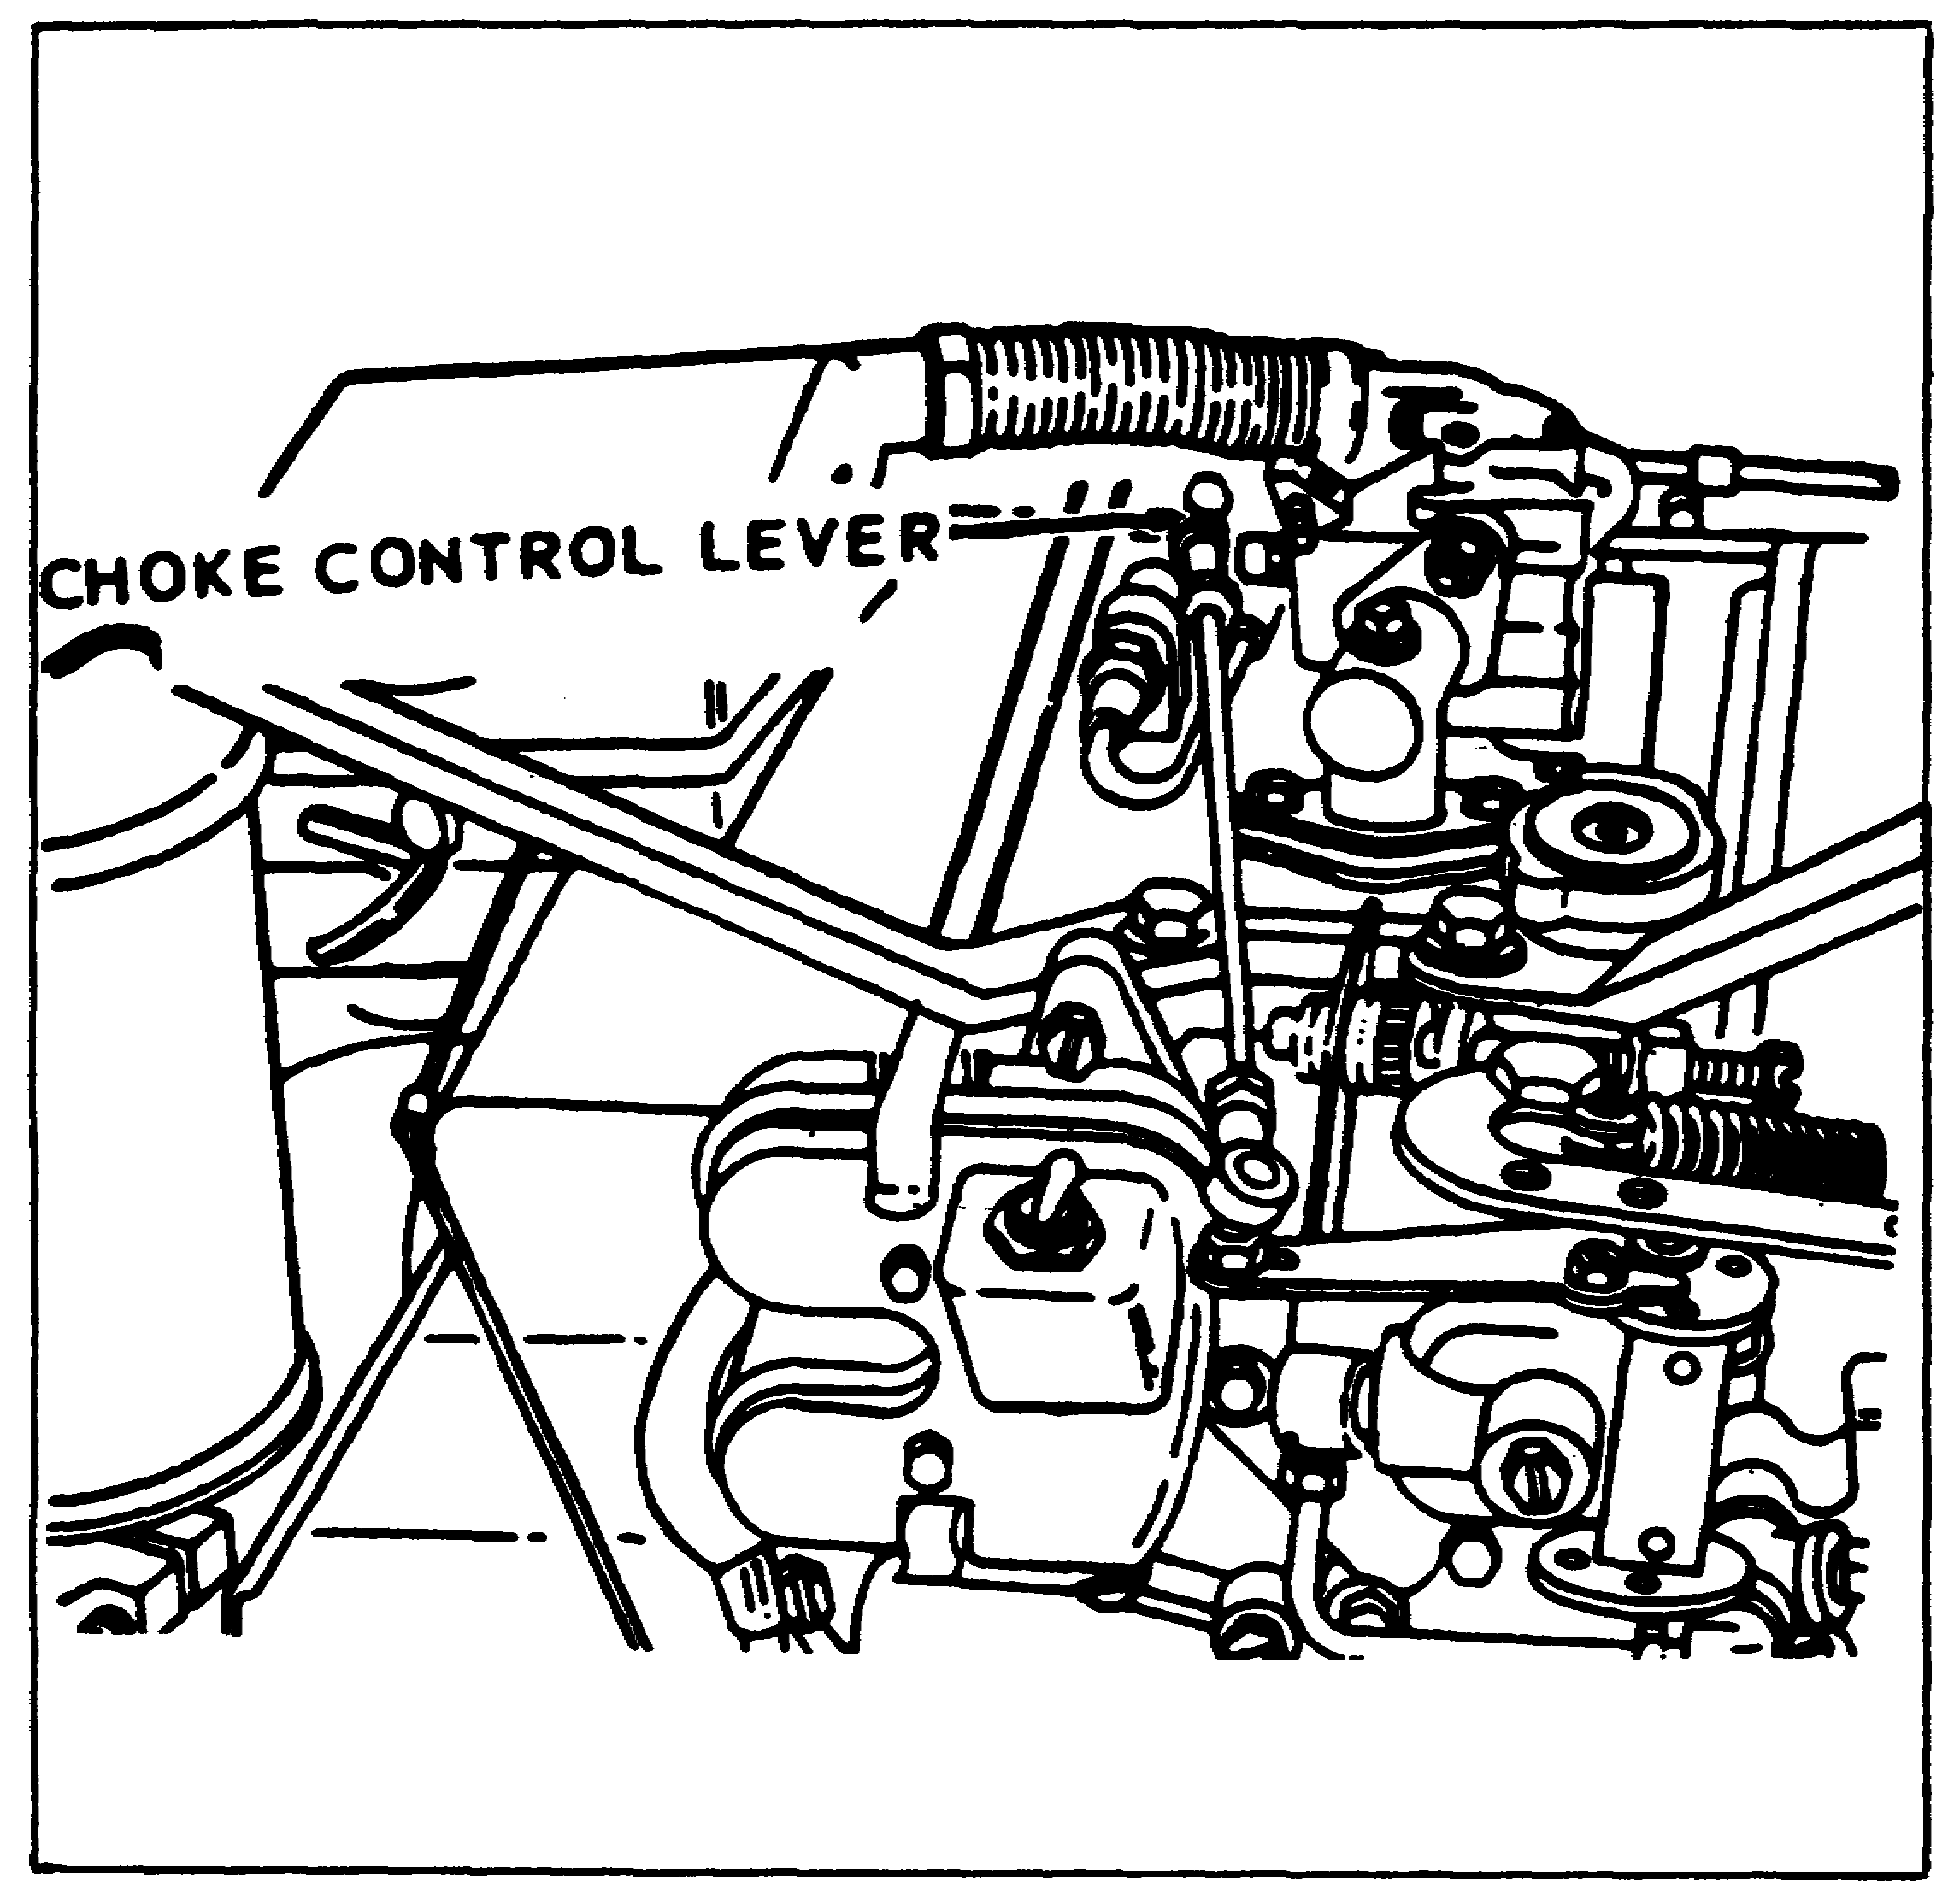

When the engine starts, release the starter switch and gradually open the choke as the engine warms up. If the engine is to be started manually, the procedures will be the same except, instead of using the starting switch, wrap the starter rope around the crankshaft flange and pull the rope with a steady motion to crank the engine. Repeat this, as necessary, until the engine starts.

79

Lesson 4/Learning Event 1

After the engine has been started, it should be allowed to warm up to normal operating temperature before loading the generator. During the warm-up period, the governor control should be left in the START AND IDLE position.

PUTTING THE GENERATOR INTO OPERATION

After the engine is warmed up, the governor control is placed in the GOVERN position and the generator is put into operation. Just how you go about doing this depends on the type of generator set you are working with.

To operate the generator set model MEP-016A or MEP-021A, proceed
as follows:

STEP 1. Start generator set
STEP 2. Place generator control in govern position
STEP 3. Place output selector switch in desired position
STEP 4. Place the circuit breaker in the off position and turn variable resistor knob counterclockwise until it stops
STEP 5. Set the voltage selector switch compatible to the connections at the load terminals
STEP 6. Using the variable resistor, adjust until the voltmeter registers desired voltage
STEP 7. Inspect the frequency meter. It should indicate 400 HZ or 60 HZ depending on machine being used.
STEP 8. Place the circuit breaker in the on position to apply load
STEP 9. Use the current selector switch and the load meter indications to determine current draw on each terminal and phase. The load reading should not exceed 100%.
STEP 10. Readjust the variable resistor, if necessary, to compensate for the current draw.

NOTE: Field flash switch is used to manually flash the generator fields only when the voltage fails to build. All MODELS WILL NOT BE EQUIPPED WITH A FIED FLASH SWITCH.

80

Lesson 4/Learning Event 1

FIGURE 29.
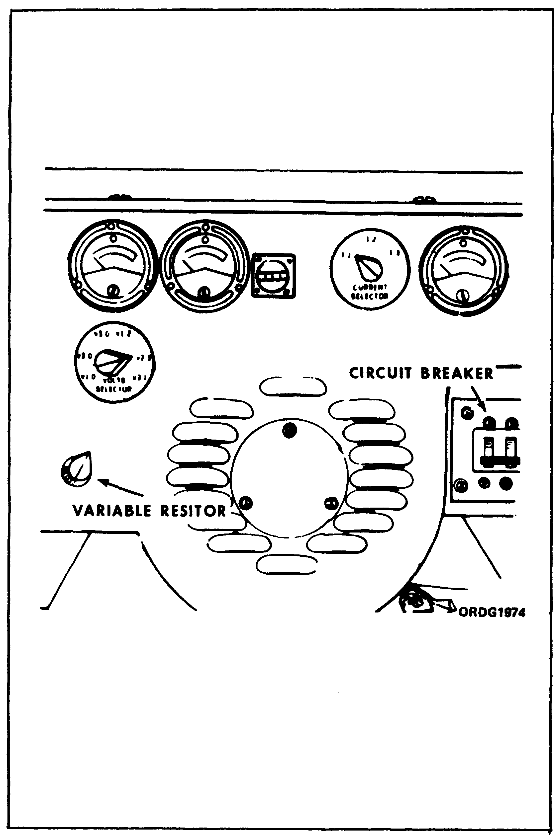

81

Lesson 4/Learning Event 1

This leaves only the 28-volt DC generator set. If this is the type generator you are working with, refer to this figure, showing its controls and instruments, and follow the steps listed below to put it into operation.

FIGURE 30.
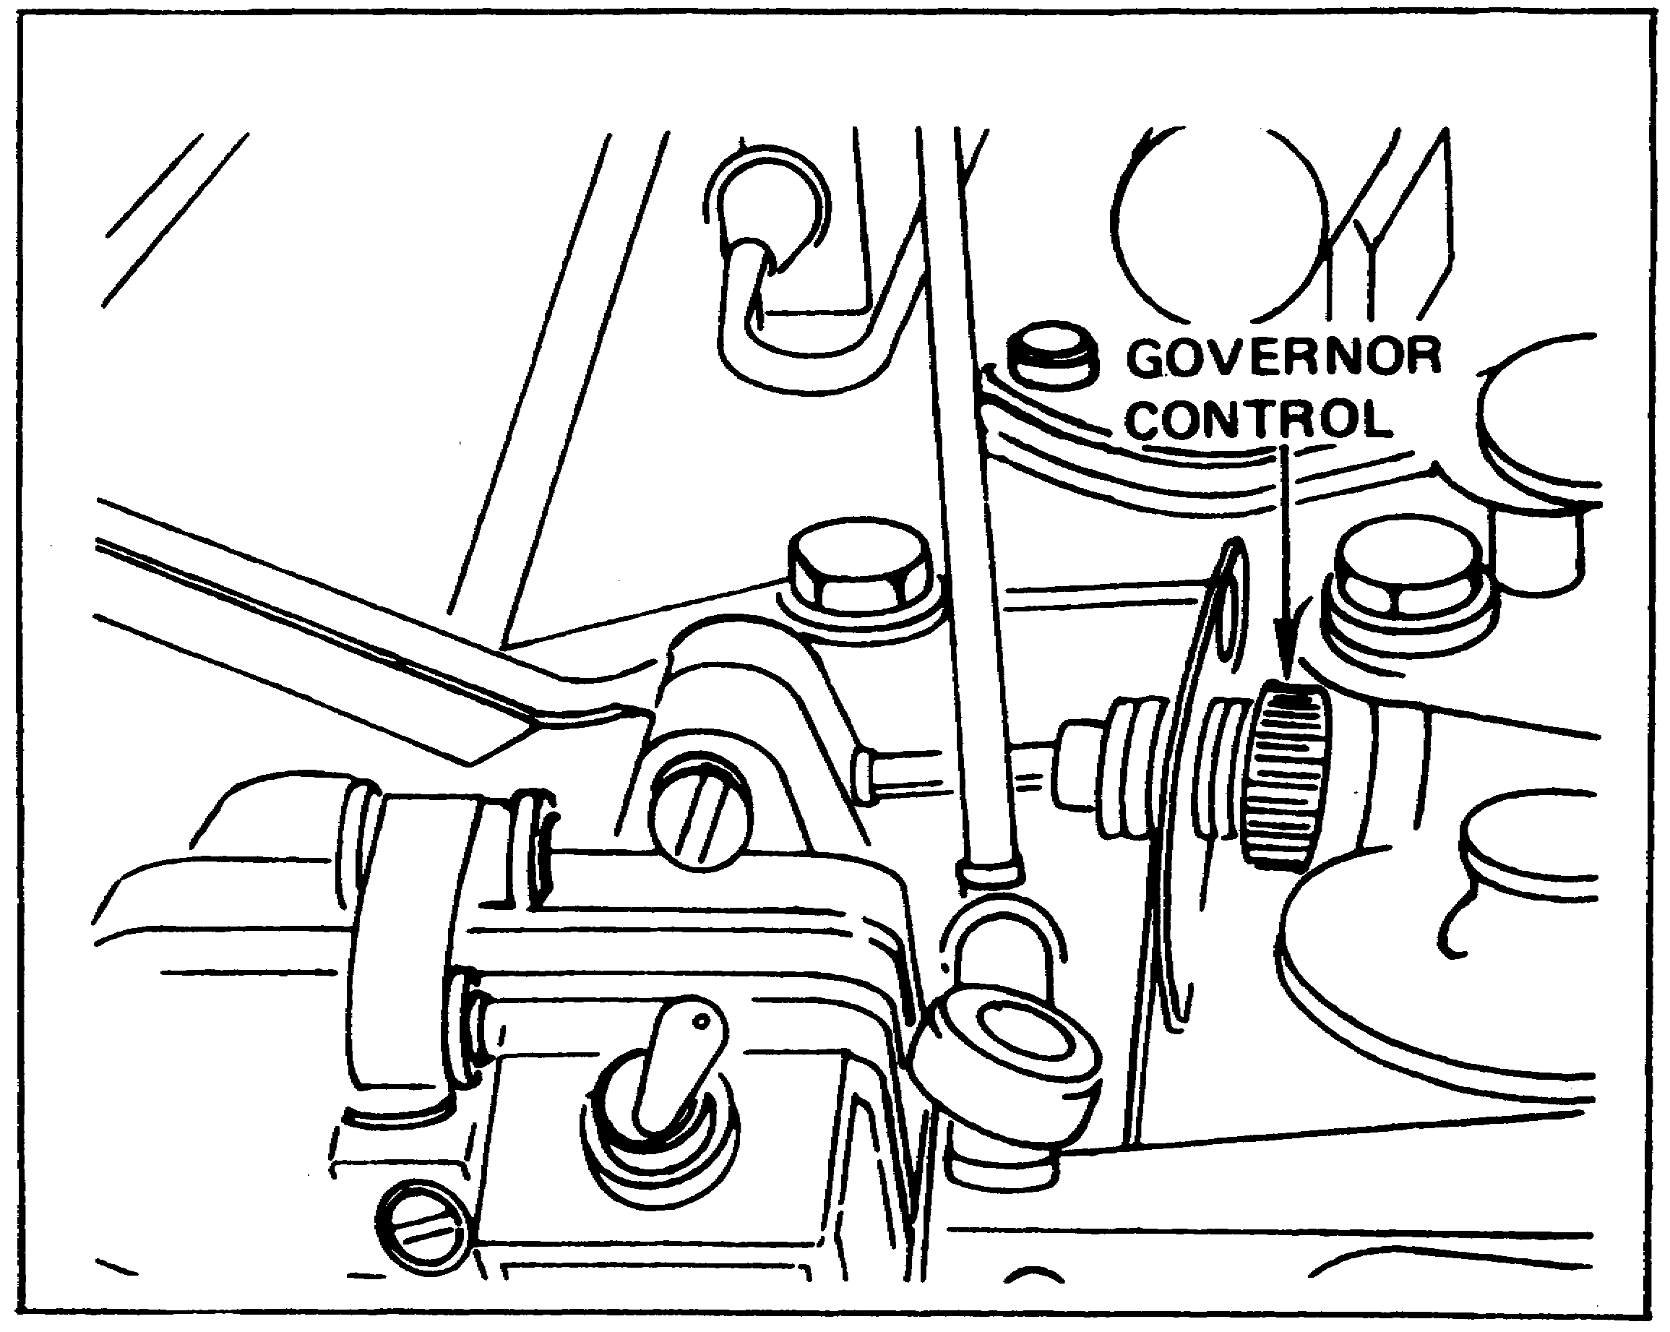

When the services of any one of the above generators are no longer required, or must be stopped for servicing, it should be stopped by following these procedures.

82

Lesson 4/Learning Event 1

FIGURE 31.
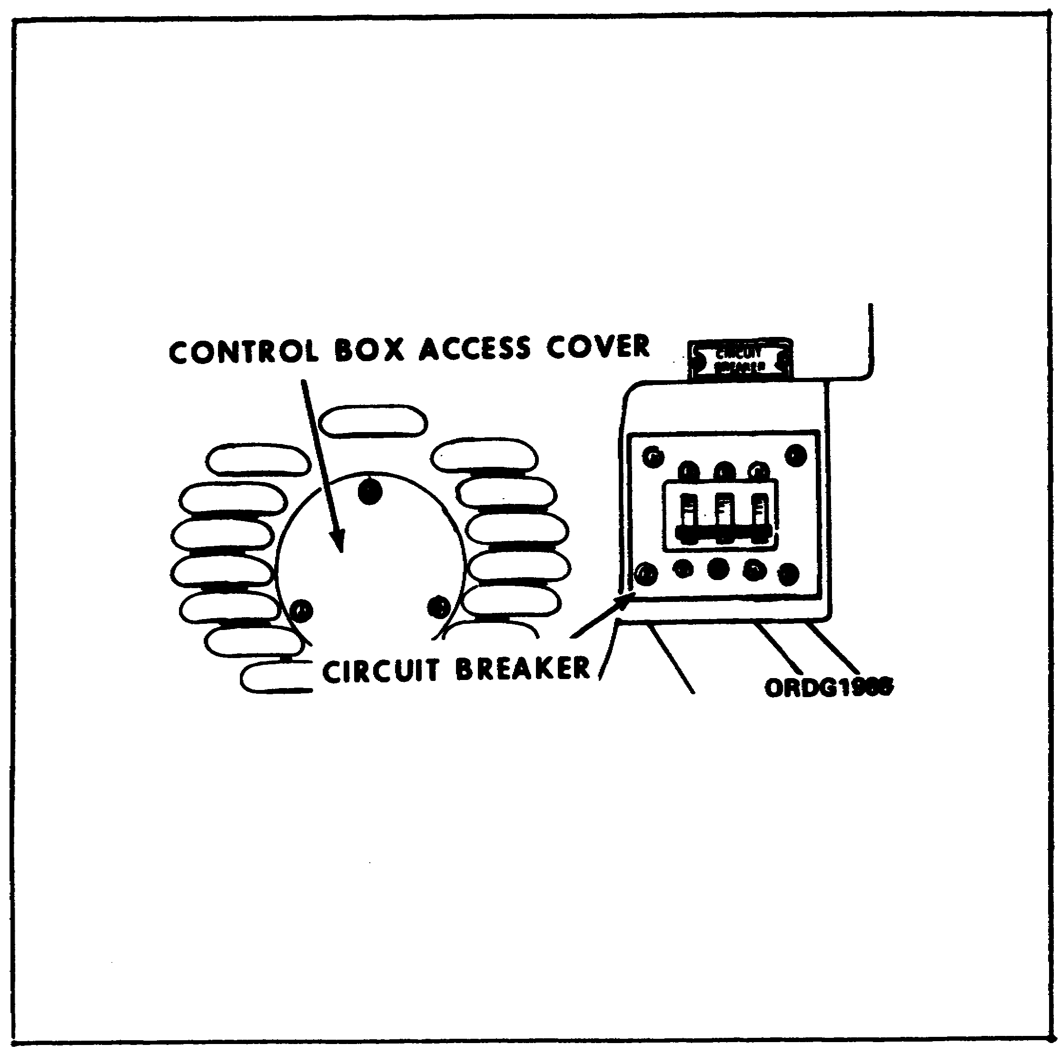

Place the circuit breaker in the OFF position and turn the variable resistor knob fully counterclockwise to remove the load from the generator.

83

Lesson 4/Learning Event 1

FIGURE 32.
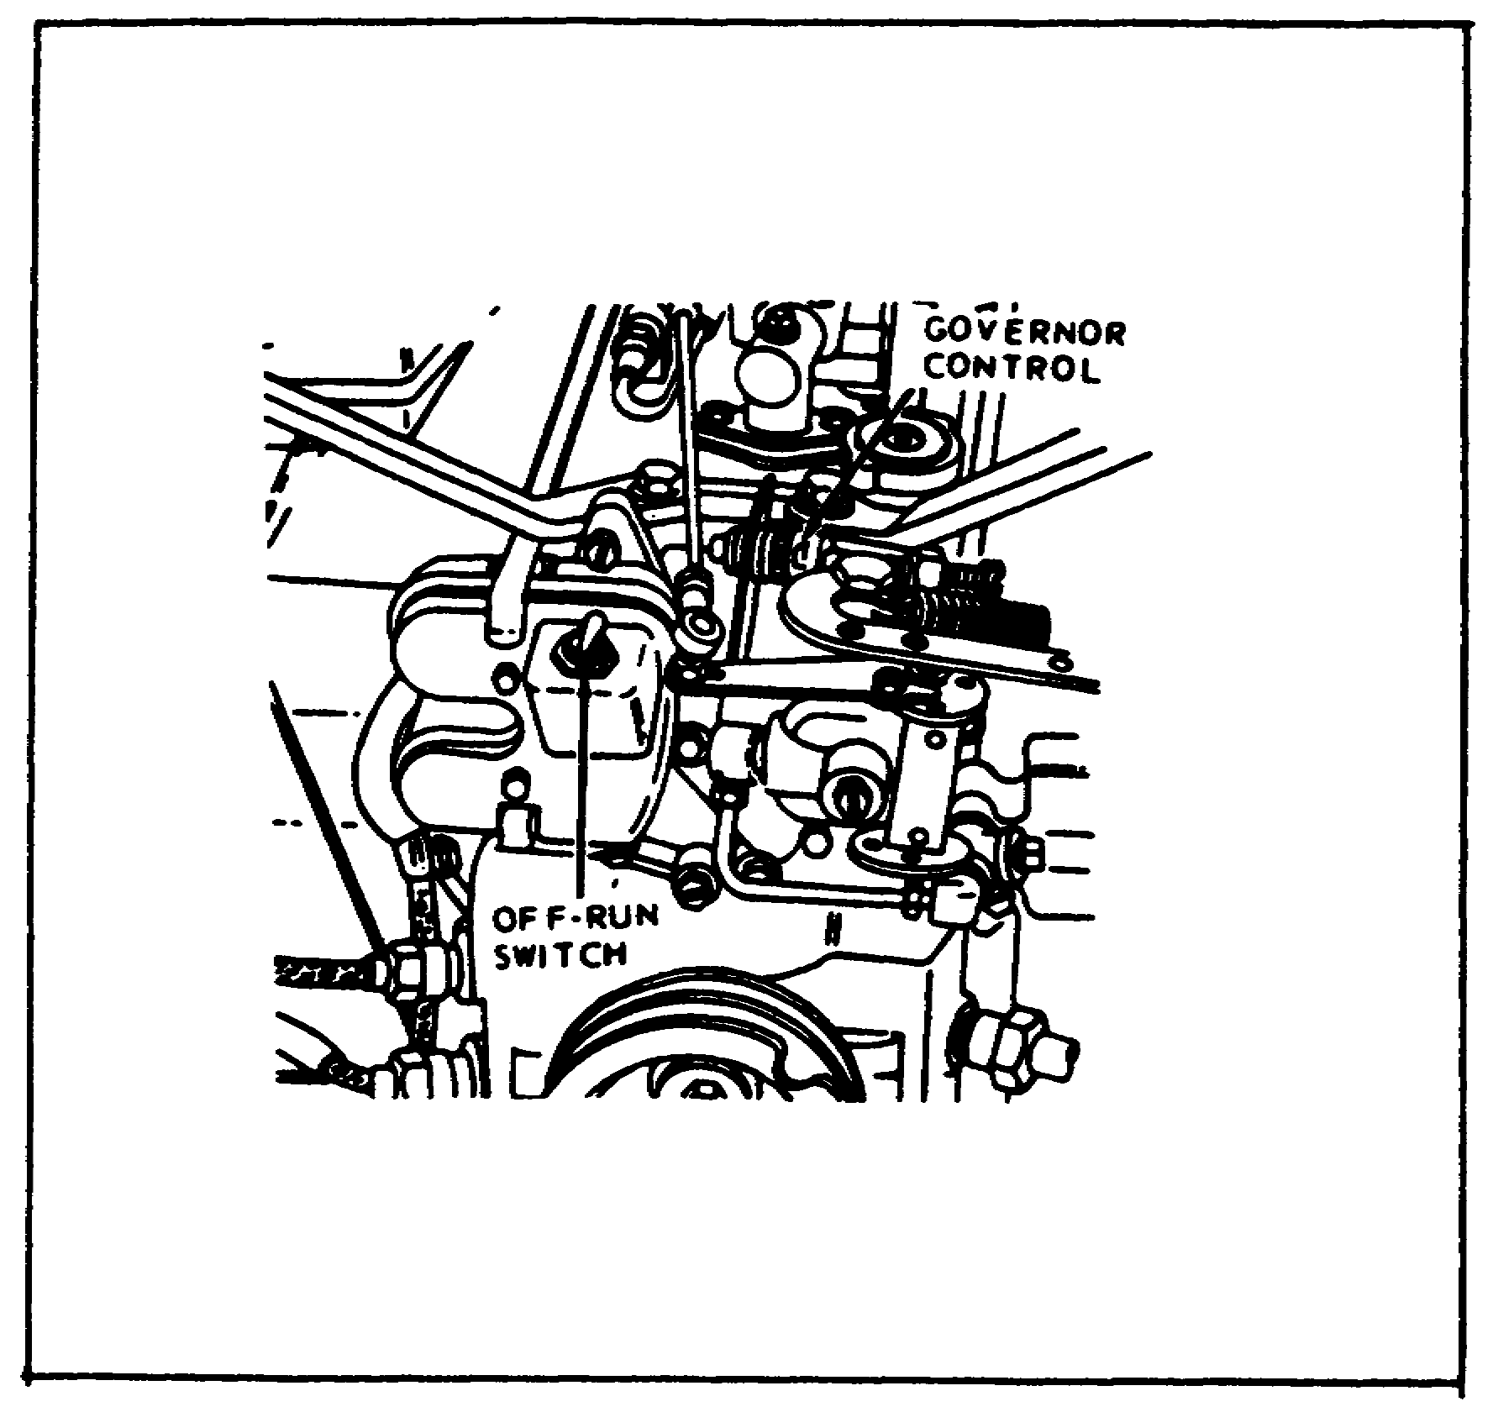

Place the governor control in the START AND IDLE position, and allow the engine to idle three to five minutes. Then place the OFF-RUN switch in the OFF position.

84

Lesson 4/Learning Event 1

FIGURE 33.
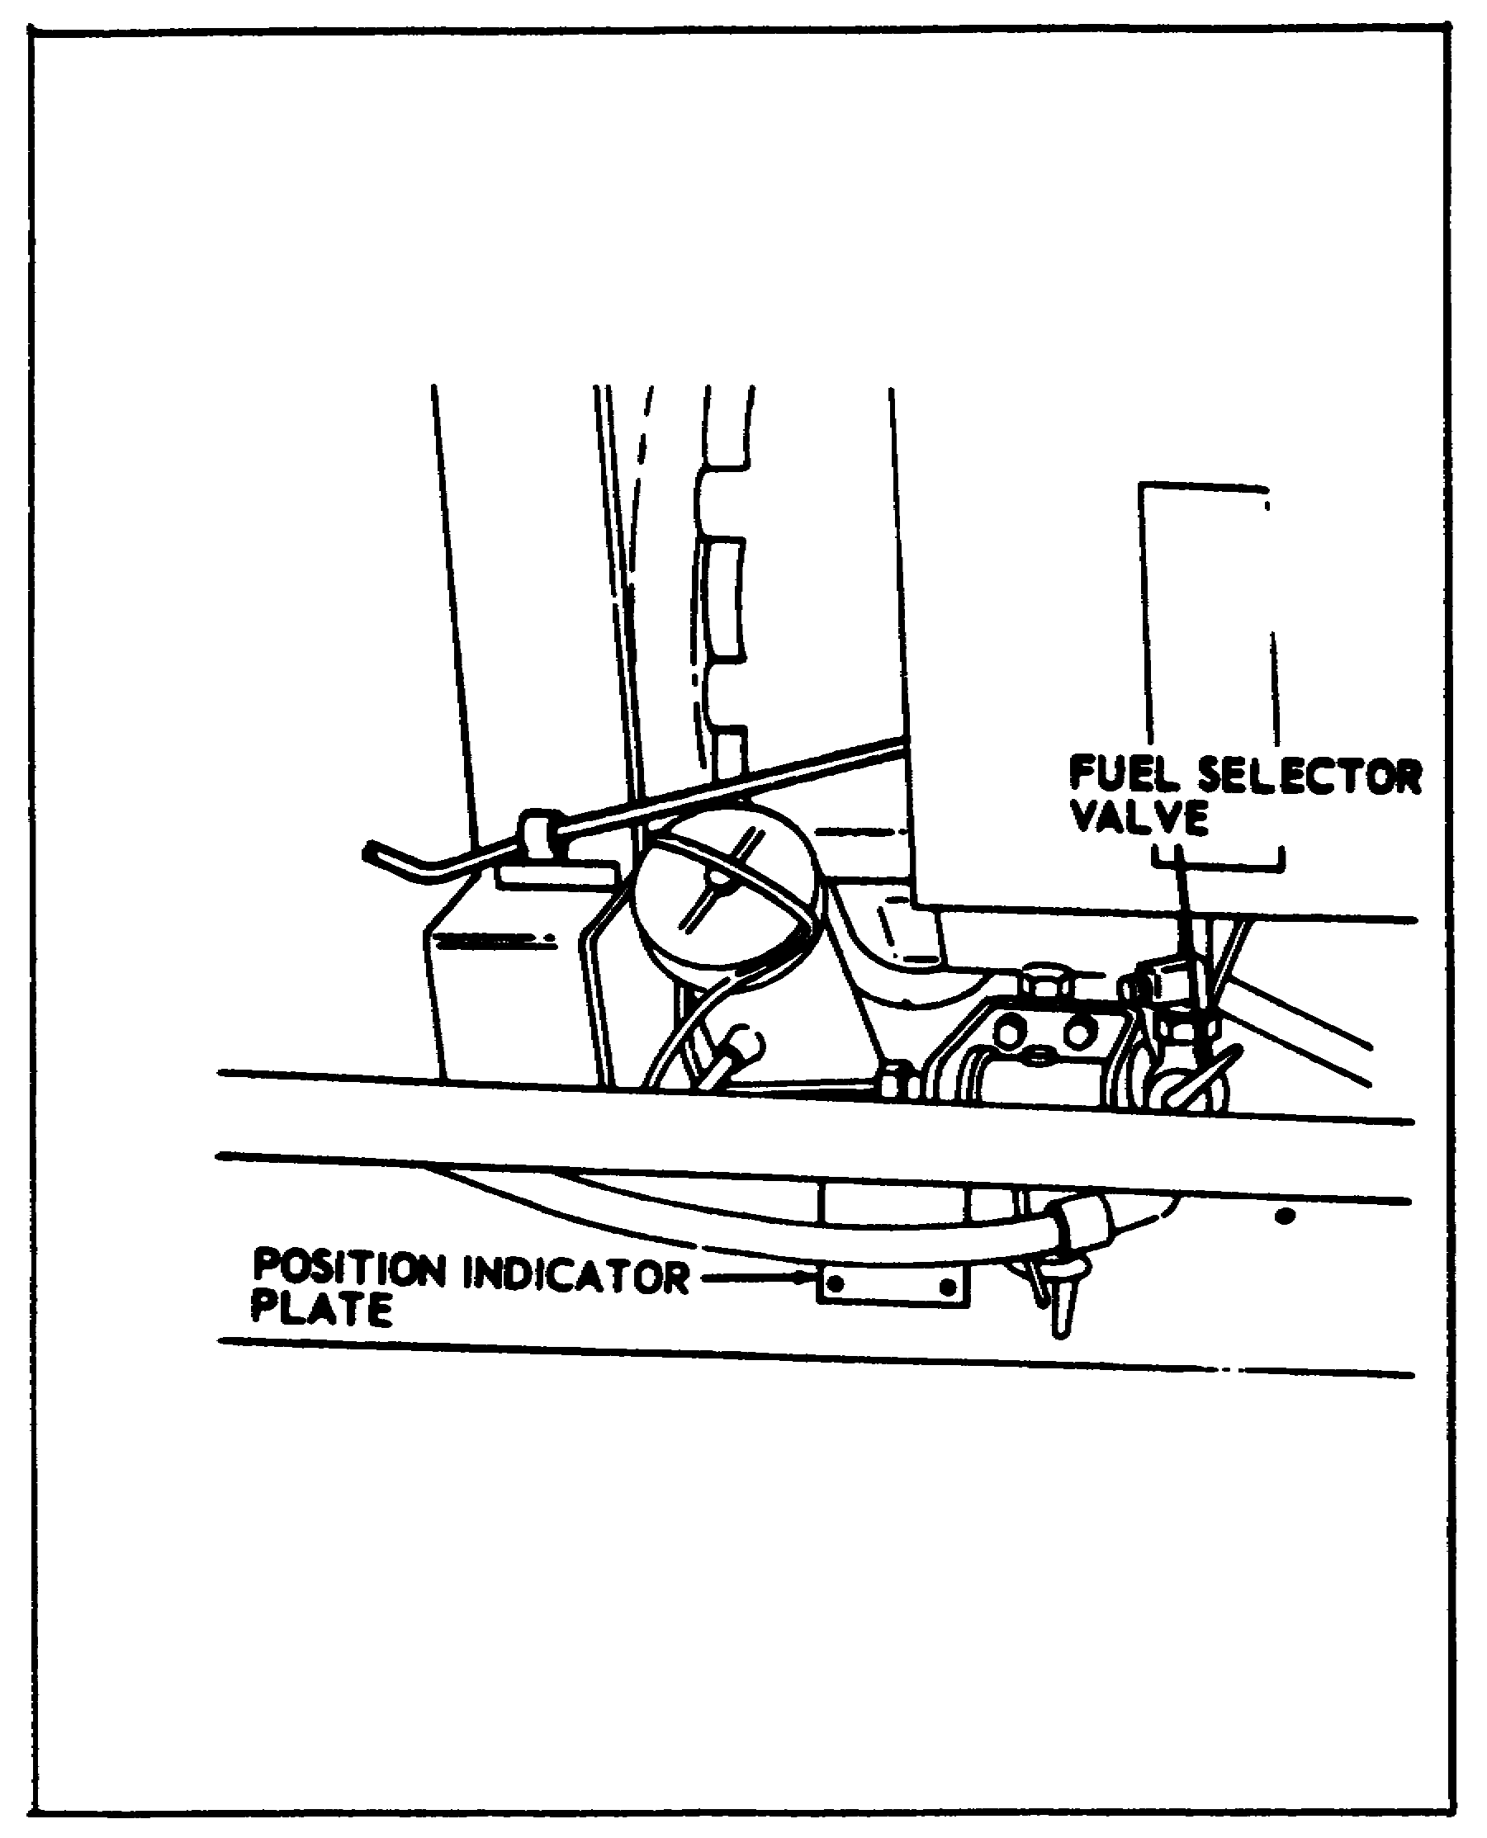

Place the fuel selector valve in the OFF position.

OPERATOR'S MAINTENANCE

Now, for the maintenance that you, as an operator, will be required to perform on the 3-kw generator sets. Except that there are more controls and instruments to check, this is not much different from daily maintenance on wheeled vehicles. Before servicing any part of the generator set, make certain the engine is stopped. Failure to observe this safety precaution may result in a severe electrical shock or death by electrocution.

85

Lesson 4/Learning Event 1

Daily maintenance services on the engine consist of the following:

- Inspect the fuel strainer, tighten the thumb nut if the gasket is leaking, and clean the filter weekly.

- Check the engine oil level and add oil as indicated by the level gage.

- Check the fuel tank for leaks.

- Add fuel as required.

Daily maintenance services on the generator are also performed by the operator-. Services consist of checking to see that the generator is properly grounded and checking the controls and instruments for damage or loose mounting; tighten if required.

TEST OPERATION

With the unit operating, check for proper operation. During the operation, check for any unusual noise or vibration. Normal operating readings for the instruments are as follows:

Model MEP-016A or model MEP-021A

- Voltage, one-phase operation - 120 or 240 volts.

- Voltage, three-phase operation - 120 or 208 volts.

- Load, one- or three-phase operation - 100-percent maximum.

- Frequency, model MEP-021A - 400 Hz.

- Frequency, model MEP-016A - 60 Hz.

Model MEP-026A

- Voltage - 28 volts maximum.

- Load - 100-percent maximum.

- RPM - 3,600 maximum.

86

Lesson 4/Learning Event 2

Learning Event 2:
DESCRIBE THE 5-KW GENERATOR SETS

GENERAL

FIGURE 34. MODEL SF-5-MD GENERATOR.
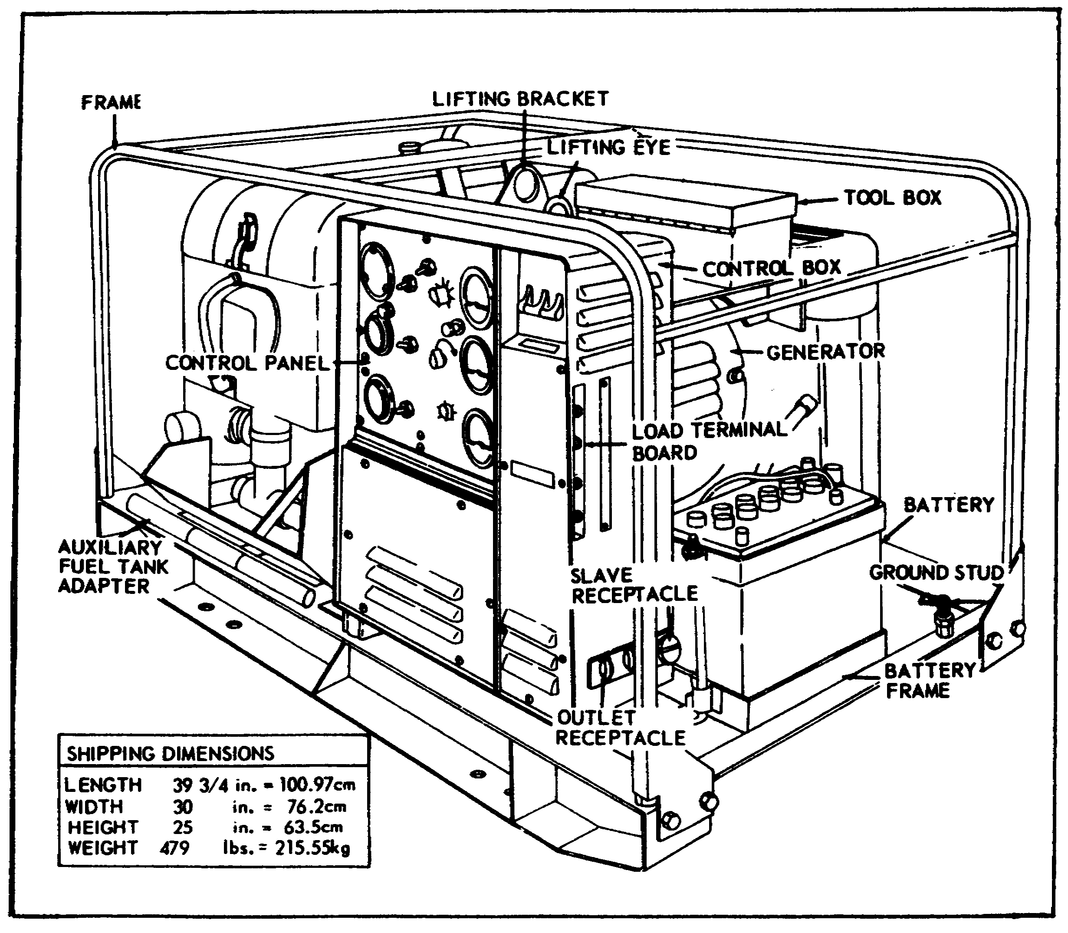

The 5-kw generator sets are larger than the 3-kw generators we have just discussed. They are designed to serve the same purpose as the 3-kw sets, but will produce more current to supply a larger load. The 5-kw generator sets, model SF-5-MD, provide 60 Hz current while model HF-5.0-MD provides 400 Hz current. Model SF-5-MD is shown in the illustration. Except for the output frequency, both models are about the same. Each generator set is powered by a two-cylinder, air-cooled, military standard engine coupled directly to the generator. The control panel contains instruments and controls for the engine as well as the generator.

87

Lesson 4/Learning Event 2

FIGURE 35.
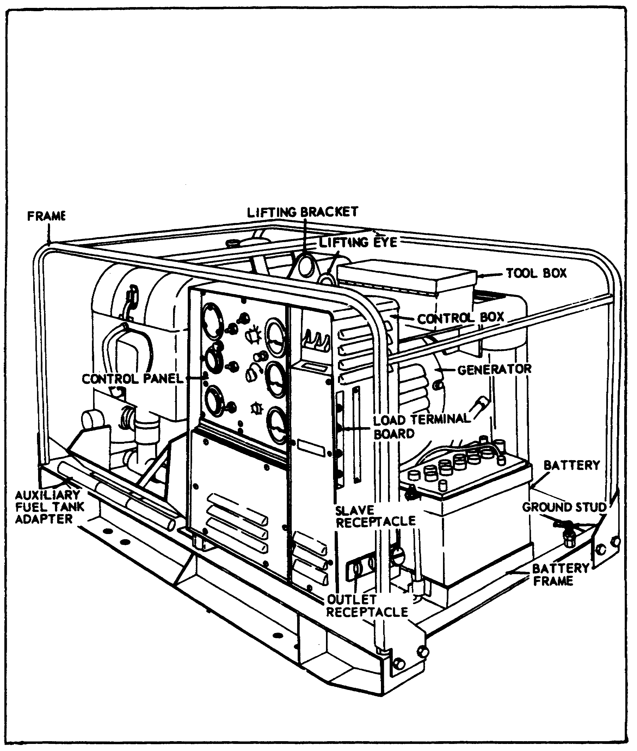

The 5-kw generator sets do not require an external power source for electric starting. Each set is equipped with its own 24-volt battery and a 24-volt charging system. The engine can also be started manually with a starter rope.

88

Lesson 4/Learning Event 2

FIGURE 36.
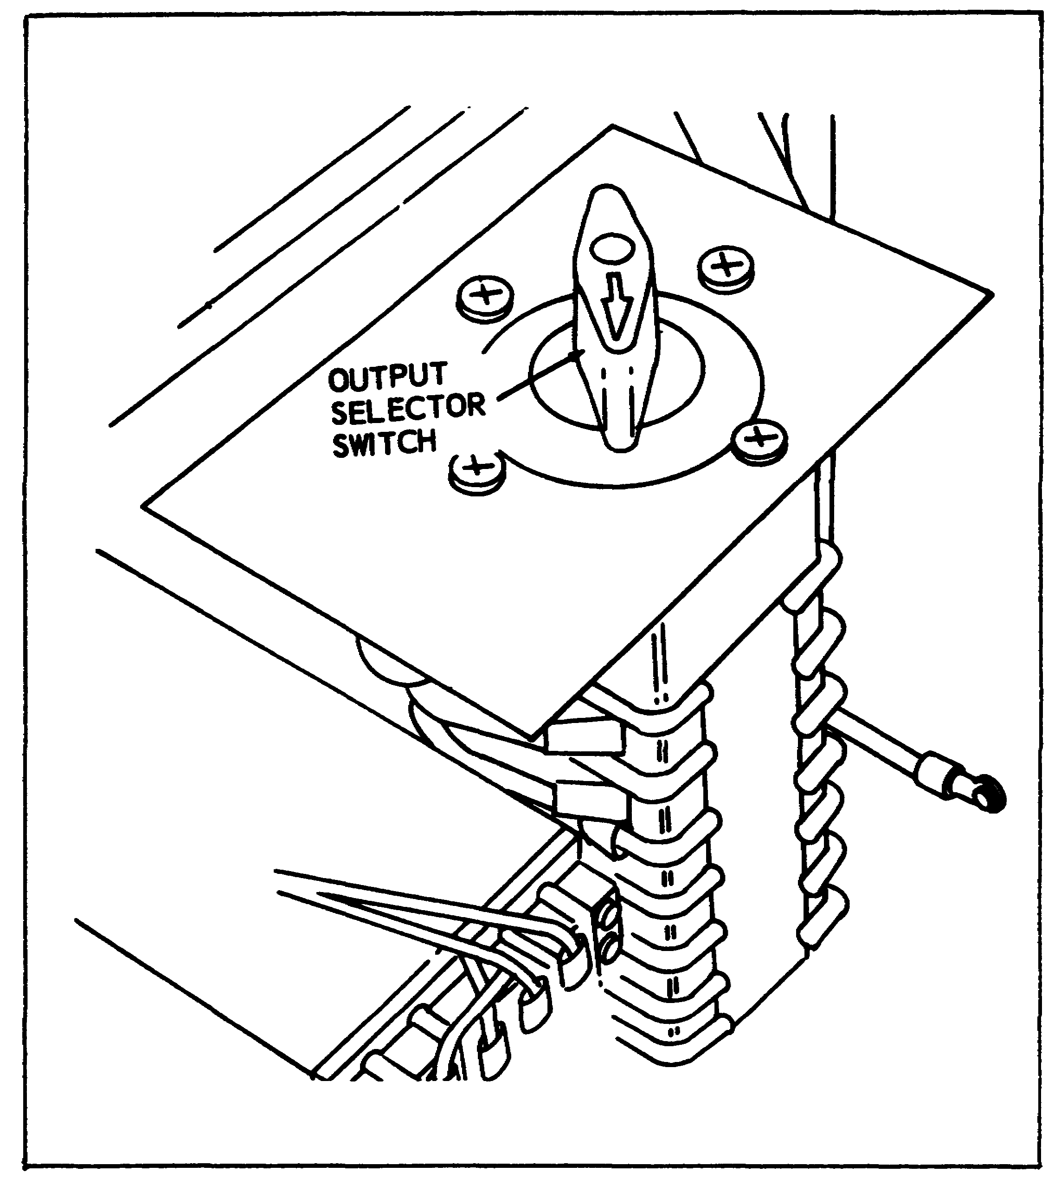

By means of an output selector switch, the operator can select the following generator outputs: 240 volts, one-phase (two-wire); 120 volts, one-phase (two-wire); 120 volts, three-phase (three-wire); or 120/208 volts, three-phase (four-wire). The set has four load terminals, located to the right of the control panel, identified by the labels LO, L1, L2, and L3. Altitude must be considered when estimating the amount of load that can be provided by the generator set. The output of a 5-kw generator set is rated 5 kw from sea level to 5,000 feet. The output drops at higher altitudes. At 8,000 feet, it is only rated at 4 kw.

89

Lesson 4/Learning Event 2

GENERATOR INSTALLATION

Setting up the 5-kw generator for operation is about the same as setting up the 3-kw generator. One difference is the use of an auxiliary fuel system.

This 5-kw generator set uses a 5-gallon fuel can as its fuel tank. If you are going to use an auxiliary fuel supply, remove the fuel can adapter from the fuel can and install the fuel can cap on the fuel can.

Remove the auxiliary fuel drum adapter from its stored position on the mounting frame of the generator set. Install the auxiliary fuel drum adapter to the fuel can adapter, and install the adapter assembly in the fuel drum to be used. Refer to Figure 38 for location of the adapter.

Remove the dust cap from the fitting on the fuel selector valve. Then install one end of the auxiliary fuel hose to the fitting on the adapter and the other end of the fitting on the fuel selector valve.

VOLTAGE SELECTION AND LOAD ODNNECTIONS

The output of the generator is controlled by the position output selector switch and the proper installation of the load cables on the load terminals. You should select the desired voltage and phase before starting the engine. To do this, push down on the knob of the output selector switch and turn it to the desired position. The voltages, phases, knob positions, and cable connections are as follows:

 |  | Connect Load Cables
Knob Position | Output | to Load Terminals
1 | 240-V, 1-phase, 2-wire | L1 and L2
2 | 120-V, 1-phase, 2-wire | L1 and L2
3 | 120-V, 3-phase, 3-wire | L1, L2, and L3
4 | 120/208-V, 3-phase, 4 wire | L0, L1, L2 and L3

90

Lesson 4/Learning Event 2

STARTING THE ENGINE

FIGURE 37. CONTROL PANEL.
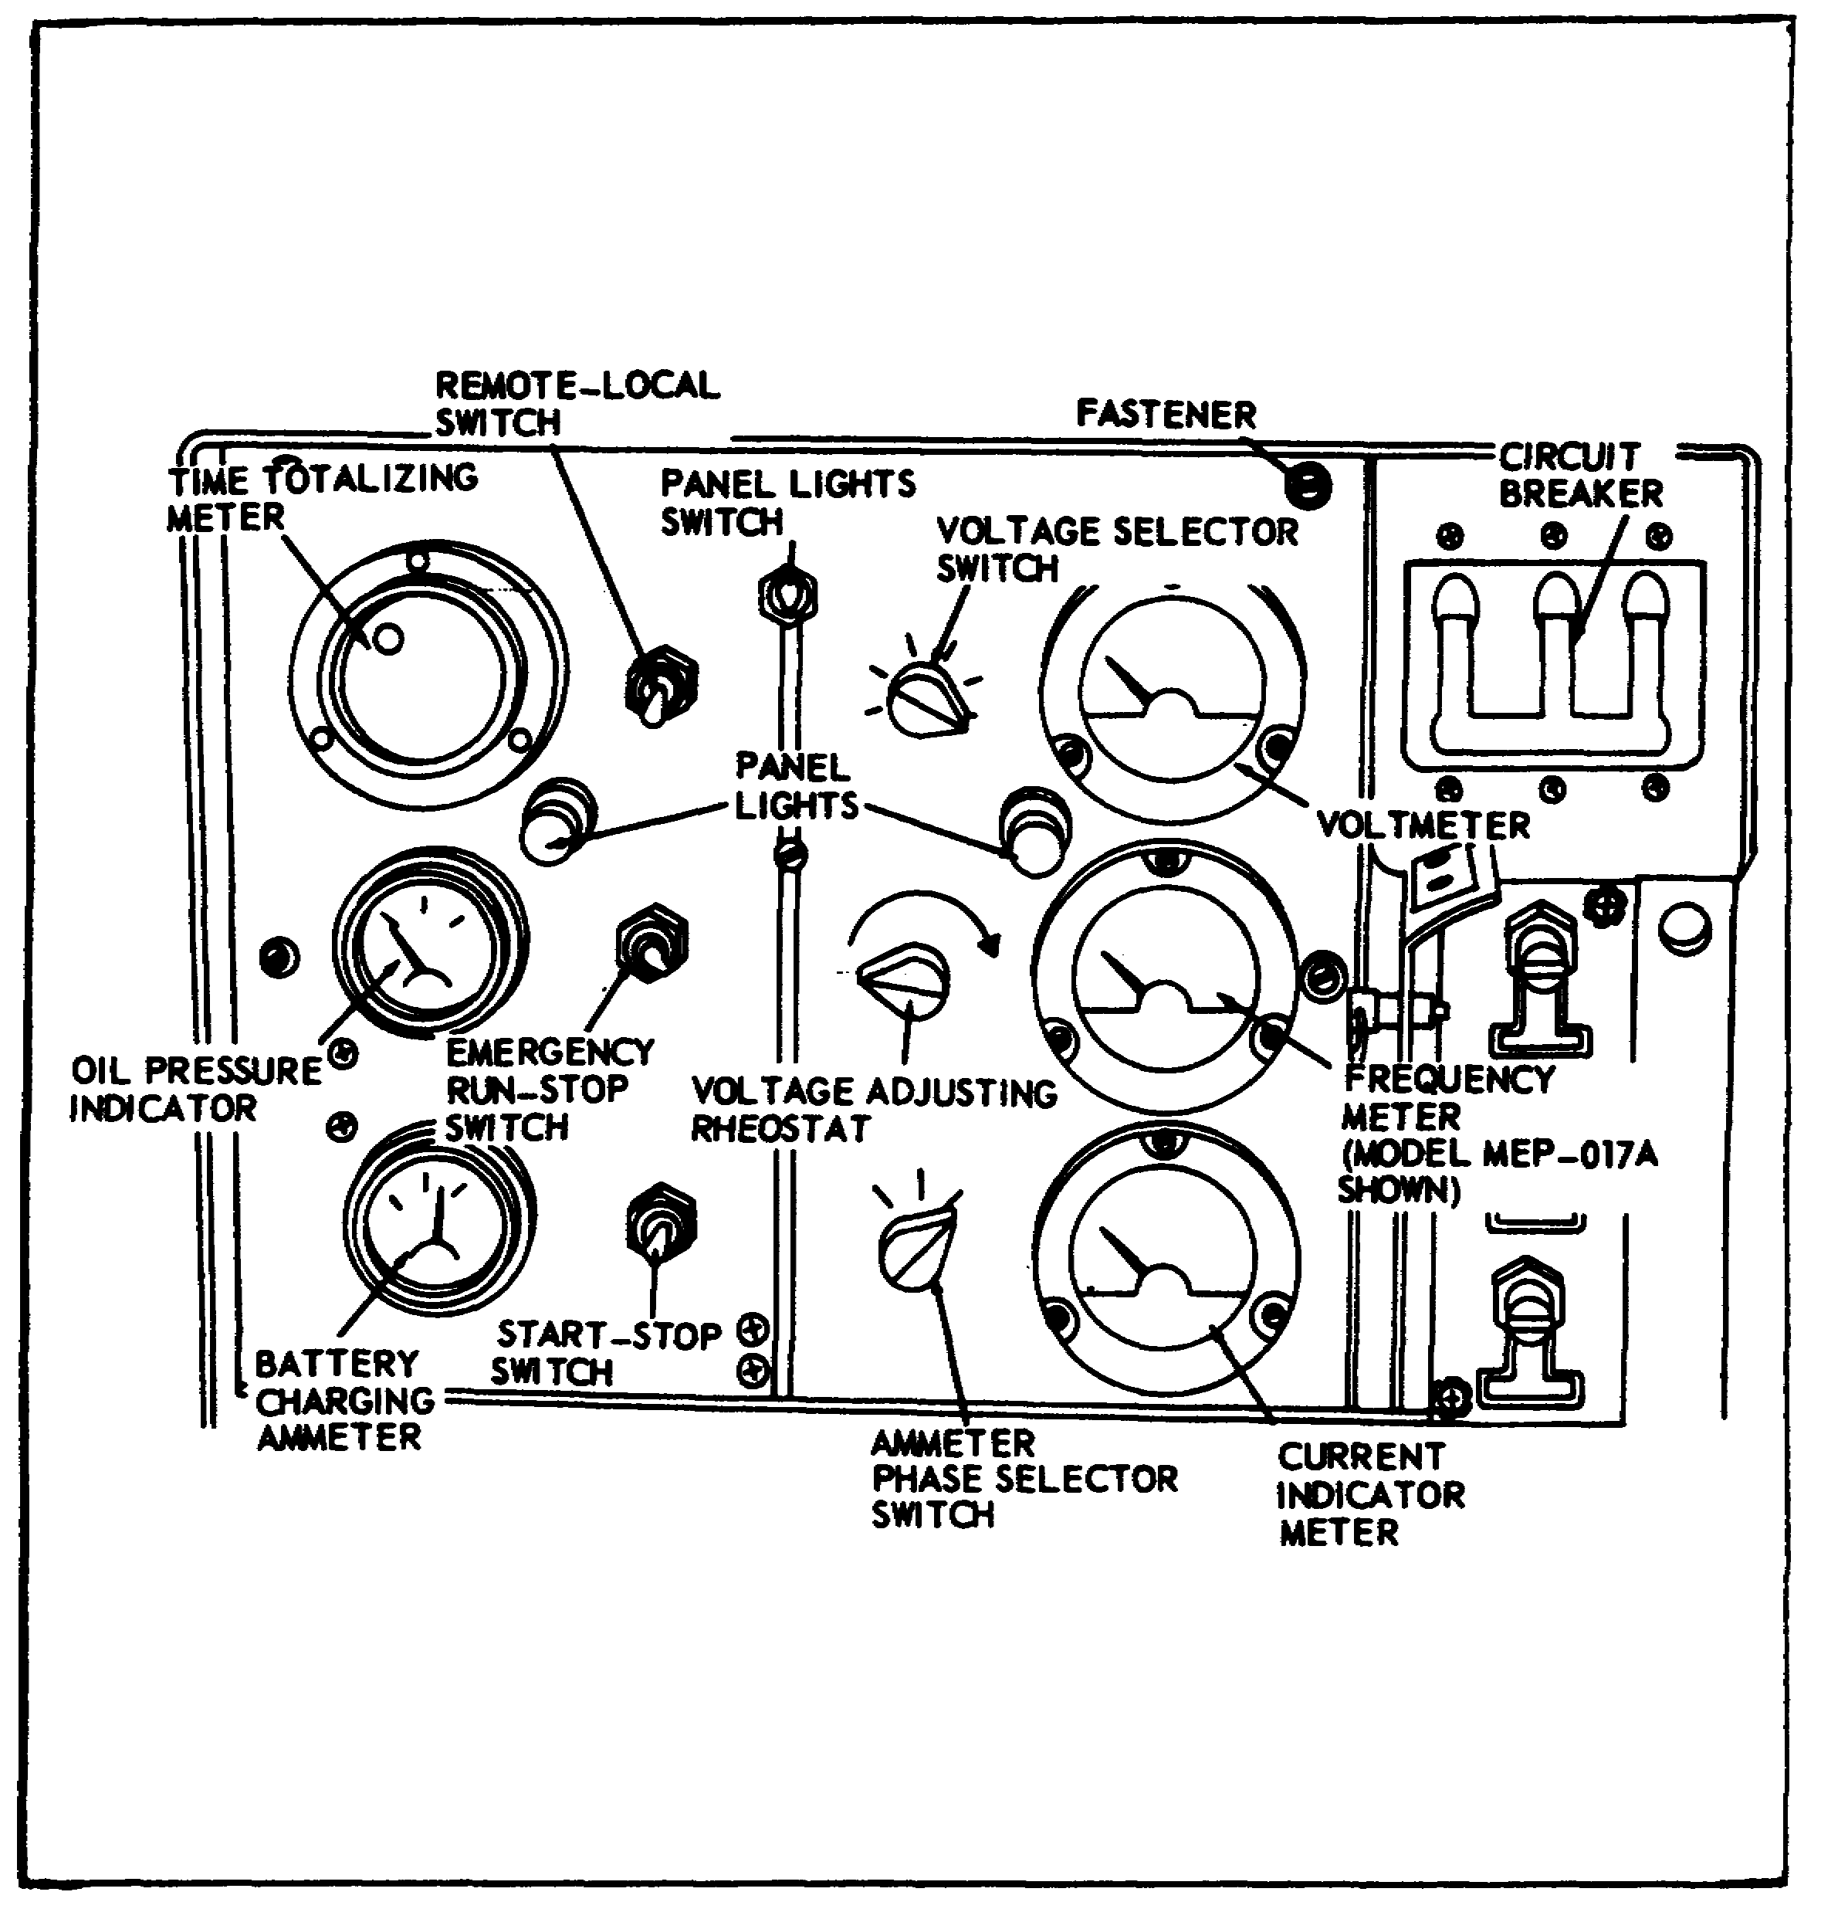

After the generator has been set up and serviced, the load connected correctly to the load terminals, and the output selector switch set in the proper position, you are ready to start the engine. Before you proceed, however, study the accompanying figure illustrating the location and purpose and normal readings of the instruments on the control panel.

For electrical starting of the engine, ensure that the circuit breaker is off and the voltage adjusting rheostat is turned fully counterclockwise; then proceed as follows:

91

Lesson 4/Learning Event 2

FIGURE 38.
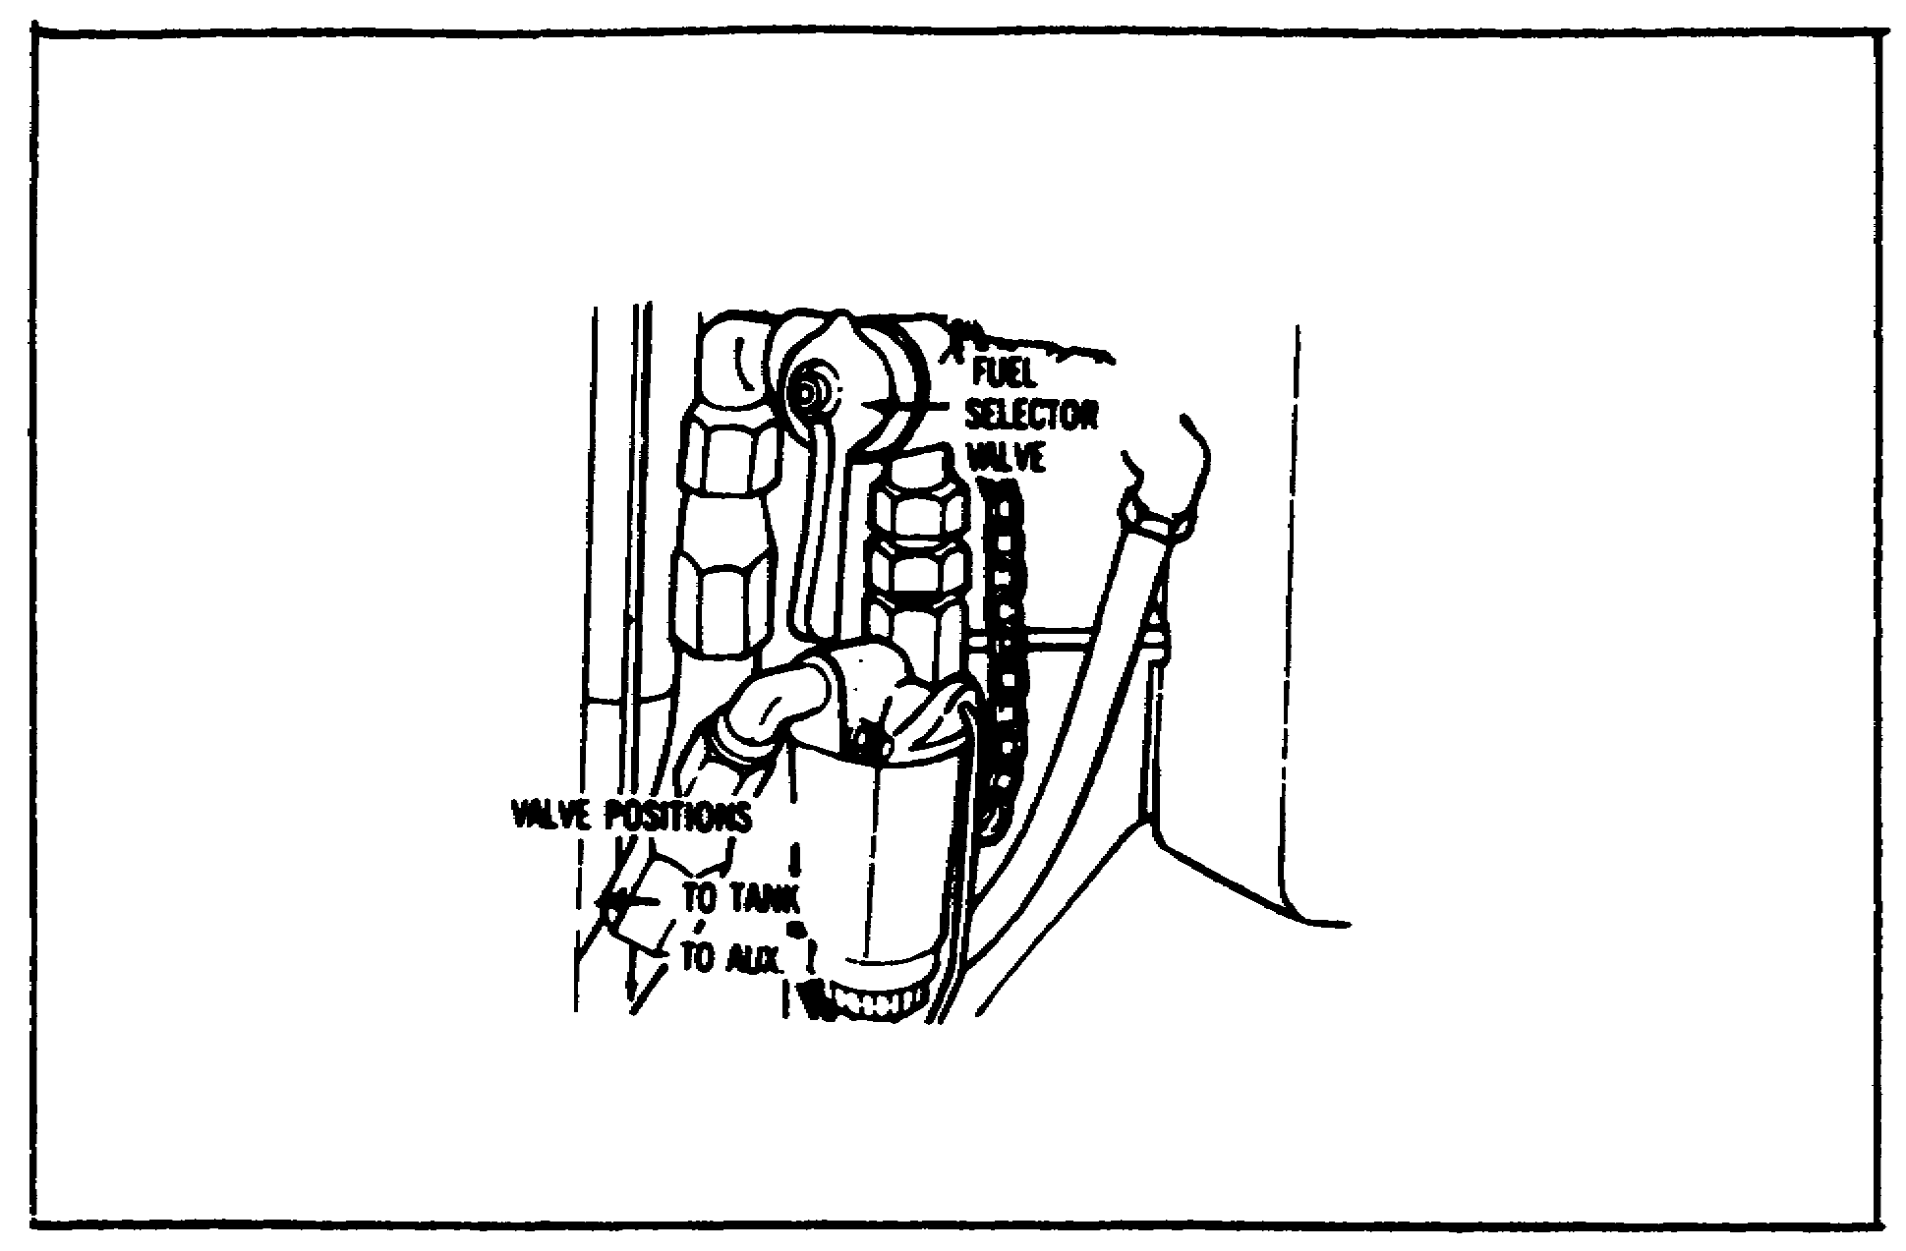

Place the fuel selector valve in the TO TANK or the TO AUX position, depending on the source of fuel supply.

FIGURE 39.
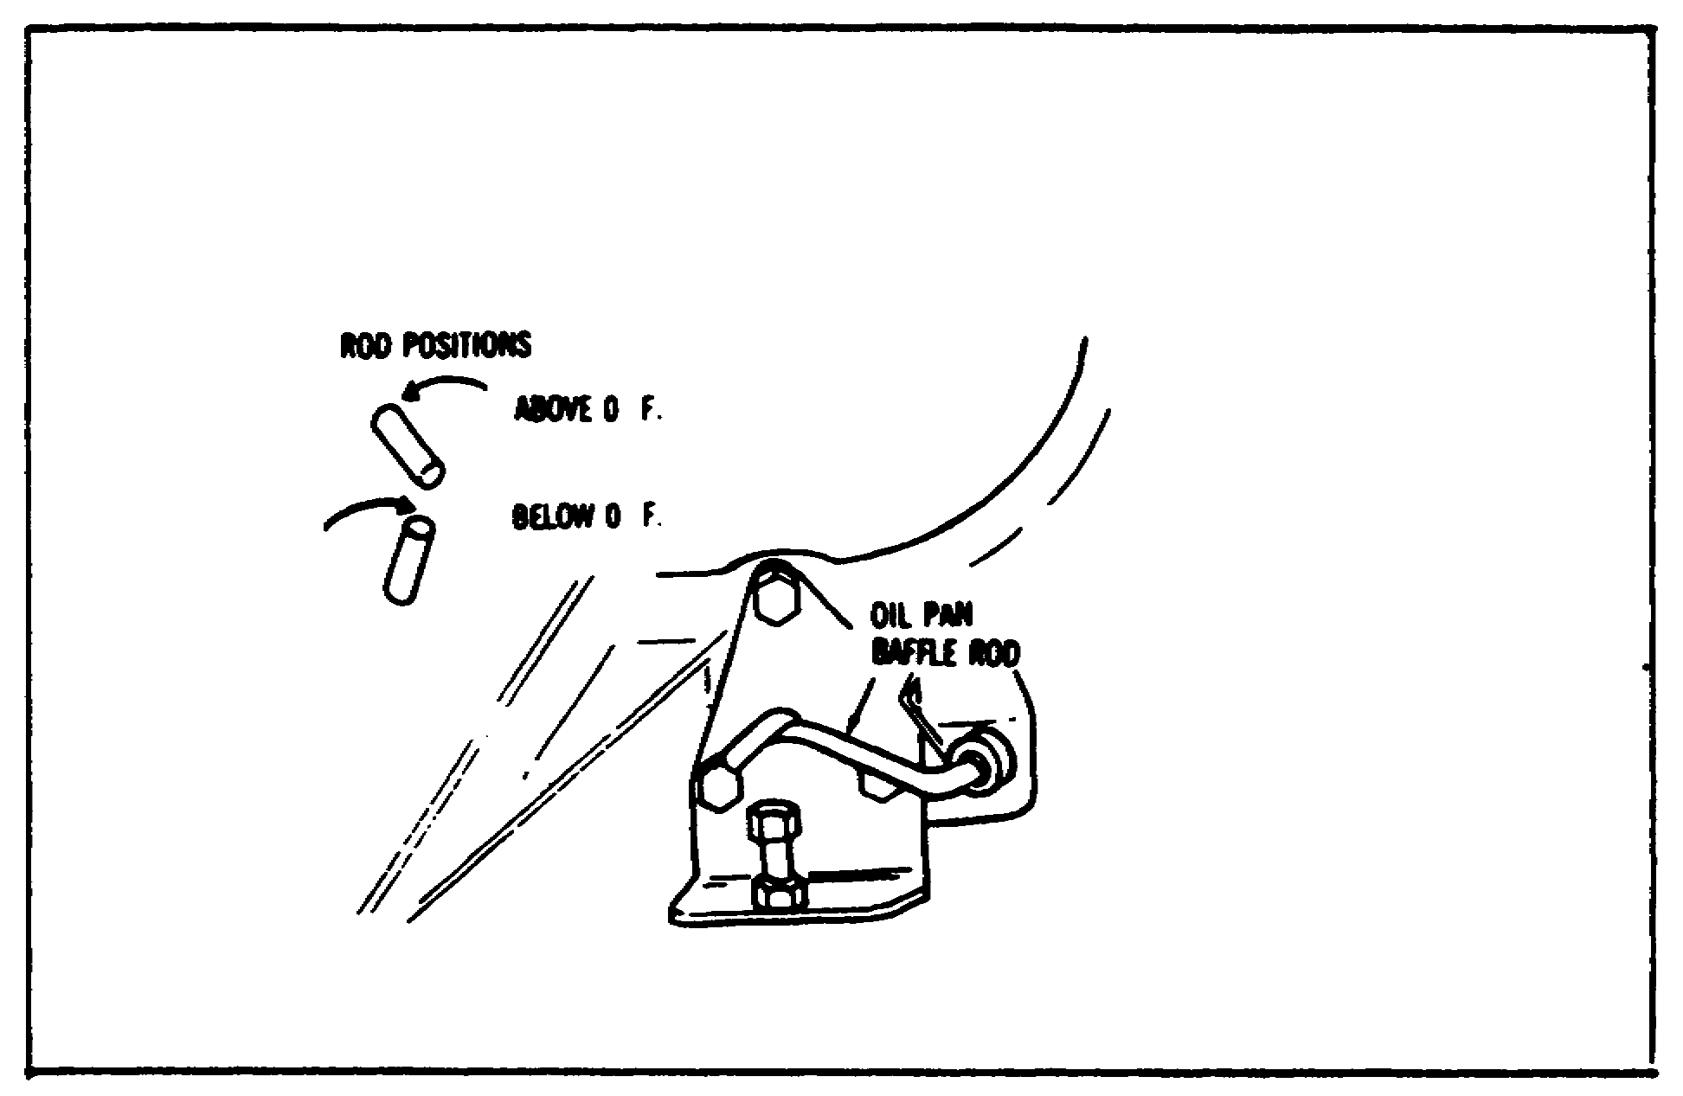

Place the oil pan baffle rod in the proper position to correspond with the temperature. This controls the flow of cooling air to the engine oil pan.

92

Lesson 4/Learning Event 2

FIGURE 40.
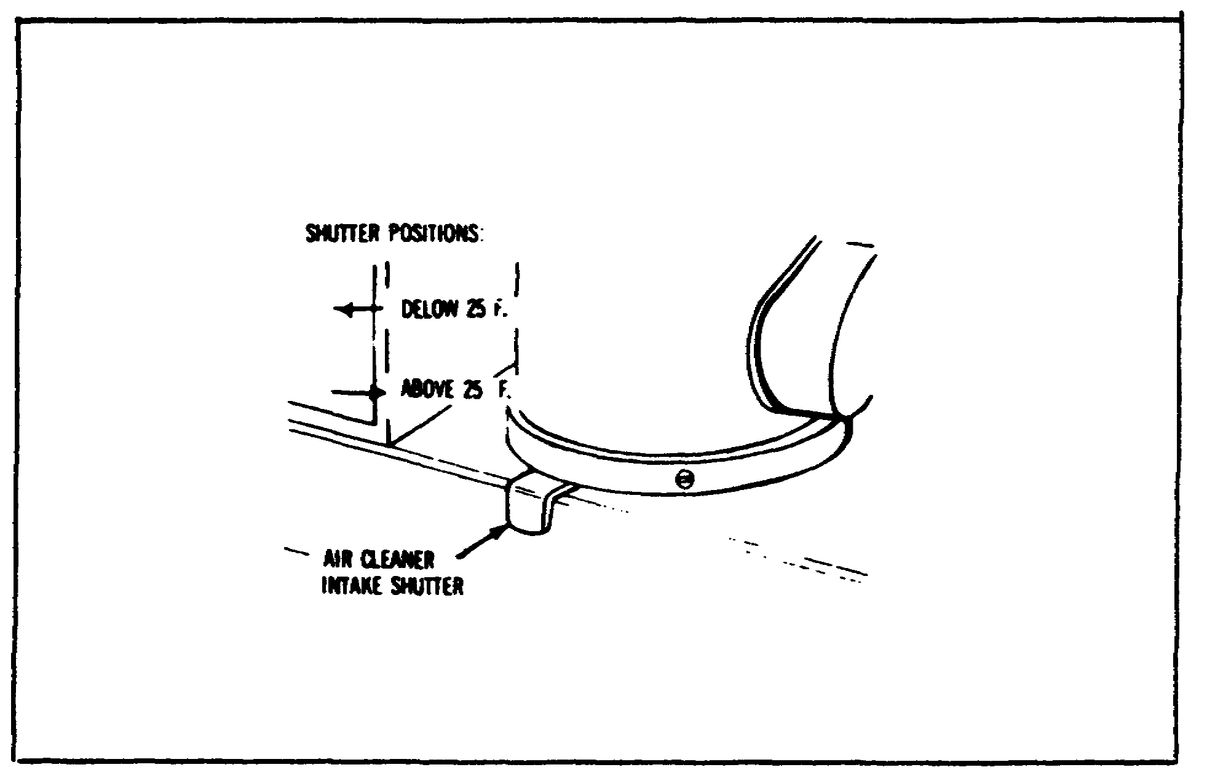

Place the air cleaner intake shutter in the proper position for the climate condition. When the shutter is positioned for cold weather operation, intake air is preheated by the exhaust system before going to the carburetor.

FIGURE 41.
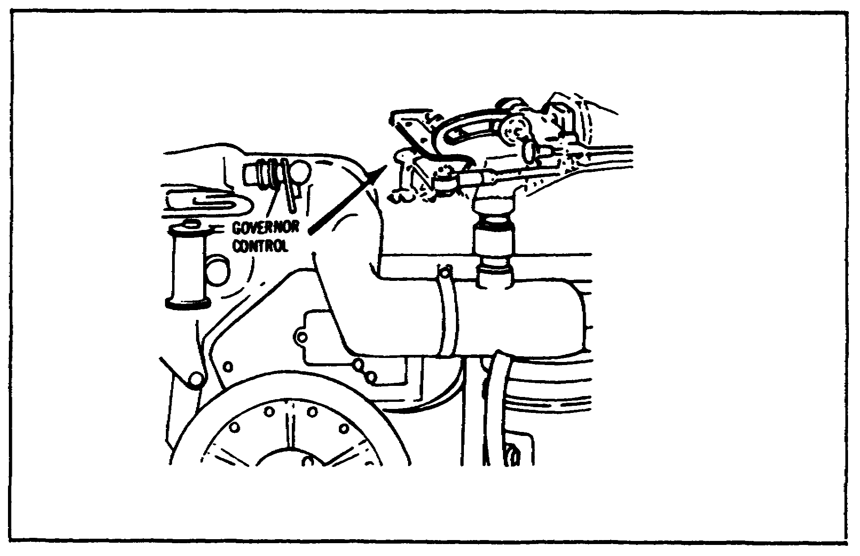

Place the governor control in the START AND IDLE position.

93

Lesson 4/Learning Event 2

FIGURE 42.
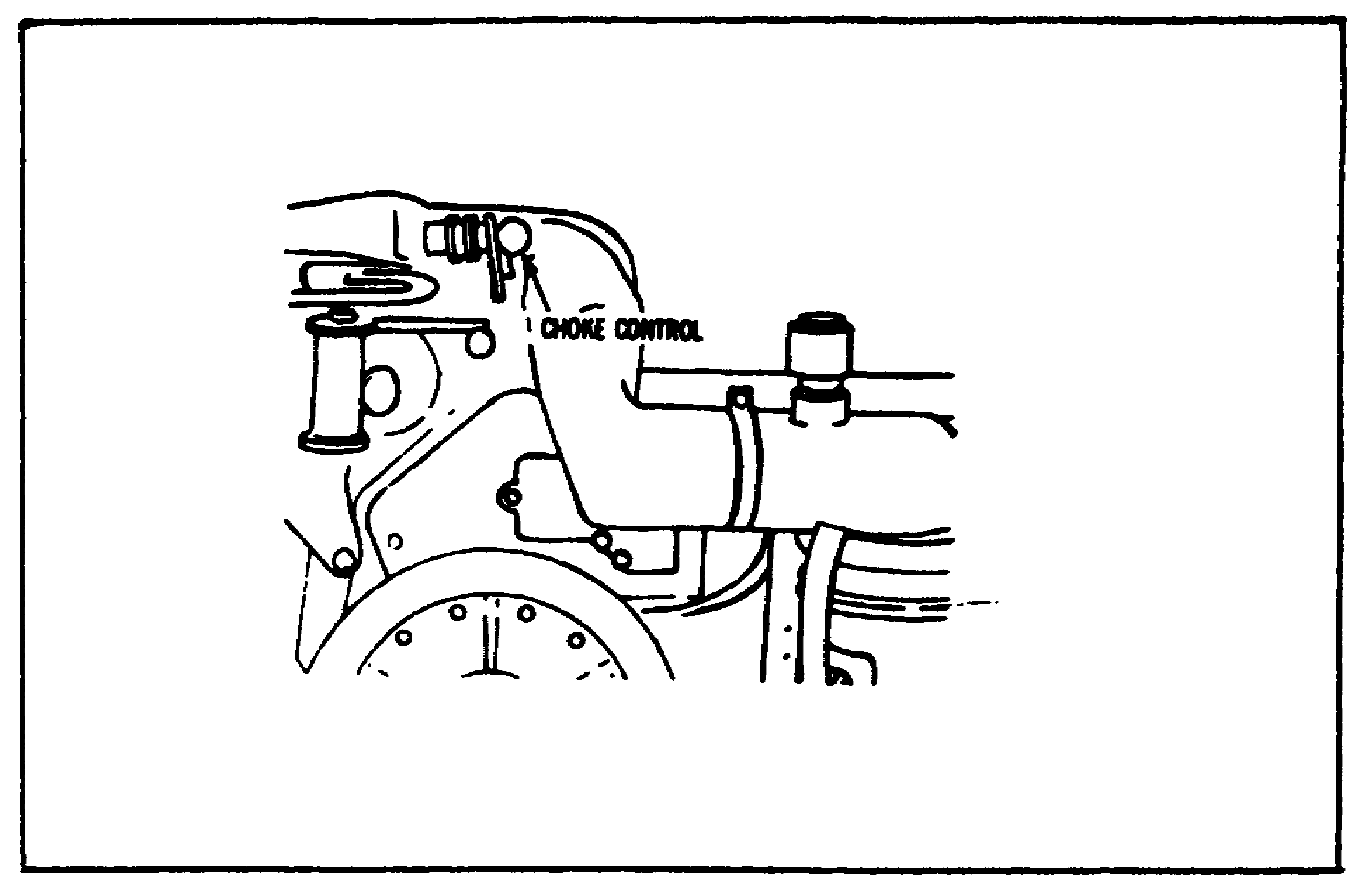

Pull the choke control out to choke the engine if the engine is cold.

FIGURE 43.
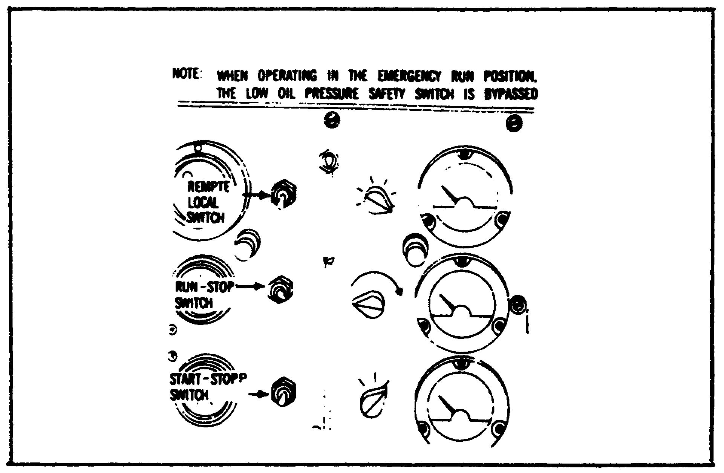

Place the REMOTE-LOCAL switch in the LOCAL position.

Place the EMERGENCY RUN-S'OP switch in the NORMAL position.

94

Lesson 4/Learning Event 2

Hold the START-STOP switch in the START position to crank and start the engine. If the engine does not start in 15 seconds, release the switch and allow a cooling off period of one minute before attempting to restart.

Once the engine starts, adjust the choke control as necessary as the engine warms up.

If the 24-volt battery is discharged, start the engine manually in the following manner:

The fuel selector valve, oil pan baffle rod, air cleaner intake shutter, governor control, and choke control are positioned the same as for electric starting.

FIGURE 44.
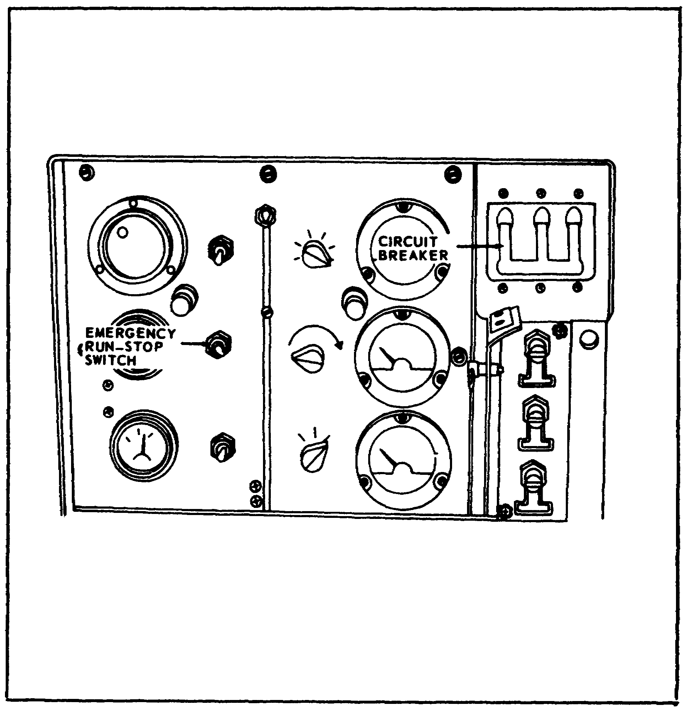

Place the EMERGENCY RUN-STOP switch in the EMERGENCY RUN position.

95

Lesson 4/Learning Event 2

FIGURE 45.
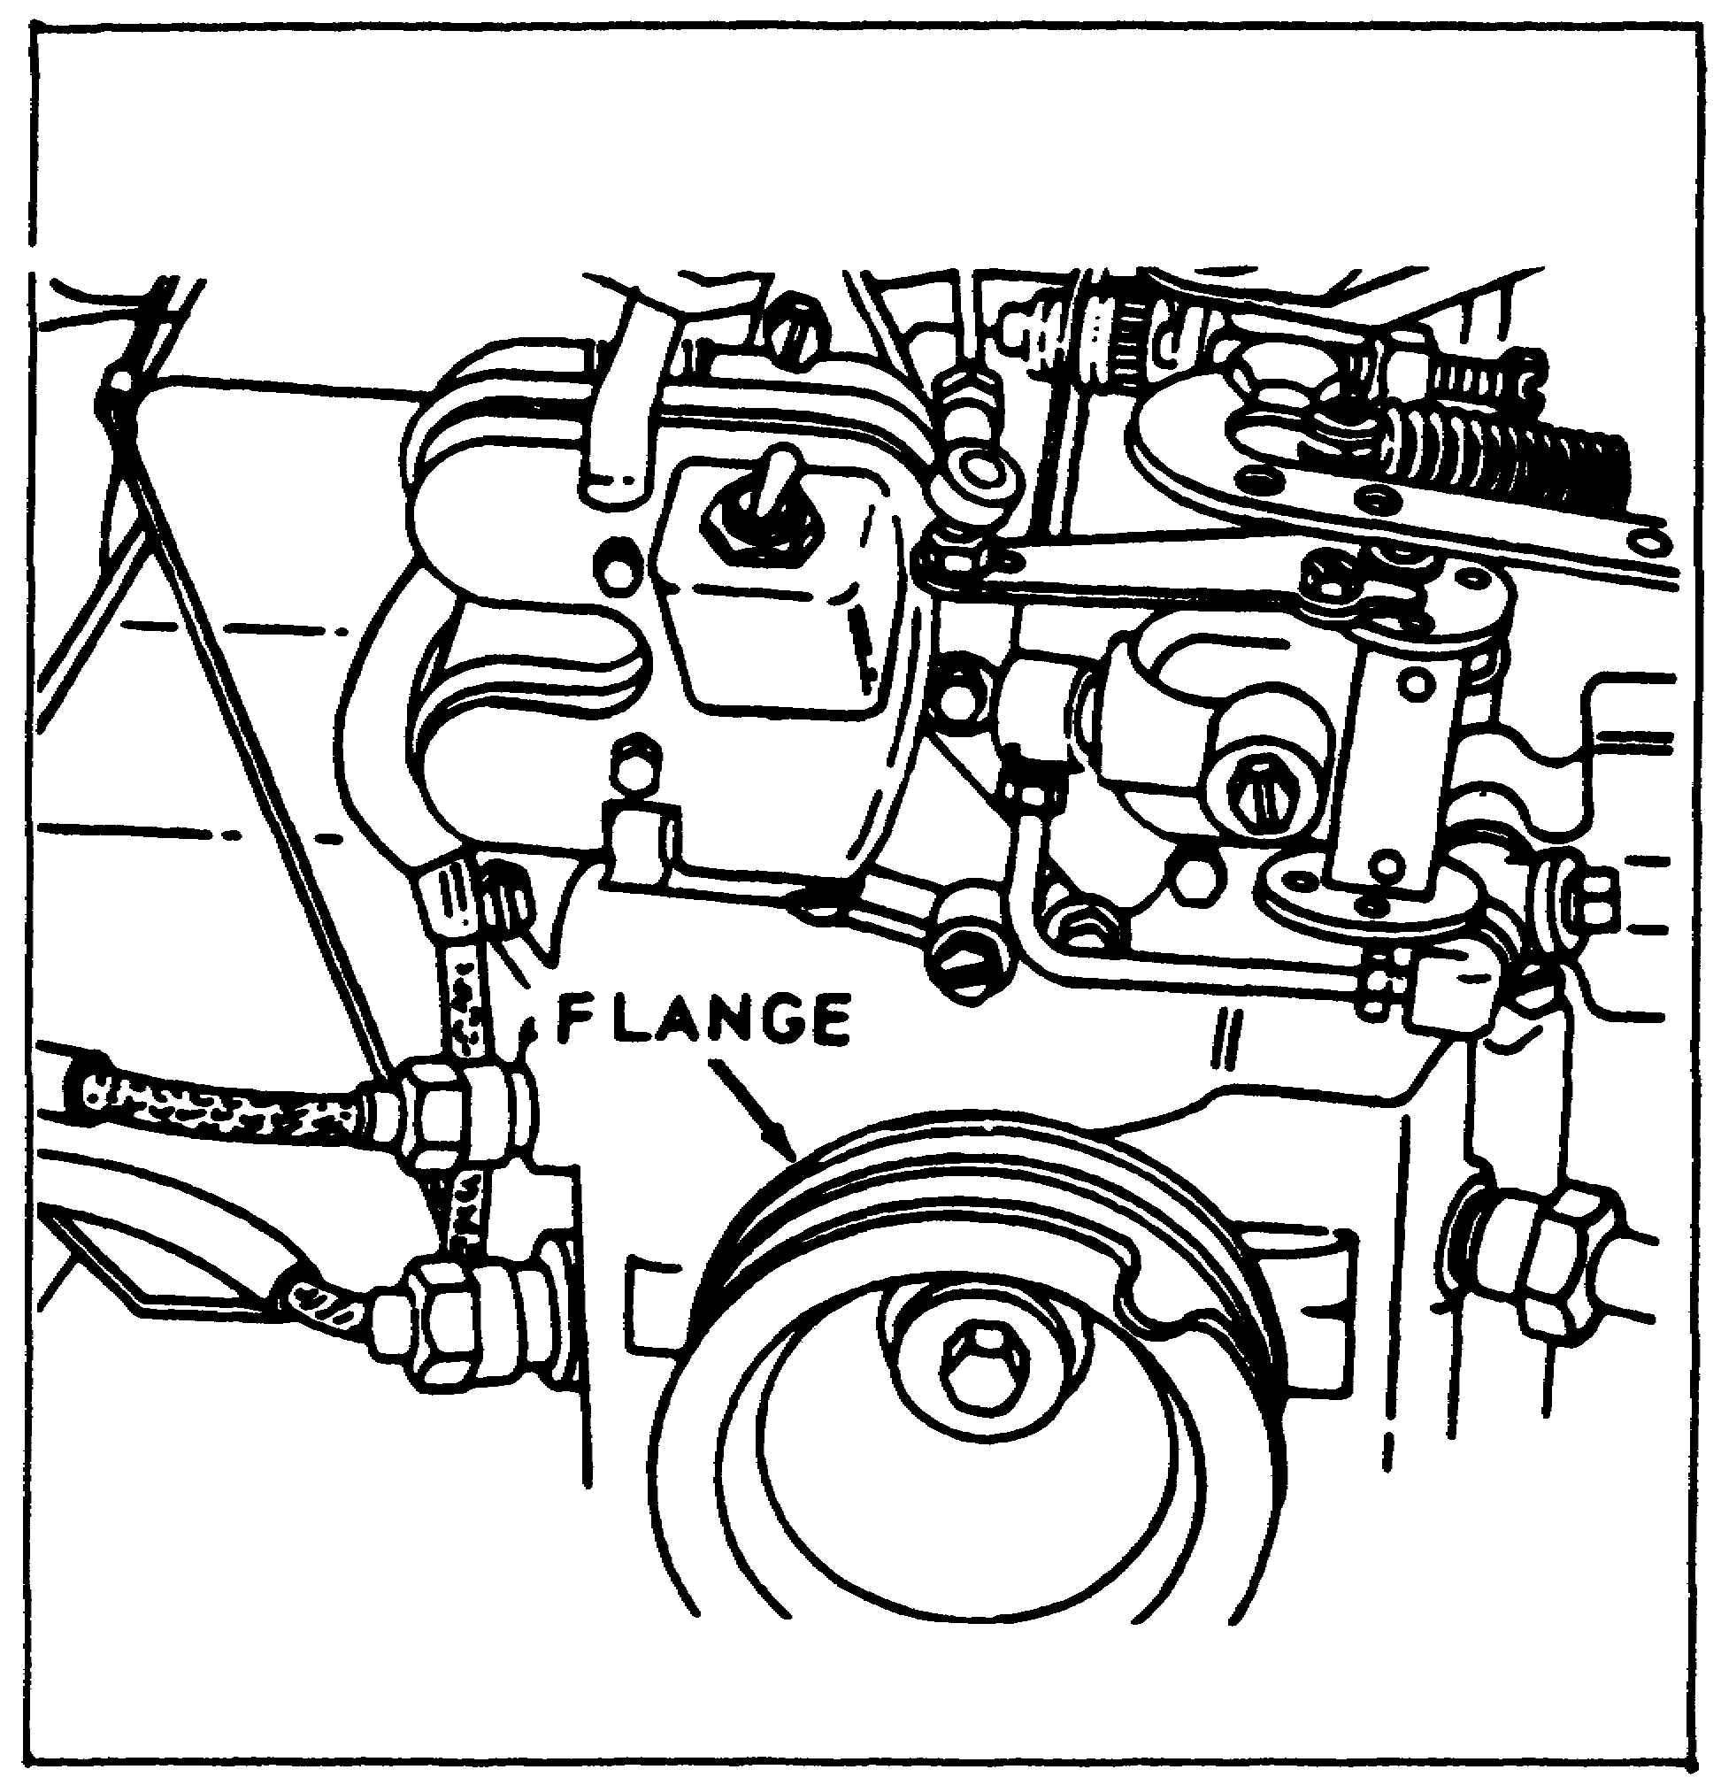

Wrap the starting rope around the crankshaft flange and pull with a quick, steady motion to crank the engine. Repeat, as necessary, until the engine starts.

96

Lesson 4/Learning Event 2

FIGURE 46.
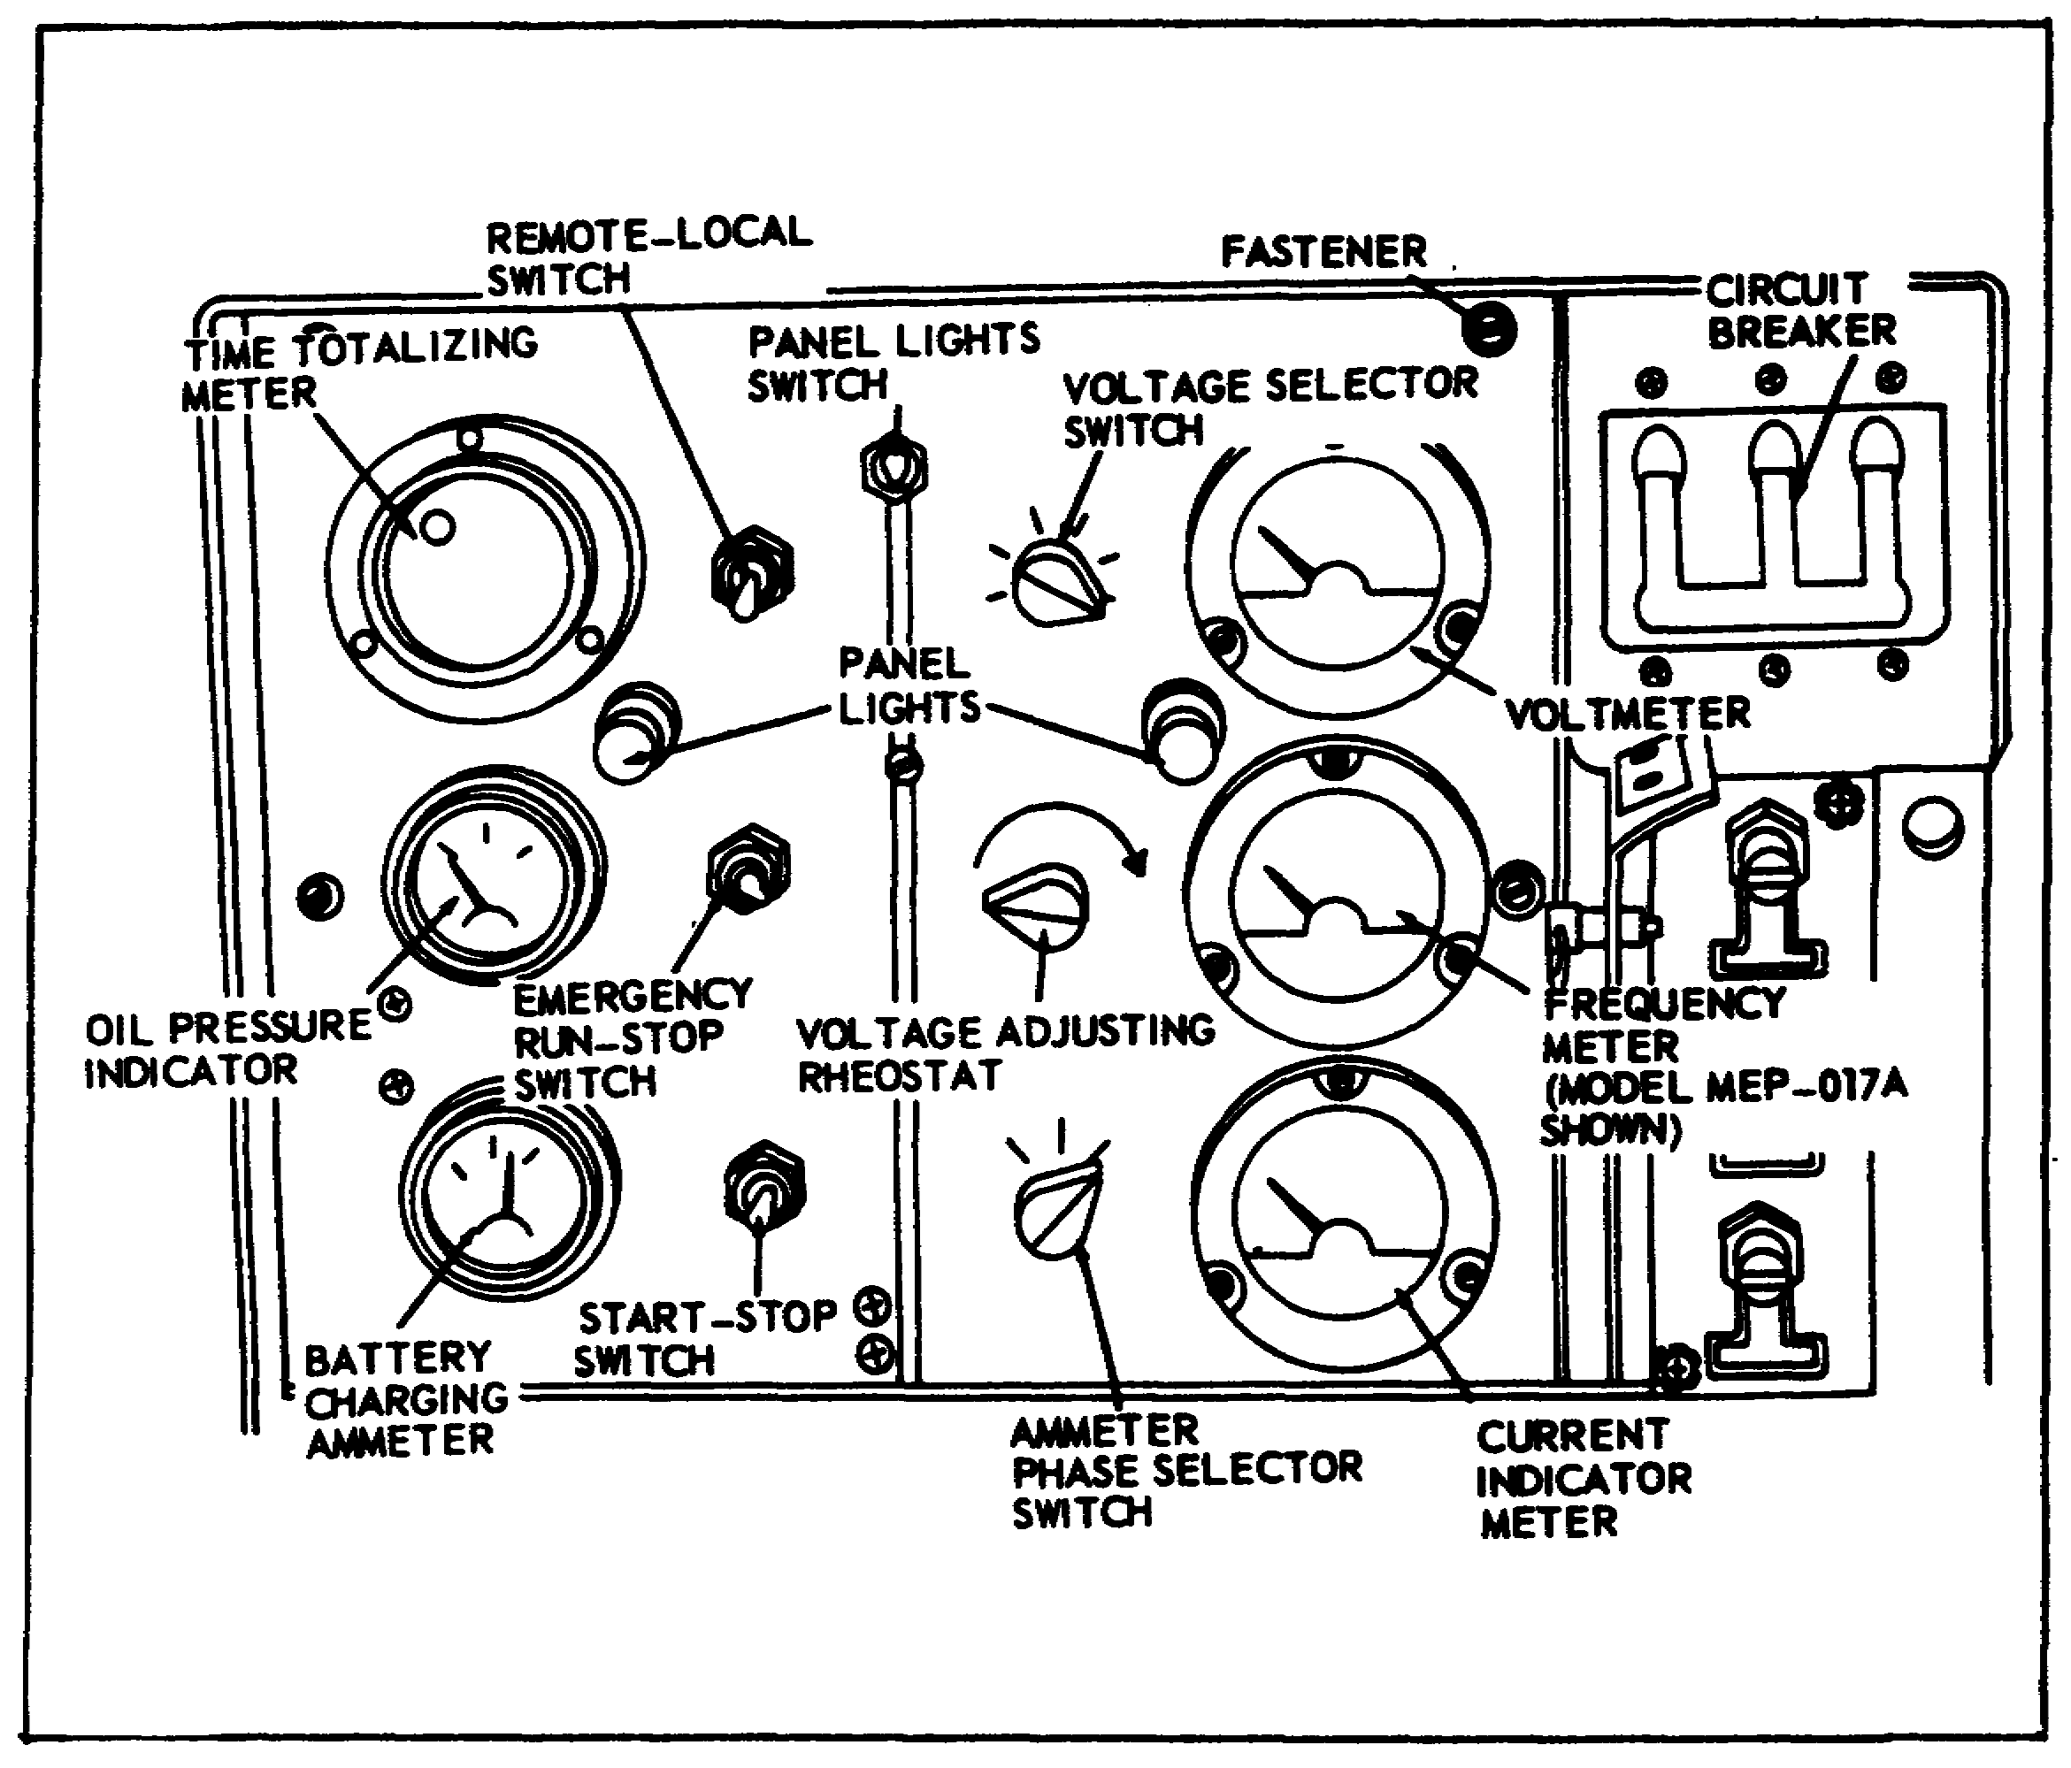

When the engine oil pressure reaches operating pressure, place the EMERGENCY RUN-STOP switch in the NORMAL position while momentarily holding the START-STOP switch in the START position.

Gradually push the choke control in as the engine warms up.

97

Lesson 4/Learning Event 2

FIGURE 47.
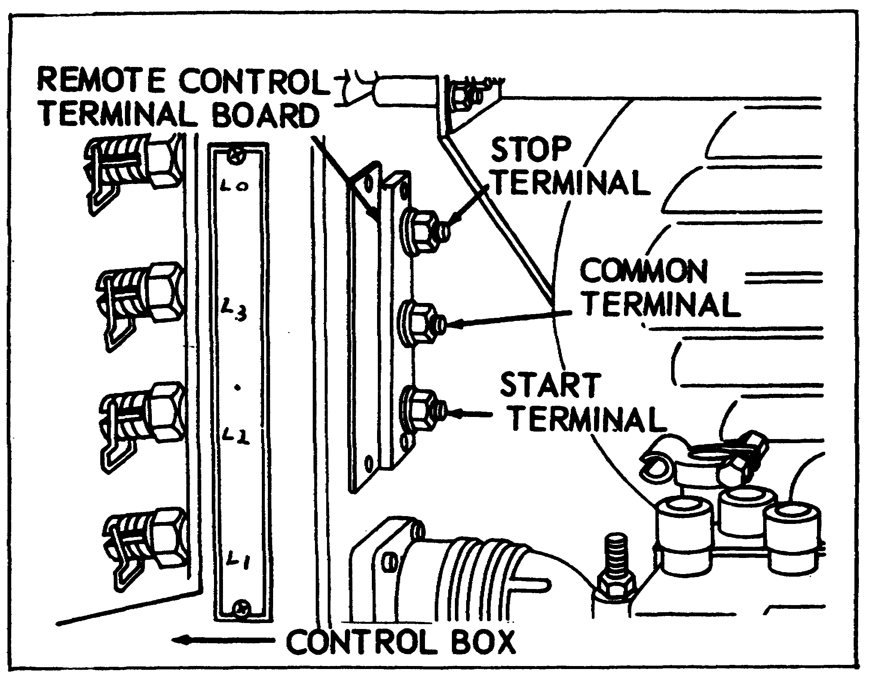

A remote terminal board is located on the rear of the control box. If a remote control cable is to be used, place the REMOTE-LOCAL switch on the control panel in the REMOTE position. Connect the remote control cable to the proper terminals. The remote starting procedures are the same as for electric starts, except the switch on the remote control cable is used instead of the START-STOP switch on the control panel. The engine will crank when the remote control closes the circuit between the start terminal and the common terminal.

PUTTING THE GENERATOR INTO OPERATION

While the engine is warming up, listen for any unusual noise and check to see that the engine oil pressure is normal.

If you hear an unusual noise or if the oil pressure is too low, notify your support maintenance. After the engine reaches normal operating temperature, put the generator into operation using the following procedures:

Place the governor in the GOVERN position. (Refer to Figure 41.)

98

Lesson 4/Learning Event 2

Position the VOLTAGE SELECTOR switch so that the voltmeter will register the voltage across the desired output terminals; then turn the knob of the voltage adjusting rheostat until the proper voltage is obtained. (Refer to Figure 47.)

FIGURE 48.
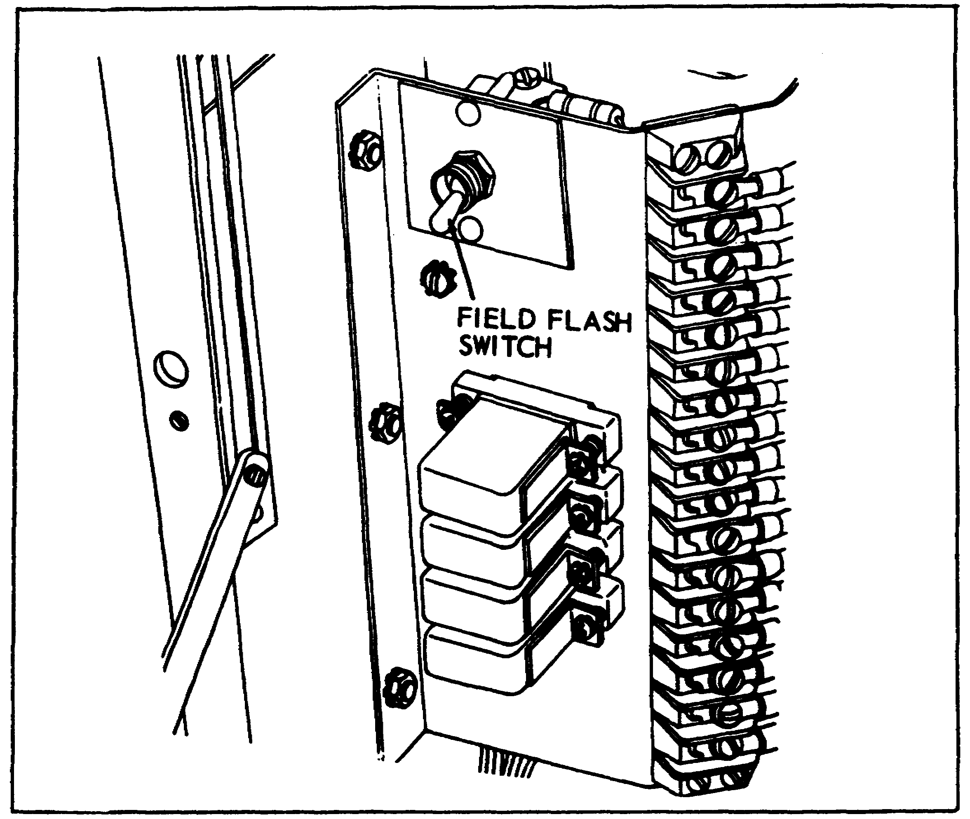

If the voltage does not register on the voltmeter, momentarily place the FIELD FLASH switch In the FLASH position; then adjust the voltage output as explained above.

Place the circuit breaker in the ON position to close the circuit between the load and the generator. The load may change the voltage slightly, so readjust the voltage adjusting rheostat if necessary.

Check the reading on the frequency meter. It should read 60 Hz on model SF-5-MD generator sets and 400 Hz on model HF-5.0-MD sets. If the reading is not correct, make slight adjustments on the engine governor, as needed, and recheck the voltage output.

99

Lesson 4/Learning Event 2

Turn the AMMETER phase selector switch to each of its three positions to determine the percentage of load. If the load exceeds 100 percent on the current indicator meter, reduce the load.

Turn the VOLTAGE SELECTOR switch to each of its six positions to check the voltage being produced in each phase. The voltage reading should not be too high or too low in any position. If it is, it may be caused by a defective rheostat or voltmeter, incorrect engine speed, or the applied load not balanced across the phases. In any case, the generator should be stopped and the trouble corrected.

STOPPING THE GENERATOR SET

FIGURE 49.
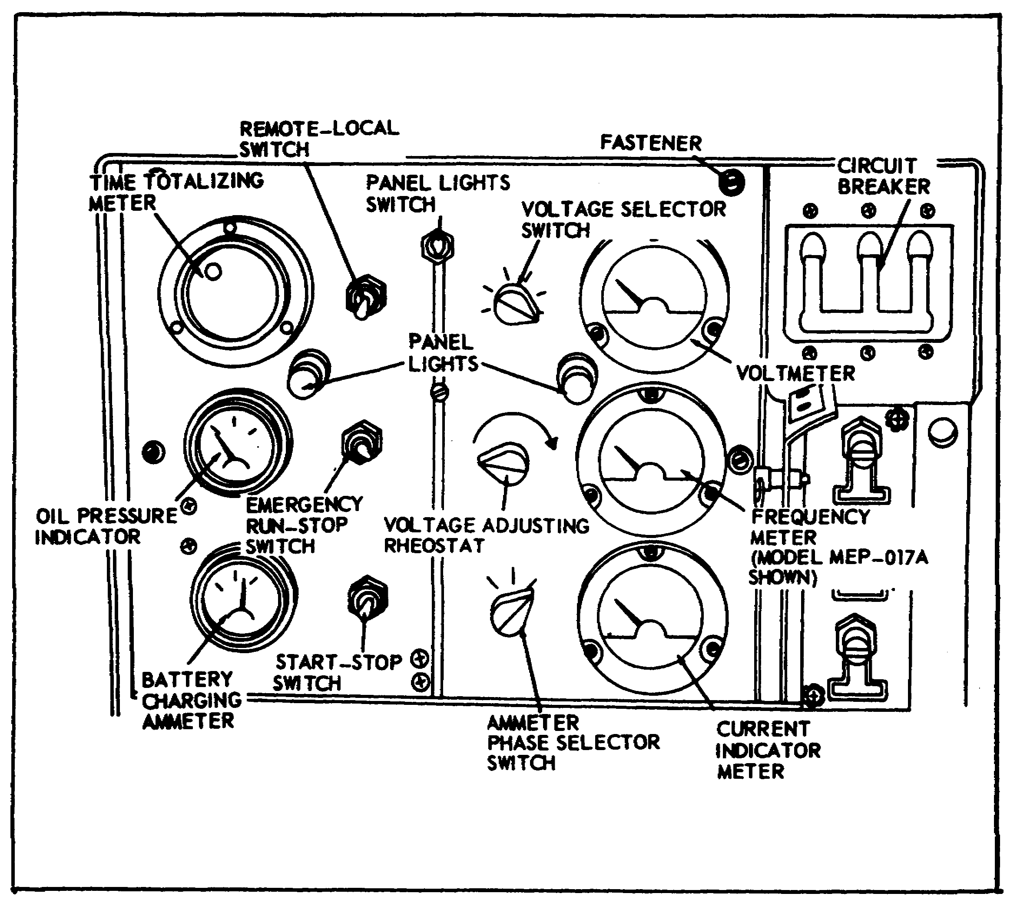

When the generator is no longer required, or for some other reason it must be stopped, use the following procedures:

100

Lesson 4/Learning Event 2

For stopping the generator in an emergency, place the circuit breaker in the OFF position and the EMERGENCY RUN-STOP switch in the EMERGENCY STOP position. Remember, this should be done only in emergencies.

The steps for normal stopping of the generator set are listed below:

- Place the circuit breaker in the OFF position.

- Place the governor control in the START AND IDLE position, and allow the engine to idle for three to five minutes. This prevents excessive heat buildup after the engine is stopped.

- Place the START-STOP switch in the STOP position.

- Place the fuel selector valve in the OFF position.

OPERATOR'S MAINTENANCE

The maintenance the operator is required to perform on this generator consists of daily preventive maintenance services and the replacement of a few parts.

The daily preoperation services the operator is required to perform consist of--

- Checking the engine oil level and adding oil if required.

- Cleaning and screening, if required, the fuel filter sediment bowl; tightening the sediment bowl thumb nut if the gasket leaks; and replacing a leaking sediment bowl gasket or a cracked bowl.

- Adding fuel as required.

- Checking the generator for proper ground.

- Inspecting the fire extinguisher for a broken seal.

- Cleaning and tightening battery cables and mountings; inspecting the batteries for cracks and leaks; checking the level of the electrolyte and adding water, if required; cleaning the vent holes in the filler caps before installing them; and, in freezing weather, running the engine at least one hour after adding water to the battery to mix the water with the electrolyte, which prevents freeze-ups. These battery checks should be performed weekly.

101

Lesson 4/Learning Event 2

- Checking the controls and instruments; replacing damaged instruments and tightening loose mountings.

With the unit running, check for any unusual noise or vibration and check for proper operation. Normal operating readings for the instruments are as follows:

- Ammeter for DC charging system - plus side of 0.

- Oil pressure gage - 30 to 40 PSI.

- Voltmeter - 120/208 to 240 volts.

- Frequency meter - 60 to 400 Hz, depending on generator set model.

QUARTERLY PREVENTIVE MAINTENANCE SERVICE

The quarterly preventive maintenance service should be performed every three months or after 250 hours of operation, whichever occurs first.

This service consists of all the steps in the daily preventive maintenance service. However, they must be performed by an organizational mechanic.

In addition to the above checks and services, there are a few more that must be made. The steps for doing this are as follows:

- Magneto points should be replaced if they are burned or pitted. The point adjustment should be checked after every 500 hours of operation. The proper gap adjustment is 0.015 inch.

- Spark plugs should be checked; replace any that have cracked insulators or burned electrodes. If the plugs look good, they should be cleaned and the spark plug gap set to 0.30 inch.

Quarterly maintenance service should be performed on both the 3- and 5-kw generator sets. The procedures are the same for both.

102

Lesson 4/Learning Event 2

SUMMARY

In this lesson, we have covered only a few of the generator sets used by the Army. You will quite likely find models of the 3-kw military standard generator sets that we did not discuss. Other 3- and 5-kw generators will be much like the ones we have discussed. The controls and instruments may look a little different and be located in different places, but the general setting up and operating procedures are the same. By using the technical manual and the instruction plate on the generator, you should not have any trouble setting up and operating these sets. The maintenance you will be required to perform will be much the same for all generator sets.

103

Lesson 4/Learning Event 2

GO TO THE NEXT PAGE

104

Lesson 4

PRACTICE EXERCISE

1. What additional precaution must be taken if the generator set is installed inside of a building?

a. The generator must be grounded
b. Enough cooling air must be provided for the engine
c. The exhaust system must be gastight

2. How many wires are required for 120-volt, single-phase operation?

a. Two
b. Three
c. Four

3. One difference between the 28-volt DC generator set and the 3-kw AC generator set is that the 28-volt generator requires no

a. voltmeter.
b. ammeter.
c. frequency meter.

4. The model MEP-021A generator set produces

a. 60 Hz current.
b. 400 Hz current.
c. direct current.

5. Newer model generator sets do not have a field flash switch because

a. the fields are flashed each time the engine is cranked.
b. permanent magnets are used to provide field magnetism.
c. the generator usually retains some residual magnetism.

105

Lesson 4

ANSWERS TO PRACTICE EXERCISE

1. c (page 62)

2. a (page 89)

3. c (page 71)

4. b (page 57)

5. a (page 74)

106

Lesson 5/Learning Event 1

LESSON 5
RECOVERY OPERATIONS

TASK

Describe the different procedures for the recovery of light wheeled vehicles.

CONDITIONS

Given information on the proper procedures for recovery operations of light wheeled vehicles.

STANDARDS

Answer 70 percent of the multiple-choice test items on the practice exercise correctly.

REFERENCES

FM 20-22

Learning Event 1:
RECOVERY OPERATIONS

Maintenance supervisors/managers must plan and train personnel to use available resources to support and sustain our forces. Recovery is an owning unit responsibility. It is accomplished with specifically designed recovery equipment, similar-/like-vehicle or self-vehicle recovery, based on the situation and damage involved.

DESCRIBE RECOVERY MANAGEMENT

The manager must recognize that the personnel system does not currently provide for a specific recovery MOS or skill level. An additional skill identifier (H8) is now authorized. Normally, recovery operations become the additional duty of wheeled or tracked vehicle mechanics. It becomes essential that the maintenance manager select the best-qualified people to operate and maintain recovery equipment.

107

Lesson 5/Learning Event 1

Recovery equipment operators/crews must be trained and skilled in the following tasks:

- Assist in security against opposing forces during recovery operations.

- Execute recovery operation to limit damage to equipment.

- Use map reading and land navigation to locate and retrieve disabled equipment.

- Use BII and other available equipment to aid in recovery.

- Use appropriate manuals and secure-voice communications equipment.

- Employ smoke, as needed, in recovery operations.

- Operate in mission-oriented protective posture (MOPP) in a nuclear, biological, and chemical (NBC) environment and decontaminate equipment.

- Use oxyacetylene for cutting operations, as needed, to aid in recovery.

- Use winches, booms, block and tackle, anchors, and mechanical advantage to effect recovery.

Recovery equipment includes wheeled vehicle wreckers; the M578, light, tracked, recovery vehicle; and the M88A1, medium, tracked, recovery vehicles. The type and quantity of these vehicles is based on the type of unit, its mission, and overall equipment authorizations.

Due to the limited number of specialized recovery equipment in an organization, proper care and maintenance is critical to the overall maintenance mission. Maintenance managers/supervisors must carefully use all resources to provide sustained support.

BASIC CRANE COMPONENTS

A good wrecker operator or repairer must know the correct names of each component of the vehicle. Wrecker cranes have many components not found on cargo trucks, so let's go over some of these components to see what they mean.

The boom assembly is the heavy beam-like structure that extends out over the back of the vehicle. A lifting cable extends out to the end of the boom assembly and passes around a pulley (block) at the outer end.

108

Lesson 5/Learning Event 1

Boom assemblies vary in construction, depending on the type of wrecker. Most wheeled vehicle wreckers have boom assemblies that can be swung left or right. They can also be tilted up or down.

Many boom assemblies can also be made longer or shorter. Boom assemblies that can be shortened or lengthened include a boom and a boom shipper. The boom shipper is a housing in which the boom can slide in or out. Most booms are slid in and out of the shipper by a hydraulic mechanism.

The boom shipper support could also be called a cradle. As the term indicates, it supports or cradles the boom shipper and boom or the boom assembly. The boom shipper support also serves as a pivot point for the boom assembly. The boom assembly can also be tilted up or down on the pivot.

Part of the wrecker controls are located in the operator's compartment. The operator's compartment swings with the boom assembly, giving the operator a continuous view of the load. The operator's compartment includes a seat and some hand-operated hydraulic controls.

The boom shipper braces are sometimes called the boom sway bars. They are used to support the boom when lifting heavy loads and prevent the boom from swaying while the vehicle is moving.

The outriggers are used to give the wrecker a more solid working platform. Once in place, they help support the wrecker crane, especially when it is extended over either side of the wrecker. The outriggers are positioned farther out than the wheels and for this reason are called outriggers.

109

Lesson 5/Learning Event 1

FIGURE 50. WINCH.
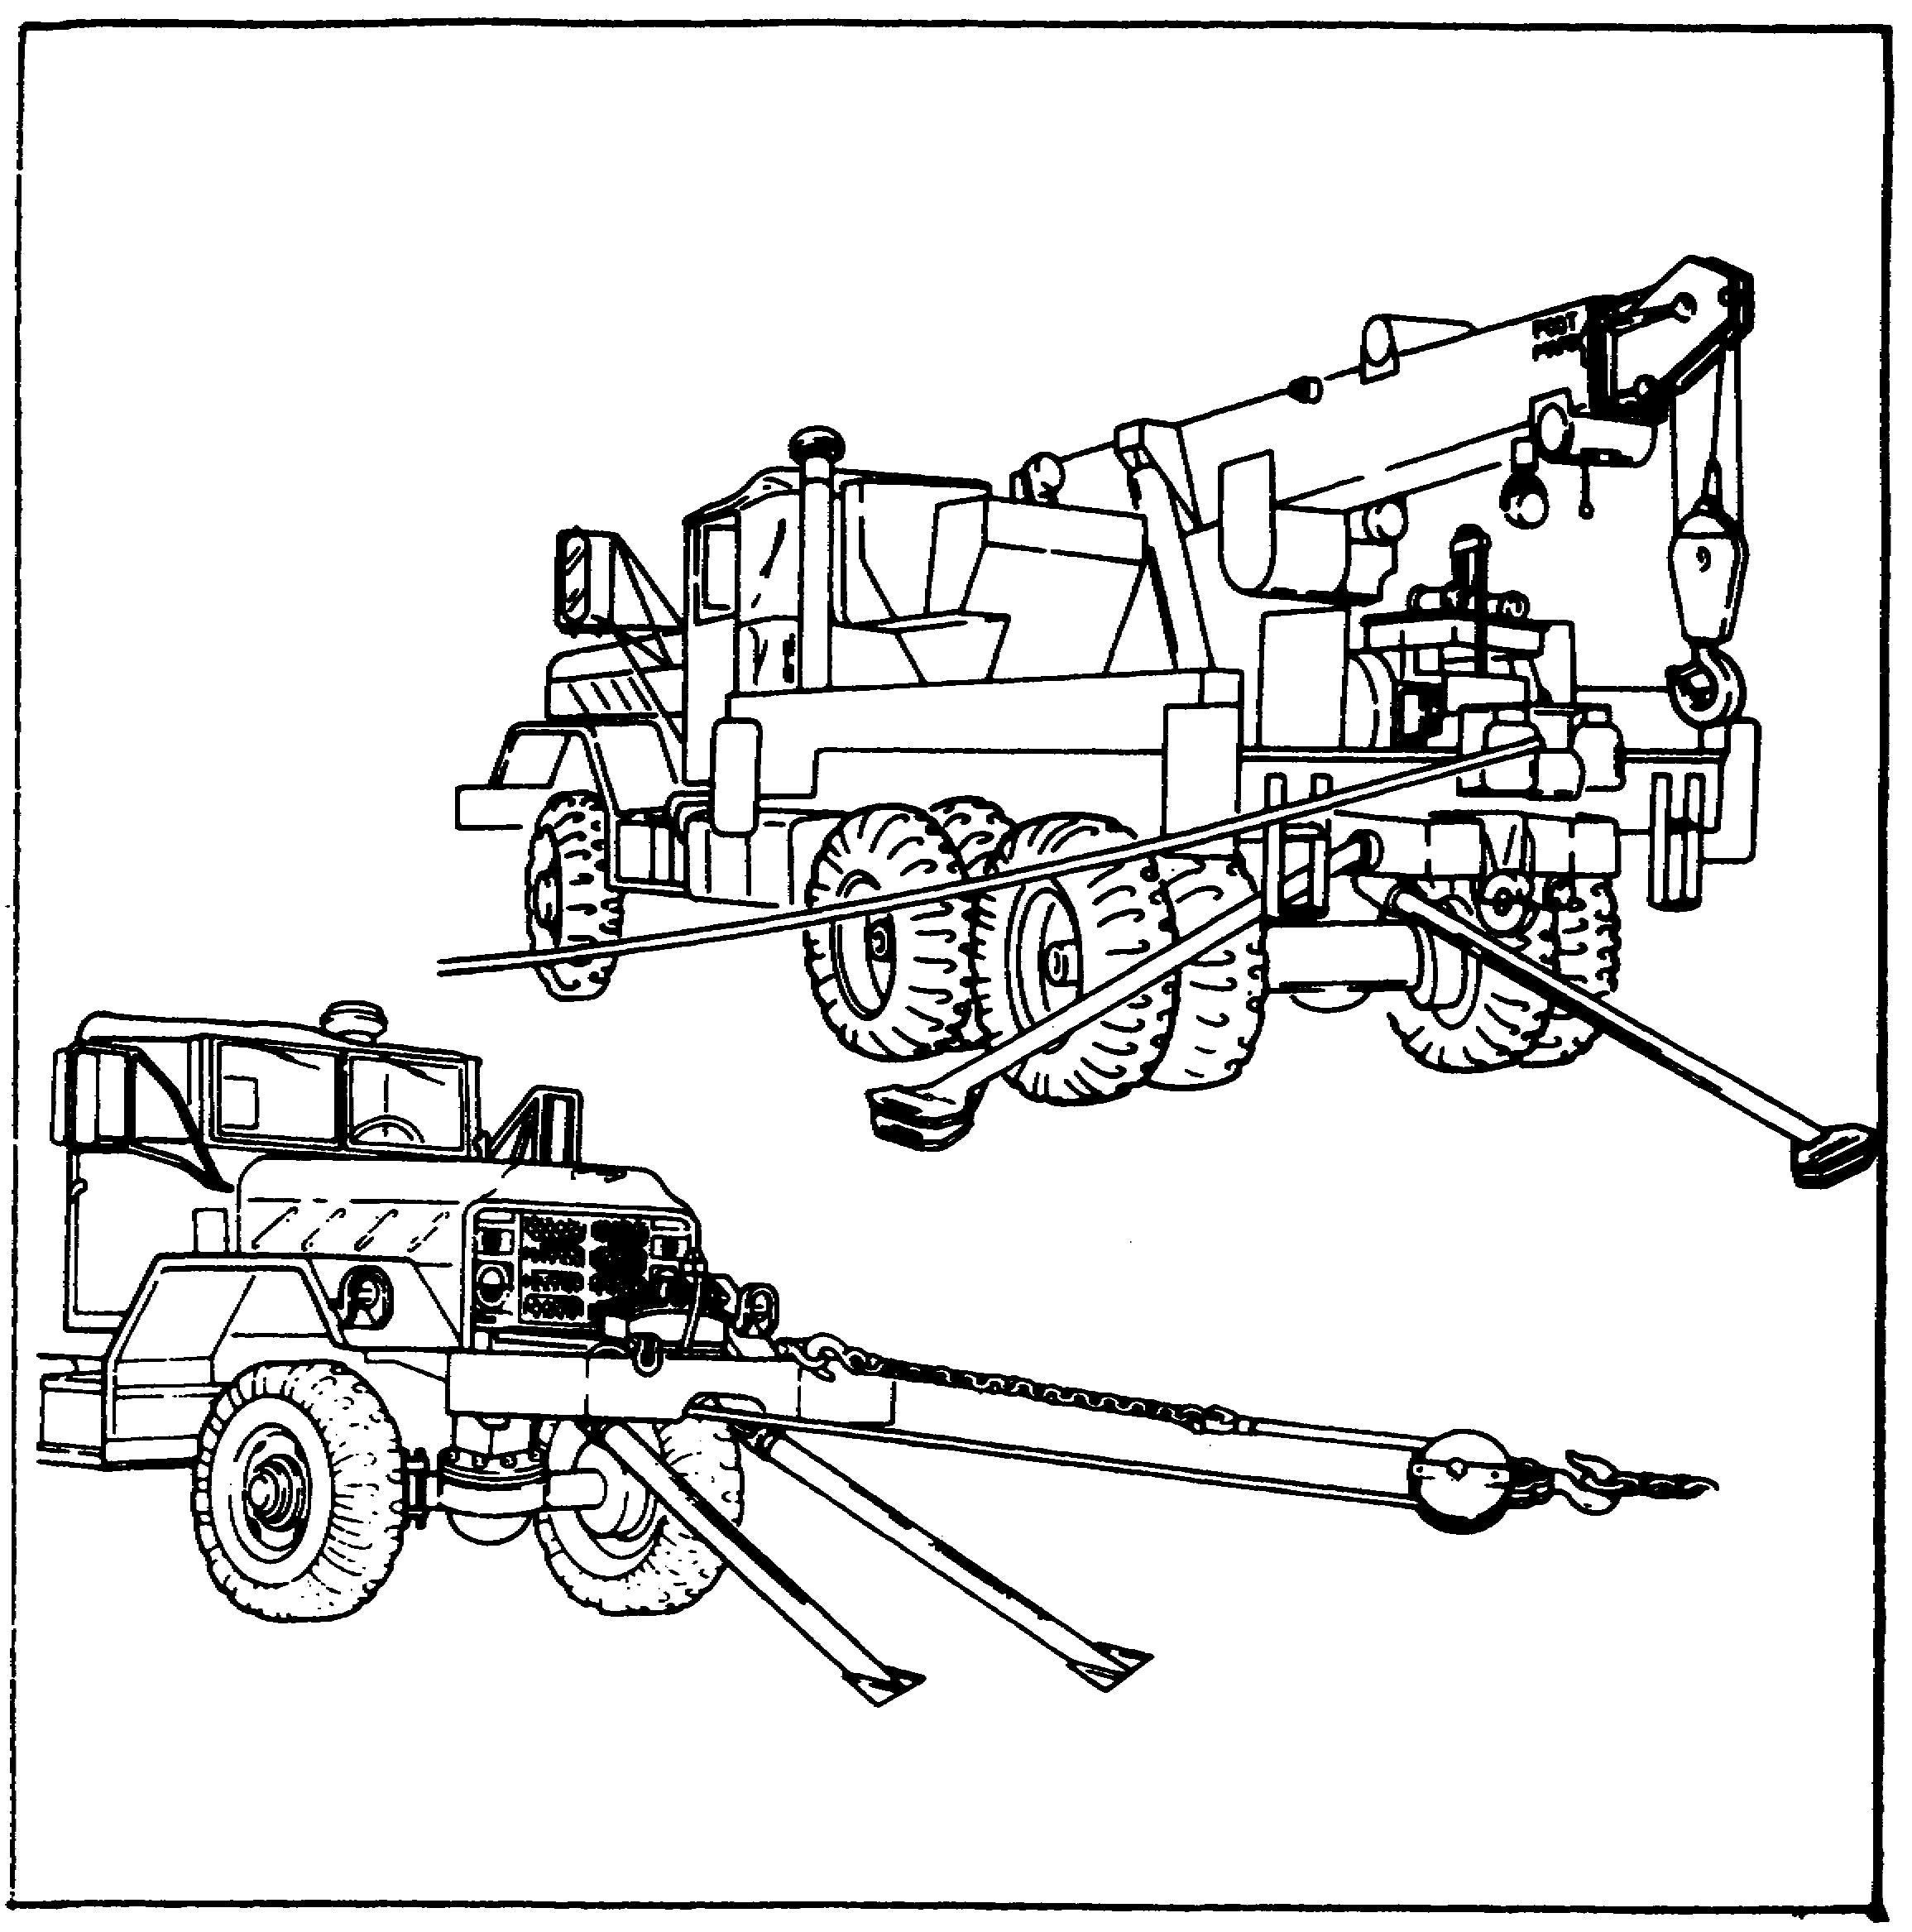

All wheeled vehicle wreckers have at least one winch. It is actually an engine-driven drum with a flexible cable wrapped around it. When the drum is turned in one direction, the cable is unwound from the drum. When the drum direction is reversed, the cable is wound onto the drum. All winches include gearing that provides a lot of reduction. This permits the cable to move very slowly and also provides a strong lifting or pulling capability. The hoisting cable of all wheeled vehicle wreckers is connected to a winch.

110

Lesson 5/Learning Event 1

FIGURE 51. CONVENTIONAL BLOCK.
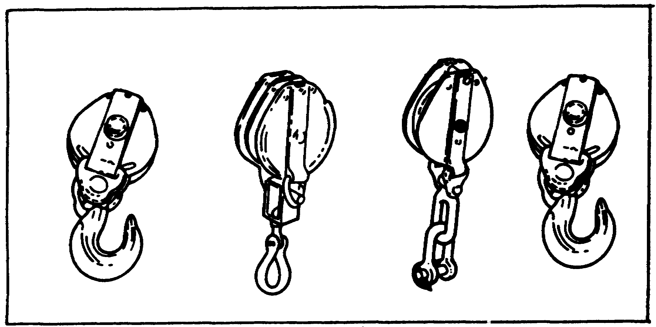

Most wreckers are equipped with at least one block. It may be a plain-type block or a snatch-type block. The wrecker in the foldout is equipped with a plain-type hoist block. Each type of block is made up of a pulley with a frame around it. All blocks have an eye in one end. Some blocks have two eyes (one in each end) and also may have a hook attached to one eye. To use a plain block, the rope or cable must be first threaded through the frame and around the pulley and then pulled through the block. The snatch block can be opened and attached to the cable or rope without passing the end of the rope through it. When either block is used, the lifting or pulling speed is decreased and the lifting or pulling power is increased.

You should now have a good idea what is needed for a wrecker crane. Now let's find out just what wreckers you may be working on.

SIZES AND TYPES OF WHEELED VEHICLE WRECKERS

The wreckers you, as a wheeled vehicle mechanic, will maintain are the M816 and the M936 5-ton size. The wreckers are 6x6 and are similar in shape and type of equipment. Both wreckers have dual rear wheels. This feature provides more support than single wheels. Wreckers need as much tire-to-ground contact as possible. This prevents the wheels from sinking in the ground when lifting heavy loads. The wreckers have hydraulically operated cranes.

There are three basic 5-ton wreckers. They are all mounted on a 6x6 truck chassis and are designated as the M816, M819, and M936 medium, wheeled vehicle wreckers.

111

Lesson 5/Learning Event 1

The M819 truck-tractor wrecker can be identified by the permanently mounted and enclosed operator's cab. This is not a part of the other two 5-ton wreckers. The H819 wrecker also has a fifth-wheel connection which is used to tow a flatbed trailer. This is why the correct name of this vehicle is truck-tractor wrecker. The entire vehicle is powered by a diesel engine.

The M816 wrecker crane is mounted on a 5-ton, 6x6 truck chassis. The wrecker crane consists of a hydraulic crane, hoist winch, and power train. The hydraulic system is powered by the truck engine. An extendable boom is capable of 360° rotation (270° with stops) and approximately 45° elevation. Each of the crane functions is dependent upon hydraulic pressure supplied by the hydraulic pump. Control of the crane is accomplished by a control valve bank consisting of four, two-way hydraulic valves. Each valve controls one of the crane's four functions, such as lifting or lowering the boom, winding or unwinding the hoist winch cable, extending or retracting the boom, and swinging the boom left or right.

The M936 wrecker has basic differences in transmissions, brakes, and front and rear winches. The M936 has an automatic transmission versus the manual transmission of the M816 and M819. The brakes on the M936 are air brakes instead of the air-over-hydraulic system. The front and rear winches are hydraulically powered while power on the M816 and M819 is delivered by the drive shaft from the power divider. The functions are the same on the wreckers, although operation of each component is slightly different.

CRANE OPERATION

All 5-ton wreckers use hand-operated, lever-type controls, some of which have a knob on the handgrip end. We could start right into the crane operating procedures; however, there is probably a better way to learn about these controls. We will first cover what the controls actually do so that when a control lever is pushed or pulled, you will know what is happening due to the lever movement. We will start with the M816 and M936 wreckers and learn what components are used to make the crane and rear winch function.

112

Lesson 5/Learning Event 1

MECHANICAL CRANE COMPONENTS OF THE M816 AND M936 5-TON WRECKERS

The hydraulic crane on all Army wheeled vehicle wreckers is powered by the vehicle engine. The crane, when in travel position, points straight to the rear. By using engine torque through various gearboxes, it can be turned on the vehicle chassis 135° to the right or left of the travel position or 270° overall. The crane is limited to 270° traverse to prevent the boom from hitting the vehicle cab. The boom, when in travel position, is 10 feet in length. It can be lengthened 8 feet more to a total of 18 feet. The boom can be raised up to an angle of about 45°. The hoist cable can be payed out or payed in and has a total length of about 95 feet. All of these operations are powered by engine torque converted to hydraulic force. Let's see how this is possible.

Engine (mechanical) turning force is delivered to the crane turntable on the M816 wrecker. At the turntable, the mechanical force is used to drive a hydraulic pump. The fluid from the hydraulic pump is then used to operate the crane.

If we look under the vehicle, we can see how the engine torque is sent through gearboxes and shafts to the crane turntable. Engine torque passes through the transmission and on to the transfer assembly. It is sent straight through the transfer, leaving through the transfer power take-off. The engine power delivered to the transfer follows the same path it follows to propel (move) the vehicle.

When the engine power leaves the transfer power take-off, it is sent to the power divider by a propeller shaft. The purpose of the power divider is to provide two outputs: one for the crane and the other for the rear winch. One power divider output shaft connects to the rear winch propeller shaft and the other connects to the crane propeller shaft.

The crane propeller shaft (M816) connects the power divider to the bevel gearbox. The purpose of the bevel gearbox is to change the direction of the power flow and send it up through the crane turntable to drive the hydraulic pump. The rear winch propeller shaft connects the power divider to the rear winch worm drive gear by the use of chains and sprockets.

113

Lesson 5/Learning Event 1

So far, we have covered the paths the power will follow as it travels back to the crane and rear winch (M816). We learned that some of these power paths are the same power path used to move or propel the vehicle. Therefore, there has to be some means of disconnecting or disengaging the power to the vehicle drive wheels so that the vehicle won't move when the crane or rear winch is in operation. Let's see what is engaged or disengaged to operate the crane and rear winch.

To deliver engine power to the crane or rear winch, the operator must first place the transmission in a forward gear. On the M936, use 3rd speed for heavy loads and 5th speed for light loads. When the clutch is released, the transmission will drive the transmission-to-transfer propeller shaft. The transfer is shifted to neutral to stop the power flow to the wheels so that the vehicle will not move. Now, when the clutch is released, it will start the transfer input shaft turning, but no torque will be delivered to the propeller shafts to the front and rear axles.

The transfer input shaft is connected to the power divider input shaft through the transfer power take-off and a propeller shaft. The transfer power take-off does not have a neutral. This means that anytime the transfer input shaft is turning, the power divider input shaft is also turning.

The power divider, unlike the transfer power take-off, has a neutral. As indicated earlier in the lesson, it has one input shaft and two output shafts. The input shaft can be connected to, or disconnected from, either output shaft.

The power divider is actually a small transmission. It has three different shifting mechanisms. Each shift mechanism has a neutral position.

114

Lesson 5/Learning Event 1

FIGURE 52. POWER DIVIDER CONTROL LEVER.
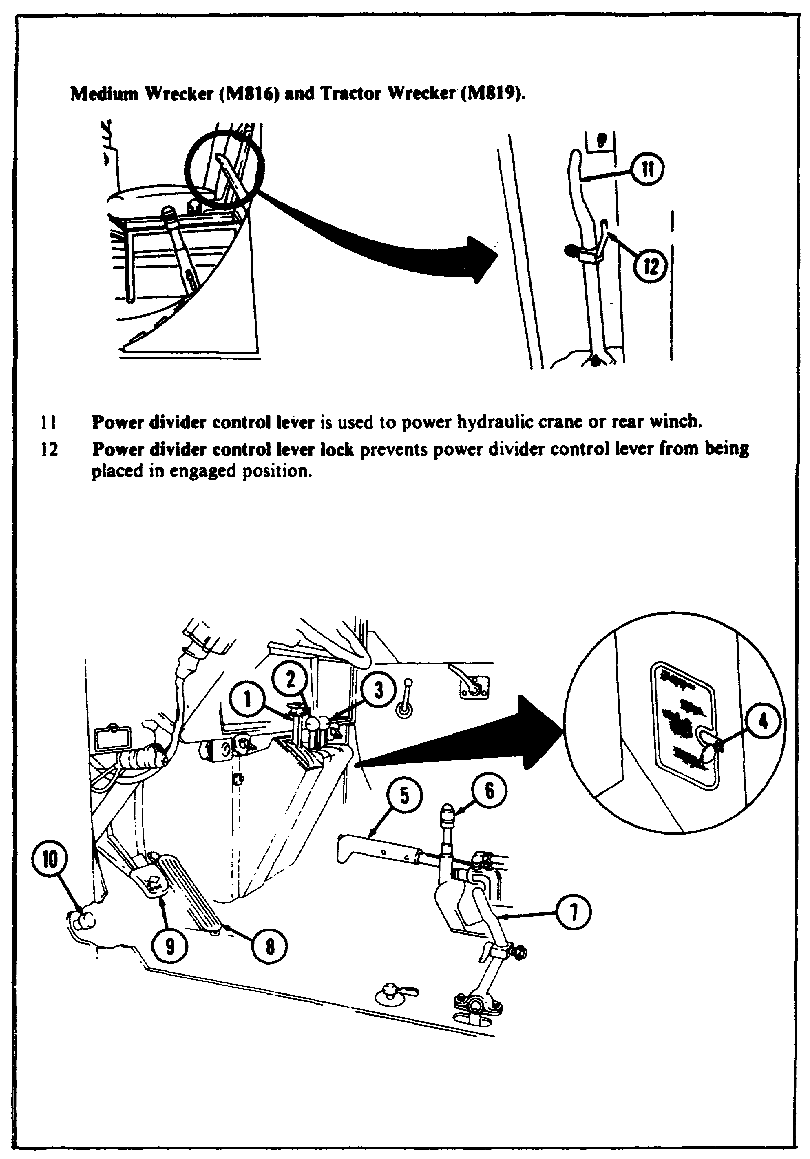

115

Lesson 5/Learning Event 1

FIGURE 52. POWER DIVIDER CONTROL LEVER (CONTINUED).
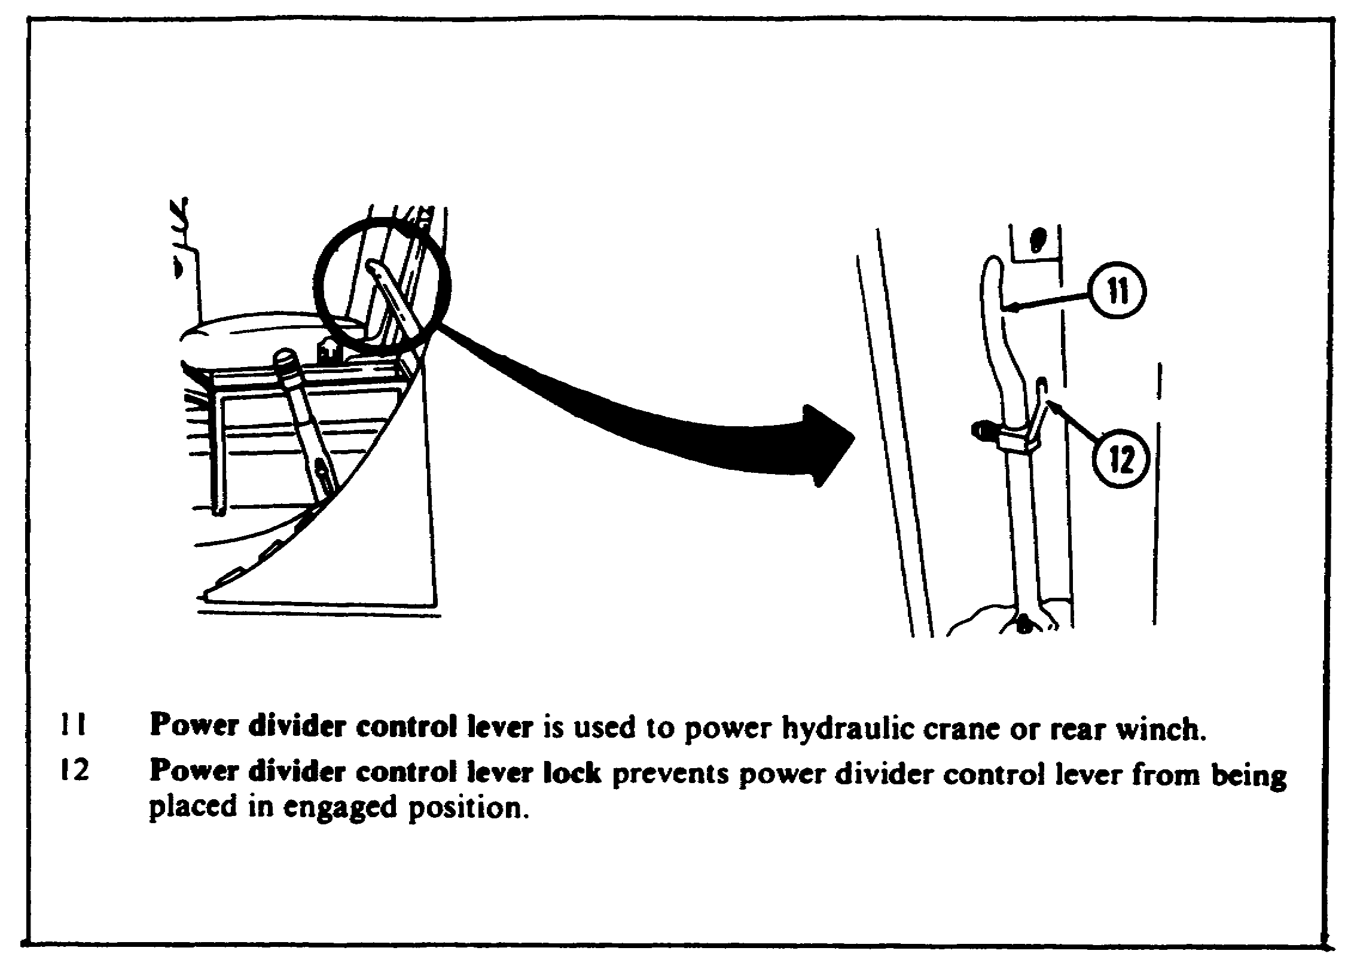

One shift mechanism is used to engage or disengage the power divider input gearing. This mechanism is connected to the power divider control lever at the left side of the driver's seat. Moving this lever forward or to the rear engages or disengages the main gearing in the power divider. This shift mechanism therefore has only two positions: engaged or disengaged. When this control is in the engage position (forward and down), there will still be no output from the power divider. To have an output, one of the other shift mechanisms must be moved out of neutral.

116

Lesson 5/Learning Event 1

FIGURE 53. HYDRAULIC PUMP SHIFT MECHANISM.
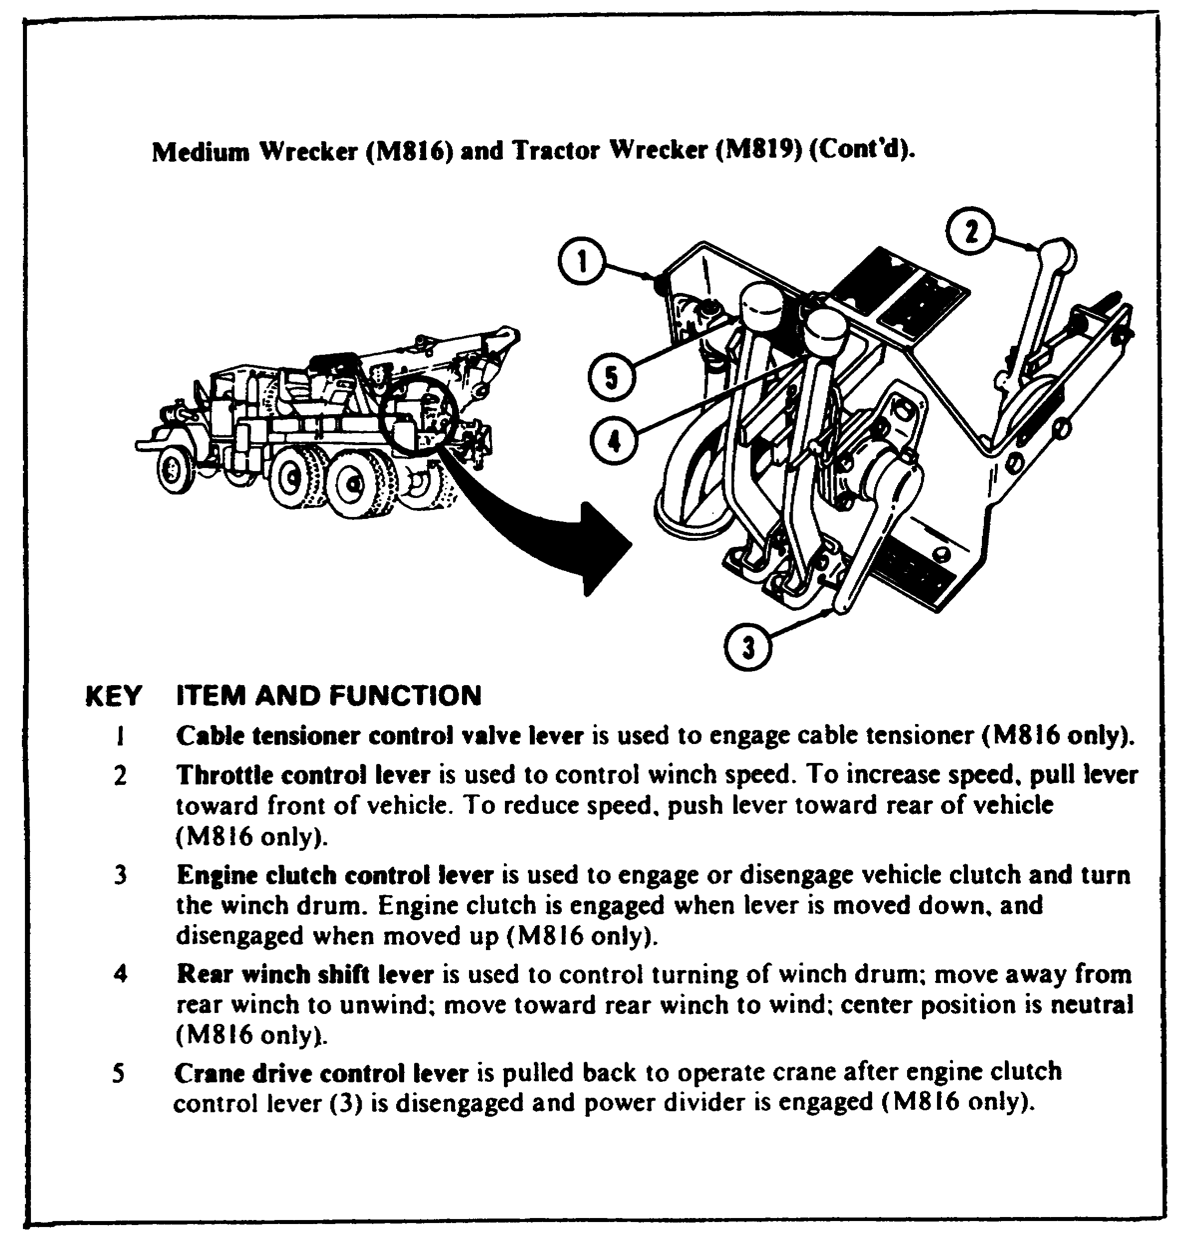

A second power divider shift mechanism is used to connect or disconnect the crane propeller shaft. This shift mechanism is generally called the hydraulic pump shift mechanism because the crane propeller shaft is used to drive the crane hydraulic pump. The hydraulic pump shift mechanism is connected by linkage to the hydraulic pump control lever. The lever is located in front of the rear winch on the bed of the wrecker. This control, like the first power divider control, has only two positions: engaged or disengaged. We often say "in gear" or "out of gear."

117

Lesson 5/Learning Event 1

The third power divider shaft mechanism is used to operate the rear winch. It is a little different from the other two shift mechanisms as it has three positions: neutral, wind, and unwind. The wind position causes the winch propeller shaft to rotate in one direction, while the unwind position causes the shaft to turn in the opposite direction. The mechanism is controlled by a lever located beside the pump control lever in front of the rear winch.

So far, we have learned that the crane hydraulic pump or rear winch can be put into operation by moving various levers. Before any levers are moved, the engine clutch should be disengaged. This can be easily done when, for example, the power divider control in the cab is shifted. The operator merely steps on the clutch pedal.

The engine clutch can also be easily disengaged or engaged by a control at the rear of the vehicle. Notice in the last illustration that the engine clutch control is mounted in the same area as the hydraulic pump and rear winch levers. The lever is connected to an air valve. When the lever is raised, the valve allows air pressure to build up in a clutch release or disengage cylinder. The cylinder is called a roto-chamber and is connected to the engine clutch linkage.

The roto-chamber then disengages the clutch. After the desired control lever is moved, the engine clutch control lever is pushed down. This releases the air pressure in the roto-chamber, and spring tension engages the clutch.

HYDRAULIC CRANE COMPONENTS OF THE h816 5-TON WRECKER

We have learned that all crane operations are hydraulically controlled. Engine torque is converted to hydraulic force in the hydraulic pump. Hydraulic fluid is then pumped into the various components to operate the crane. Let's see what components are used to make up the basic crane hydraulic system.

118

Lesson 5/Learning Event 1

FIGURE 54. RESERVOIR.
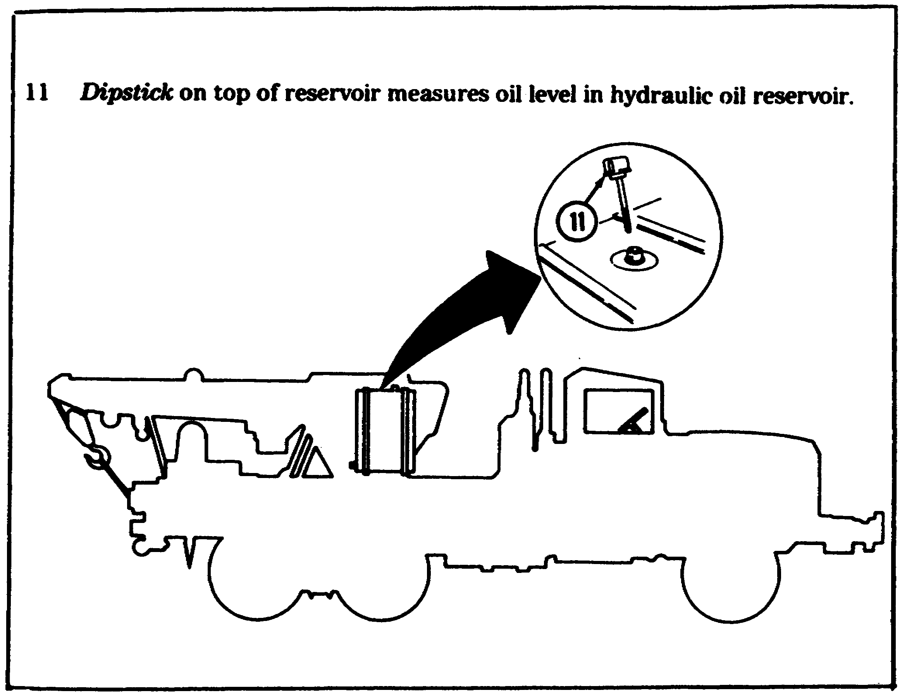

Let's start with the reservoir. Like other reservoirs, it is used for storage. In this case, it stores hydraulic fluid. The reservoir and the overall hydraulic system hold 70 gallons of hydraulic fluid.

119

Lesson 5/Learning Event 1

The reservoir supplies hydraulic fluid (or oil as we call it) to the hydraulic pump. The oil from the hydraulic pump is directed to the four control valves located in the crane operator's compartment. All four control valves are bolted together, and the assembly is called the crane control valve bank assembly. Let's just call it the control valve bank. Each control valve includes an operating lever, and each control valve is used for a specific operation of the crane. The control valve levers are all held in a neutral position by two springs. All four levers can be manually pushed forward or pulled backward from the neutral position.

The four control bank valves are directional valves. This means they can be used to direct the flow of oil in more than one direction. These four valves can direct the oil flow to either of two directions. When the lever is pulled back, the oil flow is sent in one direction. When the lever is pushed forward, the oil flow is sent in the opposite direction.

Whenever a control valve lever is moved from the center position (neutral), hydraulic oil is being directed away from the control valve through a pipe or hose. At the same time, hydraulic oil is also returning to the control valve through another pipe or hose.

If the lever is moved to the opposite position, the flow of oil changes directions. It leaves from and returns to the control valve through the opposite pipes. The crane operation, therefore, depends on the direction of oil flow from the control valves. Let's see what the purpose is of each of the control valves in the control valve bank and how the direction of oil flow affects the operation.

120

Lesson 5/Learning Event 1

FIGURE 55. CONTROL LEVERS.
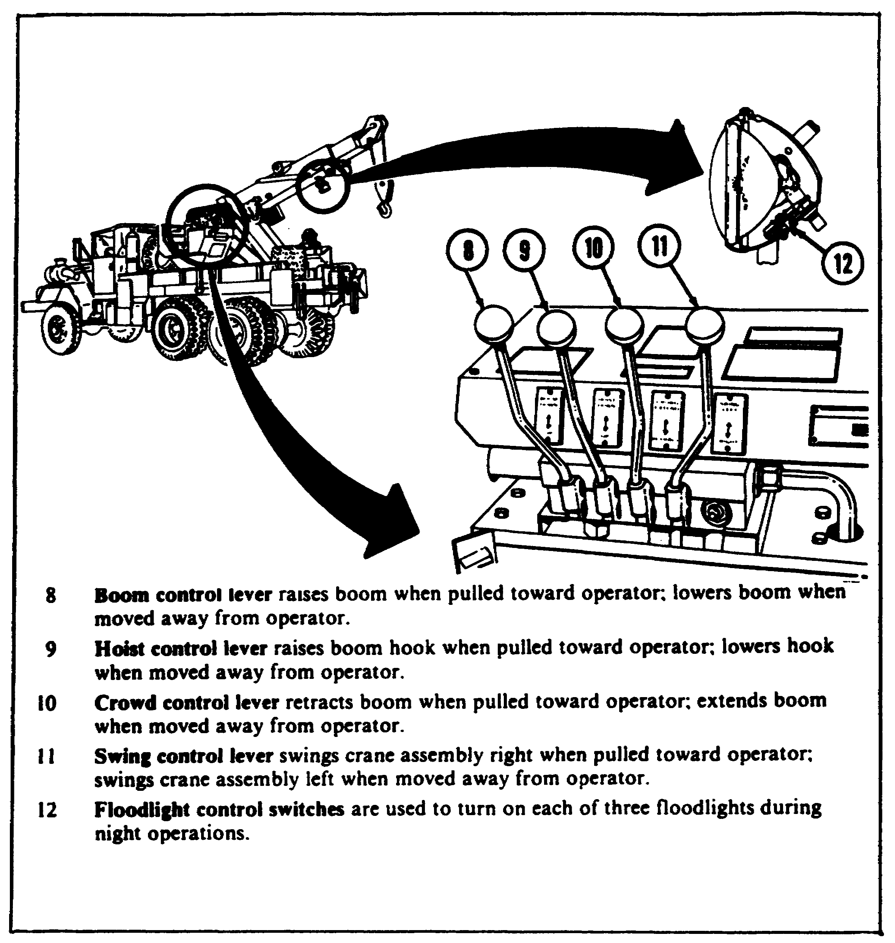

This control valve, located at the far left, is used to raise or lower the boom. To raise the outer end of the boom, the control lever is pulled back (toward the operator). To lower the outer end of the boom, the control lever is pushed forward (away from the operator). When the control lever is released, it automatically returns to the neutral position. Whichever way the lever is moved, the valve directs hydraulic oil to the two boom lift cylinders.

121

Lesson 5/Learning Event 1

As the lever is pulled back, hydraulic oil is pumped through a pipe or hose to the power side of the lift cylinder pistons. As the oil fills the area under the lift cylinder pistons, it forces the pistons and boom up. As the pistons move up in the cylinder, they push the hydraulic oil that is on the other side of the pistons out of the cylinder. This oil then flows back to the control valve through a second pipe and then back into the reservoir.

When the lever is pushed forward, oil is directed to the top of the lift cylinder piston and the oil under the piston is forced to move out of the cylinder. This lowers the boom. You can see that the oil flows in one direction when the boom is raised and in the opposite direction when the boom is lowered.

Hoist Control Valve

This valve, second from the left, is used to raise or lower the hoist cable. It works the same way as the boom control valve. Pull the lever back and the hoist cable is reeled in or the load is raised. Push the lever forward and the hoist cable is payed out or the load is lowered. This control valve directs hydraulic oil to the hoist winch hydraulic motor in one of two hydraulic hoses.

When the lever is pulled back, the oil is forced through one hose to the hydraulic motor. It then passes through the motor and flows back through the other hose to the control valve and then on to the reservoir. As the oil flows through the motor, it makes the motor turn the hoist winch in a "wind" or "raise" direction.

When the lever is pushed forward, the oil is forced down the opposite hose to the motor. It again flows through the motor, but in the opposite direction, causing the motor to turn the hoist winch in an "unwind" or "lower" direction.

Crowd Control Valve

This control valve, third from the left, is used to make the boom longer or shorter.

To lengthen or extend the boom, push the crowd lever forward. This directs oil to a cylinder located in the boom and boom shipper. With the lever pushed forward, the oil is pumped into the cylinder on one side of the piston. As the oil is pumped into the cylinder, the cylinder moves on the piston rod. This, in turn, extends the boom or slides the boom out in the boom shipper.

122

Lesson 5/Learning Event 1

To shorten the boom length, pull back on the crowd lever (toward the operator). This directs the oil to the opposite side of the crowd cylinder piston. As the oil is pumped into the cylinder, the boom is pushed back or "crowded" into the boom shipper.

Swing Control Valve

This control valve, located on the right side, is used to control the swing or turn the crane around on the vehicle. When the lever is pulled back, the crane assembly swings or turn to the right. When the lever is pushed forward, the crane assembly swings or turns to the left.

The crane assembly is swung by a hydraulic motor which is geared to the crane turntable. The hydraulic motor works just like the hoist motor. When hydraulic oil enters the motor through one hose or pipe, it causes the motor to turn the turntable in one direction. When oil enters the motor through the other hose or pipe, the turntable is turned in the opposite direction.

The control bank valves can also control the amount of oil flow as well as the direction of oil flow. When the levers are moved a slight amount from neutral or center, only a small amount of oil flows into the valve. This position is used when the crane operator wants a slow operation. The further the lever is moved from neutral, the faster the operation.

For example, while lifting an engine out of a truck, the crane operator would probably want the hoist cable to move very slowly. To do this, the hoist control valve lever must be pulled out (toward the operator) only a slight amount.

On the other hand, paying out the cable for a cable cleaning operation, the crane operator may want the cable to move as fast as possible. To do this, the hoist control valve lever must be pushed as far forward as possible.

The control bank valves are capable of varying or changing the amount of oil flow to the crane components. They are, therefore, variable-directional type valves.

CRANE COMPONENTS OF THE M936 5-TON WRECKER

So far, we have learned what makes the M816 wrecker crane function. Now let's discuss the differences between the Mb16 and the M936 wrecker cranes.

The M936 delivers power from the engine through a shaft to the hydraulic pump; therefore, the power divider of the M816 is not found on the M936. The M936 has hydraulic lines running to the components whereas the M816 uses drive shafts.

123

Lesson 5/Learning Event 2

Learning Event 2:
DESCRIBE METHODS OF RECOVERY

There are four basic methods of recovery: winching, towing, lifting, and expedients.

Winching is performed using winches on special purpose or cargo vehicles.

Towing is performed using the towing capabilities of similar or special purpose vehicles. This is the quickest recovery method.

Lifting is performed using special purpose vehicles.

Expedients are used when other methods are not adaptable to the situation or appropriate recovery vehicles or other vehicles and equipment are not readily available. This method is a field-fix, which means to effect recovery of equipment with the least possible damage.

Fiber rope may be used for recovery if the load is relatively light. The least breaking strength (BS) of fiber rope is much greater than the safe working capacity (SWC). Applying a safety factor causes the difference. To obtain the SWC, divide the BS by a factor of safety (FS):
BS
SWC = --
FS

The minimum standard safety factor is four.

The safety factor is needed because use and exposure to weather reduce the BS of rope. Shock loading, knots, sharp bends, and other stresses on the rope during use can reduce the rope strength (RS) by as much as 50 percent. To determine the SWC, square the rope diameter (D):

SWC = D2

Wire rope is the most important single item in vehicle recovery. The most common use in military units is as winch cables. Wire rope is made of many wires twisted together to make a strand. The strands are then twisted together around the core, making a rope. There are three types of rope core: fiber, strand, and independent. The core adds flexibility and elasticity to a wire rope. The most strength will be obtained from the independent wire rope core.

124

Lesson 5/Learning Event 2

OPERATING IHE 5-TON WRECKER CRANE

Before the crane is put into operation, let's refresh our memory on some safety measures.

We are working with powerful equipment. Even when lifting or pulling loads within the authorized limits, something can break. This is especially true of the hoist and which cables. Ensure all personnel stay out of the way during hoisting or winching operations.

Personnel handling cables should wear gloves. The cables can have small wires sticking out that can severely cut bare hands. ABOVE ALL, ENSURE ALL PERSONNEL STAY OUT FROM UNDER SUSPENDED LOADS.

The crane operation in this lesson is based on the M816 diesel-engine powered wrecker. Once you have learned how to operate this wrecker, you should easily be able to operate the M936 wrecker. It is best to have an assistant during crane operations; someone to hook and unhook the crane to the load. This assistant is called the rigger. Let's start with something that requires a simple wrecker operation--lifting the front end of a 1/4-ton truck.

It is always best to lift a load directly behind the wrecker. Of course, this is not always possible, especially if the load has to be swung to either side. When lifting loads, especially heavy loads behind the wrecker, the long truck chassis ahead of the rear wheels tends to hold down the front end of the wrecker. If you try to lift a heavy load from the side of the wrecker, you can run into trouble. Even with the outriggers in place, you can tip the wrecker over by lifting a load that is too heavy and extending the boom too far. This is not saying that no loads should be lifted from the side; however, certain precautions must be taken, as you will see later in the lesson.

Back the wrecker up close to the front of the 1/4-ton truck. Give yourself enough room to work between the vehicles. Remember, the boom can be extended to move the hoist cable directly over the load.

Next, you should lock the brakes on the wrecker. To do this on the M816, you first apply the service brakes and then press the electric brake lock switch button on the instrument panel. This closes a valve and holds the brakes applied. Then you release the brake pedal while holding the button in. Now release the button and the brakes will remain applied until the pedal is pushed down to release them.

125

Lesson 5/Learning Event 2

CAUTION

Release the brakes as soon as you are finished using the crane. Otherwise, brake fluid may leak from the wheel cylinders onto the brake lining.

Next, start the engine, disengage the clutch, and move the transmission manual control lever or gearshift lever to 4th on the M816. While still holding the clutch in the disengaged position, move the transfer shift lever to neutral. Then push the power divider control lever forward to engage the main power divider gearing. Once this is done, the clutch pedal can be engaged.

NOTE: After starting the engine on the M936, place the transfer shift lever in neutral; then place the transmission selector lever in "1-5" (drive).

That takes care of the controls in the vehicle cab, so now back to the controls at the rear of the M816 vehicle. The M936 does not have these controls because of its automatic transmission. There are instruction plates located near each control to show you which way to move the control lever. First, disengage the engine clutch with the engine clutch control valve lever. Then move the hydraulic pump control lever to the ENGAGE position. On the M816, there is a lockpin which must first be removed to operate the hydraulic pump control lever. Next, pull the throttle control valve at the rear of the vehicle to the FULL OPEN position. Engine speed will be governed to 1,250 ± 50. The engine speed is limited by the fuel injection pump governor. On the M936, use the hand throttle control and set engine RPM between 1,250 and 1,300 as indicated by the tachometer. Do not attempt to operate the crane at low engine idle speed, because the hydraulic pump will not provide enough operating pressure at low pump shaft speeds.

Next, push the hoist control forward to lower the hoist cable slightly to take the load off the boom braces. Then disconnect the shipper braces at the shipper brace brackets. The M816 and the M936 shipper braces disconnect at the same location. It may also be necessary to raise the boom slightly to relieve the load on the shipper braces.

Next, store the shipper braces along the side of the boom shipper. As soon as the hoist block is lowered, unhook the lifting sling at the rear of the wrecker.

126

Lesson 5/Learning Event 2

Once the shipper braces are stored on the boom shipper, you are ready to disconnect the hoist block from the lifting sling and remove the sling. Push the hoist lever forward to lower the hoist block. Remove the lifting sling from the hoist block and allow the snatch block to hang free. Then extend the boom with the crowd control until the hoist block hangs directly over the 1/4-ton truck front bumper.

As you extend the boom, look at the hoist block. It will raise even though you are not using the hoist control. You must always remember that the hoist block raises when the boom is made longer (extended) and lowers when the boom is made shorter (retracted). You can correct this problem by operating the hoist control lever in the same direction as the crowd control lever. For example, when you extend the boom, you should also lower the hoist cable at the same time. This way, the cable is payed out the same amount that is taken up by the extending boom and the hoist block does not raise or lower any appreciable amount.

Hook up the hoist block to a suitable sling or chain and then raise the hoist cable. By now, you know that the hoist control lever is pulled back to raise or pay in the hoist cable. If you look at the hoist cable as the hoist block goes up, you can see that they move at two different speeds. The cable moves much faster than the hoist block. This is due to the mechanical advantage gained by the use of a block. Another advantage of using a block is that the load can be moved very slowly. This is an important point when the wrecker is used for power plant removal/installation.

Once the 1/4-ton truck is raised the desired amount, support the 1/4-ton truck in the proper place with jack stands or cribbing blocks. The proper place depends upon what is going to be repaired or replaced. Check both rear wheels and then lower the front of the vehicle onto the supports. Ensure the 1/4-ton truck is solidly supported before you start to work on it.

Once you finish using the wrecker, you should secure the crane for traveling. This means putting everything back like it was when you started. Retract the boom as far as it will go in the boom shipper. Position and connect the shipper braces at the lower end. It will probably be necessary to raise or lower the boom to make the shipper brace pinholes line up. You may also have to swing the boom to the left or right to line up the holes with the pins. One person should operate the crane controls while someone else (rigger) inserts the pins. Next, connect the

127

Lesson 5/Learning Event 2

cable sling to the two small rings or eyes at the rear of the wrecker and connect the hoist block hook to the center loop of the sling. Then carefully raise the hoist cable just enough to take the slack out of the cable. Remember, the hoist is very powerful and you can rig the rings right out of the rear of the wrecker if you are not careful.

Now you are in the traveling position, so go back to the control at the rear of the wrecker and disengage the engine clutch; then disengage the hydraulic pump and engage the engine clutch. Now push the throttle control back as far as it will go, and the engine speed should drop to normal idling speed. Next, go to the controls in the cab and put them back in the traveling position and you are finished. By the way, do not forget to step on the brake pedal to release the locked brakes (on the M816). You do not want the wheel cylinders to start leaking.

So far, we have used the wrecker to lift a light load-the front end of a 1/4-ton truck. We went through this operation just so we would learn how to put the crane into operation. We did not have to swing the load, nor was it necessary to extend the boom the full amount when the load was connected.

NOTE: Refer to Supplement 3 as you study the following paragraphs.

Before lifting any heavy loads with the crane, you should know how much you can safely lift. This can be determined from the safe load chart located near the control valve bank assembly.

The crane load capacity decreases as the boom radius (length) increases. The illustrations in Supplement 3 show how to determine the boom radius. The capacity of the wrecker without the riggers, boom jack, or shipper braces in place is from 6,700 pounds at a 10-foot boom radius to 3,000 pounds at an 18-foot boom radius. As indicated earlier in the lesson, the vehicle should be positioned for a direct rear lift, whenever possible, and with the least amount of boom extension.

If the weight to be lifted is more than mentioned above, crane supports of some type will have to be used. Suppose we have a 20,000-pound weight that can be lifted by a direct rear lift at a 10-foot radius. Outriggers, shipper braces, and a three-part line should do this. So let's see how to set up the wrecker for the lift.

128

Lesson 5/Learning Event 2

Remove the L-shaped pin at the end of one outrigger frame tube. Pull out the base until the frame hits the stop. Lower the outrigger to the vertical position, and replace the L-shaped retaining pin. Insert the jack adjusting bar, and turn out the adjusting screw until the base is in firm contact with the ground. Repeat these procedures on the other three outriggers.

Next, properly position the shipper braces. The shipper braces should be lengthened about 10 to 12 inches from the travel position. This can be done by pulling the L-shaped retaining pin out of the telescoping tubes and then raising the boom. Make sure the L-shaped pins are reinserted when the holes line up.

No less than a three-part line should be used to lift this much weight. Normally, the M816 and M936 cranes are equipped with a three-part line. If you look at the accompanying illustration, you can see an example of a three-part line. There are actually two pulleys, or sheaves as we call them, in the end of the boom. Each sheave is free to turn on the shaft. The hoist cable passes over one boom sheave, then around the plain or snatch block sheave, and then up and around the second boom sheave. The end of the hoist cable is then hooked to the body of the block with a cable anchor pin. This arrangement is like a gear reduction. The hook movement speed is decreased; however, it can lift much more than if no snatch block at all were used. The accompanying illustration shows a wrecker properly prepared and lifting a 20,000-pound load. Preparation of the M816 and M936 is done the same manner.

Now, let's try a side lift using the boom jacks. The outriggers are not required while using the boom jacks. The 5-ton wreckers include a CAUTION instruction plate in reference to the use of boom jacks. Notice in the illustration that a good footing is necessary. This also holds true with the outriggers. It may be necessary to build a solid footing under the bases of these supports.

To rig the boom jacks, lower the boom and then extend it to expose the boom jack pinholes. Secure the boom jacks to the boom with the retaining pins. The boom jacks are normally stowed in the storage box mounted on the left side of the crane platform.

Next, elevate the boom and align the holes in the boom jack male and female members. Then insert the retaining pins and lower the boom slightly to relieve the load from the elevating mechanism. With this setup, using a three-part line, you can lift 20,000 pounds.

129

Lesson 5/Learning Event 2

In the above part of the lesson on rigging a crane for lifting, we have learned how to use a three-part line. While we are not going to cover rigging in this lesson, we should discuss how the crane operator goes about rigging the crane for two-part and four-part line operations as well as the three-part line.

To right a two-part line, pass the crane hoist cable over one boom sheave (pulley), then around the hoist block sheave, and secure the cable end to the boom end with a cable anchor pin. A two-part line increases the lifting capacity of the cable over a one-part line operation. However, a three-part line is stronger than a two-part line, and a four-part line is therefore still stronger.

To right a four-part line, you will need a hoist block with two free-turning sheaves. Install the hoist cable as you did with the three-part line. Then pass the cable around the second hoist block sheave and hook the cable end to the end of the boom. This is the same place the cable end was secured in the two-part line operation.

Now that we have learned how to lift with the wrecker crane hoist, let's take a look at some of the things you may be lifting and how you should go about it.

You may be required to remove an engine or an engine and transmission (power plant) from a wheeled vehicle. The procedures are a little different for each type of vehicle, and we will not try to cover them all. Refer to the proper vehicle technical manual for the procedures you will need to follow. In this lesson, we will use the gasoline engine in an M54 5-ton truck as an example. We will assume that disconnecting lines, mountings, and shafts and getting the engine ready for removal have been done, so we will start with the actual engine removal.

You will need a sling to connect the crane hook to the engine. Use the highest hole for this operation.

With the engine sling supported by the crane hook, insert the books on the ands of the sling in the lifting eyes at the left front end of the front cylinder head and the right rear end of the rear cylinder head. Before starting to lift the power plant, check to be sure that all disconnect procedures have been accomplished and that all accessories and lines are clear of the power plant. Make sure that the hoist cables hang straight down; otherwise, the engine could be pulled to one side or forward once it is lifted. From now until the engine is removed, you are going to be at the controls of the crane, so you need someone to work with you when removing as well as replacing the engine.

130

Lesson 5/Learning Event 2

You are now ready to carefully lift the power plant. Use a series of short lifts until the radiator and front engine support bracket will clear the front of the vehicle.

Continue to raise the power plant slowly, at the same time moving it forward until the power plant is free of the vehicle. Make sure that you do not damage the engine oil pan. You can now move the power plant to the desired location and lower it onto the engine and transmission stand or floor. Do not rest the weight of the engine on the oil pan as this may crack or crush the oil pan. When the power plant is in position and secured, remove the engine sling.

You removed the power pack from the vehicle, so you will most likely have to put one back into it. Let's see how you should go about this. Again, we are not going to cover all of the preliminary procedures, such as inspecting to see if everything is on the power pack that should be, as this lesson covers only the removal and replacement operations.

Connect the engine sling just as you did for the power pack removal. Then lift the power pack high enough to clear the front of the truck and move it part way into the engine compartment. Check to be sure that all lines and accessories are clear of the power pack.

Continue to lower the power pack slowly, at the same time moving it further into the engine compartment. Keep moving it until the mounting bosses on the left and right sides of the flywheel housing are directly above the engine rear mounts which are attached to the left and right frame side rails. Do not rest the power plant solidly on the engine mounts at this time.

With tension on the engine lifting sling, align the holes in the engine front mounting support with the holes in the front cross member. Install the four lock washers and cap screws, turning the screws in only four or five threads.

With tension still on the engine sling, align the holes in the flywheel housing mounting bosses with the engine rear mounts. Insert two cap screws, one on each side, and loosely install the safety nuts on the cap screws.

Now, completely lower the power pack. Tighten the front mounting cap screws and the nuts on the rear mounting cap screws. Remove the engine lifting sling from the engine. Notice, for safety measures, that the power plant was bolted in place before the crane and sling were disconnected from the power plant.

131

Lesson 5/Learning Event 2

We have not tried to cover all of the power packs you may have to remove. However, the procedures will be much like the ones covered. Also, we did not cover positioning the wrecker for power pack removal. This will vary with the type shop and work space you have available.

USE OF SLINGS

Another lifting operation in which you may become involved is the lifting of boxes or crates. We are not going to be able to tell you how to lift each box, for they come in all sizes, shapes, and weights. However, we will give you some general information that can be applied in most box-lifting situations.

Slings are usually used for lifting boxes. The term "sling" includes a wide variety of designs. Slings may be made of chains, fiber rope, wire rope (cable), or a steel bar as used for power plant removal.

The rope sling for lifting a given load may be an endless sling. It could also be a single sling or several single slings used together to form a combination sling.

The ends of single slings usually are made up into eyes, either with or without thimbles, to go over the hoisting hook. Each type or combination has its particular advantages, and the advantages must be considered when selecting a sling to do a job.

Fiber rope makes a good sling because of its flexibility, but it is more easily damaged by any sharp edges on the material being hoisted than are wire rope or chain slings. Wire rope (cable) is widely used for slings because it has both strength and flexibility. Chain slings are used for special jobs where sharp edges of metal could cut wire rope. Fiber rope slings are used for lifting light loads and for temporary work.

Properly designed and fabricated, wire rope slings are the safest type of slings. They do not wear away as do slings made of fiber rope, nor do they lose their strength from exposure as rapidly. They also do not have the disadvantage of "being only as strong as the weakest link" ailment of chains caused by the uncertainty of the strength of the welds. Wire rope slings show, by inspection, their true condition. Broken wires clearly indicate the fatigue of the metal and the end of the useful and safe life of the sling.

132

Lesson 5/Learning Event 2

A single sling can be made of wire rope, fiber rope, or chain. Each end of a single sling is made into an eye or has a hook attached. Sometimes, the ends of a wire rope are spliced into eyes and one eye is fastened to a hook with a shackle. With this type of single sling, the shackle and hook can be removed when desired. A single sling can be used in several different ways for hoisting.

It is a good idea to have four single slings of wire rope available at all times. These can be used singly or in combination. Single slings can be combined in several different types of slings to lift almost any type of load. The cables that run from the lifting hook down to and around the load are called 'legs."

When lifting heavy loads, fasten the bottom of the sling legs to the load in such a way that the load will not be damaged. Various hitches can be used to lift various loads without damage to the load. On many pieces of equipment, lifting eyes are fastened to the equipment when it is manufactured. On large crates or boxes, the legs may be passed under the object to form a basket sling.

Sometimes there is a problem in hoisting and moving loads when the items to be lifted are packaged in small boxes and the individual boxes are not crated. In this case, it takes too much time to pick up each small box and move it separately. The use of pallets and slings is a good way of handling such loads. Only one set of slings is required with a number of pallets. Several pallets should be used so that one pallet can be loaded while the pallet previously loaded is being hoisted or unloaded.

133

Lesson 5/Learning Event 2

Sometimes it is necessary to hoist loads that are not strong enough in the upper portion to prevent crushing by the sling legs. In such cases, spreaders may be used with the slings. Spreaders are short bars or pipes with eyes fastened to each end. The sling leg passes through the eye down to its connection with the load. By setting spreaders in the sling legs above the top of the load, the angle of the sling leg is changed so that crushing of the load is prevented. Spreaders should be used when lifting vehicles.

There are many things about lifting that we have not covered in this lesson. For example, the size of fiber rope, wire rope, or chain to use to lift a load. Just be sure that whatever you use is strong enough to take it. If you have any doubt, use something stronger. The safe working loads for rope and chain are given in TM 5-725 as well as information on knots, splices, rigging, hoisting, and so forth.

OPERATING THE REAR WINCH

Now that we have a good idea of how the crane is used, let's see how the rear winch is used.

134

Lesson 5/Learning Event 2

FIGURE 56. REAR WINCH.
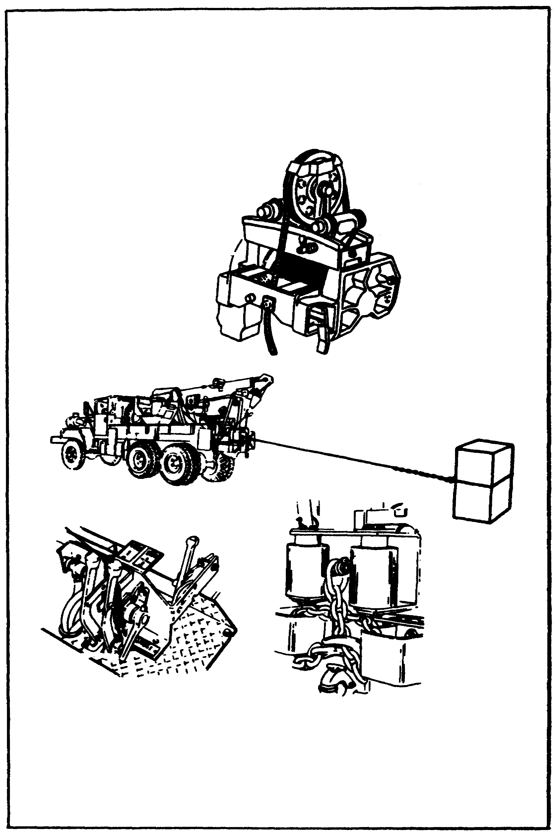

135

Lesson 5/Learning Event 2

The rear winch is a worm-geared, horizontal-drum winch mounted on the rear of the wrecker trucks. It can be used to pull loads up to 45,000 pounds. An automatic brake, which is attached to the rear end of the drive (worm gear) shaft, retains (holds) the winch load whenever the delivery of power to the winch propeller shaft is interrupted. All wrecker rear winches are equipped with a level wind and a manually controlled, pneumatically (air) operated, cable tensioner. The tensioner is mounted on the rear of the winch.

We learned that power for operating the winch is supplied by the truck engine through a power take-off, which is connected by a propeller shaft to the power divider.

A two-piece propeller shaft extends from the power divider to the bearing assembly. The bearing assembly is bolted to the rear of the wrecker body. A drive sprocket secured to the rear end of the bearing assembly shaft is connected by a drive chain to the driven sprocket on the front end of the winch drive shaft. The driven sprocket is secured to the drive shaft by a shear pin, which prevents damage to the winch resulting from overload.

Notice in the illustration of the rear winch (Figure 56) that the level wind (D) is bolted to the top of the end frame (right end of the winch) and gear case (left end of the winch). When winding the cable, tension of the cable on the swivel sheave (H) causes the swivel sheave frame (E) to move (on its four wheels) from side to side on the trolley track (A). This causes the cable to wind on the drum in tight, even coils and layers. The level wind mechanism prevents loose layers or crossed coils, which might crush or foul the cable.

Now let's see how you should go about using the rear winch. First, move the wrecker into the most effective position possible. The most effective position of the vehicle is when the load is directly behind the winch. However, cable guide rollers permit pulling a load at any angle up to 90° right or left, or at any angle up to 600 above or below the horizontal centerline of the winch.

After the vehicle is positioned, set the electric brake lock (if so equipped). With the engine running, disengage the engine clutch and move the transmission shift lever to 5th speed for light loads and 3d speed for heavy loads. Next, place the transfer shift lever in the neutral position as when using the crane. You then move the power divider control lever to the engaged position, engage the engine clutch, and set the throttle on the instrument panel to deliver 1,000 RPM no-load engine speed.

136

Lesson 5/Learning Event 2

That takes care of the controls in the cab of the vehicle, so now let's go to the rear of the vehicle. Shift the clutch control lever to the DISENGAGE position, move the rear winch shift lever to the UNWIND position, and move the cable tension valve lever to the OFF position. Now return the clutch control valve lever to the ENGAGE position and unwind the required amount of cable. Next, return the clutch control valve lever to the DISENGAGE position and place the winch shift lever in the NEUTRAL position after the required amount of cable is unwound. Tension should be maintained on the cable while the drum is turning to prevent snarled cable on the drum, so you will need someone to pull cable out while it is unwinding. You should always wear leather gloves when handling the winch cable. Never allow the cable to run through your hands, even with gloves on. A broken strand of cable can give you a long, deep cut. Also, during winch operation or when stopping the winch, direct all personnel to stand clear of the winch and load. A snapped cable or a shifting load can be extremely dangerous.

After the cable is where you want it, attach it to the load and move the cable tensioner valve lever to ON. Next, move the clutch control valve lever to ENGAGE and remove all the slack from the cable before winching. After all cable slack is removed, shift the clutch control valve lever to DISENGAGE, move the cable tension control valve to OFF, and move the clutch control valve lever to ENGAGE. Be sure the incoming cable is winding tightly and evenly on the drum. Tap or push the coils in place with a block of wood if necessary. To stop the winch, move the clutch control valve lever to DISENGAGE and move the winch lever to NEUTRAL.

Snatch blocks can be used to increase the pulling power of winches. The illustration shows how two snatch blocks are used with the rear winch. Notice that one snatch block has two sheaves, while the other snatch block has a single sheave.

137

Lesson 5/Learning Event 2

FIGURE 57. SNATCH BLOCKS.
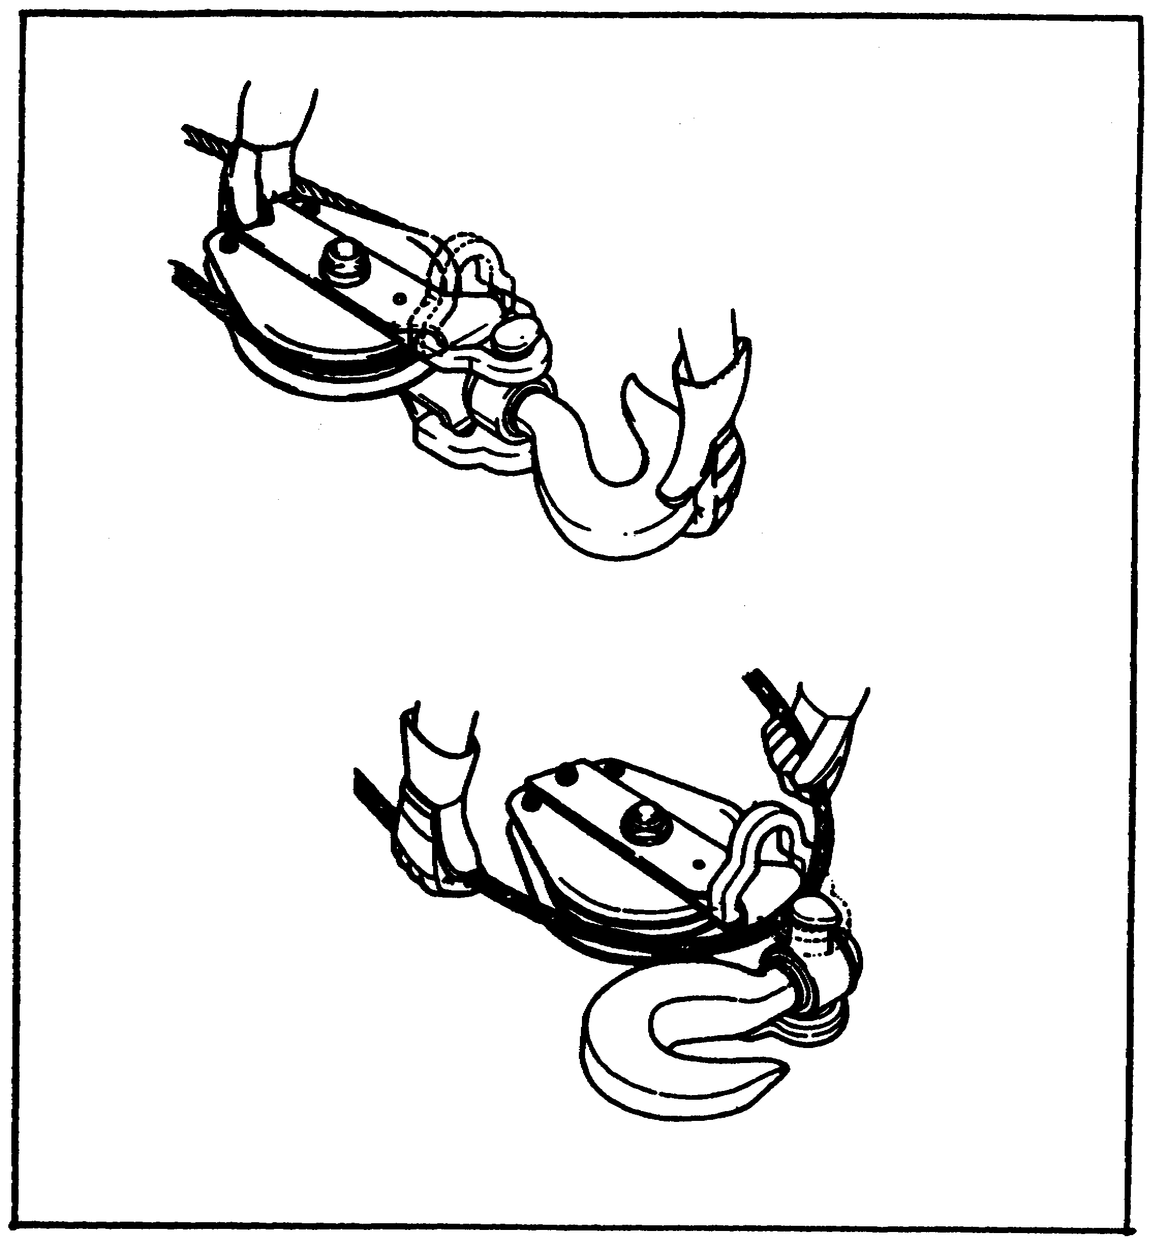

Snatch blocks have an advantage over conventional blocks because snatch blocks can be opened. Notice how the snatch block is opened to accept the cable. Both single- and double-sheave snatch blocks can be opened in a similar manner.

138

Lesson 5/Learning Event 2

EQUIPMENT STOWAGE

Wheeled vehicle wreckers carry a lot of equipment. Each piece of equipment should be stowed in a specific location. The rear of many wheeled wreckers is made up of stowage compartments, These compartments provide room for additional equipment that might be needed for a certain wrecker operation. Stowage arrangements vary depending on the specific wrecker. Always refer to the operator's manual for the stowage procedures for each wrecker.

TOWING DISABLED VEHICLES

Lifting may not be the only job you will have to do with the wrecker. It is often used for towing disabled vehicles. The towing procedures given here are for towing a 5-ton truck, but they will apply, in a general way, to other vehicles. Always check the technical manual pertaining to the vehicle to be towed to find any procedures peculiar to that vehicle.

139

Lesson 5/Learning Event 2

FIGURE 58. TOWING CONNECTIONS.
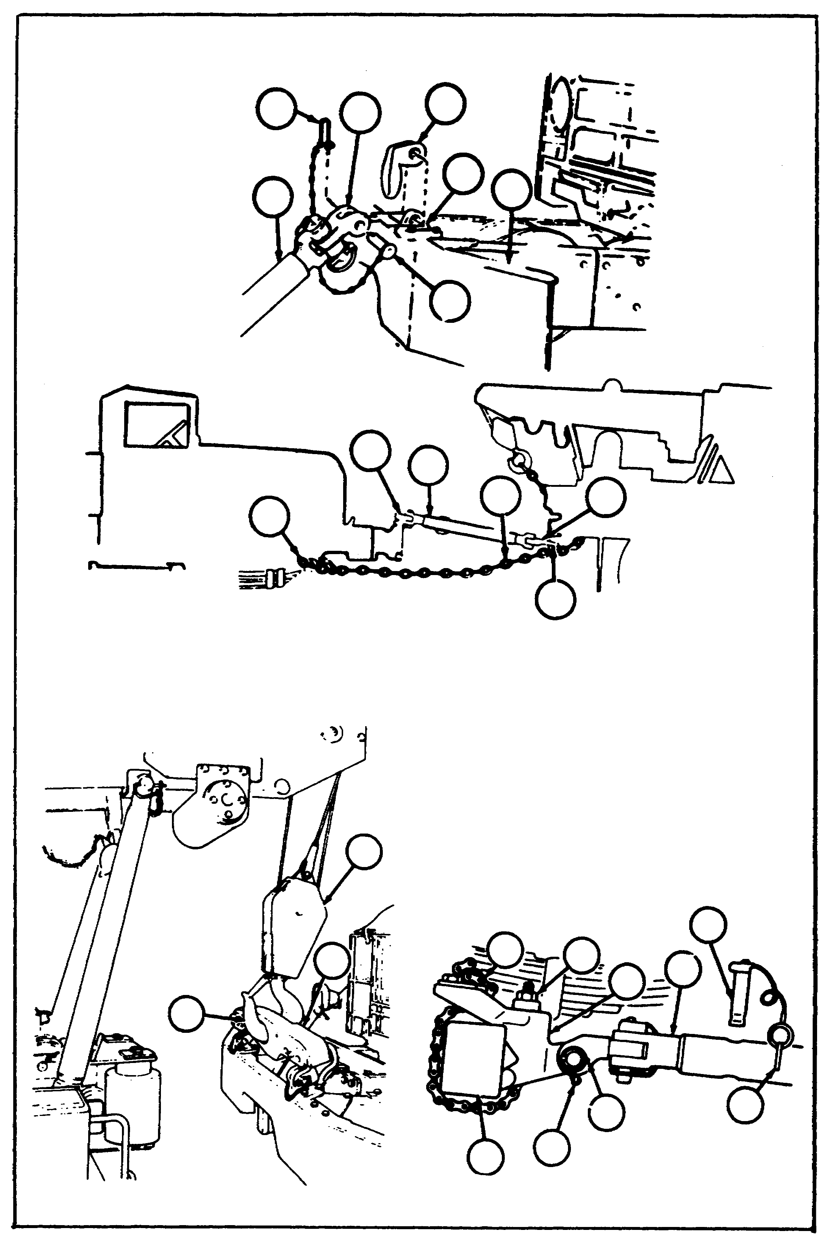

140

Lesson 5/Learning Event 2

Particular care must be taken when towing damaged trucks to ensure that no additional damage occurs while the truck is being towed. While chains or ropes may be used for towing a vehicle, use the tow bar stowed on the wrecker whenever possible. It works much better. The tow bar should be connected from the front lifting shackles of the towed vehicle to the pintle on the rear of the wrecker.

Let's say you want to tow a disabled 6x6 truck with all wheels on the ground. If the transfer on the truck to be towed is not damaged, place the transmission and transfer gearshift levers in their neutral positions. With this arrangement, some of the gears in the transfer will turn but the gears in the transmission will not turn. If the transfer on the truck to be towed is damaged, disconnect the transfer-to-front axle and the transfer-to-forward rear axle propeller shafts (transfer output shafts) at the axles. Don't forget to relieve torsional strain (windup). This is done by raising one wheel on each axle. After the propeller shafts are disconnected, secure the disconnected ends of the propeller shafts to the truck frame. Place the self-locking nuts and bolts in the map compartment of the towed truck.

Whenever a truck is to be towed with the front wheels off the ground, support the front of the truck so that the wheels of both rear axles contact the ground. Disconnect the transfer-to-forward rear axle propeller shaft at the forward rear axle companion flange. (Don't forget about windup.) Secure the disconnected end of the propeller shaft to the truck frame. Finally, place the self-locking nuts and bolts in the map compartment in the cab of the towed truck.

A truck should be towed backward only after other methods have proven unsatisfactory. To tow a truck with the rear wheels off the ground, disconnect the transfer-to-front axle propeller shaft at the front axle companion flange. (Again, don't forget about windup.) Secure the disconnected end of the propeller shaft to the truck frame and place the self-locking nuts and bolts in the map compartment.

141

Lesson 5/Learning Event 2

Sometimes, conditions will be such that the truck can be towed in only one direction. This can be caused by the transfer being locked through one of the two overrunning clutches (sprag unit). Towing in one direction will cause the wheels to skid. You may be able to correct this condition by first jacking up one front wheel to relieve the front axle of any binding torque load (wind-up). Then, open the drain cock of the air reservoir. This will bleed the air system of all pressure and allow the overrunning clutch unit in the transfer to return to neutral. This is true only on the 5-ton truck. On a 2 1/2-ton truck, or if the above does not work on the 5-ton truck, you will have to remove the transfer output propeller shafts.

These towing procedures are general; therefore, each time you have to tow a vehicle you may find something different. Remember, do not cause more damage to a vehicle while towing it. Find out what component is damaged. After that, you can come up with some way of preventing more damage either to that component or other components. Refer to the vehicle technical manual for precautions and towing procedures.

OPERATOR MAINTENANCE OF THE CRANE AND REAR WINCH

Operating the winch and crane is not all you will have to do on the wreckers. As an operator, you will also have to perform before-, during-, and after-operation maintenance services. Let's see what should be done starting with before-operation maintenance services.

before operating the winch, the cable should be checked to see if it has been wound onto the drum properly. This also goes for the hoist winch and the rear winch. You should also check for any signs of damage. Inspect the rear winch for a broken shear pin and both winch housings for secure mountings, leaks, or damage. The cable tensioner and cable level wind on the rear winch should be checked for mounting and condition. Also check the condition of the drive shafts, sprockets, and drive chain of the rear winch.

The hydraulic crane, control valve bank, cylinders, hoist drum and worn drive gear, hoses, power divider, pump, governor control valve, shipper and boom assembly, and the swing motors should be checked for secure mounting and damage. Look, particularly for leaks, at the hydraulic pump shafts, cylinder piston rods, and hose connections. Be sure you check the reservoir oil level weekly.

142

Lesson 5/Learning Event 2

When you test-operate the rear winch, check the operation of the controls, cable tensioner, and level wind and listen for unusual noise. When you test-operate the crane, observe if the governor control valve holds the engine speed at 1,250 ± 50 RPM. Operate the crane through the full range of movements and notice whether the pump control linkage and control valve levers operate freely without sticking. Also, listen for unusual noises.

After each operation of the winch and crane, hoist cables should be cleaned by soaking or brushing off any accumulation of dirt, grit, or other foreign material. The cables should then be oiled with used crackcase oil or engine oil (EO). If the cables are not generally used, you should unwind each entire cable every six months. Clean the entire cable and then soak it in OE or preservative lubricant (PL). Wipe off the excess oil and then coat the cable with CW (lubricating oil, chain-wire rope, or exposed gears). The winch drum should also be coated with CW before rewinding the cable. Be sure to check the condition of the cable as it is unwound and rewound. Finally, lubricate the winch and boom according the proper lubrication order (LO). Don't forget to use gloves when working on the winch cables.

Check the condition of all the equipment stowed on the wrecker. Clean off any rust found on the equipment and coat the metal parts with PL. All pins should have a free fit in each base. Items such as the shipper braces should telescope with little effort.

Operator maintenance services are important to all wrecker personnel. Before- and during-operation maintenance services make the wrecker easier and safer for you, the operator, to use. After-operation services help the next operator(s). You could be one of the next operators, so leave the wrecker with the maintenance brought up to date.

SUMMARY

After studying this lesson, you should have a good idea of bow to operate any 5-ton wrecker. You learned the purpose of various components used on cranes and how to operate the wreckers. The operating procedures were primarily on the M816 5-ton wrecker, as you will probably find more of this model in the field than other models. These operating procedures are basically the same for all wheeled vehicle wreckers, either the M816 or the M936 5-ton wreckers. The 5-ton wrecker rear winch can be used to pull up to 45,000 pounds. When pulling heavy loads, you will have to secure the wrecker so that it will not slide toward the load you are pulling. You may use the wrecker to tow a disabled truck.

143

Lesson 5/Learning Event 2

Ensure you first disconnect the drive components between the wheels and the defective components. Complete the operator maintenance service before, during, and after operating the wrecker. These vehicle, like other military vehicles, must be ready to go at all times.

144

Lesson 5

PRACTICE EXERCISE

1. Which statement is true about basic wrecker crane components?

a. The boom shipper braces provide a more solid working platform when lifting from the side of the wrecker
b. The boom can be tilted up or down on a pivot point located in the boom shipper
c. The operator's compartment on most wheeled vehicle wreckers is mounted on the crane turntable

2. If your unit is issued a wheeled vehicle wrecker with an automatic transmission, it would be described as a 6x6, truck, wrecker,

a. 5-ton, medium, M819.
b. 5-ton, medium, M816.
c. 5-ton, medium, M936.

3. Where would you look to find a leak in the crane hydraulic pump on the M816 wrecker?

a. Crane turntable
b. Rear of power divider
c. Front of transfer case

4. What connects the transfer power take-off to the power divider on the M816 wrecker?

a. Propeller shaft
b. Chain and sprockets
c. Three V-belts

5. When the crane is being operated, which drive train component disengages engine power from the drive wheels?

a. Transfer case
b. Transmission
c. Engine clutch

145

Lesson 5

ANSWERS TO PRACTICE EXERCISE

1. b (page 109)

2. c (page 112)

3. a (page 120)

4. a (page 114)

5. a (page 114)

146

